MEDHA DRISHTI · NATIONAL AI HACKATHON · YUGMA TECHFEST 2.0
MRI Enhancement and Region-of-Interest Segmentation
Restoring degraded MRI scans and delineating the region of interest
JNNCE Shivamogga · Phase 2 Evaluation

1. Objectives
MRI trades image quality for acquisition speed. Faster scans carry two characteristic defects: Rician noise, the grain inherent to MRI magnitude images, and a bias field, a smooth intensity gradient from RF coil inhomogeneity. Both obscure the fine boundaries that carry diagnostic meaning — the rim of a tumour, the margin of a compressed disc.
This project delivers an end-to-end pipeline that:
1. characterises the supplied datasets quantitatively before any processing;
2. preprocesses and standardises heterogeneous scans;
3. restores degraded scans using a deep-learning model, benchmarked against classical enhancement methods; and
4. delineates the region of interest — tumour sub-regions and CSF/grey/white matter for brain, and disc/vertebra/cord regions plus abnormality localisation for lumbo-sacral spine.
A hard constraint shaped the spine work: the supplied spine data carries no annotations, and external data is not permitted. Every spine method is therefore unsupervised or self-supervised.

2. Datasets
Dataset | Role | Cases | Annotations
BraTS2020 | Standard training set | 127 used (of 369) | Expert tumour masks
Hackathon — brain | Testing / validation | 20 | None
Hackathon — spine | Testing / validation | 20 | None

Splits are at patient level, never slice level: slices from one patient are highly correlated, so a slice-level split leaks information and inflates every reported score. BraTS is split 80/20; the offline groups 5 train / 5 test per the organisers' instruction. All volumes are read directly from .nii/.nii.gz.
Stage-1 analysis measured seven properties — contrast, complexity, sharpness, edge strength, noise level, mean and deviation — across every dataset and sub-modality. BraTS is uniform (240×240×155 at 1 mm isotropic), while the offline scans are highly heterogeneous (in-plane voxels 0.25–1.3 mm, slice thickness 3–13 mm), which is the direct justification for resampling all inputs to a common 224×224 grid in Stage 2.
A second finding governs the loss function: in the annotated data, background occupies 99.03 % of pixels, while edema, enhancing tumour and necrotic core occupy 0.71 %, 0.17 % and 0.10 % respectively.
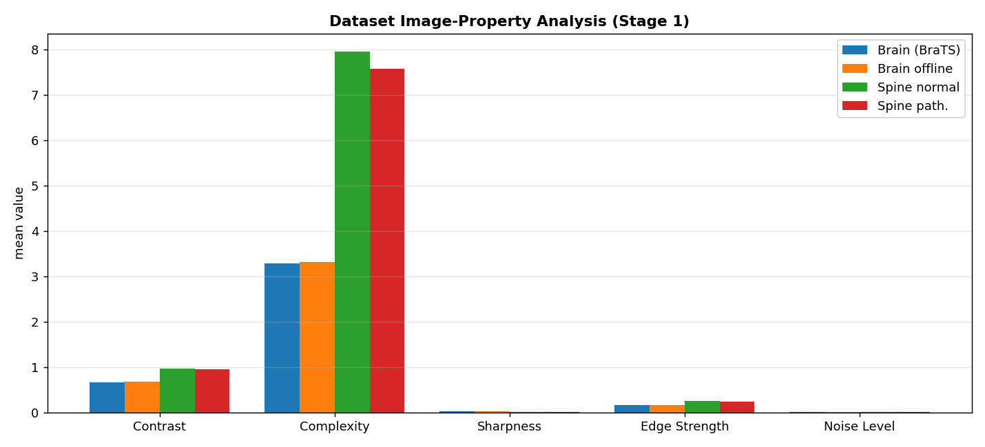
Figure 1 — Image properties across all datasets and sub-modalities. Spine scans carry roughly twice the complexity of brain scans; the offline brain data matches BraTS closely, supporting transfer of BraTS-trained models.

3. Methodology

3.1 Preprocessing (Stage 2)
Volumes are normalised to [0,1] using robust percentiles (0.5–99.5), sliced axially with near-empty slices discarded, and resampled to 224×224 with cubic interpolation followed by clipping, since cubic interpolation overshoots at sharp edges. Label masks use nearest-neighbour interpolation only, as interpolating labels would invent class values that do not exist. BraTS label 4 is remapped to 3 for contiguity. Histogram equalisation and CLAHE are applied as classical baselines, and the seven properties are re-measured after every step.

3.2 Enhancement model (Stage 3)
A 2D U-Net — encoder, bottleneck, decoder, with skip connections — with 7.77 M parameters. Training pairs are built by degrading clean scans with MRI-correct corruption: Rician noise (σ 0.02–0.20), a smooth multiplicative bias field, and mild blur. Gaussian noise would be a methodological error, as it does not match the physics of MRI magnitude images.
The loss is L1 + SSIM: L1 drives per-pixel fidelity, SSIM preserves structure, so the output is visually faithful and not merely numerically close. Optimiser: Adam at 1e-3 with mixed precision.
Because the three spine sequences are physically different images — T1 shows anatomy, T2 shows fluid, STIR suppresses fat — a separate model was trained per sequence and compared against a single pooled model on identical held-out slices.

3.3 Segmentation model (Stage 4)
The same backbone with four input channels (T1, T1c, T2, FLAIR stacked) and four output classes; each sequence reveals a different tumour component — T1c the enhancing rim, FLAIR and T2 the surrounding edema. The loss is cross-entropy + soft Dice: given the 99 % background imbalance, cross-entropy alone converges to predicting background everywhere, while Dice optimises region overlap directly.
For healthy subjects, CSF, grey and white matter are separated by unsupervised Gaussian-mixture clustering on T1 intensity, since no tissue labels exist. For spine we implemented and measured a progression of annotation-free methods: intensity k-means, SLIC superpixels, and a self-supervised CNN (differentiable feature clustering) optimised on each scan using the image's own structure as supervision. Autoencoder anomaly detection was validated rather than assumed — it did not work (§4.3).

3.4 Use of a pretrained model for per-vertebra instances
Degenerative disc, herniation and stenosis are named clinical entities, and naming them is inherently supervised. With no annotations, no external data and 20 spine cases, that target cannot be learned from the supplied data — a property of the problem as specified, not a shortfall of effort (§4.5 quantifies the gap). With the organisers' approval we therefore use SPINEPS (Möller et al., European Radiology 2025, Apache-2.0) for this one output: the first publicly available whole-spine model for sagittal T2w MRI, giving semantic and instance masks for 14 structures at published Dice 0.92 (vertebrae), 0.967 (discs) and 0.958 (canal), validated on over 1,600 subjects. We supply it no annotations and do not train it; its provenance is labelled wherever it appears. Full reasoning: docs/PRETRAINED_MODEL_JUSTIFICATION.md.
Slice-based 2D processing throughout keeps memory within a 6 GB laptop GPU; the published 3D BraTS models document a 16 GB+ requirement.

4. Results

4.1 Enhancement
Evaluated on held-out slices under identical degradation, against the classical baseline family that the referenced literature benchmarks against:
Method | PSNR (dB) | SSIM | FSIM | VIF
Degraded input | 18.05 | 0.196 | 0.430 | 0.302
Histogram equalisation | 8.05 | 0.149 | 0.211 | 0.192
Adaptive HE | 6.35 | 0.133 | 0.187 | 0.199
CLAHE | 11.84 | 0.156 | 0.280 | 0.248
Proposed (2D U-Net) | 27.08 | 0.903 | 0.959 | 0.361

Every classical method scores below the degraded input on all four metrics. This is not a defect of the implementations — those methods redistribute contrast without any model of noise, so measured against the clean reference they move away from it. Re-measurement confirms the mechanism: noise rises from 0.0068 to 0.0138 under HE and 0.0106 under CLAHE, while the proposed model reduces it to 0.0043 — the only stage in the pipeline that removes noise.
On BraTS FLAIR the trained model reaches PSNR 30.34 dB and SSIM 0.965. Per-sequence spine models outperformed a single pooled model on all three sequences, on identical test slices: T1 0.598 → 0.827, T2 0.594 → 0.802, STIR 0.540 → 0.714 SSIM.
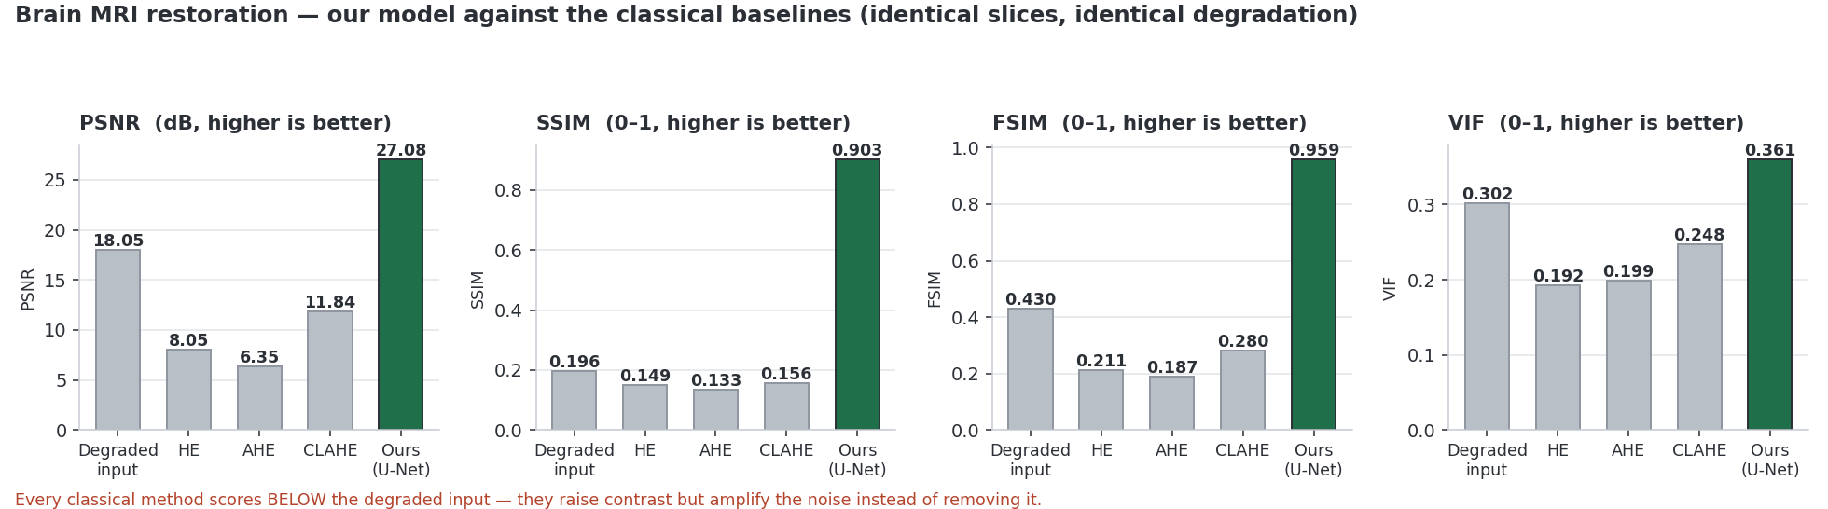
Figure 2 — Restoration quality against the classical baselines on identical slices.

4.2 Segmentation
Evaluated against expert annotation on held-out patients, accumulating counts across the whole validation set rather than averaging per slice — per-slice averaging inflates results because most slices contain no tumour at all.
Class | Dice | Jaccard | Sensitivity | Specificity | Precision | F1 | HD | ASD | RVE
Necrotic core | 0.672 | 0.506 | 0.744 | 0.9998 | 0.613 | 0.672 | 8.59 | 1.68 | 0.214
Edema | 0.768 | 0.623 | 0.654 | 0.9996 | 0.930 | 0.768 | 19.71 | 1.59 | 0.297
Enhancing tumour | 0.840 | 0.723 | 0.783 | 0.9998 | 0.905 | 0.840 | 6.94 | 0.86 | 0.134

Mean tumour Dice: 0.760. Training converged at epoch 25 with an overfitting gap of approximately zero, and 3-fold cross-validation gives 0.59 ± 0.04 Dice — the small spread across folds indicates a consistent model rather than a favourable split.
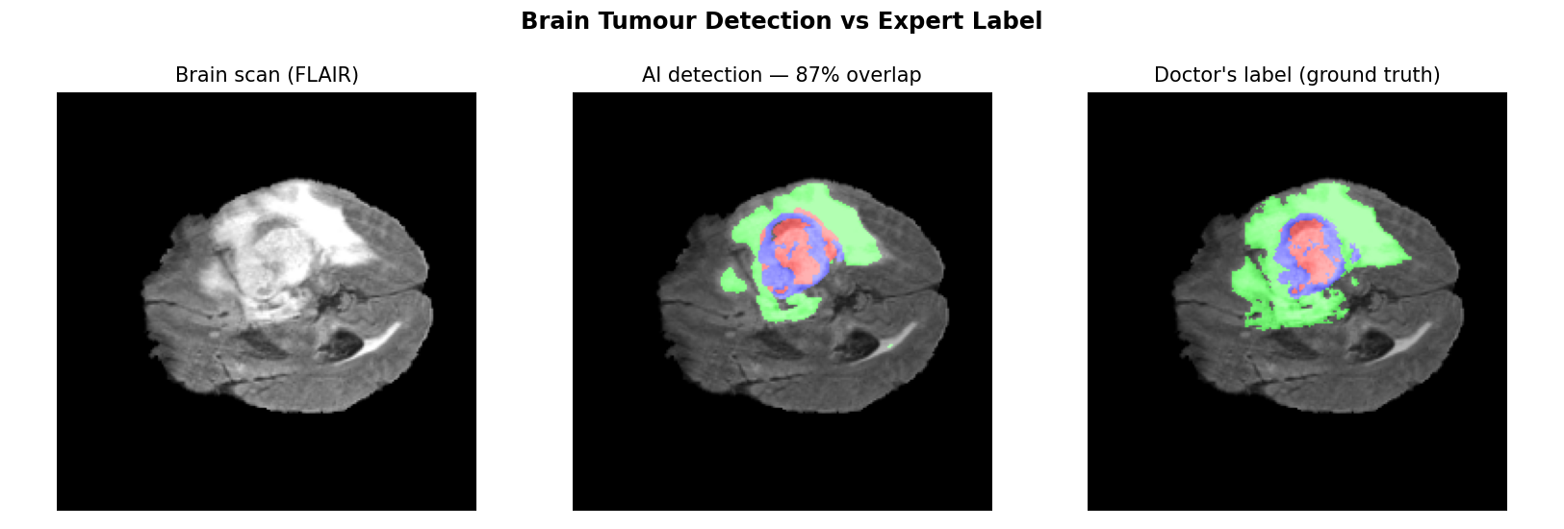
Figure 3 — Predicted tumour sub-regions (centre) beside the radiologist's annotation (right) on a patient excluded from training. Green edema, red enhancing tumour, blue necrotic core.

4.3 A negative result: autoencoder anomaly detection
The autoencoder reconstructs healthy spinal anatomy convincingly, but the score does not separate diseased from healthy spines on held-out cases: normal (n=28) mean 0.0199 (0.0137–0.0314) against pathological (n=27) mean 0.0167 (0.0101–0.0234). AUC = 0.27, worse than chance, with completely overlapping distributions and no usable threshold — normal spines score higher than pathological ones. The error is dominated by image texture and anatomical complexity, not disease. The detection claim was withdrawn and the map is presented purely as a visualisation: an unvalidated detector that fires on healthy patients is more dangerous than none (results/anomaly_validation.json).
[ insert images/spine_anomaly.png ]
Figure 4 — Reconstruction difference against a healthy-only autoencoder. Left, a pathological spine; centre, the model's healthy reconstruction; right, the difference map. Presented as a visualisation only — validation showed the score does not distinguish pathological from normal spines.

4.4 Efficiency
Both models share the same backbone: 7.77 M parameters, 31 MB on disk, 4.24 ms per image on GPU (236 images/sec). Peak GPU memory is 385 MB for enhancement and 390 MB for segmentation, at 84 % and 98 % GPU utilisation respectively.

4.5 Spine ROI segmentation against a reference standard
The spine data carries no annotation, so our own segmentation cannot be scored against ground truth. We instead use the pretrained model as an independent reference standard and quantify how much our annotation-free methods recover without ever seeing a label. Evaluated on case SP11, slice 5; the self-supervised CNN is stochastic — seeded, but cuDNN selects nondeterministic kernels — so its figures are mean ± SD over three runs.
Structure | k-means | SLIC | Self-supervised CNN (ours)
Vertebral bodies | 0.263 | 0.204 | 0.257 ± 0.018
Intervertebral discs | 0.047 | 0.047 | 0.090 ± 0.017
Spinal canal + cord | 0.304 | 0.302 | 0.380 ± 0.041
Posterior elements | 0.071 | 0.097 | 0.169 ± 0.032
Dice against the reference standard. Separating precision from recall makes these numbers interpretable: the classical methods reach high recall (k-means 0.807 on vertebral bodies) at very low precision (0.157) — they locate the structure but flood far past its boundary, the expected failure of grouping by brightness. Our CNN attains the highest precision on all four structures (0.191 / 0.050 / 0.310 / 0.116) and the best Dice on three of four.
Two methodological points. These Dice values are oracle-assisted upper bounds: unsupervised methods produce anonymous cluster indices, so the reference selects which cluster to score — the figure answers whether a structure was isolated, not whether the method can name it. We also tested whether the metric penalises methods producing more clusters (ours 9–10, k-means 4) with a greedy best-union score; it moved the result by 0.002.
The conclusion is two-sided. Our annotation-free CNN is the strongest label-free method and clearly better than the classical baselines on precision, yet far from the reference: best Dice 0.380 against SPINEPS's published 0.920, and zero numbered vertebrae, because numbering requires labels we do not have. That measured gap justifies the pretrained model for that single output. Applied to SP11 it produced 13 semantic structures and 17 numbered vertebrae in 401 s, mapped back through the image affine.
[ insert images/spine_vs_spineps.png ]
Figure 5 — Our annotation-free methods against the pretrained reference: Dice by structure with the reference's published accuracy marked; precision, where our CNN leads on all four structures; and what external labels buy — named, numbered vertebrae our methods cannot produce.
[ insert images/spine_method_comparison.png ]
Figure 6 — Every spine method on one slice. Intensity clustering floods the background; our self-supervised CNN resolves cord, vertebral chain and soft tissue without annotations; SPINEPS adds the 17 numbered instances neither reaches.

5. Conclusion and Limitations
The proposed pipeline restores degraded MRI substantially better than the classical enhancement methods, and delineates brain tumour sub-regions at a mean Dice of 0.76 against expert annotation, while running in 4 ms per image on consumer hardware. The spine track satisfies the no-annotation constraint via three independent unsupervised and self-supervised methods.
Three limitations are stated deliberately. First, quantitative segmentation accuracy is reported only on BraTS, the sole dataset with expert annotation; on the unlabelled hackathon data we report enhancement metrics and qualitative segmentation rather than inventing figures. Second, our autoencoder-based spine anomaly detector failed validation (AUC 0.27) and the claim was withdrawn; our own spine contributions are therefore restoration, self-supervised region segmentation and canal morphometry, while per-vertebra instance segmentation is provided by a pretrained model (§3.4), clearly attributed, because that output cannot be learned from unlabelled data — a gap we quantify rather than assert (§4.5: best Dice 0.380 against the reference's published 0.920, and zero numbered vertebrae). Third, the restoration model corrects noise and intensity artefacts only; it does not synthesise anatomy — the SSIM above 0.9 against the reference scan is the evidence. All results are reproducible from the accompanying source code.

