Introduction to Databases (CSE 3151)

**Assignment 3: Subqueries and Joins**

1. **Write the expression for the following set of queries in SQL, based on the set of schemas of Assignment (4), using concept of sub query.**

a) Find out the name, phone_no and cust_no of customer having Account_no “A0004”.

Ans-

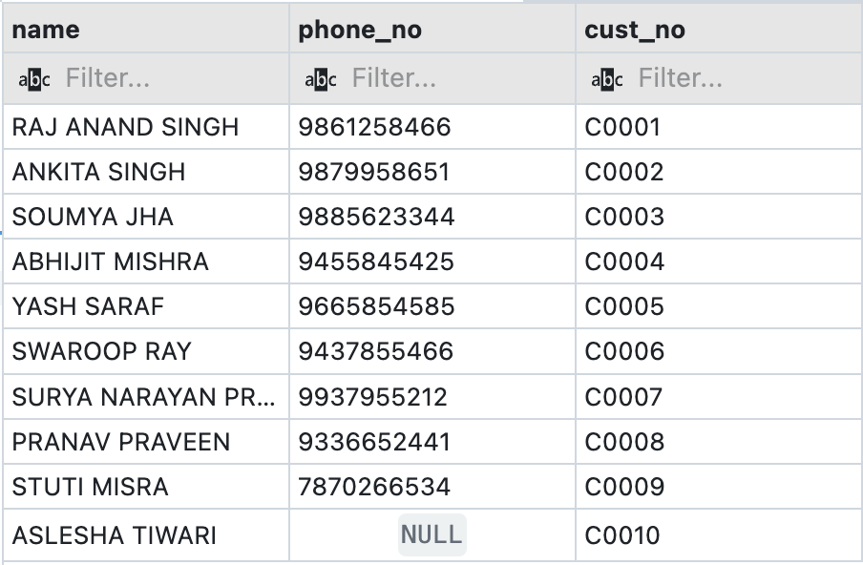

b) Find out the name of the customer who has not taken any loan.

Ans-

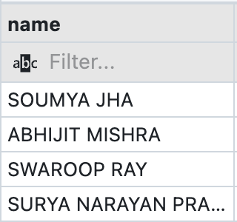

c) Find out the account_no and Balance of customer with cust_no = “C0010”.

Ans-

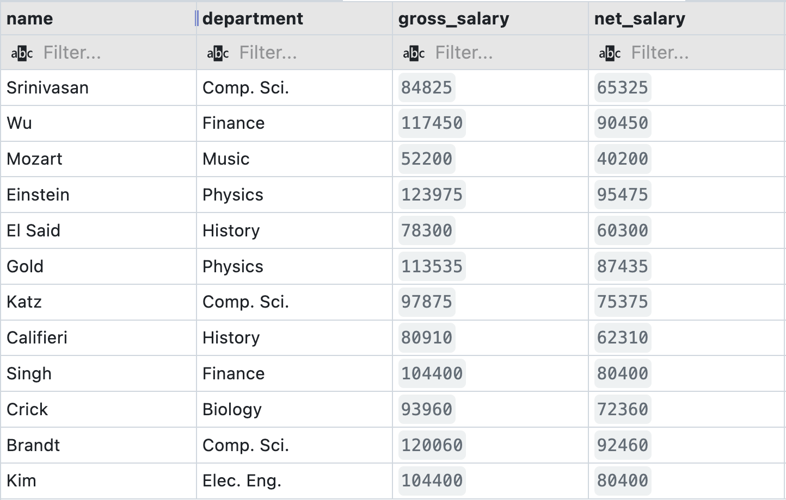

d) Display records of the Instructors with salary range 60000 to 80000.

Ans-

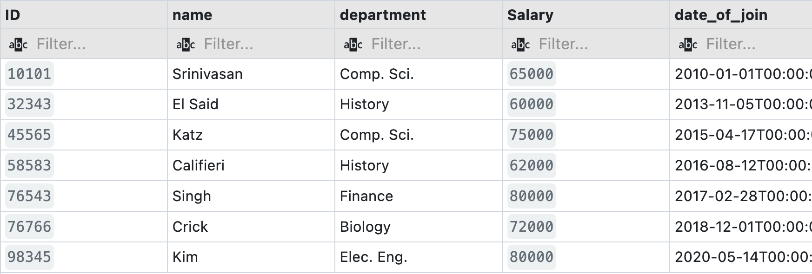

e) Display the records of the instructors having the second letter in their name as ‘r’.

Ans-

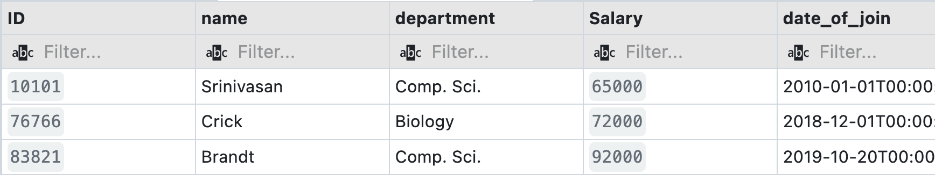

f) Display the names of the instructors of Comp.Sci. Department in the descending order of their salary.

Ans-

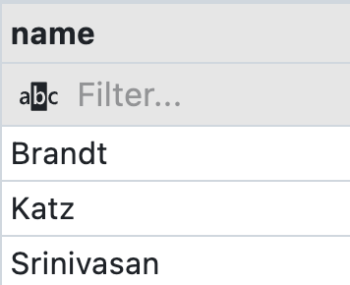

g) Update all records of Instructor table with a salary hike of 15%.

Ans-

Output- No output as it only updated the record

h) Update the records with a salary hike of 3% for Comp.Sci. Dept instructors having salary

less than 70000.

Ans-

Output- No output as it only updated the record

1. Display the annual salary of each instructor.

Ans-

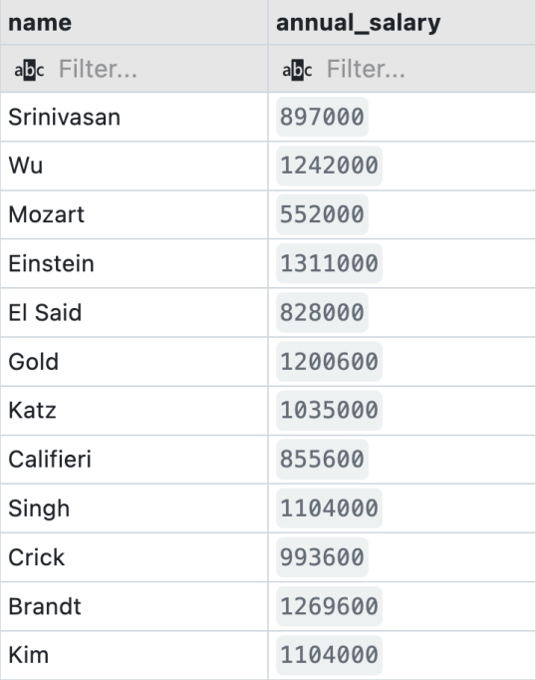

j) Update the title of the course having title 'Game Design' to 'Game Theory'.

Ans-

Output- No output as it only updated the record.

k) Delete the instructor records of History department.

Ans-

Output- No output as it only updated the record.

l) Delete the course records of the courses having course_id starting with 'BIO'.

Ans-

Output- No output as it only updated the record.

**2. Write the SQL Expressions for the following queries using suitable SQL aggregate function.**

a) Display the Avg. salary of instructors of Physics department.

Ans-

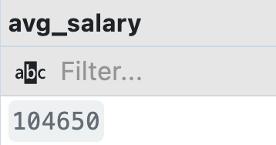

b) Display the Dept_ name and Average salary paid to instructor of each department.

Ans-

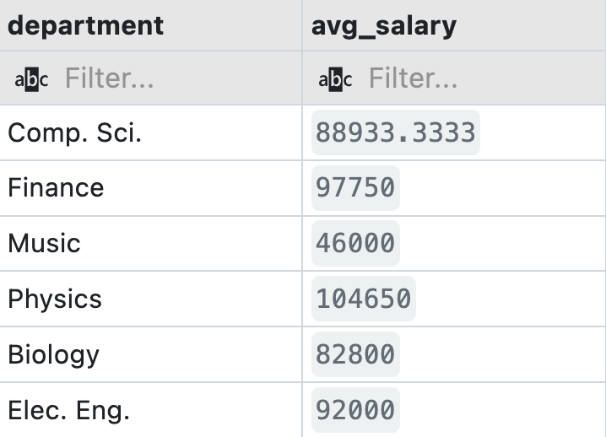

c) Display the ID, Name & Department of the instructor drawing the highest salary.

Ans-

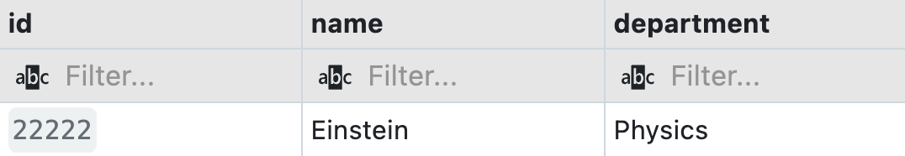

d) Display the number of instructors available in Comp. Sci. Department.

Ans-

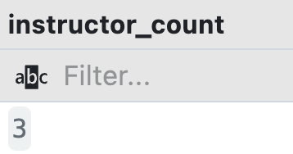

e) Display the total credits of all courses offered in Comp.Sci. Department.

Ans-

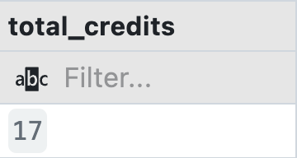

f) Display the number of instructors and total salary drawn by Physics and Comp. Sci. departments.

Ans-

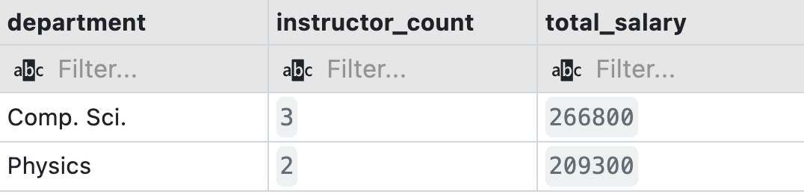

g) Display the total credits of Comp.Sci. and Biology departments from course table.

Ans-

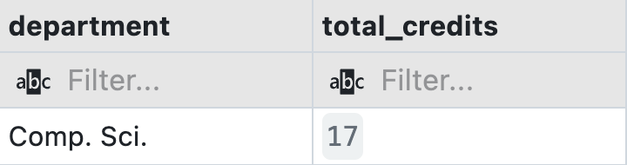

h) Display building wise total budget values.

Ans-

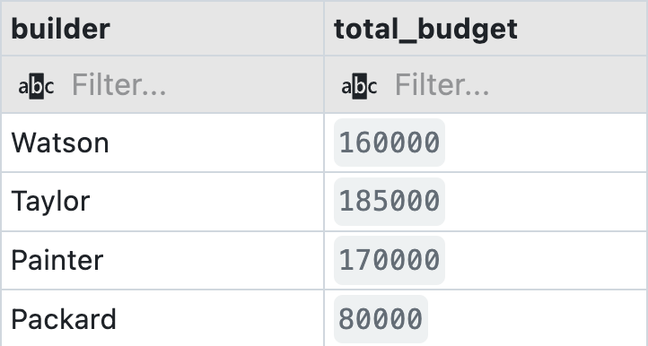

1. Display the number of instructors of each department.

Ans-

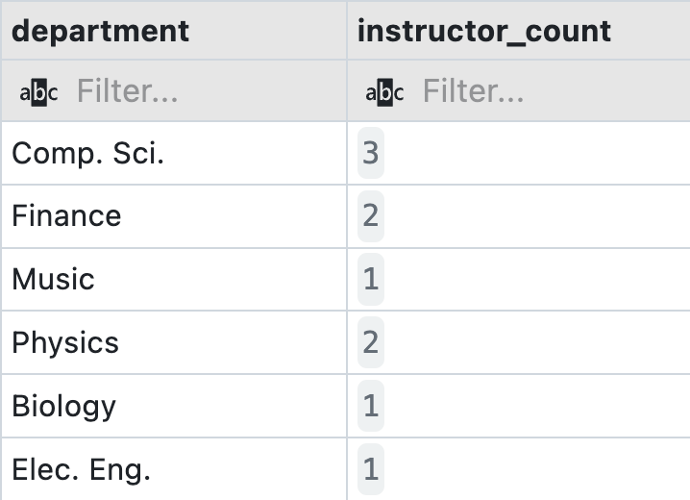

j) Display the number of instructors of each department sorted in high to low.

Ans-

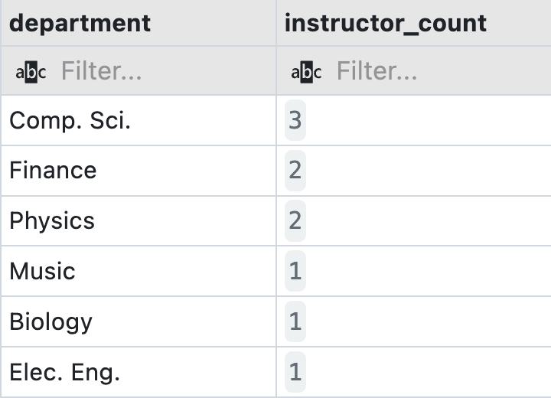

k) Display the number of courses offered semester wise.

Ans-

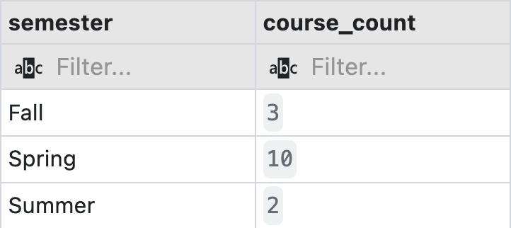

l) Display the name of departments having number of instructors less than 2;

Ans-

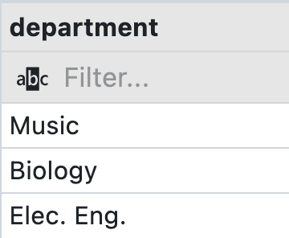

m) List the number of instructors of each department having 2 or more than 2 instructors except Finance department, sorted in high to low order of their number.

Ans-

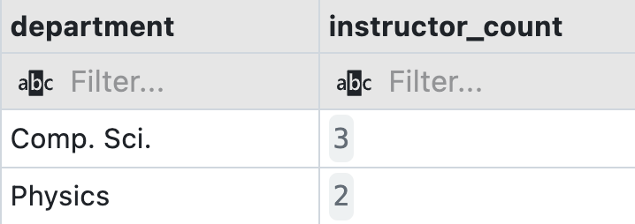

n) Display the Dept_name that has paid total salary more than 50000.

Ans-

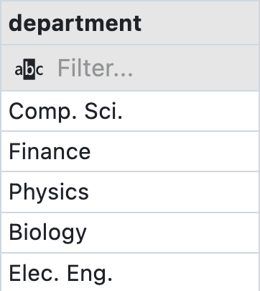

o) Display the total budget for the building built by Watson.

Ans-

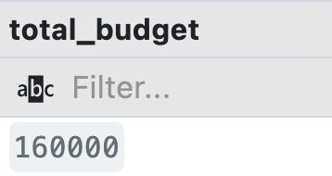

p) Display the highest salary of the instructor of Comp.Sci. Department.

Ans-

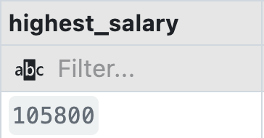

**3. Write the SQL Expressions for the following queries using suitable SQL scalar function.**

a) Display your name with first letter being capital, where the entered name is in lower case.

Ans-

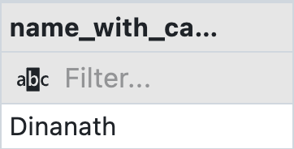

b) Display 2nd- 6th characters of your name.

Ans-

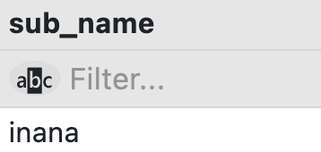

c) Find length of your full university name.

Ans-



d) Display all the Instructor names with its first letter in upper case.

Ans-

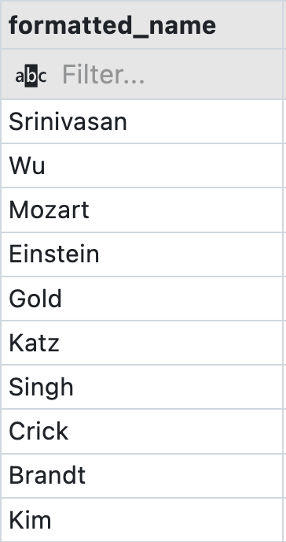

e) List the department name of each instructor as a three letter code.

Ans-

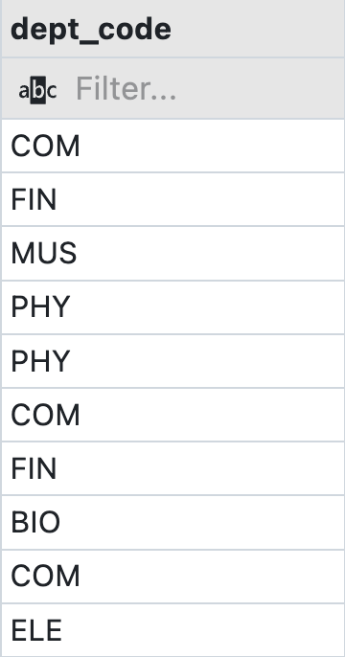

f) Display the month of the joining of each instructor.

Ans-

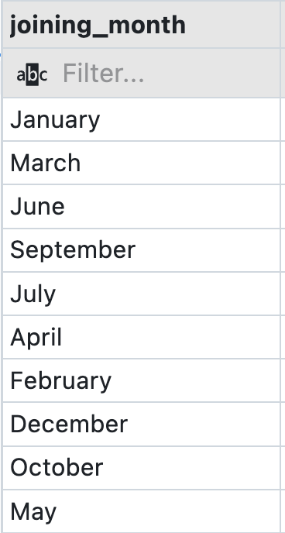

g) Display the date of joining of each instructor in dd/mm/yy format.

Ans-

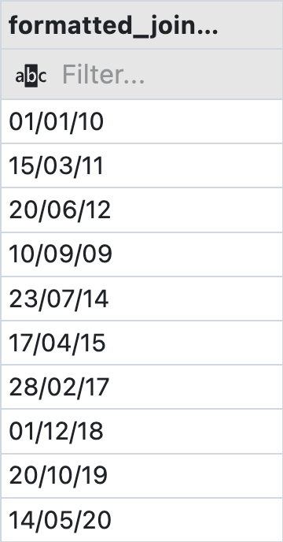

h) Display the experience of each instructor in terms of months.

Ans-

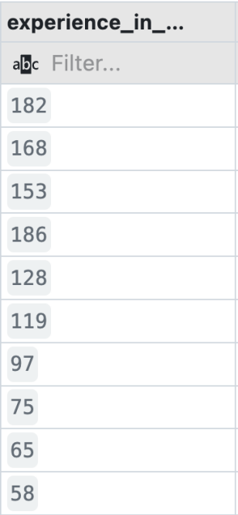

1. Display the experience of each instructor in term of years and months.

Ans-

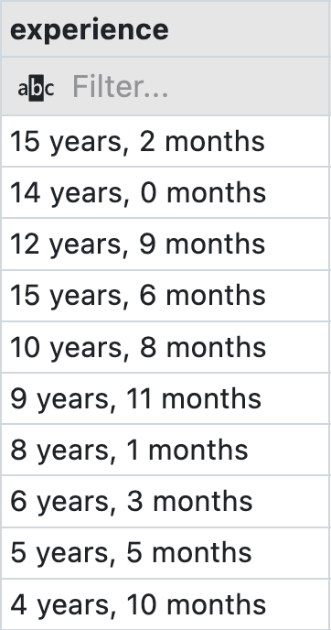

j) Display the day of joining of each instructor.

Ans-

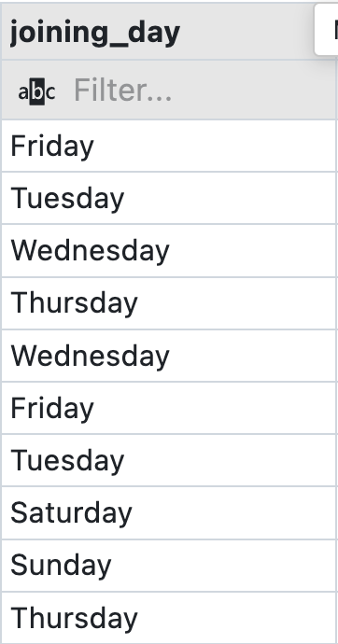

k) Display the date corresponding to 15 days after today's date.

Ans-

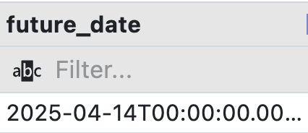

l) Display the value 94204.27348 truncated up to 2 digits after decimal point.

Ans-

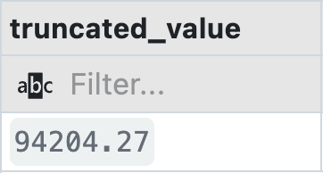

m) Display the value of the expression 5 + 89.

Ans-

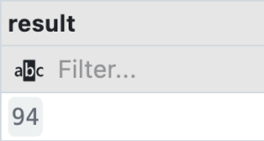

n) Find out the square root of 6464312.

Ans-

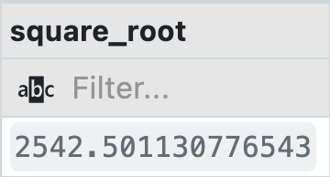

o) Display the string “HELLO ITER” in lower case with a column heading lower case.

Ans-

