Python for Computer Science and Data Science 2 (CSE 3652)

**Minor Assignment-4: MACHINE LEARNING- CLASSIFICATION, REGRESSION AND CLUSTERING**

1. Perform dimensionality reduction using scikit-learn’s TSNE estimator on the Iris dataset, then graph the results.

**Ans:-**

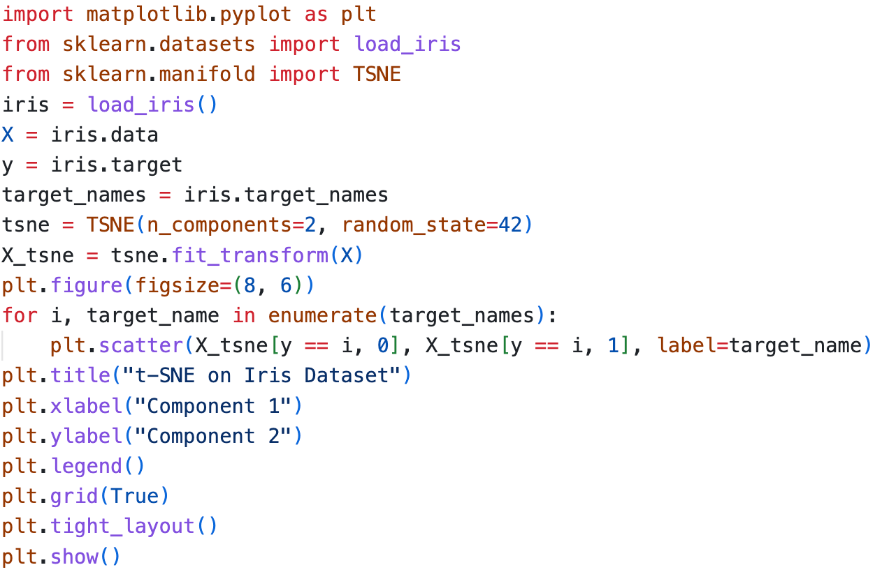

Output: -

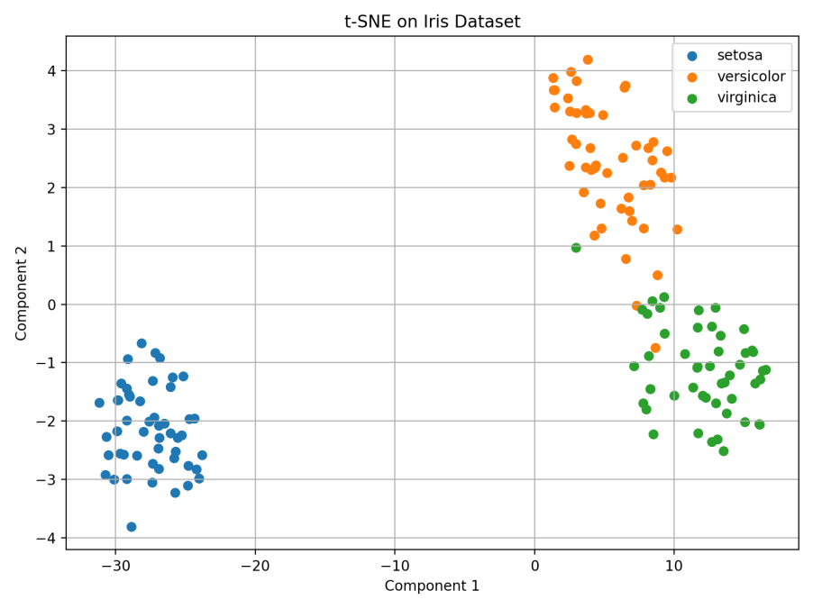

1. Create a Seaborn pairplot graph for the [California Housing dataset](https://scikit-learn.org/stable/datasets/real_world.html" \l "california-housing-dataset). Try the Matplotlib features to panning and zoom in on the diagram. These are accessible via the icons in the Matplotlib window.

**Ans:-**

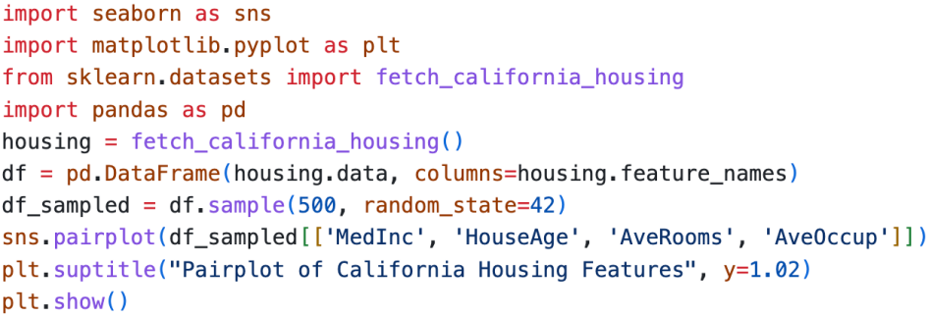

Output: -

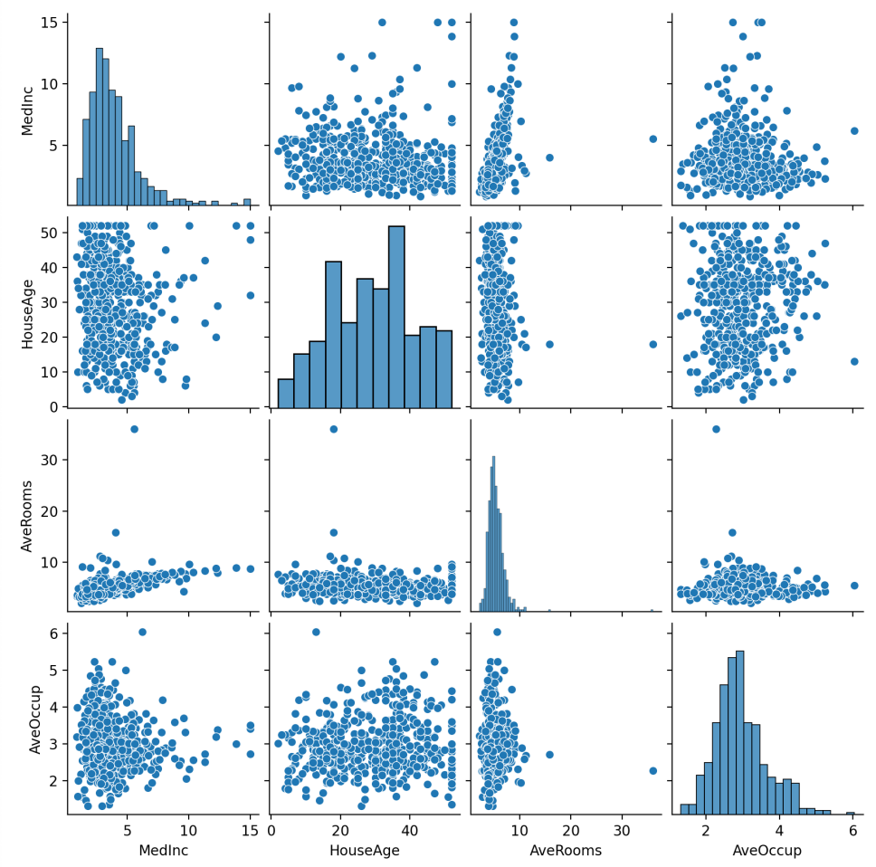

1. Go to NOAA’s Climate at a Glance page ([Link](https://www.ncei.noaa.gov/access/monitoring/climate-at-a-glance/national/time-series/110/tmax/1/1/1895-2025)) and download the available time series data for the average annual temperatures of New York City from 1895 to today (1895-2025). Implement simple linear regression using average annual temperature data. Also, show how does the temperature trend compare to the average January high temperatures?.

**Ans:-**

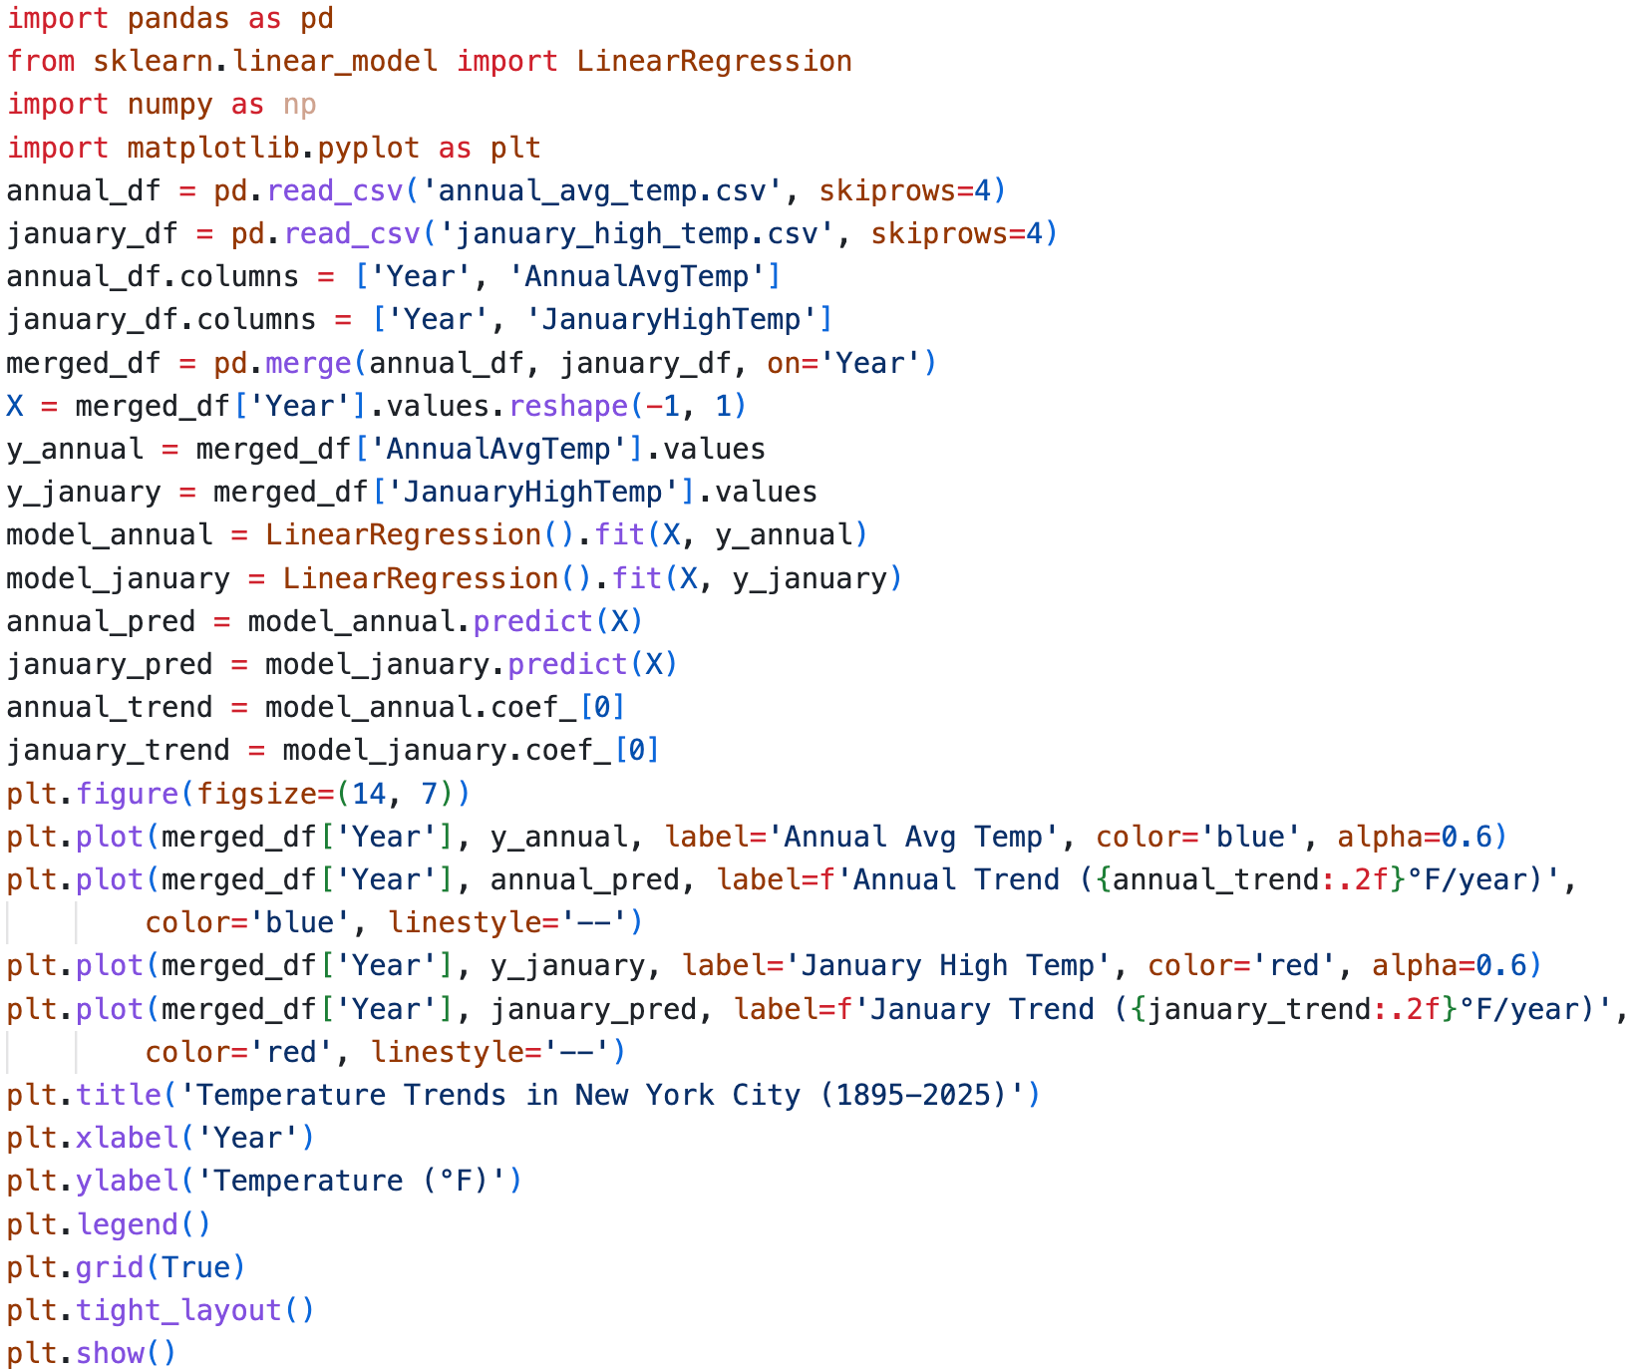



Output: -

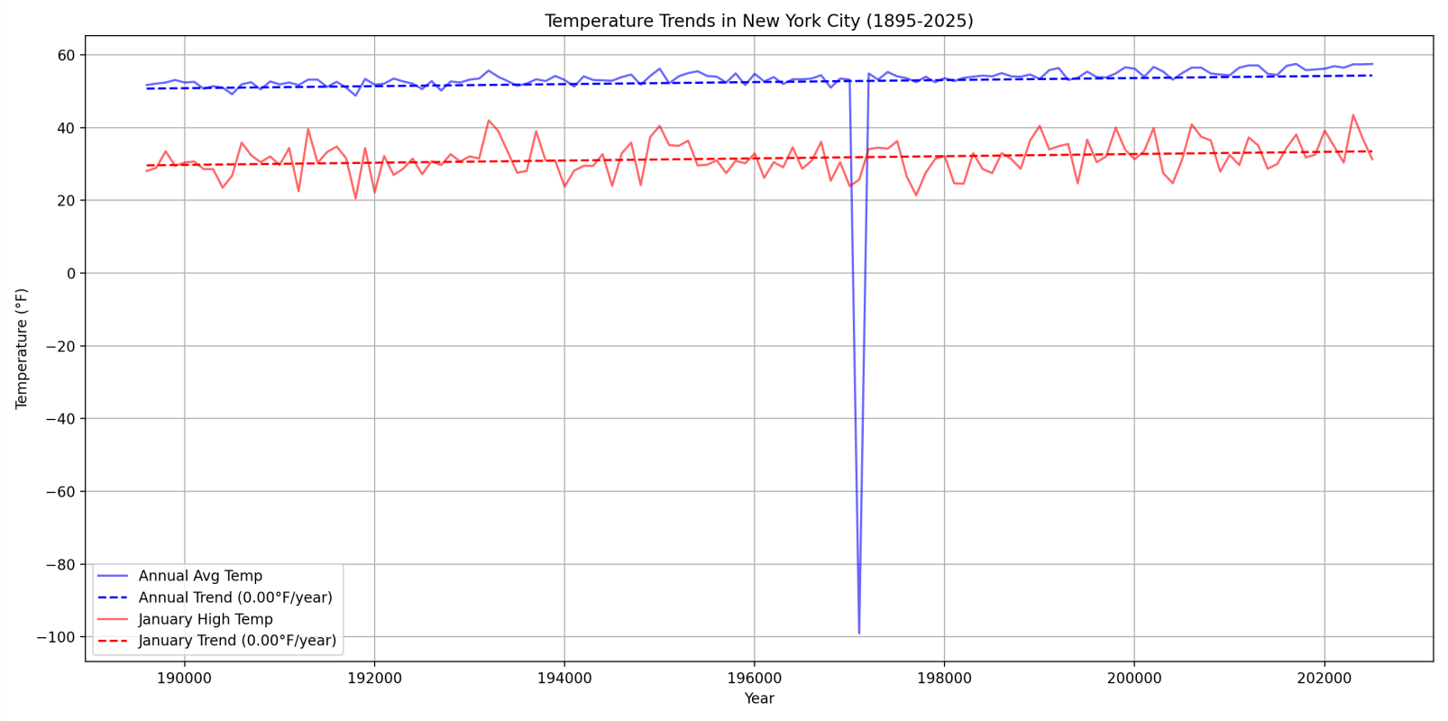

1. Load the Iris dataset from the scikit-learn library and perform classification on it with the k-nearest neighbors algorithm. Use a KNeighborsClassifier with the default k value. What is the prediction accuracy?

**Ans:-**

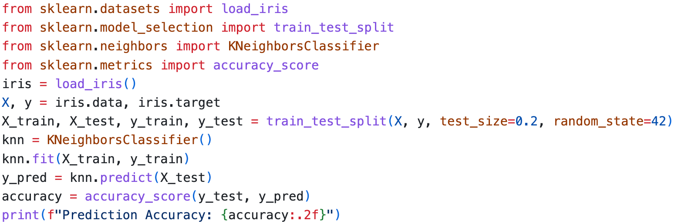

Output:- Screenshot 2025-04-18 at 6.57.40 PM

1. You are given a dataset of 2D points with their corresponding class labels. The dataset is as follows:

|  |  |  |  |
| --- | --- | --- | --- |
| Point ID | *x* | *y* | Class |
| A | 2.0 | 3.0 | 0 |
| B | 1.0 | 1.0 | 0 |
| C | 4.0 | 4.0 | 1 |
| D | 5.0 | 2.0 | 1 |

A new point *P* with coordinates (3*.*0*,* 3*.*0) needs to be classified using the KNN algorithm. Use the

Euclidean distance to calculate the distance between points.

**Ans:-**

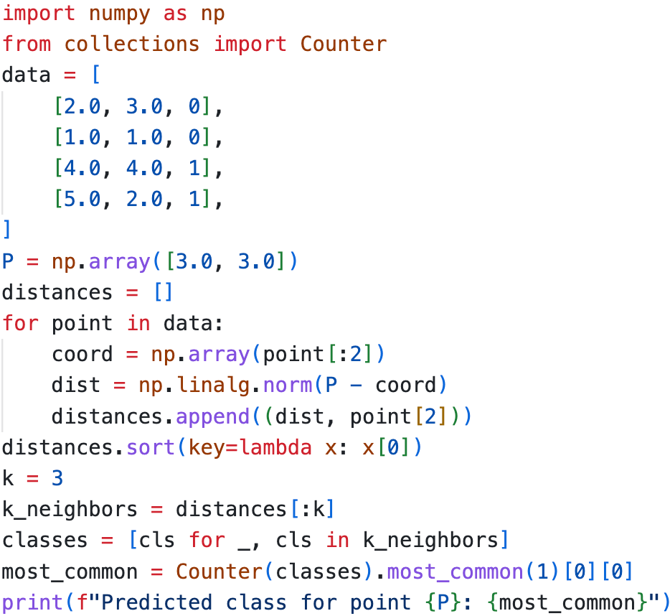

Output:- Screenshot 2025-04-18 at 7.21.19 PM

1. A teacher wants to classify students as ”Pass” or ”Fail” based on their performance in three exams. The dataset includes three features:

|  |  |  |  |
| --- | --- | --- | --- |
| Exam 1 Score | Exam 2 Score | Exam 3 Score | Class (Pass/Fail) |
| 85 | 90 | 88 | Pass |
| 70 | 75 | 80 | Pass |
| 60 | 65 | 70 | Fail |
| 50 | 55 | 58 | Fail |
| 95 | 92 | 96 | Pass |
| 45 | 50 | 48 | Fail |

A new student has the following scores:

• Exam 1 Score: 72

• Exam 2 Score: 78

• Exam 3 Score: 75

Classify this student using the K-Nearest Neighbors (KNN) algorithm with k = 3.

**Ans: -**

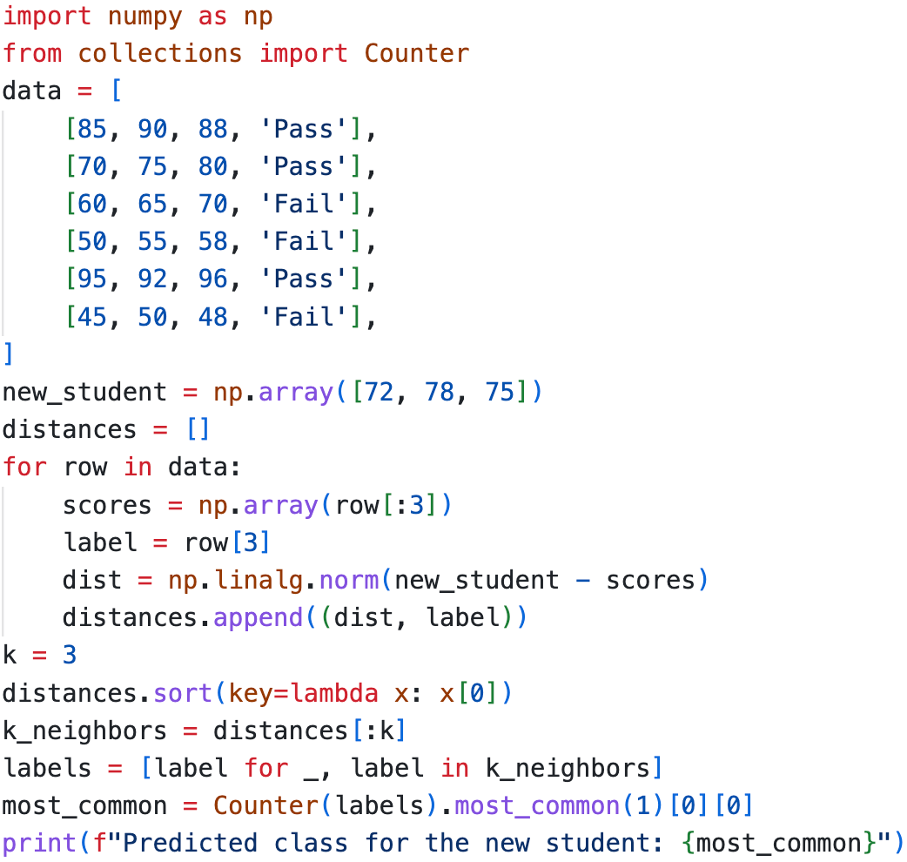

Output - Screenshot 2025-04-18 at 7.39.13 PM

1. Using scikit-learn’s KFold class and the cross val score function, determine the optimal value for k to classify the Iris dataset using a KNeighborsClassifier.

**Ans:-**

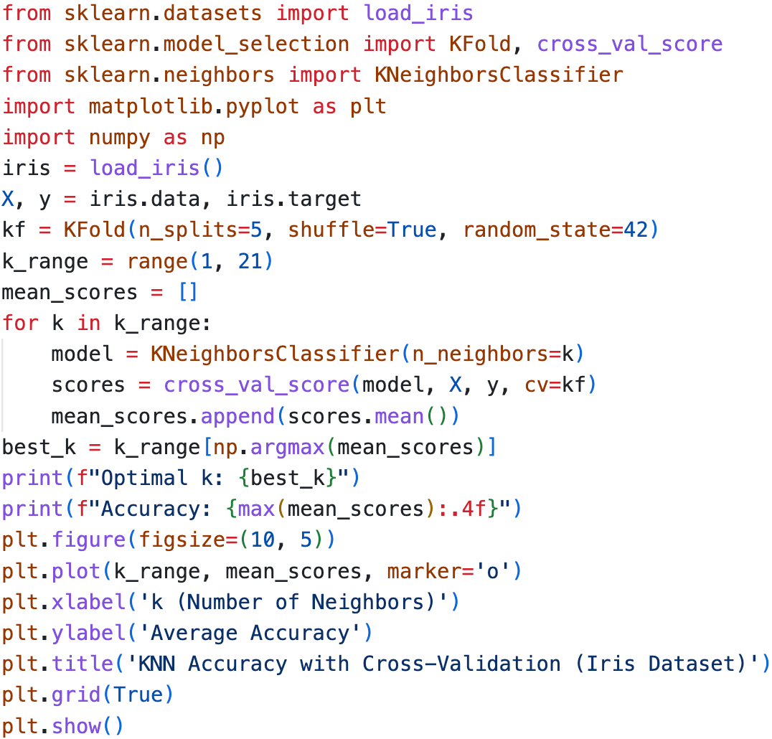

Output:-

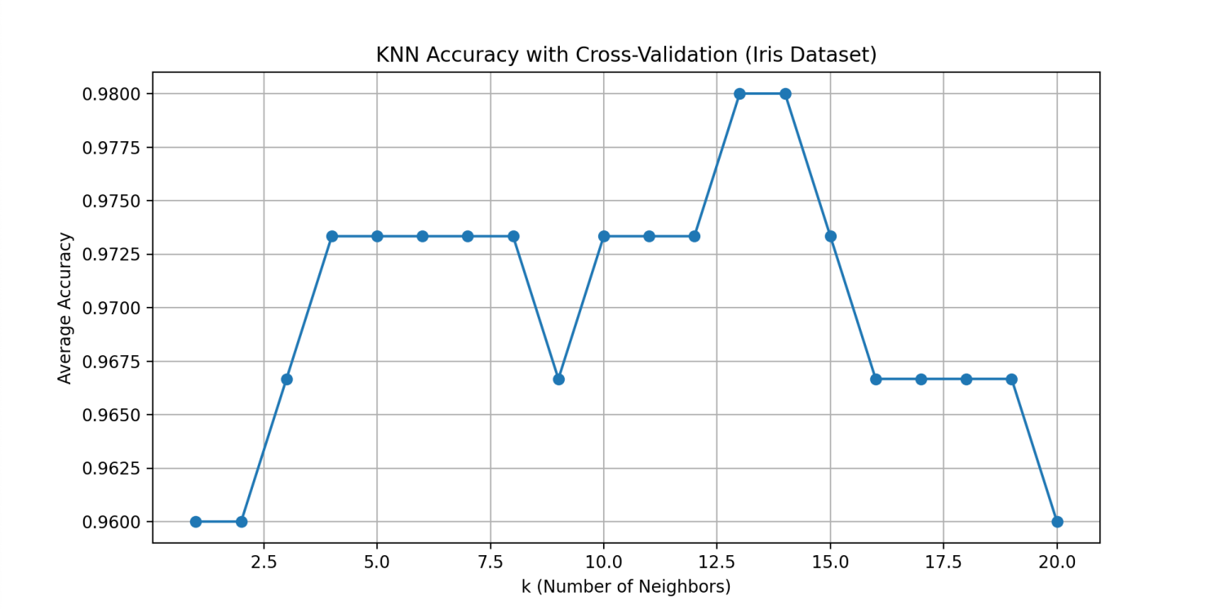

1. Write a Python script to perform K-Means clustering on the following dataset:

Dataset: {(1, 1),(2, 2),(3, 3),(8, 8),(9, 9),(10, 10)}

Use k=2 and visualize the clusters.

**Ans:-**

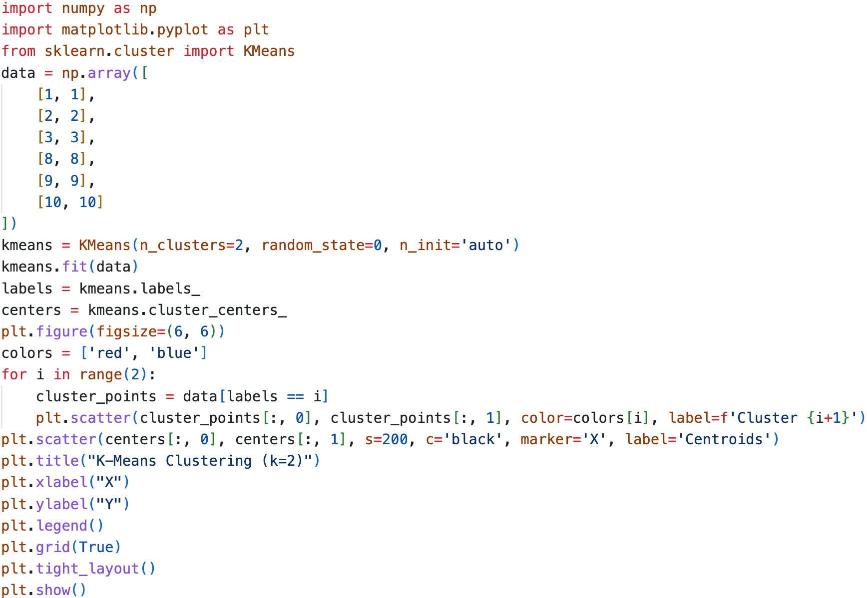



Output:-

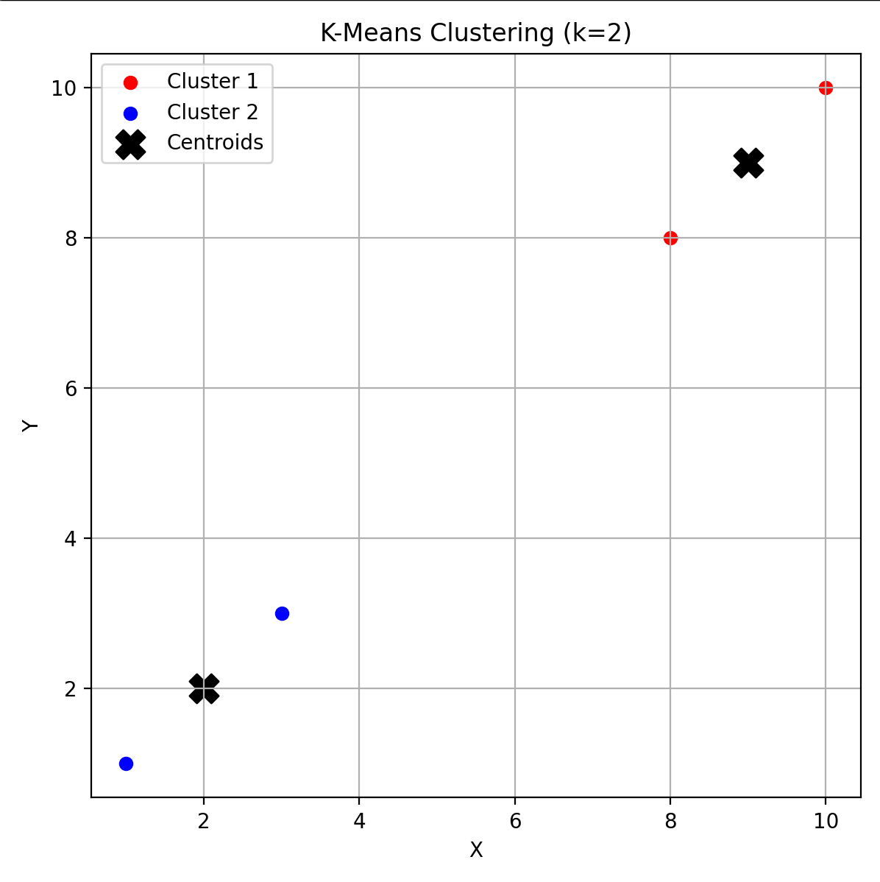

1. Write a Python script to perform K-Means clustering on the following dataset: [Mall Customer Segmentation](https://www.kaggle.com/datasets/vjchoudhary7/customer-segmentation-tutorial-in-python?resource=download). Use k = 5 (also, determine optimal k via the Elbow Method) and visualize the clusters to identify customer segments.

Expected Output:

• Scatter plot showing clusters (e.g., “High Income-Low Spenders,” “Moderate Income-Moderate Spenders”).

• Insights for targeted marketing strategies.

**Ans:-**

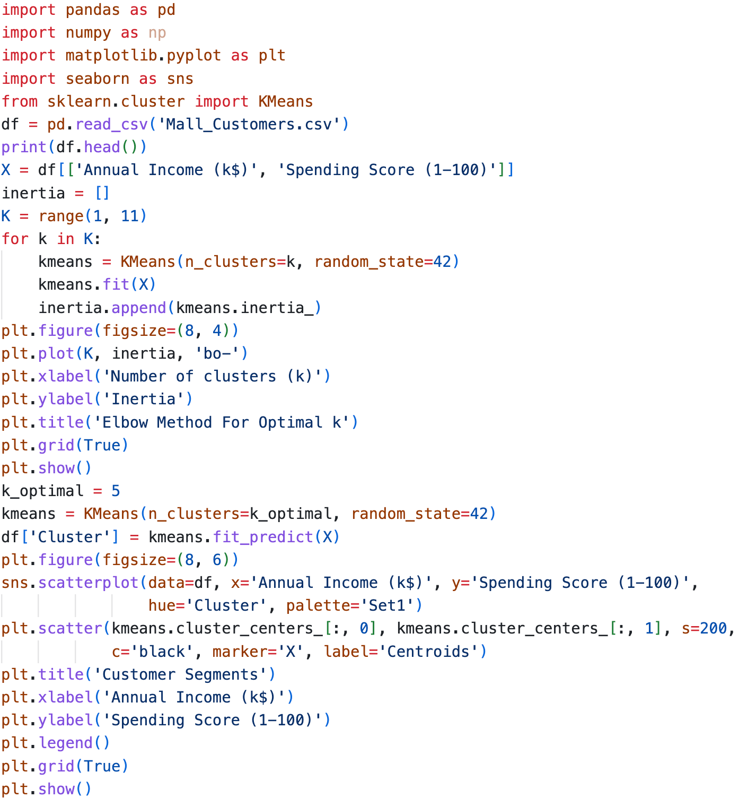



Output:-

Insights: - 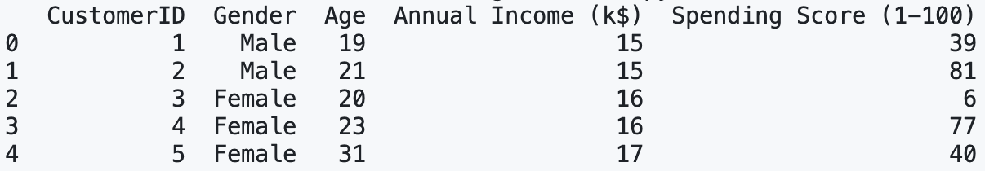

Figure 1: -

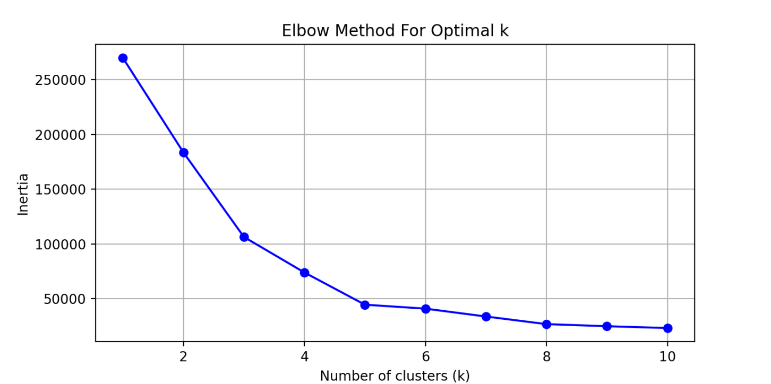

Figure 2: -

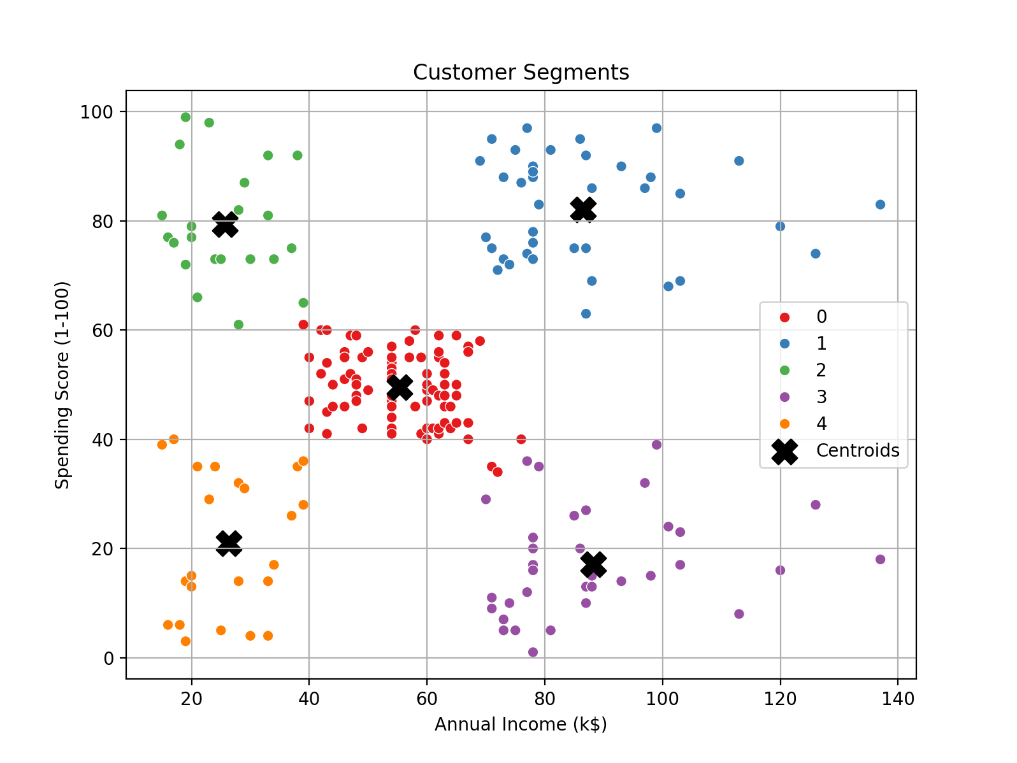

1. Perform the following tasks using the pandas Series object:

(a) Create a Series from the list [7, 11, 13, 17].

(b) Create a Series with five elements where each element is 100.0.

(c) Create a Series with 20 elements that are all random numbers in the range 0 to 100. Use the describe method to produce the Series’ basic descriptive statistics.

(d) Create a Series called temperatures with the following floating-point values: 98.6, 98.9, 100.2, and 97.9. Use the index keyword argument to specify the custom indices ‘Julie’, ‘Charlie’, ‘Sam’, and ‘Andrea’.

(e) Form a dictionary from the names and values in Part (d), then use it to initialize a Series.

**Ans:-**

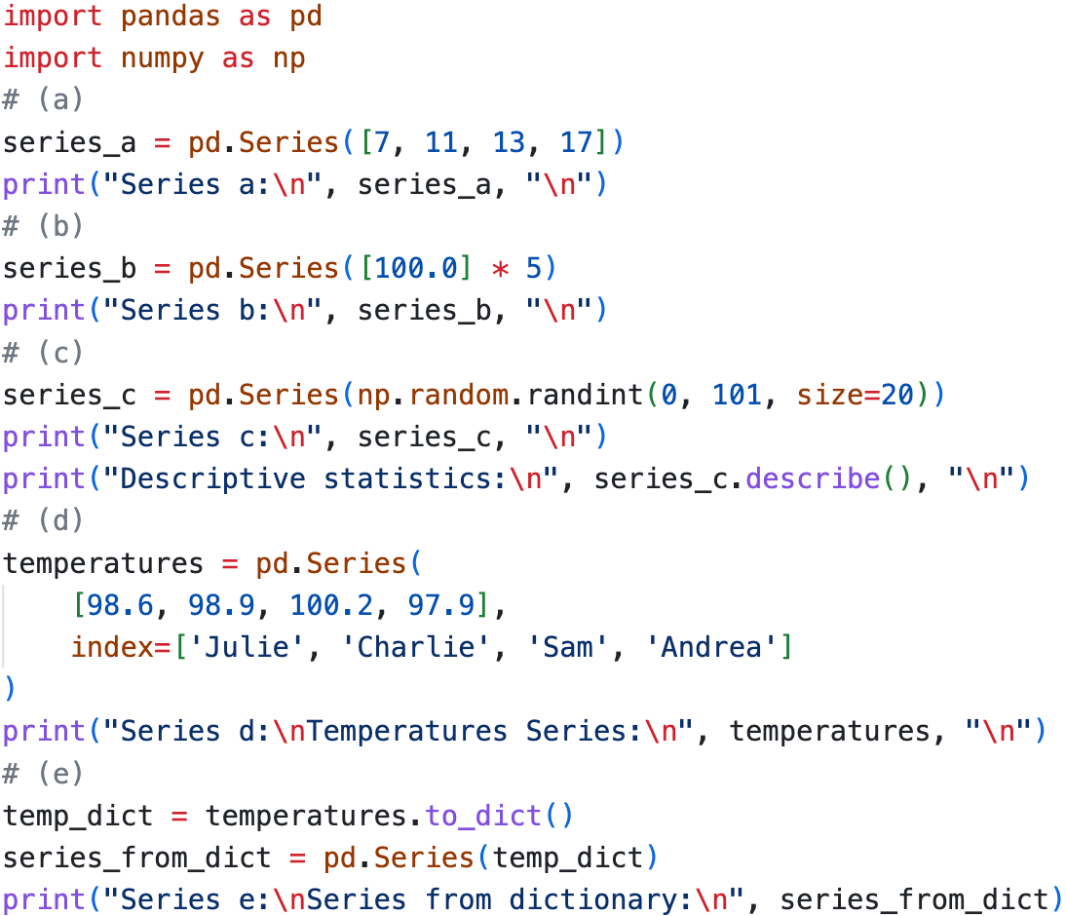



Output:-

