Introduction to Databases (CSE 3151)

Assignment 3: Practicing SQL queries using SQL operators, Aggregate and Scalar functions
- Write the SQL Expressions for the following queries using suitable SQL operators .
a) Display the Course_ids, Titles and Credits of course that are offered in any of the departments namely: Physics, Music, Finance and Biology.
Ans-

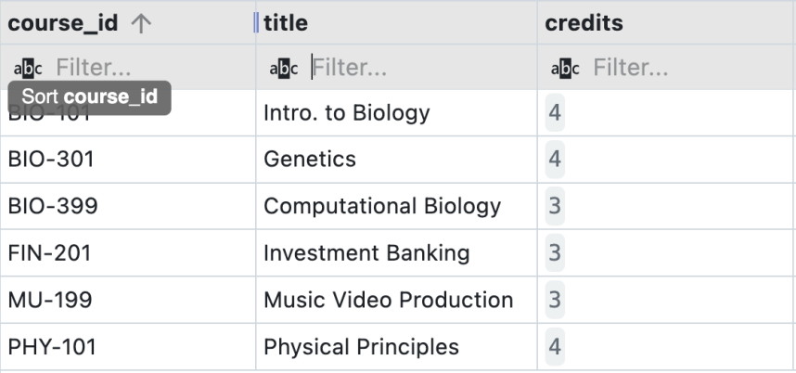
b) Display records of the instructors whose name starts with “K” and who get salary more than 65000.
Ans-
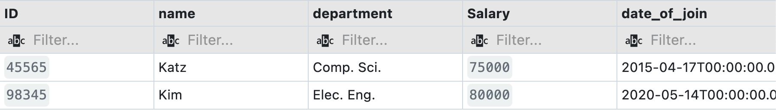
c) Display name, department, gross salary and net salary of instructors with 105% DA, 20% HRA, 30% IT. (gross salary = salary + DA + HRA, net salary = gross salary – IT)
Ans-

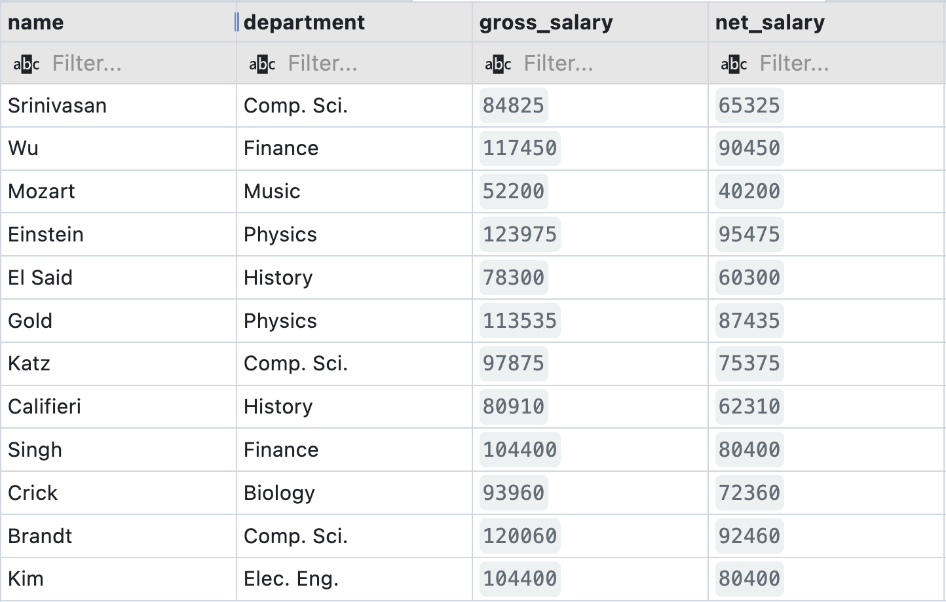
d) Display records of the Instructors with salary range 60000 to 80000.
Ans-
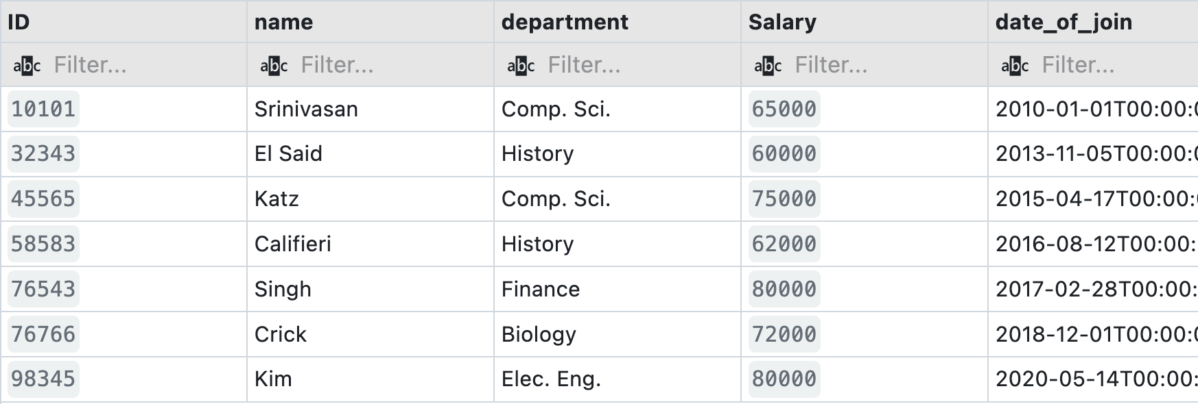
e) Display the records of the instructors having the second letter in their name as ‘r’.
Ans-
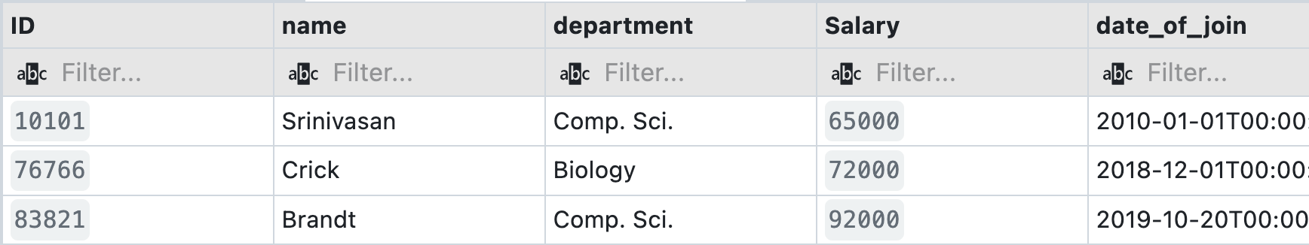
f) Display the names of the instructors of Comp.Sci. Department in the descending order of their salary.
Ans-

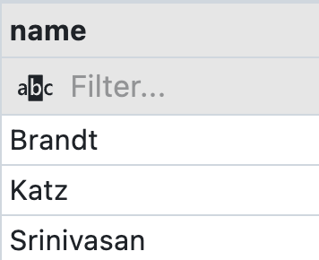
g) Update all records of Instructor table with a salary hike of 15%.
Ans-
Output- No output as it only updated the record
h) Update the records with a salary hike of 3% for Comp.Sci. Dept instructors having salary
less than 70000.
Ans-

Output- No output as it only updated the record
- Display the annual salary of each instructor.
Ans-
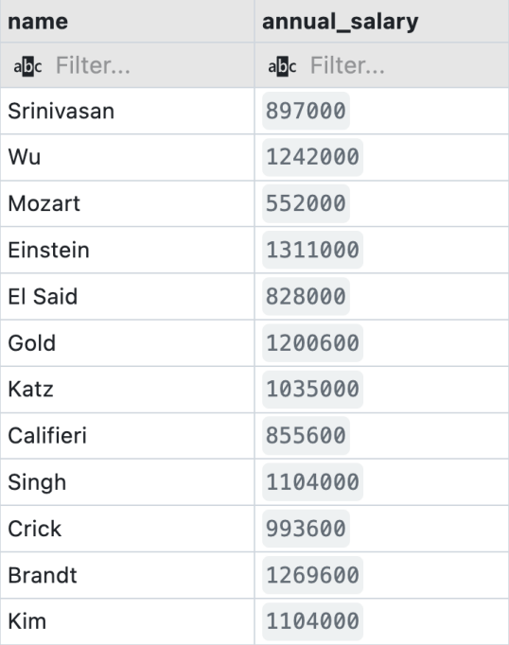
j) Update the title of the course having title 'Game Design' to 'Game Theory'.
Ans-
Output- No output as it only updated the record.
k) Delete the instructor records of History department.
Ans-
Output- No output as it only updated the record.
l) Delete the course records of the courses having course_id starting with 'BIO'.
Ans-
Output- No output as it only updated the record.
2. Write the SQL Expressions for the following queries using suitable SQL aggregate function.
a) Display the Avg. salary of instructors of Physics department.
Ans-
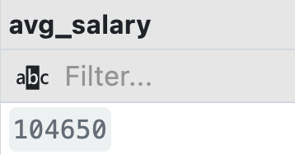
b) Display the Dept_ name and Average salary paid to instructor of each department.
Ans-

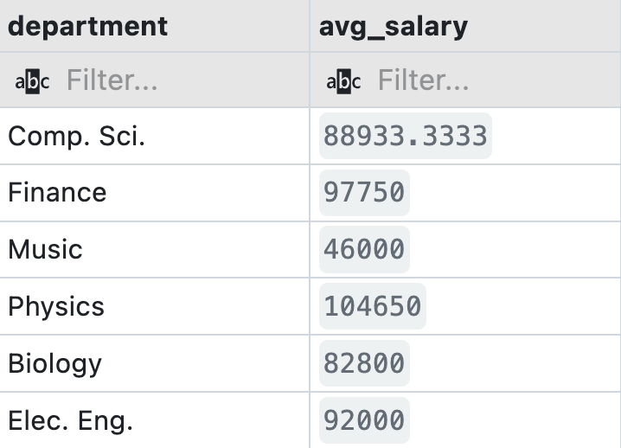
c) Display the ID, Name & Department of the instructor drawing the highest salary.
Ans-

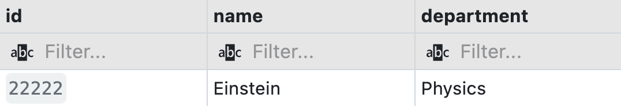
d) Display the number of instructors available in Comp. Sci. Department.
Ans-
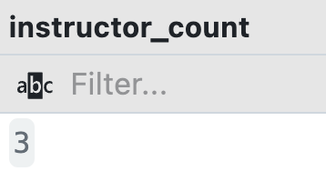
e) Display the total credits of all courses offered in Comp.Sci. Department.
Ans-
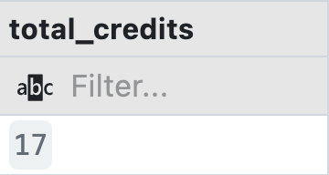
f) Display the number of instructors and total salary drawn by Physics and Comp. Sci. departments.
Ans-

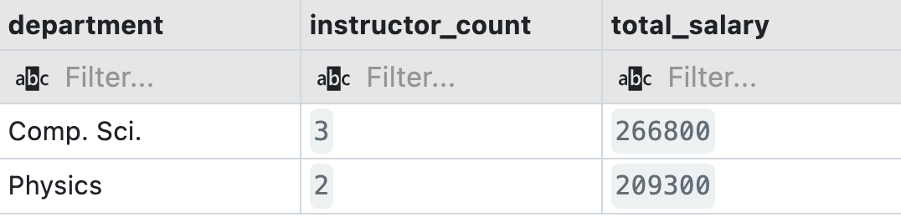
g) Display the total credits of Comp.Sci. and Biology departments from course table.
Ans-

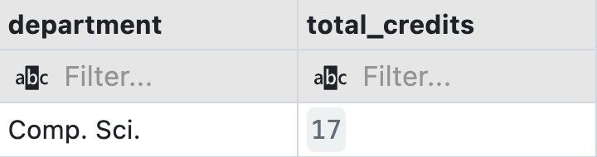
h) Display building wise total budget values.
Ans-

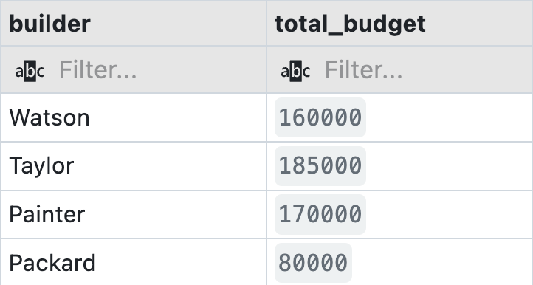
- Display the number of instructors of each department.
Ans-

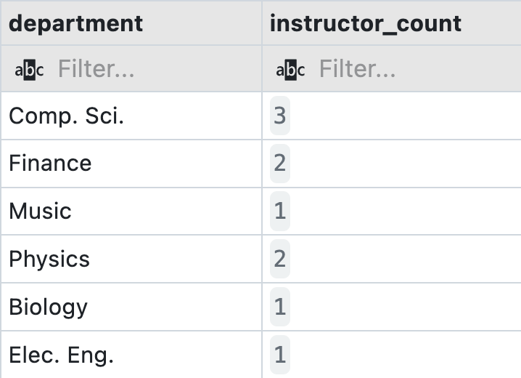
j) Display the number of instructors of each department sorted in high to low.
Ans-

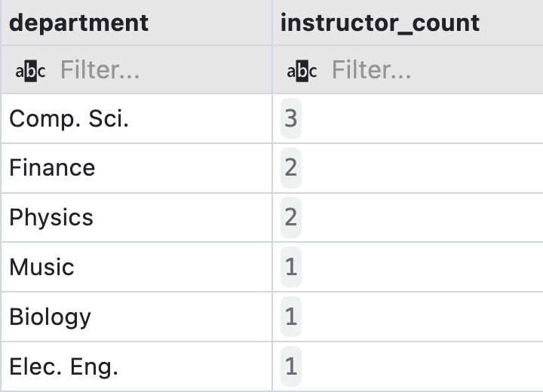
k) Display the number of courses offered semester wise.
Ans-
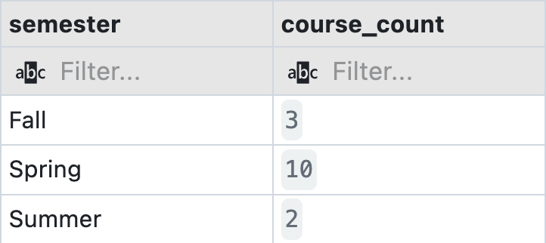
l) Display the name of departments having number of instructors less than 2;
Ans-
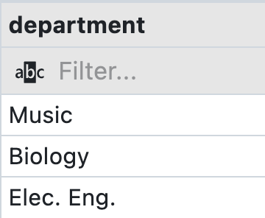
m) List the number of instructors of each department having 2 or more than 2 instructors except Finance department, sorted in high to low order of their number.
Ans-

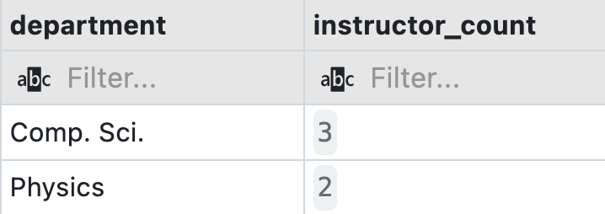
n) Display the Dept_name that has paid total salary more than 50000.
Ans-

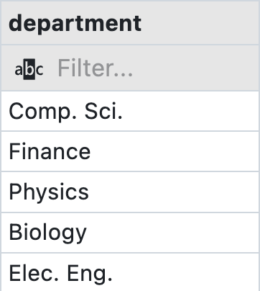
o) Display the total budget for the building built by Watson.
Ans-
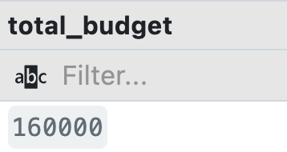
p) Display the highest salary of the instructor of Comp.Sci. Department.
Ans-
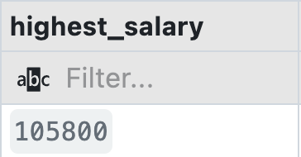
3. Write the SQL Expressions for the following queries using suitable SQL scalar function.
a) Display your name with first letter being capital, where the entered name is in lower case.
Ans-

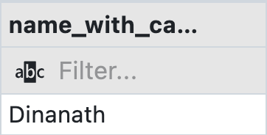
b) Display 2nd- 6th characters of your name.
Ans-
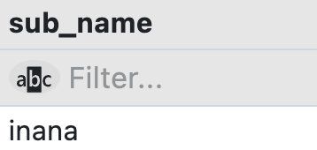
c) Find length of your full university name.
Ans-

d) Display all the Instructor names with its first letter in upper case.
Ans-

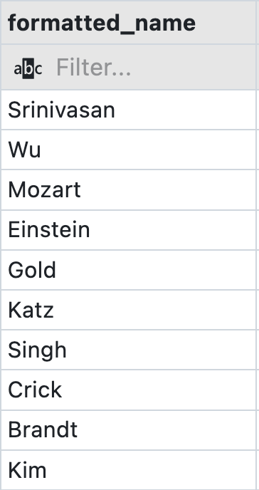
e) List the department name of each instructor as a three letter code.
Ans-
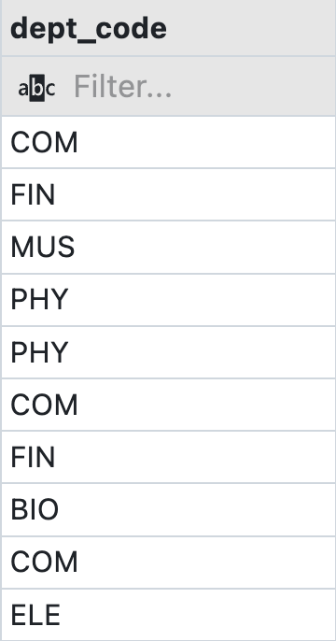
f) Display the month of the joining of each instructor.
Ans-
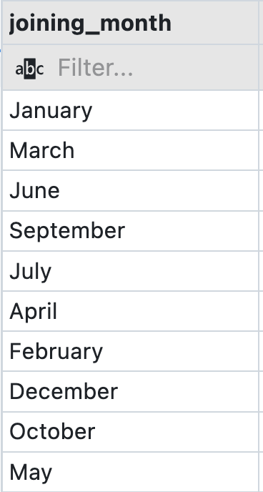
g) Display the date of joining of each instructor in dd/mm/yy format.
Ans-
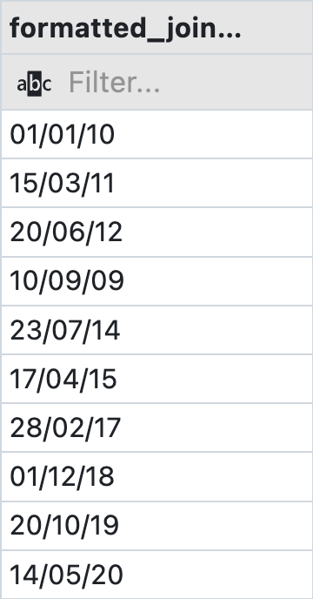
h) Display the experience of each instructor in terms of months.
Ans-

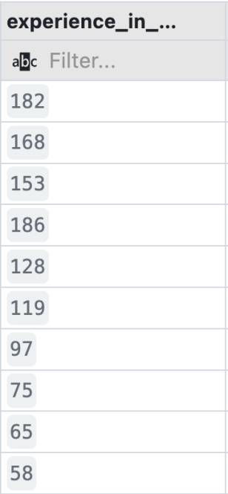
- Display the experience of each instructor in term of years and months.
Ans-
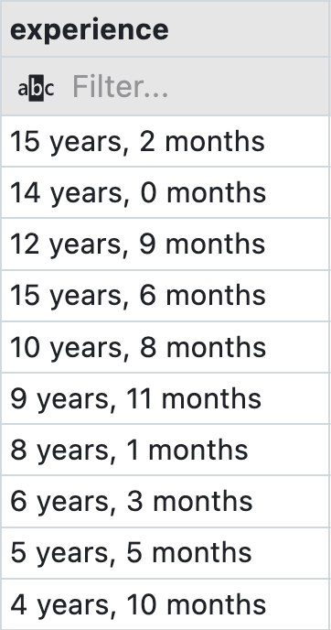
j) Display the day of joining of each instructor.
Ans-


k) Display the date corresponding to 15 days after today's date.
Ans-
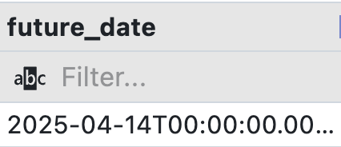
l) Display the value 94204.27348 truncated up to 2 digits after decimal point.
Ans-
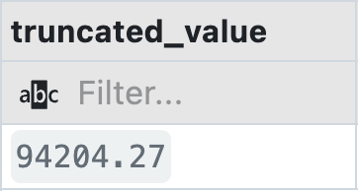
m) Display the value of the expression 5 + 8⁹.
Ans-
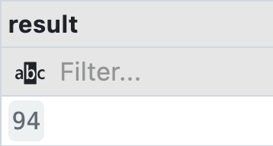
n) Find out the square root of 6464312.
Ans-
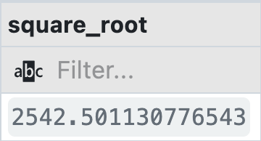
o) Display the string “HELLO ITER” in lower case with a column heading lower case.
Ans-

