**Databases Laboratory Work Nr 1**

**Title: Creation and Maintenance of The Database**

**Prerequisites: Installation of the SQL Server 2017 pack, and reading of the chapter 2.**

**Objectives: Creating a database and tools for maintaining the database automatically.**

**Tasks:**

**Implementation**

1. Practical Task 1

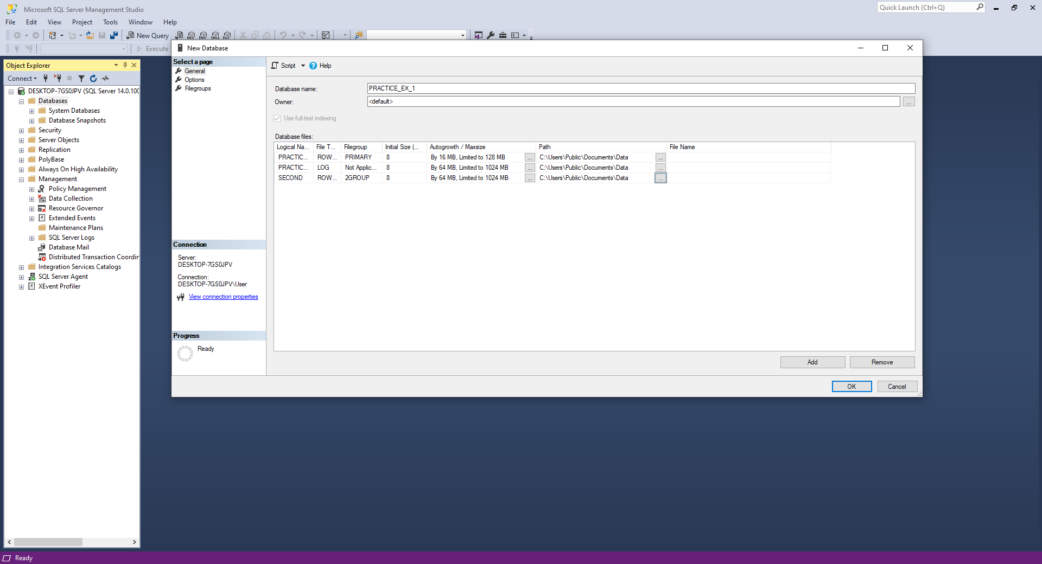

This practical task had as aim to create a simple Database, for that we have to change the initial properties of the main files of a database (primary file, log file and a secondary created file). The task was to change the storage limits of the main files and more specifically the auto growth sizes. Also, we had to create a new File Group to group the newly created secondary file. All the data base files had to be located physically in the Documents\Data.

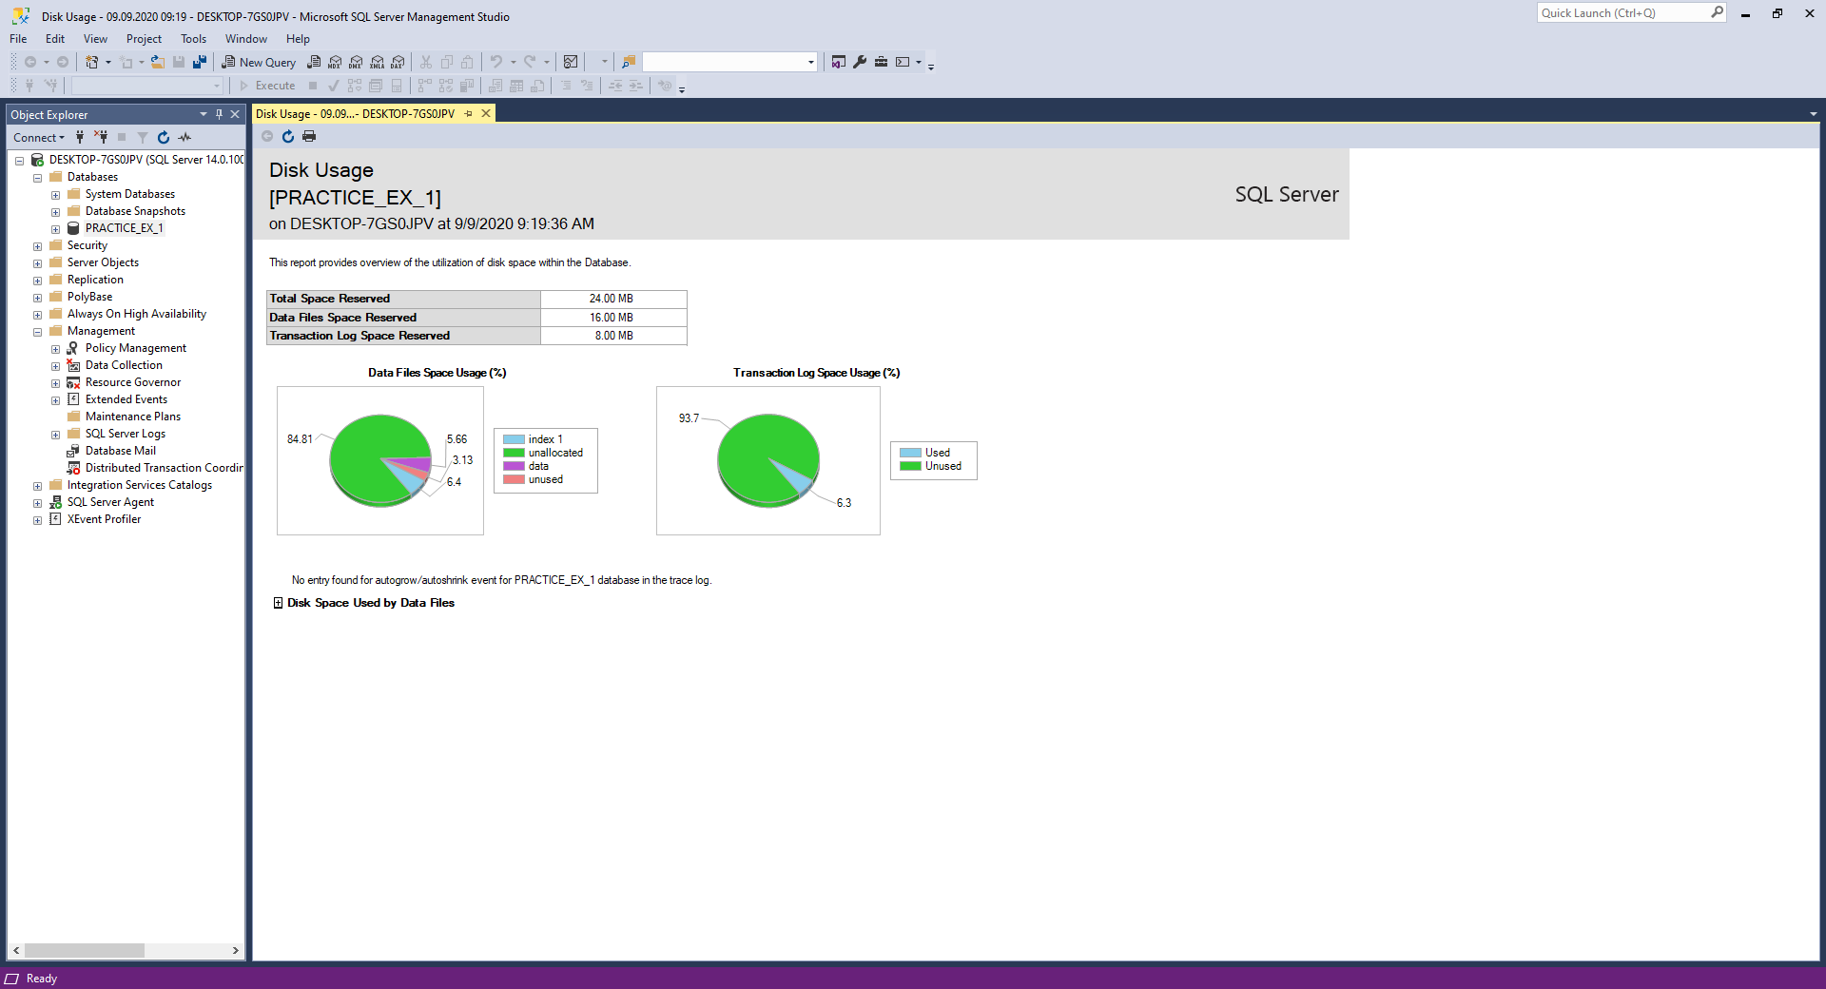

In the picture above we can see the newly created database.

1. Practical Task 2

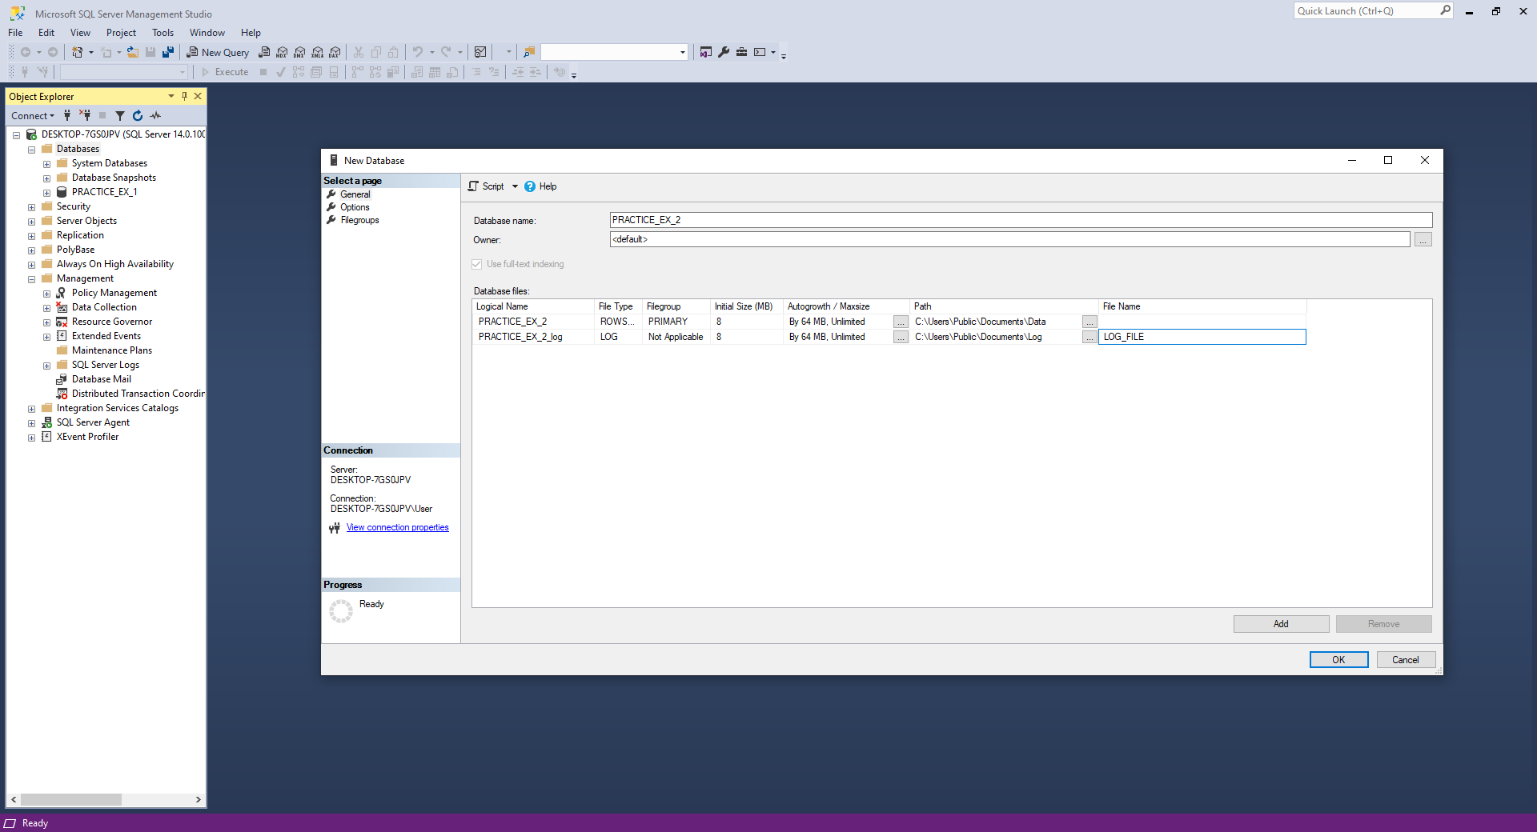

The task was to create a data base for which we set the log file location to Documents\Log and also, we have to change the **File Name** of the log file to be different from Logical Name.

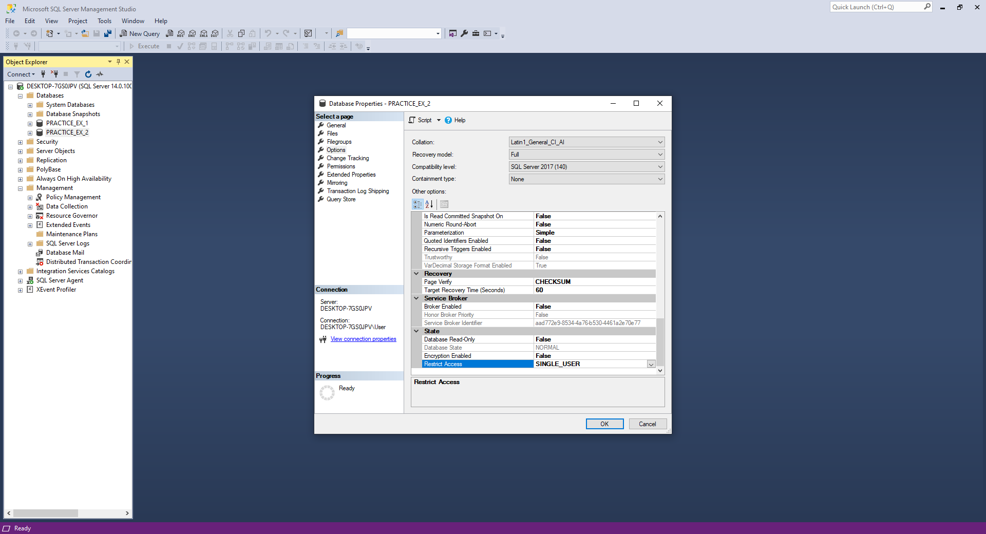

The next step is setting the Compatibility Level to SQL Server 2017 and also to set the **Restrict Access** to a single user that will have the possibility to access the database in a specific moment.

1. Practical Task 3

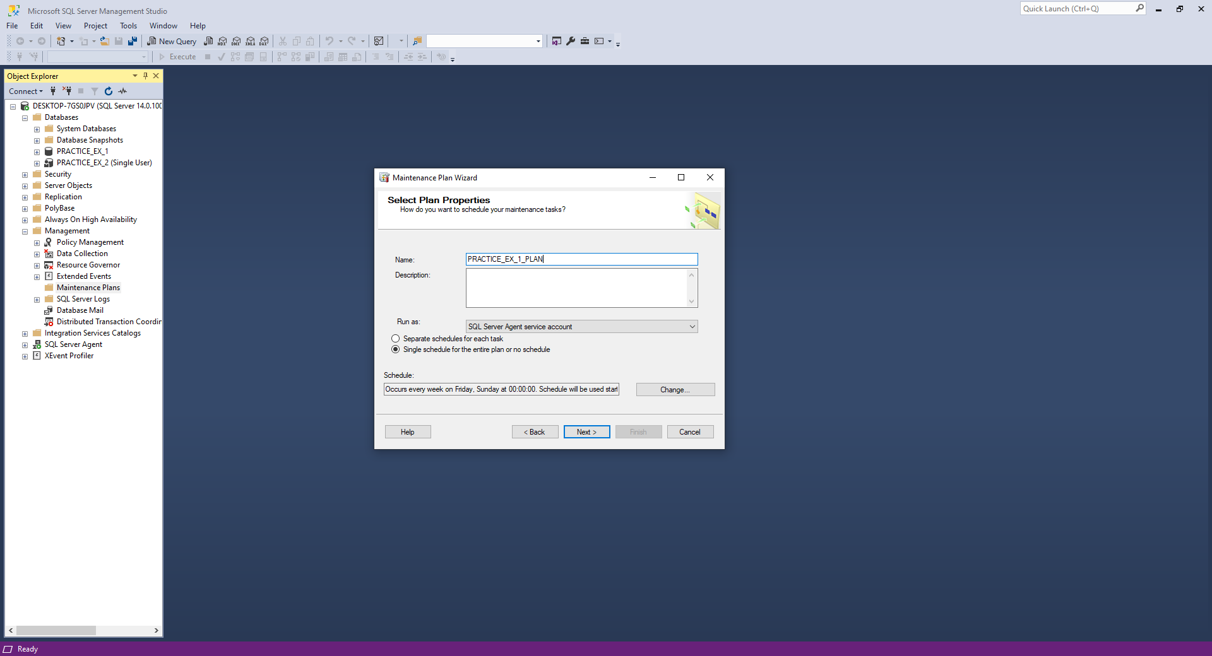

Setting up the Maintenance Plan, using Wizard, that will be Scheduled every week on Friday at 00:00.

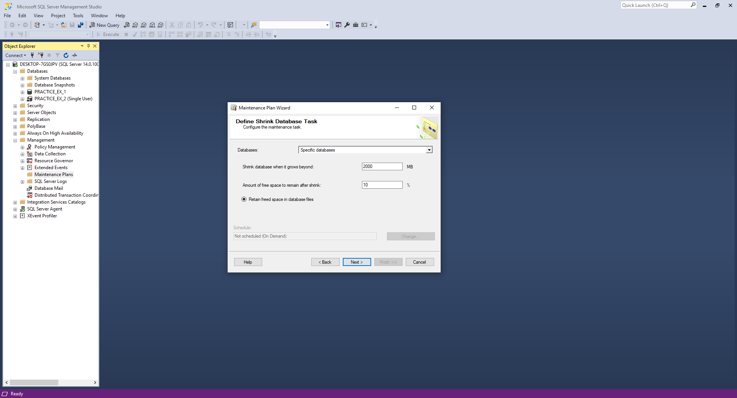

Adding the Shrink Database Task that will limit the space to 2000MB and return the space to operational system.

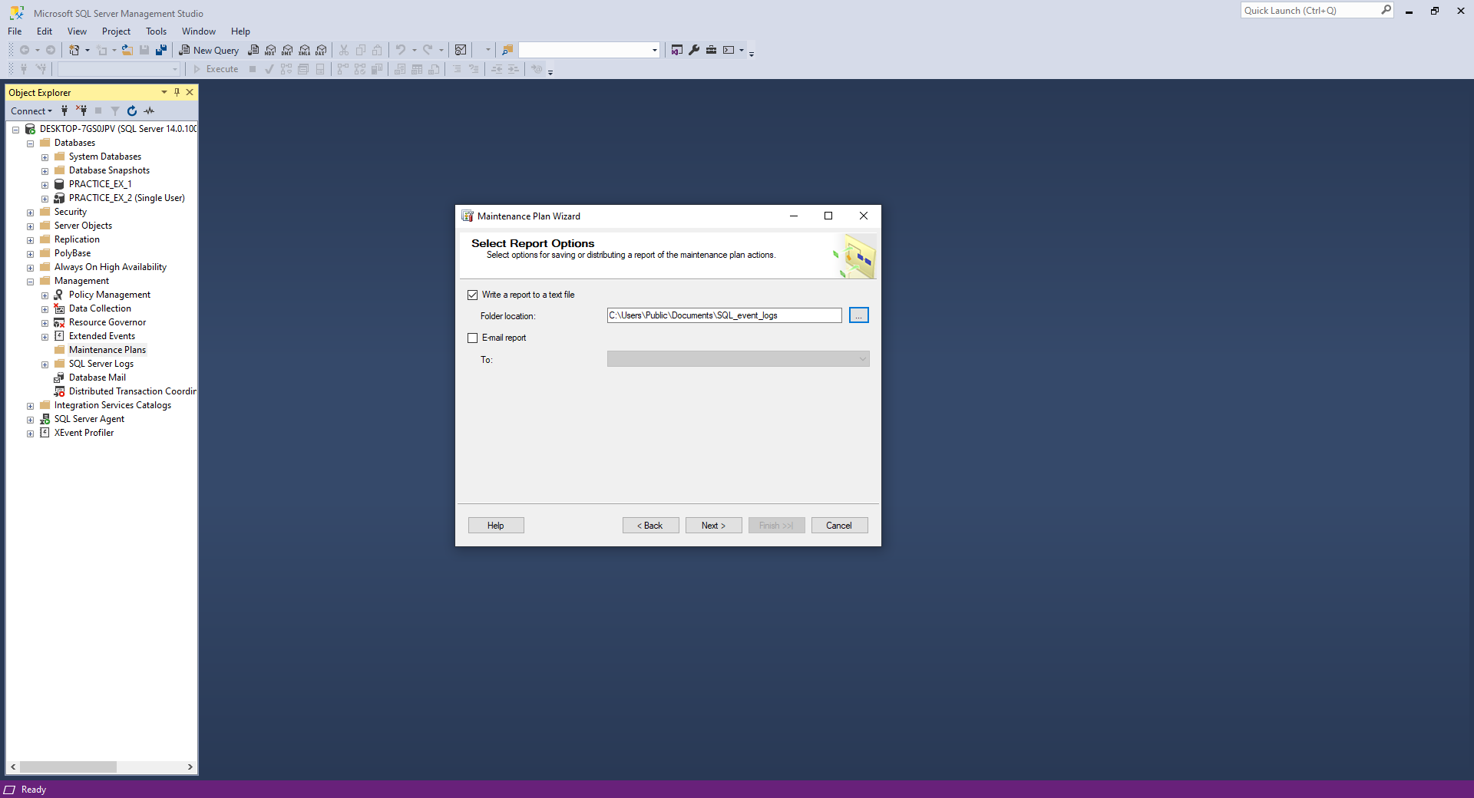

Adding a destination for the report file with the logs.

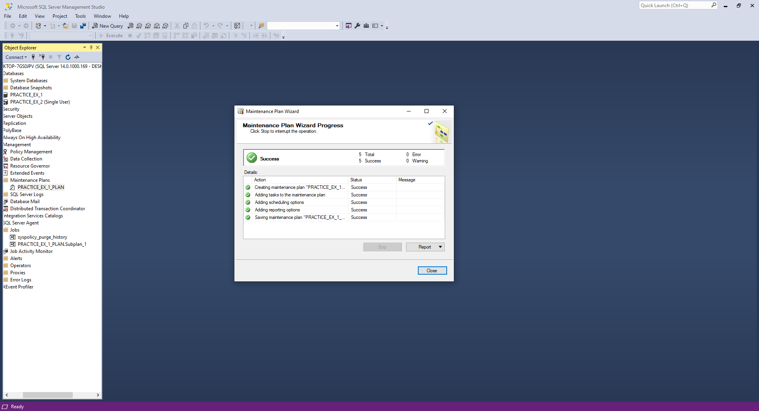

The Maintenance Plan was created successfully.

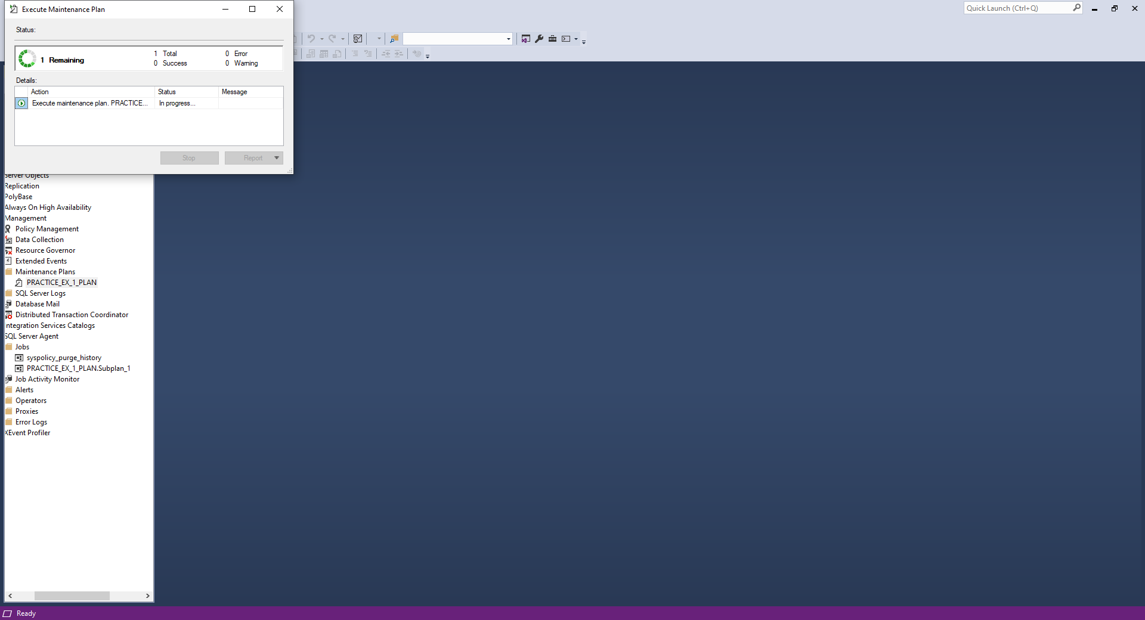

Executing the newly created Maintenance Plan for the database 1.

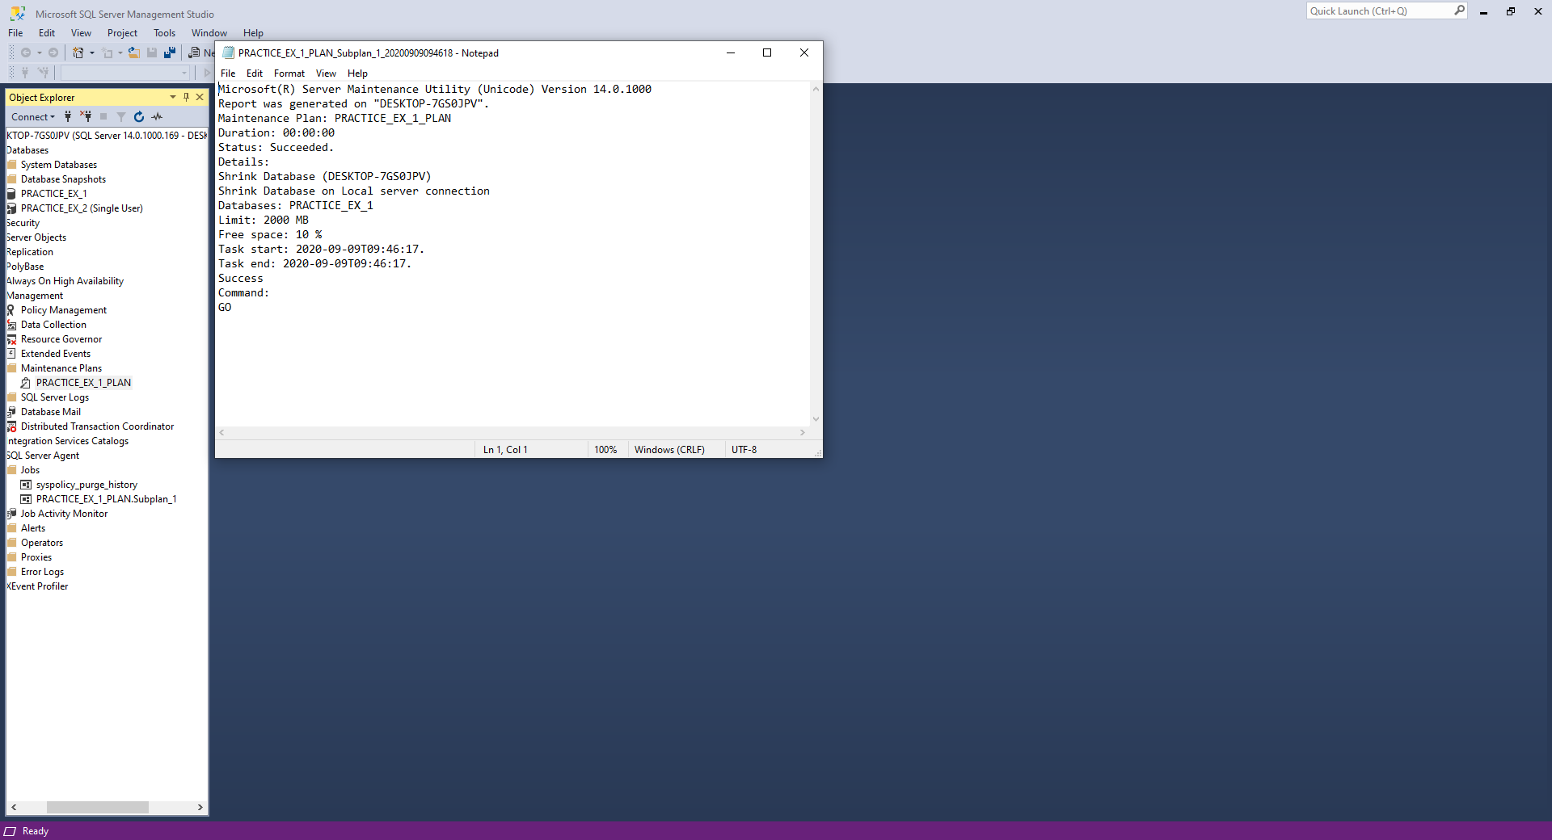

Here is the report file with the logs about the execution of the Maintenance Plan.

1. Practical Task 4

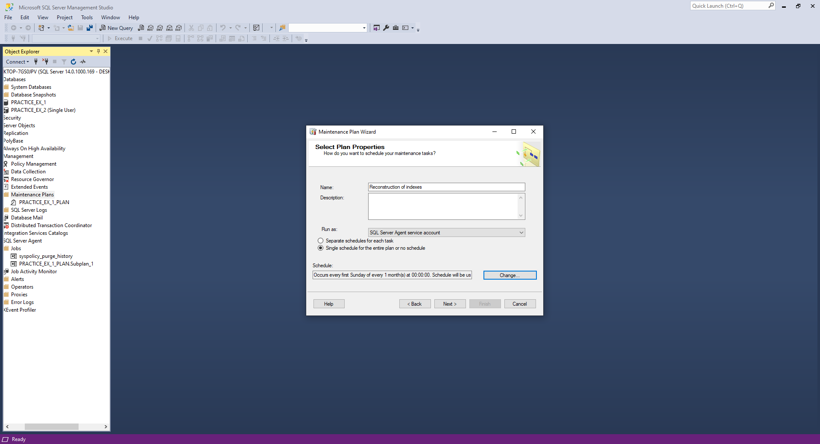

Setting up the new Maintenance Plan for the second database with the name “Reconstruction of indexes” which will occur every first Sunday of every month.

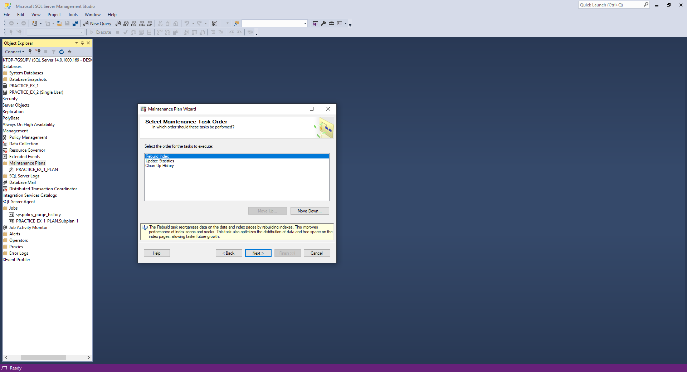

Selecting the necessary task to be executed in this plan, first of all the Rebuild of index, then we have to collect the statistics about the newly rebuild indexes and as a final step the task of cleaning up the BackUp-Restore.

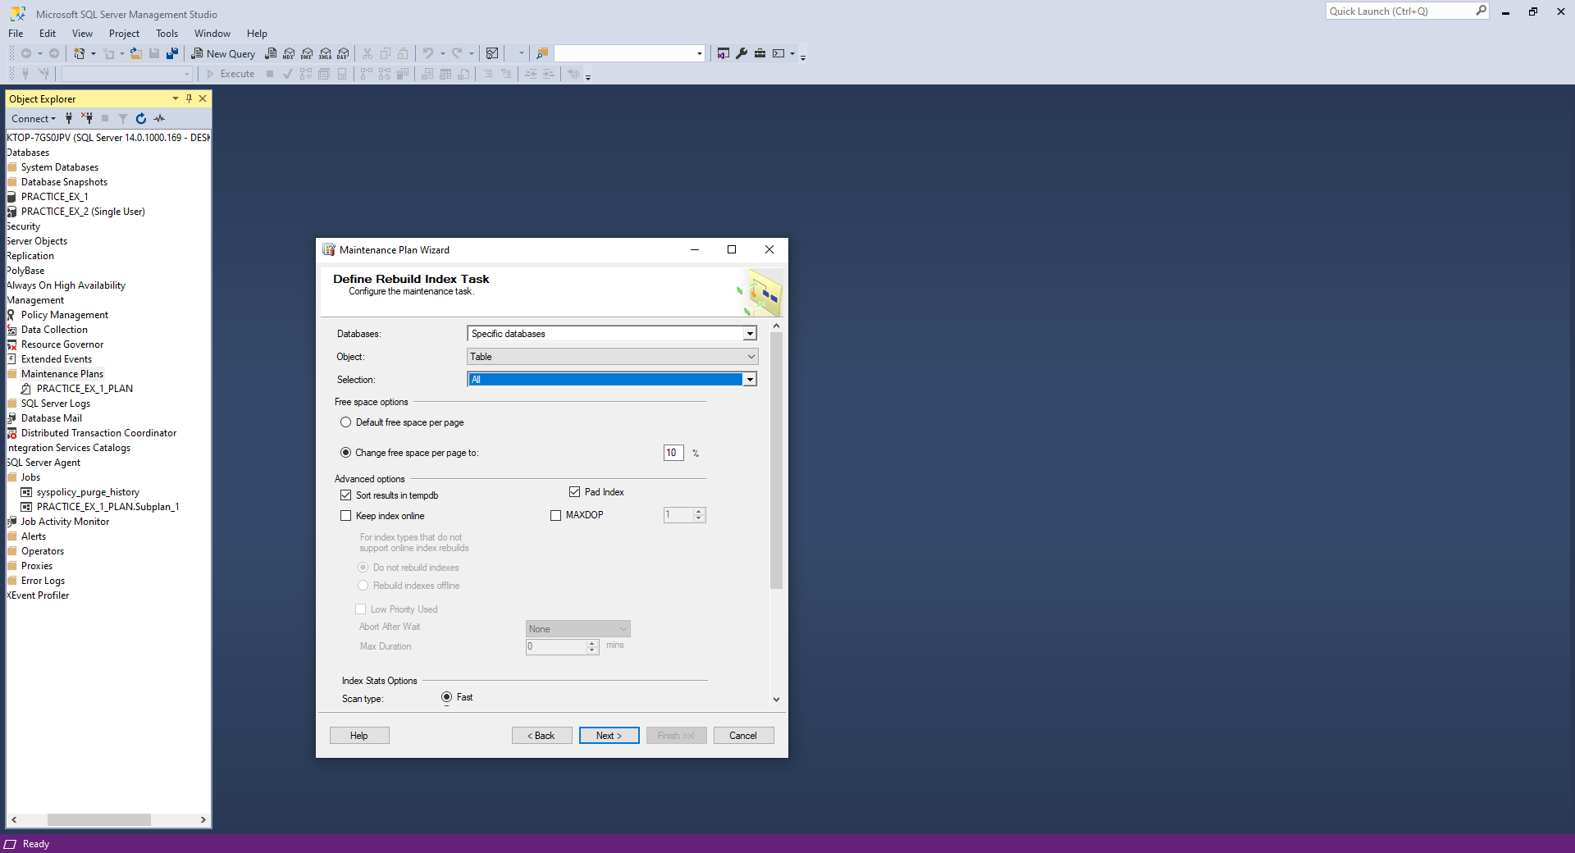

The configuration process of the Rebuild Index Task. Setting the reconstruction only on tables, changing the free space to 10% and also checking the radio button of sorting results in tempdb.

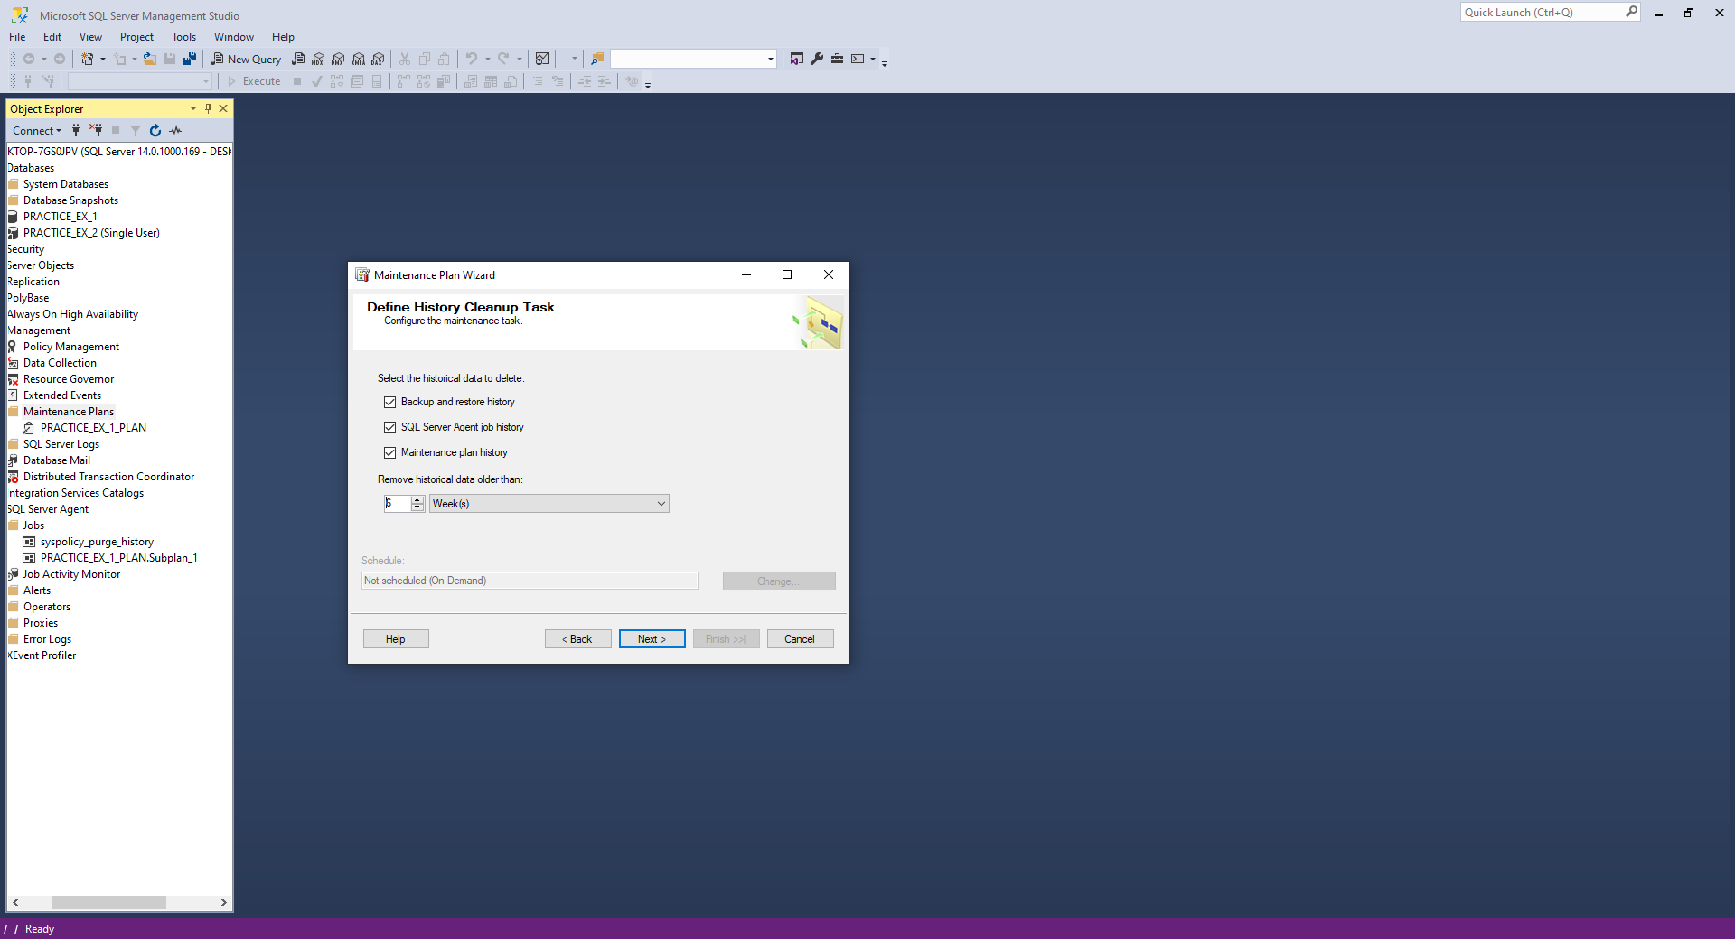

Setting up the History Cleanup Task to remove historical data older than 6 weeks.

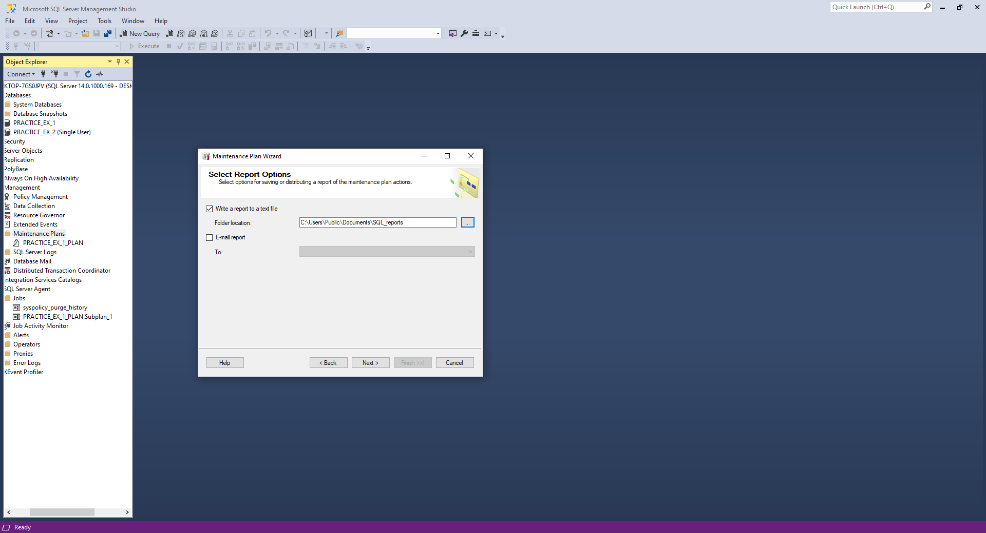

Selecting the report file location.

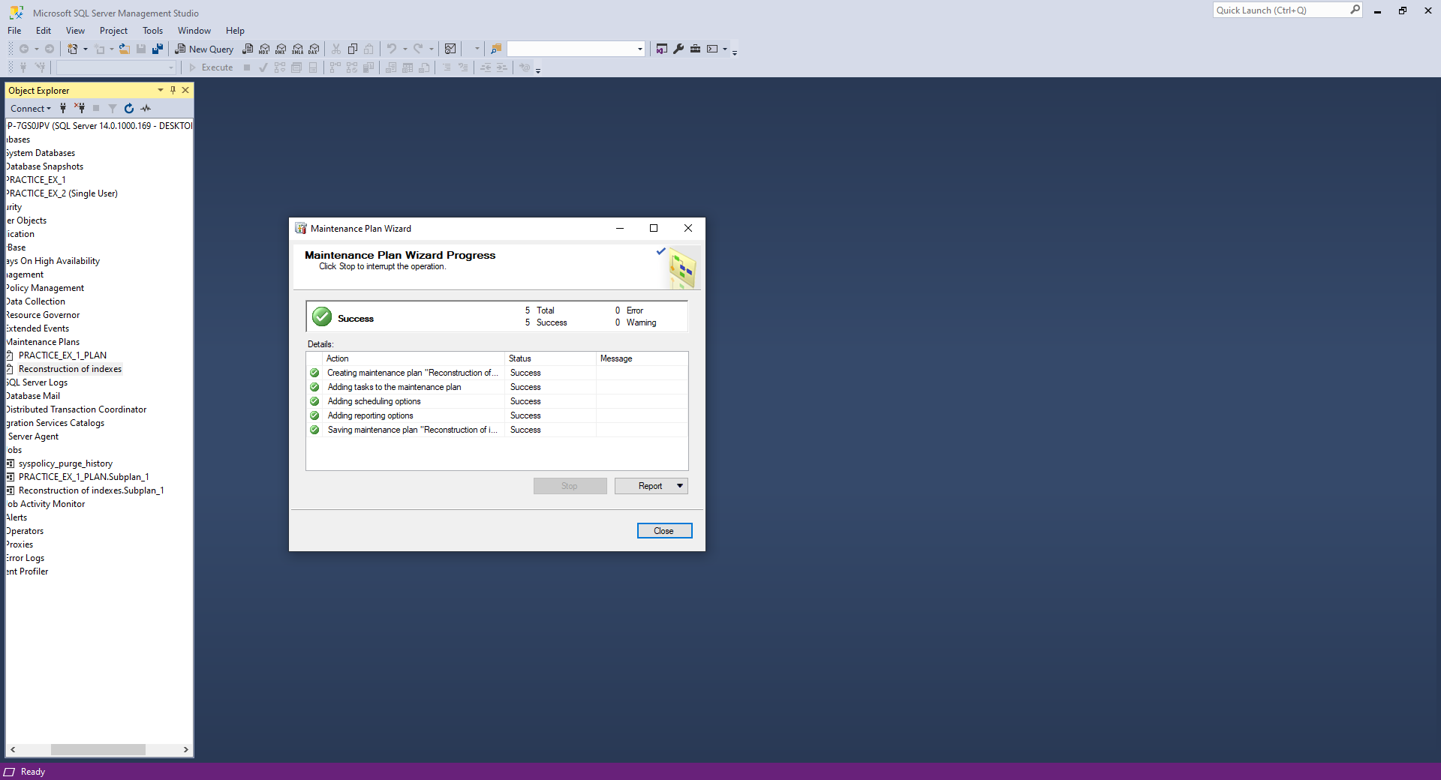

The Maintenance Plan was created successfully.

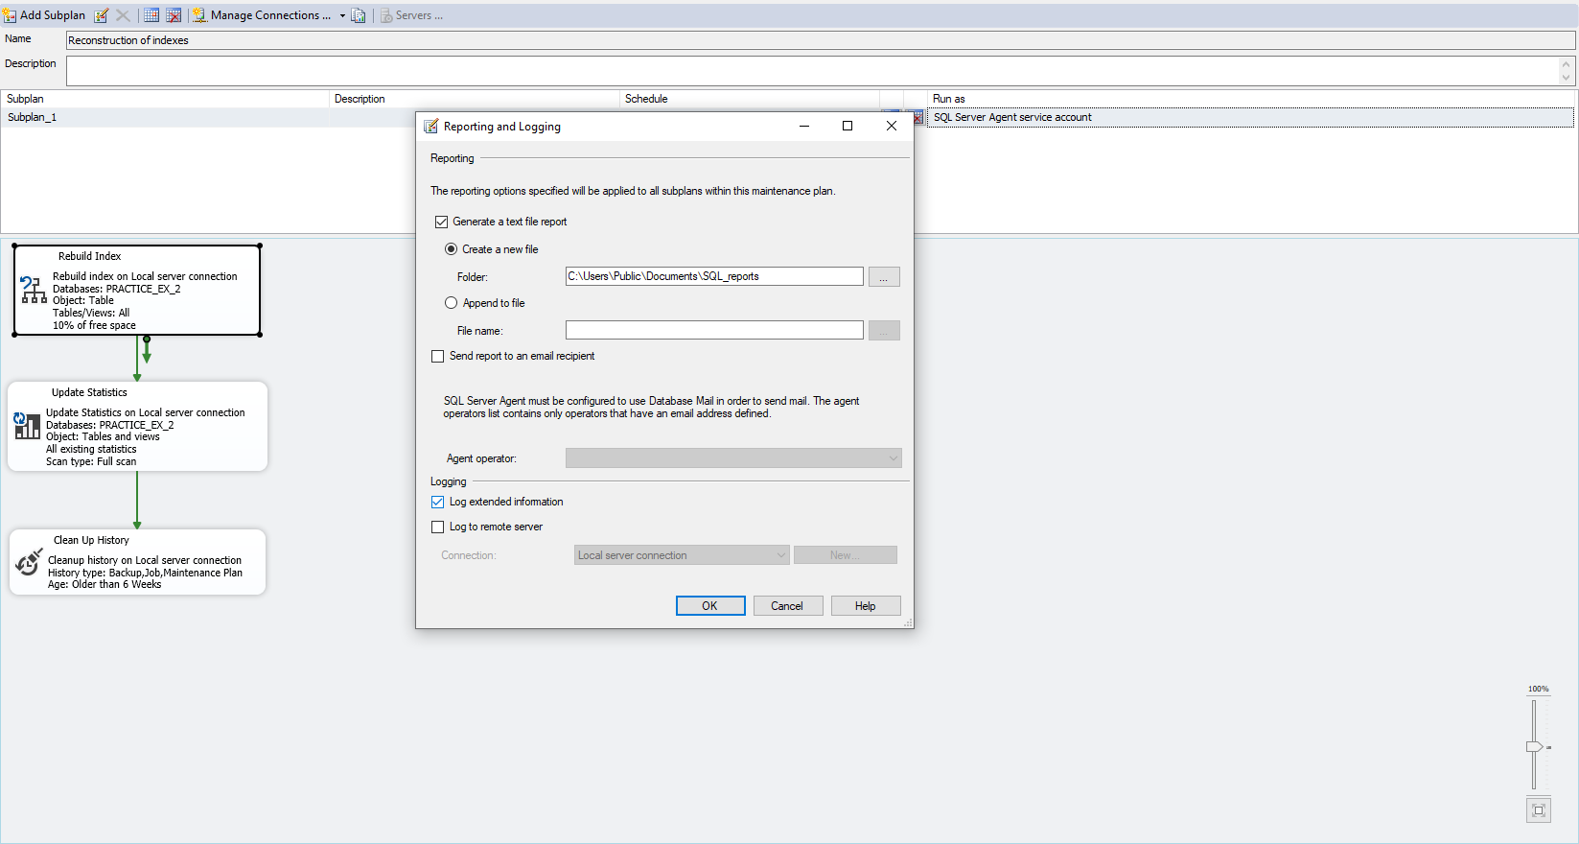

Set the logging to extend.

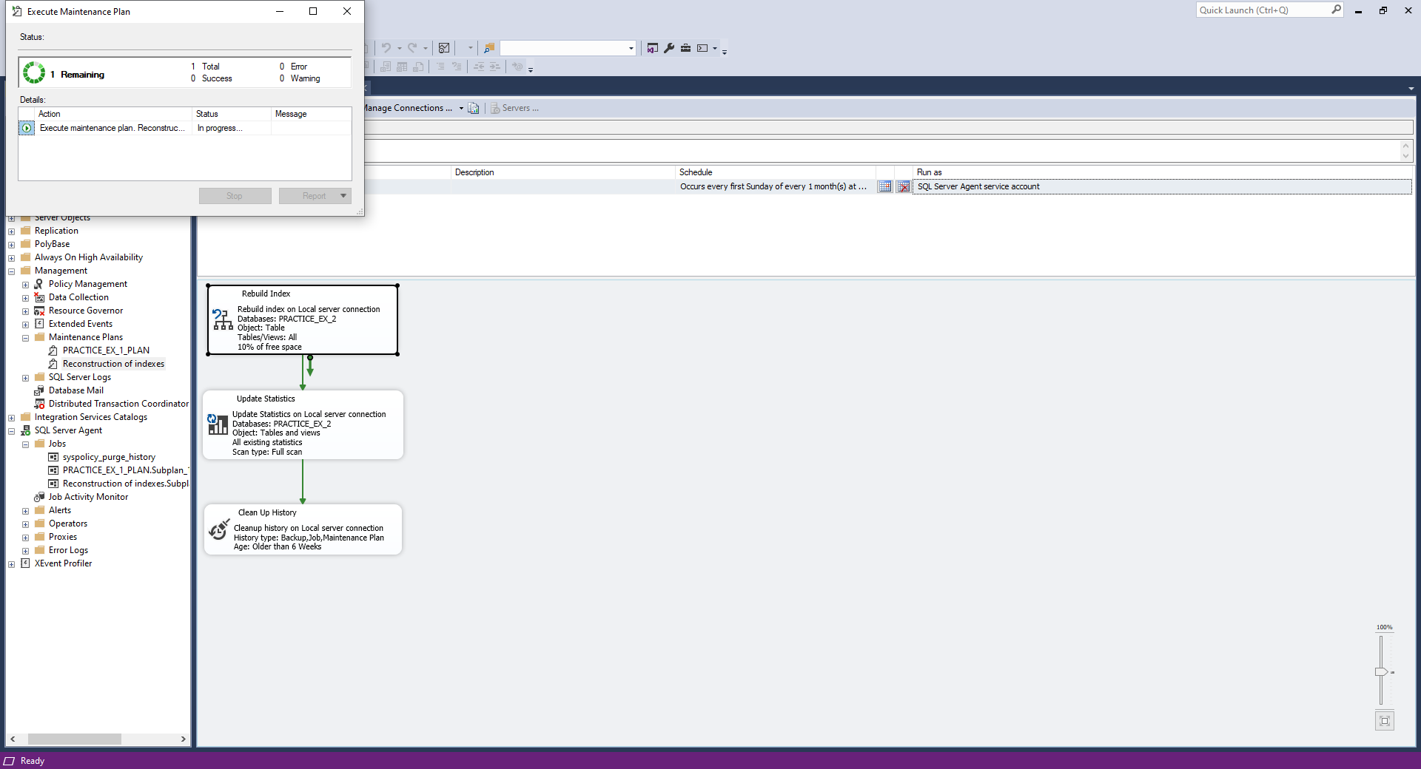

Executing the newly created Maintenance Plan for the database 2.

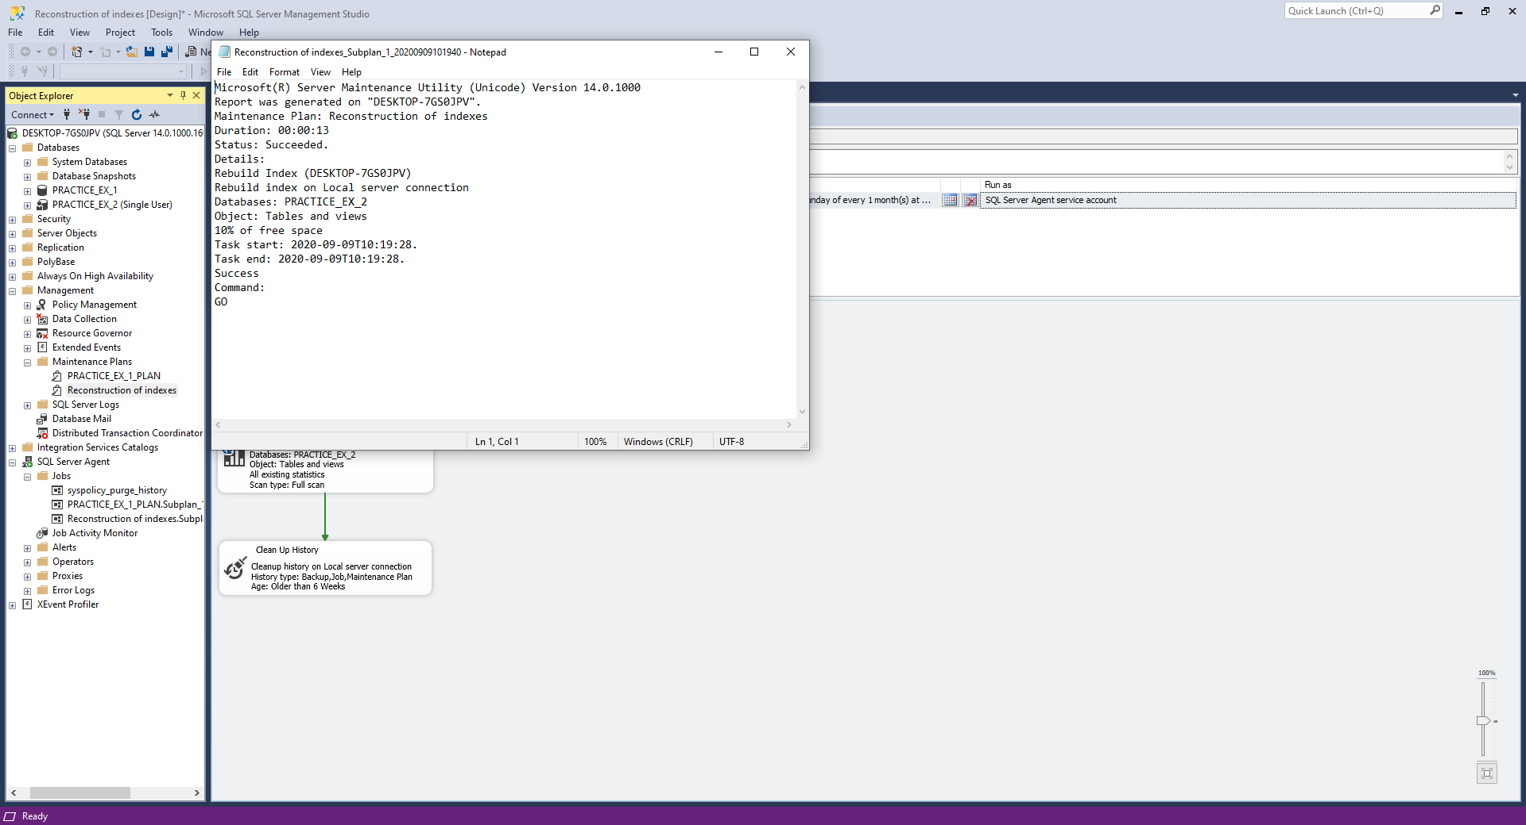

Here is the report file with the logs about the execution of the Maintenance Plan.

**Conclusion:**

In this laboratory work I familiarized my self with the SQL Server Management Studio tool for creating and maintaining databases, also studying the necessary information I acquainted the necessary steps for creating a database that can be configured from the limits in the storage to the physical location on the disk. Also, I studied the tools that allow the maintenance of a database. There were created 2 Maintenance Plans that had as task the automatic execution of some tasks specific to a database.