**CREATE DATABASE**

CREATE DATABASE Airport;

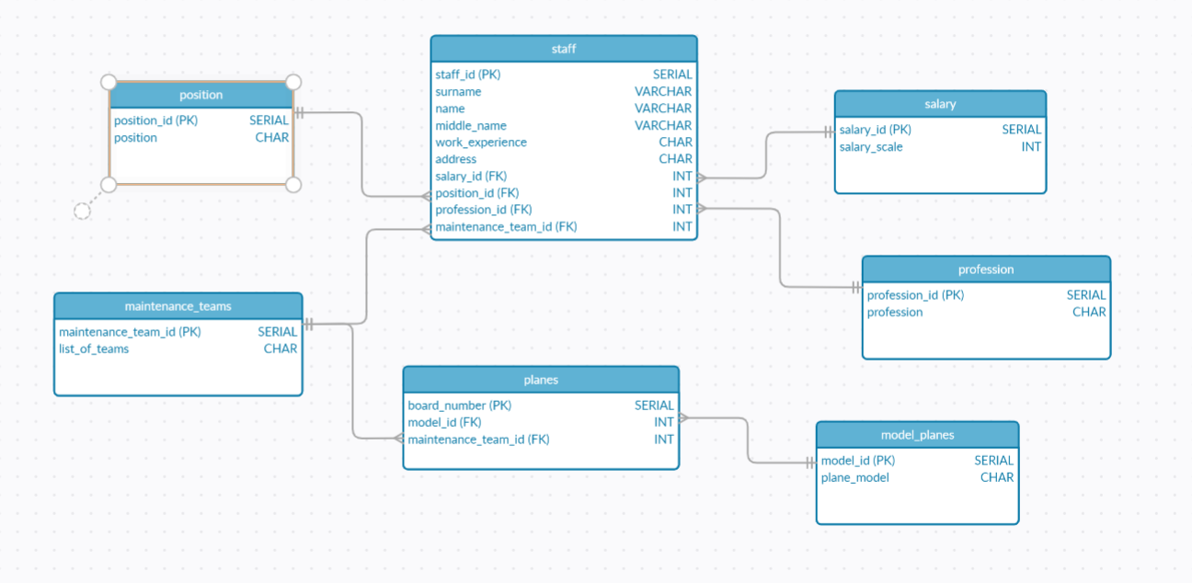**ERD DIAGRAM**

**CREATE TABLE**

1)

CREATE TABLE position(

position_id SERIAL PRIMARY KEY,

position CHAR(255)

);

2)

CREATE TABLE maintenance_teams(

maintenance_team_id SERIAL PRIMARY KEY,

list_of_teams CHAR(255)

);

3)

CREATE TABLE planes(

board_number SERIAL PRIMARY KEY,

model_id INT REFERENCES model_planes(model_id),

maintenance_team_id INT REFERENCES maintenance_teams(maintenance_team_id )

);

4)

CREATE TABLE profession(

profession_id SERIAL PRIMARY KEY,

profession CHAR(255)

);

5)

CREATE TABLE salary(

salary_id SERIAL PRIMARY KEY,

salary_scale INT

);

6)

CREATE TABLE model_planes(

model_id SERIAL PRIMARY KEY,

plane_model CHAR(255)

);

7)

CREATE TABLE staff(

staff_id SERIAL PRIMARY KEY,

surname VARCHAR(255),

name VARCHAR(255),

middle_name VARCHAR(255),

work_experience CHAR(255),

address CHAR(255),

salary_id INT REFERENCES salary(salary_id),

position_id INT REFERENCES position(position_id),

profession_id INT REFERENCES profession(profession_id),

maintenance_team_id INT REFERENCES maintenance_teams(maintenance_team_id)

);

**ALTER TABLE STATEMENT**

1. ALTER TABLE staff ADD COLUMN summer_composition_id INT;
2. ALTER TABLE staff DROP COLUMN summer_composition_id;
3. ALTER TABLE staff ALTER address SET NOT NULL;
4. ALTER TABLE staff RENAME TO personal;
5. ALTER TABLE personal RENAME COLUMN work_experience TO experience;

**Insert**

1)

INSERT INTO position(position)

VALUES('flight_support_dispatcher'),

('air_navigation_specialist'),

('maintenance_Manager'),

('equipment_maintenance_engineer'),

('passenger_registration_agent'),

('receptionist'),

('loader'),

('driver'),

('customs_declarant'),

('navigator');

2)

insert into salary (salary_scale) values ('398914');

insert into salary (salary_scale) values ('69573');

insert into salary (salary_scale) values ('50834');

insert into salary (salary_scale) values ('156555');

insert into salary (salary_scale) values ('1611494');

insert into salary (salary_scale) values ('958088');

insert into salary (salary_scale) values ('3600388');

insert into salary (salary_scale) values ('106777');

insert into salary (salary_scale) values ('1281894');

insert into salary (salary_scale) values ('1382219');

3)

INSERT INTO profession(profession)

VALUES('engineer'),

('Steward'),

('Civil_aviation_pilot'),

('Air_traffic_controller'),

('Fireman'),

('Law_enforcement_officers'),

('it_specialist'),

('Customs_officer'),

('Physicians'),

('Aircraft_designer');

4)

INSERT INTO maintenance_teams(list_of_teams)

VALUES('Border_control'),

('Security control'),

('Customs_control'),

('Service_of_passengers'),

('Air_fuel_refueling_service'),

('Maintenance_on_transit_shape'),

('Forklift_Transporter'),

('Telescopic_ladder'),

('Escort_car'),

('Aviation_security');

5)

INSERT INTO model_planes(plane_model)

VALUES('The_Wright_Flyer'),

('Concorde'),

('Air_Force_One '),

('Supermarine_Spitfire'),

('Airbus A380'),

('Spirit_of_St_Louis'),

('Lockheed_Vega_5b'),

('Gulfstream GIV'),

('Cessna Citation XL'),

('SpaceShipTwo');

6)

insert into planes (model_id , maintenance_team_id ) values (1, 1);

insert into planes (model_id , maintenance_team_id ) values (2, 2);

insert into planes (model_id , maintenance_team_id ) values (3, 3);

insert into planes (model_id , maintenance_team_id ) values (4, 4);

insert into planes (model_id , maintenance_team_id ) values (5, 5);

insert into planes (model_id , maintenance_team_id ) values (6, 6);

insert into planes (model_id , maintenance_team_id ) values (7, 7);

insert into planes (model_id , maintenance_team_id ) values (8, 8);

insert into planes (model_id , maintenance_team_id ) values (9, 9);

insert into planes (model_id , maintenance_team_id ) values (10, 10);

7)

insert into personal (surname, name, middle_name, experience, address, salary_id, position_id, profession_id, maintenance_team_id) values ('Kensy', 'Kimberlyn', 'Geistmann', 8, '70 Columbus Park', 1, 1, 1, 1);

insert into personal (surname, name, middle_name, experience, address, salary_id, position_id, profession_id, maintenance_team_id) values ('Shalders', 'Essie', 'Hurnell', 27, '0 Shasta Circle', 2, 2, 2, 2);

insert into personal (surname, name, middle_name, experience, address, salary_id, position_id, profession_id, maintenance_team_id) values ('Menelaws', 'Tova', 'Eddoes', 9, '7 Armistice Drive', 3, 3, 3, 3);

insert into personal (surname, name, middle_name, experience, address, salary_id, position_id, profession_id, maintenance_team_id) values ('Colten', 'Amby', 'Troppmann', 15, '19950 Talisman Parkway', 4, 4, 4, 4);

insert into personal (surname, name, middle_name, experience, address, salary_id, position_id, profession_id, maintenance_team_id) values ('Ventham', 'Ede', 'Brew', 6, '023 Welch Point', 5, 5, 5, 5);

insert into personal (surname, name, middle_name, experience, address, salary_id, position_id, profession_id, maintenance_team_id) values ('Marritt', 'Saidee', 'Nardi', 10, '794 Springview Drive', 6, 6, 6, 6);

insert into personal (surname, name, middle_name, experience, address, salary_id, position_id, profession_id, maintenance_team_id) values ('Arnet', 'Lucho', 'Kernoghan', 18, '01 Lighthouse Bay Junction', 7, 7, 7, 7);

insert into personal (surname, name, middle_name, experience, address, salary_id, position_id, profession_id, maintenance_team_id) values ('Huton', 'Ddene', 'Waine', 29, '2 Sachs Junction', 8, 8, 8, 8);

insert into personal (surname, name, middle_name, experience, address, salary_id, position_id, profession_id, maintenance_team_id) values ('Hillyatt', 'Angelo', 'Jojic', 29, '5 Anhalt Place', 9, 9, 9, 9);

insert into personal (surname, name, middle_name, experience, address, salary_id, position_id, profession_id, maintenance_team_id) values ('Dyte', 'Grover', 'Morrell', 4, '591 Ronald Regan Street', 10, 10, 10, 10);

**Update**

1)

UPDATE maintenance_teams

SET list_of_teams='aviation_engineering_division'

WHERE maintenance_team_id = 5;

2)

UPDATE model_planes

SET plane_model = 'Bombardier CSeries'

WHERE model_id = 3;

3)

UPDATE personal

SET experience = 10

WHERE staff_id >= 5;

4)

UPDATE position

SET position = 'Gate Agent'

WHERE position_id = 4;

5)

UPDATE profession

SET profession = 'Ticketing'

WHERE profession_id = 8;

6)

UPDATE salary

SET salary_scale = '20000'

WHERE salary_scale < '20000';

**Query**

1)

SELECT SUM(salary_scale) AS overall

FROM salary;

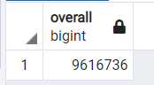

2)

SELECT AVG(salary_scale) :: numeric(10, 2) AS average

FROM salary;

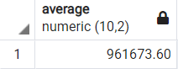

3)

SELECT MAX(salary_scale) AS max

FROM salary;

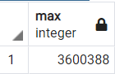

4)

SELECT MIN(salary_scale) AS min

FROM salary;

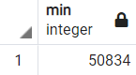

5)

SELECT surname, name, middle_name, salary_scale

FROM personal

INNER JOIN salary

ON personal.salary_id=salary.salary_id;

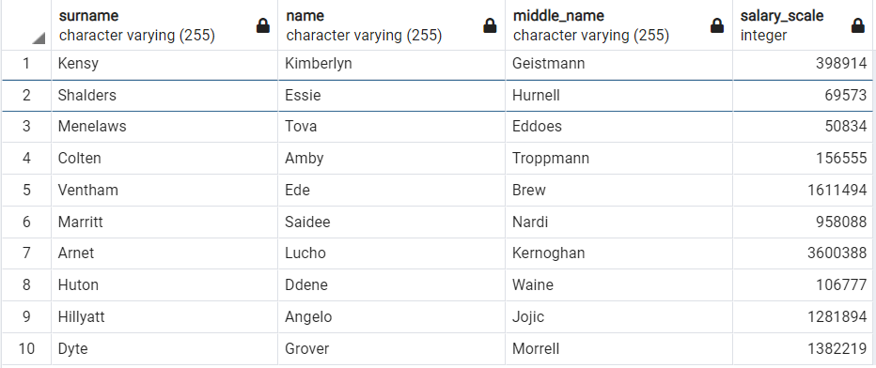

6)

SELECT surname, name, middle_name, salary_scale

FROM personal

LEFT JOIN salary

ON personal.salary_id=salary.salary_id;

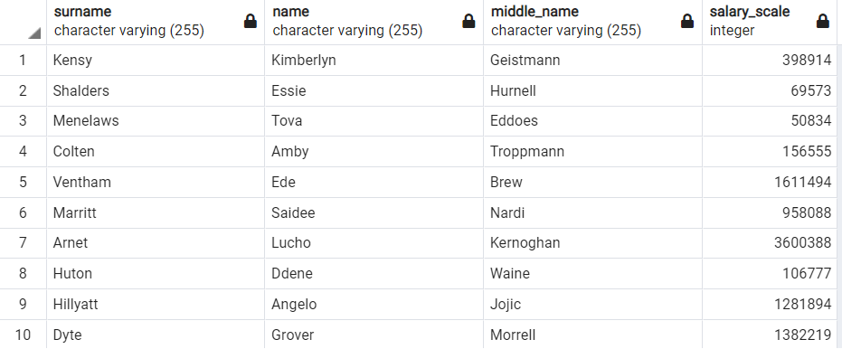

7)

SELECT surname, name, middle_name, salary_scale

FROM personal

RIGHT JOIN salary

ON personal.salary_id=salary.salary_id;

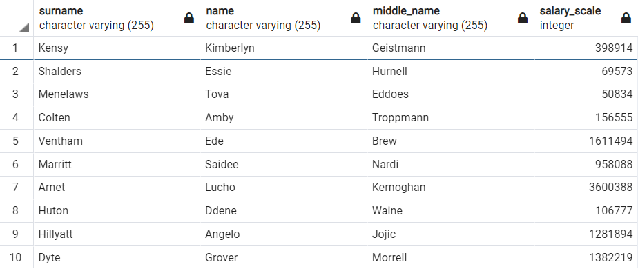

8)

SELECT surname, name, middle_name, salary_scale

FROM personal

FULL JOIN salary

ON personal.salary_id=salary.salary_id;

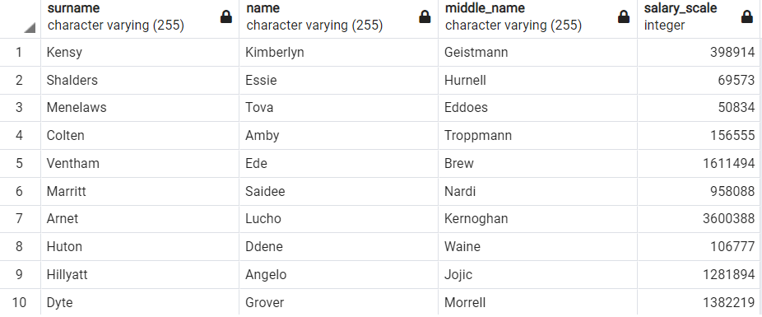

9)

SELECT COUNT(*)

FROM planes;

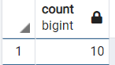

10)

SELECT * FROM salary

WHERE salary_scale BETWEEN 100000 AND 450000;

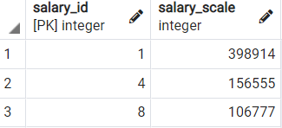

11)

SELECT surname, name, middle_name

FROM personal

WHERE SURNAME LIKE 'H%';

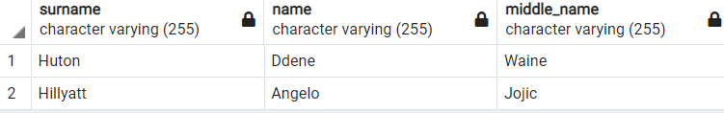

12)

SELECT DISTINCT surname FROM personal;

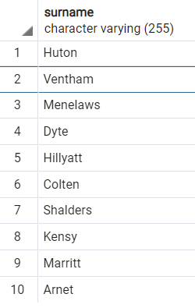

**Delete**

DELETE FROM planes;

DELETE FROM personal;

DELETE FROM maintenance_teams;

DELETE FROM model_planes;

DELETE FROM position;

DELETE FROM profession;

DELETE FROM salary;