Design Document
Revision History
Version | Date | Description
v1.0 | 10/16/19 | Initial version

Table of Contents
1Introduction 1
1.1Design Overview 1
1.2Intended Audience 1
1.3References 1
2Detailed Design 2
2.1Architecture 2
Components 2
Interfaces 2
2.2Algorithms and Data Structures 2
2.3Performance 2
2.4Test Scripts 2

Introduction
We are creating an Unified interface which will open-source preprocessor, solver and post-prcessor
of pre-existing OSS.
For initial implementation we are using gmsh as preprocessor fluidity as solver and paraview as post-prcessor

Design Overview
Our UICFD is using Gmsh and Fludity which is distributed under the terms of the GNU General Public License (GPL) so we are free to use and modify it.
We are using Tkinter python module for creating interface.

Intended Audience
This document is intended for software managers, coders and testers.

References
[1] What is gmsh http://gmsh.info/doc/texinfo/gmsh.html

[2] What is Fludity https://fluidityproject.github.io/
[3] Parview Documentation https://www.paraview.org/documentation/

Detailed Design

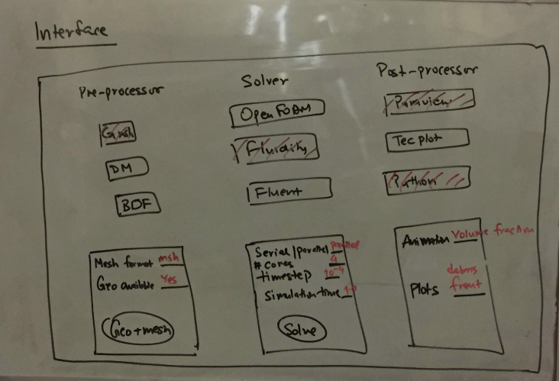Fig. 1: BookIt Architecture
For rapid implementation and future expansion, we will be using Github as plateform .

Architecture
The BookIt architecture (Fig. 1) conforms to the user-interface of our product. The block(button) underlying pre-processor, Solver and Post-prcessor are pre-existing OSS. The red part is entry where user will input his requred format.

Components
Gmsh: is used as-is for creating grid or mesh.
This can be install using
sudo apt-get update && sudo apt-get install gmsh
Fludity: is used as-is for solving .msh
This can be install using following method.
sudo apt-add-repository -y ppa:fluidity-core/ppa
sudo apt-get update
sudo apt-get -y install fluidity
Paraview: is used as-is for showing graphics.

Interfaces
1.)For creating folder from tkinter we are using system call os.mkdir()
2.)

Algorithms and Data Structures
There are no significant algorithms developed for this product.

Performance
The product will be benchmarked on different entry-level and server-class PCs. This will result in graphical repersantation of fluid.

Test Scripts
The following scripts will be used to create interface and connect OSS.
GUI.py: Launches graphical interface.
Script.sh: Create following folders in parent folder
- pre-processing
- solver
- post-processing
Connect.py: sends output of pre-processor to solver and solver to specified post-prcessor
Connect.py: plots output of post-prcessor

