Unified interface for CFD software
Requirements Document
Revision History
Version | Date | Description
v1.0 | 10/15/19 | Initial version

Table of Contents
1Introduction 2
1.1Need and Purpose 2
1.2Intended Audience 2
1.3References 2
2Description 2
2.1Features and Functions 2
Features 2
Functions 3
2.2Users 3
2.3Operating Environmen 3
2.3.1Hardware 3
2.3.2Software 3
3Mini-Project Plan 4

Introduction
This is an User-interface which will connect open source software like gmesh, fludity, and paraview
which int turn will make them easy-to-use.

Need and Purpose
With Computational Fluid Dynamics or CFD is used to generate flow simulations with the help of computers. CFD involves the solution of the governing laws of fluid dynamics numerically. The complex set of partial differential equations are solved on the geometrical domain divided into small volumes,commonly known as mess or grid.
There are many companies who provides CFD software but there softwares are costly. There are many open source CFD softweres also but they are not easy-to-use which makes them expensive (human cost and skillset wise). This Unified Interface will make those open source softwares easy-to-use.

Intended Audience
This document is intended for software managers and designers, person who analys environment, predict rain, design mechanical structure and study Heat Transfer.

References
[1] http://gmsh.info/doc/texinfo/gmsh.html
[2] https://fluidityproject.github.io/
[3] https://www.paraview.org/documentation/

Description

Features and Functions

Features
This UICFD can be used by many type of user for fluid analysis. Users will have to run a Python programme. Which in turn will open a window.
Once the interface is launched user will have to provide a name for project in project name forum.
The user selects one box from Pre-precessor option, one from the Solver option and one or more from Post-prcessor.
The user then fills the red text in boxes, taps Geo+Msh button this will create a .msh file.
The user then taps the Solve button in the solver option , after all the red fields have been filled, this will show them some graphics.

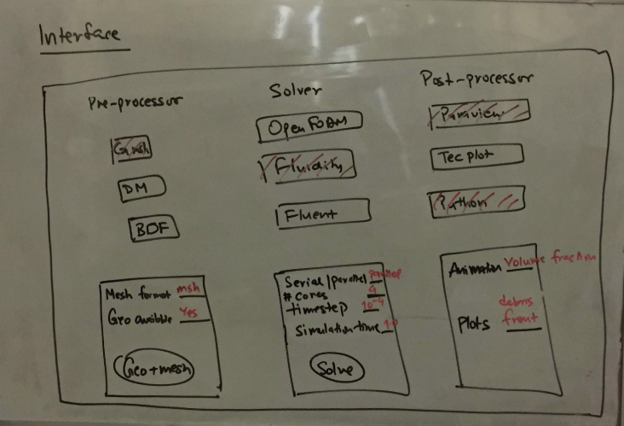

Functions
This UICFD connects gmesh, fludity and paraview and give users easy working experience.

Users
- Managers
- Civil and Machanical Engineers.
- Students.
- Data Analyst.

Operating Environmen

Hardware
This requires an entry-level PC for small computation. For larger application PC with good graphics is needed.

Software
This Unified interface can run on any recent version of Linux, such as Ubuntu, Debian, Fedora Core, Redhat Enterprise, etc. It requires:
- Python 3.x
- gmsh
- Fludity
- Parview
- Tkinter
- DM
- BOF
- Fluent
- Open Foams
- Tec Plot

Mini-Project Plan
Timeline | Assigned Work | Status
16th October | Working Interfaces tested with the pre-processing and solver should be functional . | completed
24^{h} October | Post-Processing section functional, enhancement of the interface accepting options interactively from the user. Demonstrating mesh format conversion based on options selected by user . | Initiated
1st november | Completed Open FOAM solver functional | Planned
5th november | Full-functional project uploaded on Github –containing Makefile for the project and documentation. Unit test devloped Exceptional handling in place. | Planned

