Web Page Data Validation
Tool tip based Instructional and Error Messages

Every Data entry page we develop, we have to find a better way to display the instructional and error messages, to make process of data entry smooth and easy for our users. The objective is to display all the error messages at the same time, save unnecessary trip to server and add no additional control or occupy space on page to display the error message. Let us review few scenarios.

Scenario One - One error message is displayed at a time
User competes data entry and click save, validation logic returns first error message, User correct the error and resubmit the page, may be another error is found and user is again see a message to fix the data. This process continues as long as all the errors are cleared. Error message may appear in a popup window, hidden field (made visible to display message) on the page, or as a JavaScript alert. It may be a slow process, if there are lot fields on the page and several trips to the server.

Scenario Two – All the errors messages are displayed at the same time
User compete data entry and clicks save, validation logic collects all the error messages and sends them back to user. User sees all the error message and fix the data. Sometime messages may disappear, the moment user start fixing the data. (JavaScript alert / popup window). If there are lots of error messages, user may not remember what to fix and may have to resubmit the page again to the server, to see the remaining messages. If the messages are visible on the page (hidden field containing messages made visible) then page layout may look different, one without error and another with errors. Layout with errors may not be user friendly.

Scenario Three – Use ASP.NET validation controls
ASP.NET validation controls are great controls to validate the data. Please consider the following points.

- We add additional validation control on our form.

- Either display style is static or dynamic in both the cases message will be displayed on the page. If form is crowded or messages are long then display may not be very user friendly.

Scenario Four – Use tool tip at field label to display the instructional and error messages.
Whenever user moves mouse pointer on field label (Date, State, and City .etc.) help message about the field is displayed in a tool tip, as long as the pointer is on the field label. User submits page to server, Business or data related errors messages are send back to the user. The client-side JavaScript reads these messages from a Hidden field and concatenate the error message with the help messages of the field. The color of fields with error also turns red and as user moves mouse on the field label, tool tip message containing help text and error message is displayed.

Important Note:
- Field labels IDs are named as L0, L1 and L2 etc. to match the index of message array defined in JavaScript code.

- Tool tip JavaScript is copied from http://www.walterzorn.com/tooltip/tooltip_e.htm#docu
Script also allows you to customize your tool tip message.

- Format of the error message returned by server is
Label ID: Message: Field ID| Label ID: Message: Field ID|
L0: Date Field is Blank:TextBox1|

- Color of the required fields is wheat, optional fields are lavender and conditionally required field is rosybrown. Lightyellow for field selected.

- Color of field have bad data turns to red after validation and tool tip message of the field is appended to the error message returned by the server.

- JavaScript mouse pointer is stored in two separate style sheet (one for IE and another for NS) not visible is picture in this document.

- Tested OK in IE 6.0, NS 7.2 and FF 1.0.7

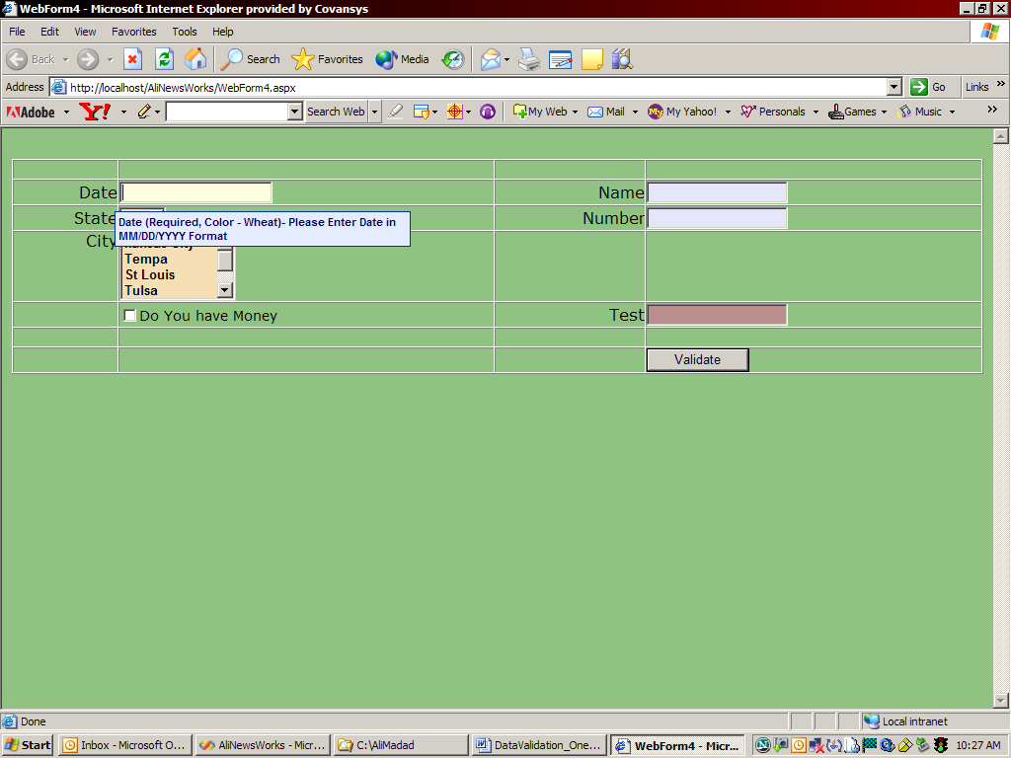
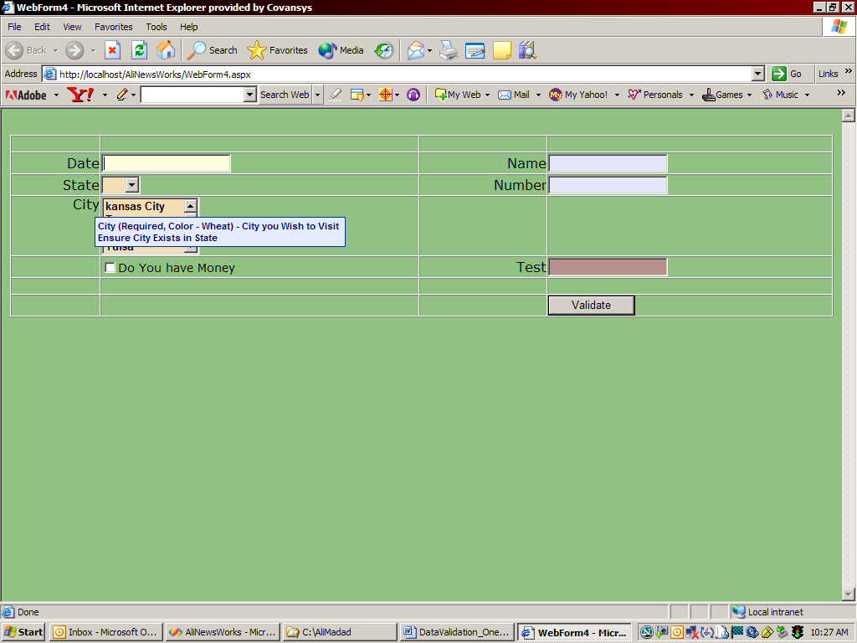

After Validate button is clicked.
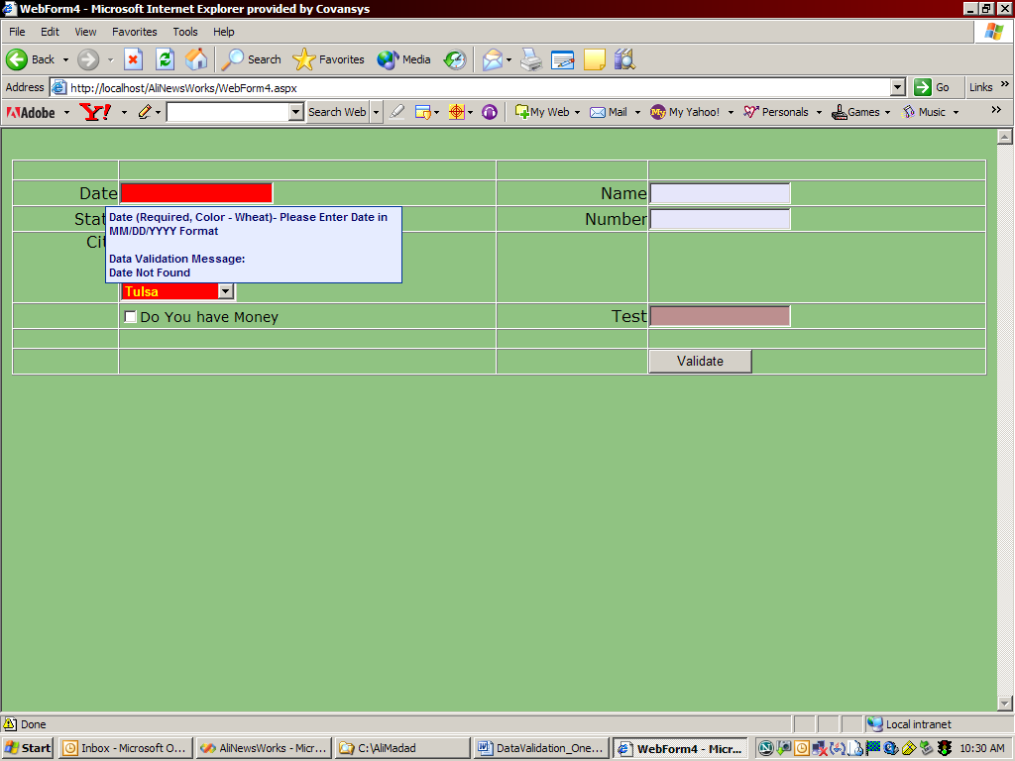
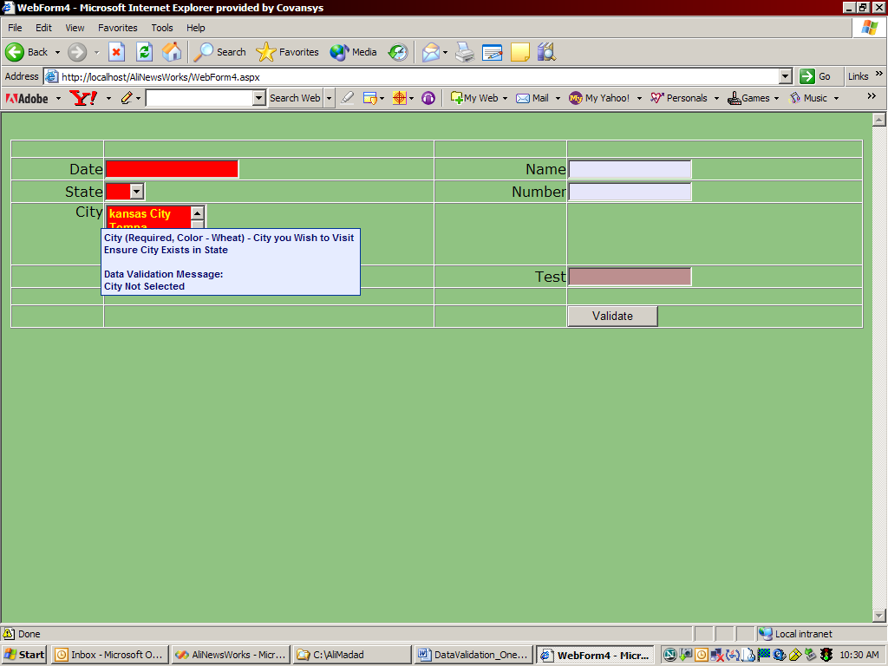

Date is populated and validate button is clicked.
