s

EventBuddy App

**Call Flow:**

**Reponse:**

Rest Payload

Profile

Manager

**Request:**

Rest Payload

Add

Fetch

Update

Delete



**Entity Relationships:**

**EventBuddy_DB**

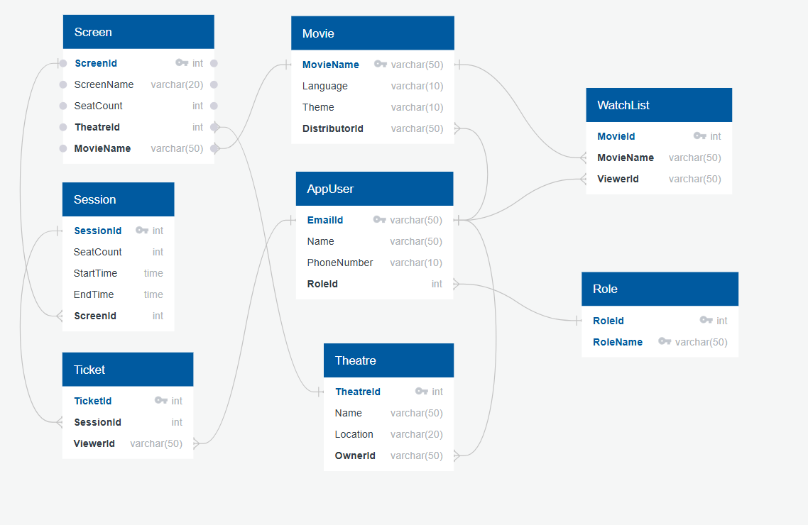

**Request and Response**

|  |  |  |  |
| --- | --- | --- | --- |
| **Client** | **Operation** | **RequestBody** | **ResponseBody** |
| EventBuddy | AddAppUser | * EmailId * Name * PhoneNumber |  |
| EventBuddy | AddAppUserRole | * EmailId * RoleId |  |
| EventBuddy | AddMovie | * MovieName * Language * Theme * DistributorId |  |
| EventBuddy | AddTheatre | * Name * Location * OwnerId |  |
| EventBuddy | AddMovieToWatchlist | * MovieName * ViewerId |  |
| EventBuddy | AddScreenToTheatre | * ScreenName * SeatCount * TheatreId * MovieName |  |
| EventBuddy | AddSessionToScreen | * SeatCount * StartTime * EndTime * ScreenId |  |
| EventBuddy | AddTicket | * SessionId * ViewerId |  |