Dineish V S

Chennai(digital)

directories:  
/development  
/development/website  
/development/website/images  
/development/website/test

1) create a file called index.txt within the website directory and enter the your resume within 15 lines in the file  
2) create a file country.txt within the test directory and enter the some 10 countries names in the file line by line  
3) copy the file country.txt and index.txt both to images directory  
4) move the file country.txt to website directory  
5) rename the file index.txt to sample.txt  
6) create a file fruits.txt within development directory and add around 10 fruits description lines into it  
7) copy the fruits.txt to images directory  
8) delete the directory test

9) open the vim editor in development directory and do operations (1) and (2) above same

# Answers

1. 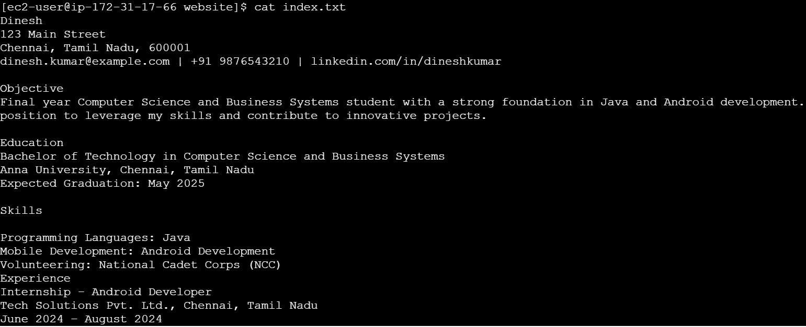

2. 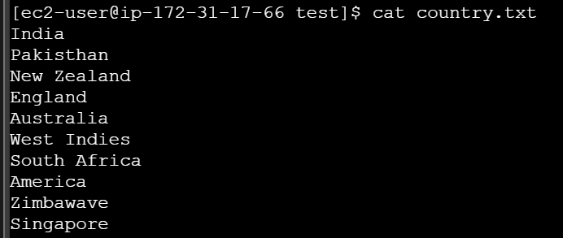

3. 



4. 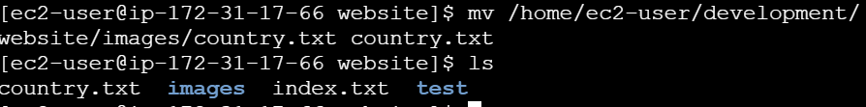

5. 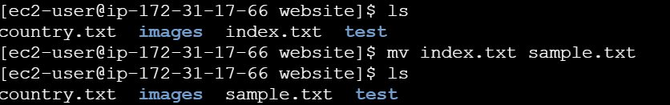

6. 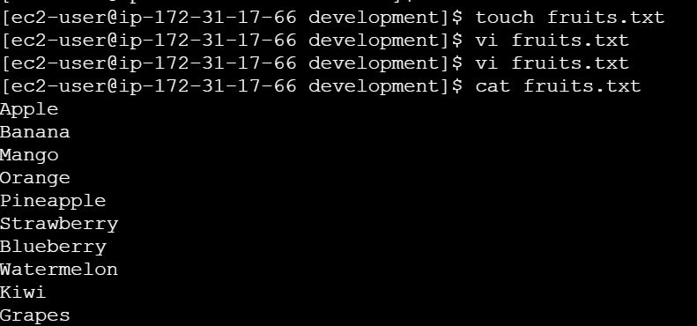

7. 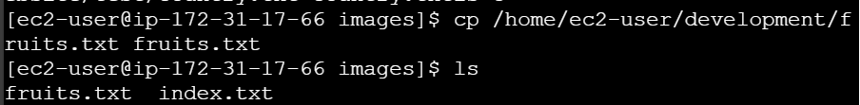

8. 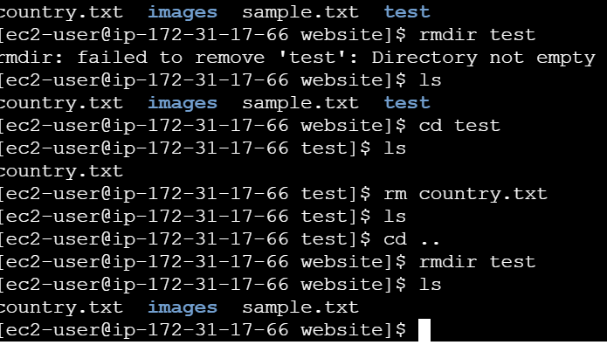

9. 