Admin Module

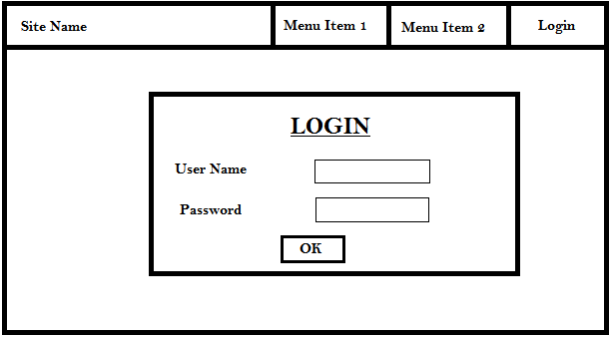

After admin logs in he/she will be able to feed the data to db.

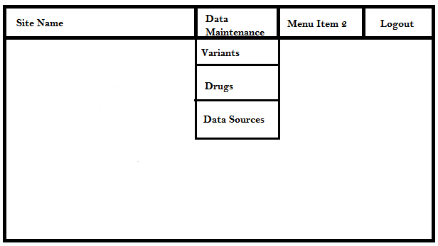

Data Maintenance -> 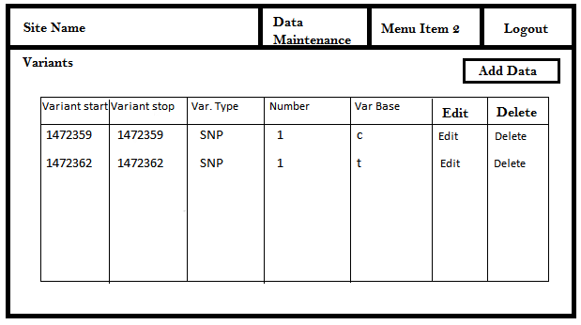Variants

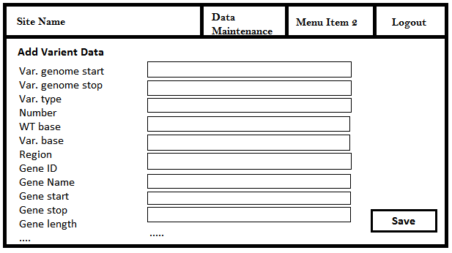Add Variant ->

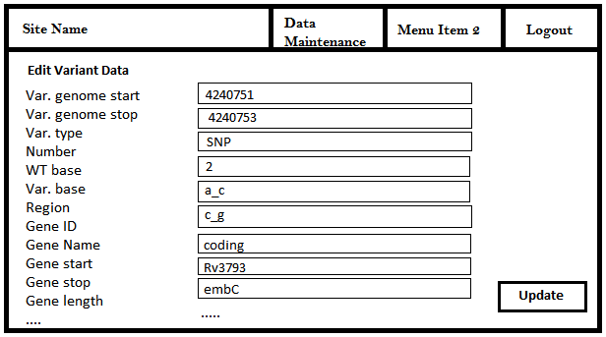Edit Variant data ->

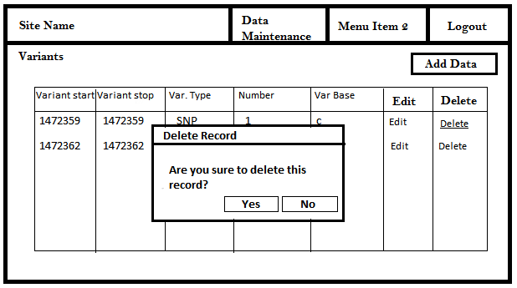 Delete Variant Data ->

Data Maintenance -> Drugs

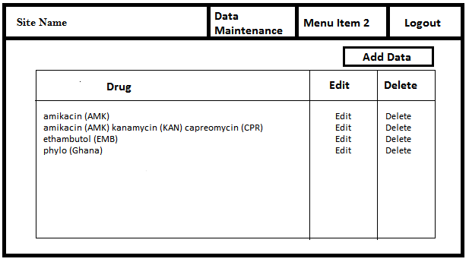

Add drug details ->

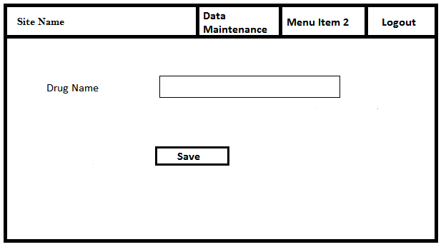

Drug edit, delete is pretty much similar to variant data edit and delete user interfaces.

Data Maintenance -> Data Sources

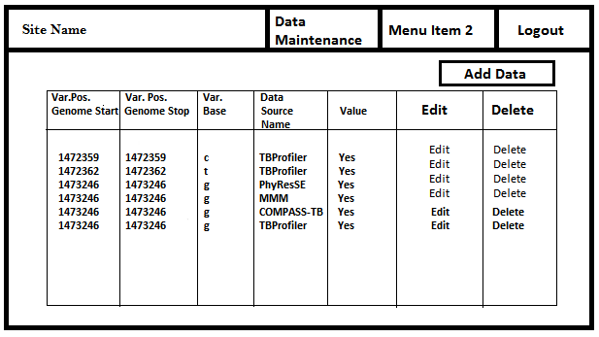

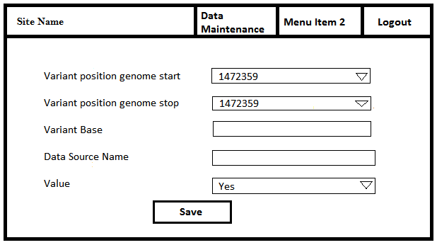Add data source details ->

Genome start and stop values can be selected from a drop down and the var.base value will be automatically displayed according to the selected values. Data source name can be type in or can be displayed through a predefined list.

Data source edit, delete is pretty much similar to variant data edit and delete user interfaces.

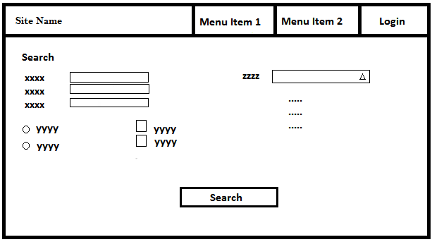Normal user view -> Search

User is given different set of options (type in/select values from drop downs, radio buttons, checkboxes) to generate the desired search query.

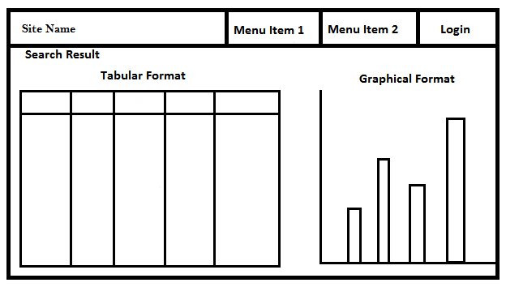Search result can be displayed in tabular and graphical formats.