BUILDING REST APIs WITH PYTHON
A Project Article Document
Name: Dineshkumar C
Register Number: 2303737720521021
Course: Prompt Engineering

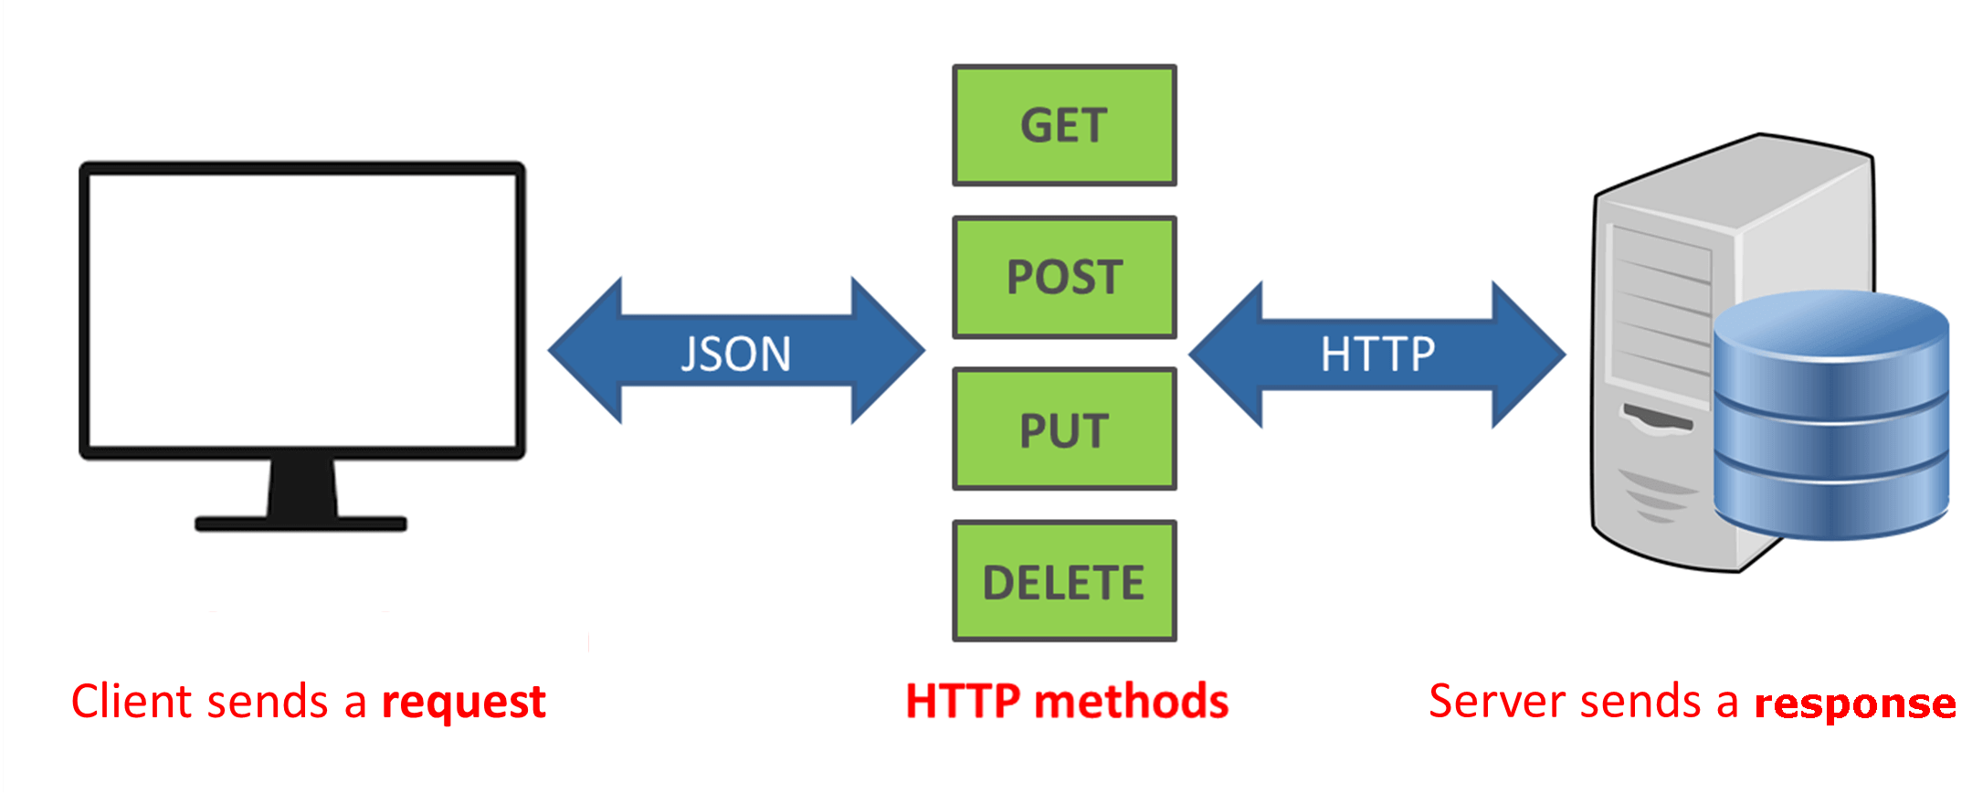

Introduction

REST APIs play a crucial role in modern web applications. They enable communication between software systems over the internet using standard HTTP protocols. Python is widely used for API development because it is simple, readable, and supported by powerful frameworks.
REST APIs play a crucial role in modern web applications. They enable communication between software systems over the internet using standard HTTP protocols. Python is widely used for API development because it is simple, readable, and supported by powerful frameworks.
REST APIs play a crucial role in modern web applications. They enable communication between software systems over the internet using standard HTTP protocols. Python is widely used for API development because it is simple, readable, and supported by powerful frameworks.
REST APIs play a crucial role in modern web applications. They enable communication between software systems over the internet using standard HTTP protocols. Python is widely used for API development because it is simple, readable, and supported by powerful frameworks.
REST APIs play a crucial role in modern web applications. They enable communication between software systems over the internet using standard HTTP protocols. Python is widely used for API development because it is simple, readable, and supported by powerful frameworks.

What is an API

REST APIs play a crucial role in modern web applications. They enable communication between software systems over the internet using standard HTTP protocols. Python is widely used for API development because it is simple, readable, and supported by powerful frameworks.
REST APIs play a crucial role in modern web applications. They enable communication between software systems over the internet using standard HTTP protocols. Python is widely used for API development because it is simple, readable, and supported by powerful frameworks.
REST APIs play a crucial role in modern web applications. They enable communication between software systems over the internet using standard HTTP protocols. Python is widely used for API development because it is simple, readable, and supported by powerful frameworks.
REST APIs play a crucial role in modern web applications. They enable communication between software systems over the internet using standard HTTP protocols. Python is widely used for API development because it is simple, readable, and supported by powerful frameworks.
REST APIs play a crucial role in modern web applications. They enable communication between software systems over the internet using standard HTTP protocols. Python is widely used for API development because it is simple, readable, and supported by powerful frameworks.

REST Architecture

REST APIs play a crucial role in modern web applications. They enable communication between software systems over the internet using standard HTTP protocols. Python is widely used for API development because it is simple, readable, and supported by powerful frameworks.
REST APIs play a crucial role in modern web applications. They enable communication between software systems over the internet using standard HTTP protocols. Python is widely used for API development because it is simple, readable, and supported by powerful frameworks.
REST APIs play a crucial role in modern web applications. They enable communication between software systems over the internet using standard HTTP protocols. Python is widely used for API development because it is simple, readable, and supported by powerful frameworks.
REST APIs play a crucial role in modern web applications. They enable communication between software systems over the internet using standard HTTP protocols. Python is widely used for API development because it is simple, readable, and supported by powerful frameworks.
REST APIs play a crucial role in modern web applications. They enable communication between software systems over the internet using standard HTTP protocols. Python is widely used for API development because it is simple, readable, and supported by powerful frameworks.

REST Principles

REST APIs play a crucial role in modern web applications. They enable communication between software systems over the internet using standard HTTP protocols. Python is widely used for API development because it is simple, readable, and supported by powerful frameworks.
REST APIs play a crucial role in modern web applications. They enable communication between software systems over the internet using standard HTTP protocols. Python is widely used for API development because it is simple, readable, and supported by powerful frameworks.
REST APIs play a crucial role in modern web applications. They enable communication between software systems over the internet using standard HTTP protocols. Python is widely used for API development because it is simple, readable, and supported by powerful frameworks.
REST APIs play a crucial role in modern web applications. They enable communication between software systems over the internet using standard HTTP protocols. Python is widely used for API development because it is simple, readable, and supported by powerful frameworks.
REST APIs play a crucial role in modern web applications. They enable communication between software systems over the internet using standard HTTP protocols. Python is widely used for API development because it is simple, readable, and supported by powerful frameworks.

HTTP Methods

REST APIs play a crucial role in modern web applications. They enable communication between software systems over the internet using standard HTTP protocols. Python is widely used for API development because it is simple, readable, and supported by powerful frameworks.
REST APIs play a crucial role in modern web applications. They enable communication between software systems over the internet using standard HTTP protocols. Python is widely used for API development because it is simple, readable, and supported by powerful frameworks.
REST APIs play a crucial role in modern web applications. They enable communication between software systems over the internet using standard HTTP protocols. Python is widely used for API development because it is simple, readable, and supported by powerful frameworks.
REST APIs play a crucial role in modern web applications. They enable communication between software systems over the internet using standard HTTP protocols. Python is widely used for API development because it is simple, readable, and supported by powerful frameworks.
REST APIs play a crucial role in modern web applications. They enable communication between software systems over the internet using standard HTTP protocols. Python is widely used for API development because it is simple, readable, and supported by powerful frameworks.

Python for API Development

REST APIs play a crucial role in modern web applications. They enable communication between software systems over the internet using standard HTTP protocols. Python is widely used for API development because it is simple, readable, and supported by powerful frameworks.
REST APIs play a crucial role in modern web applications. They enable communication between software systems over the internet using standard HTTP protocols. Python is widely used for API development because it is simple, readable, and supported by powerful frameworks.
REST APIs play a crucial role in modern web applications. They enable communication between software systems over the internet using standard HTTP protocols. Python is widely used for API development because it is simple, readable, and supported by powerful frameworks.
REST APIs play a crucial role in modern web applications. They enable communication between software systems over the internet using standard HTTP protocols. Python is widely used for API development because it is simple, readable, and supported by powerful frameworks.
REST APIs play a crucial role in modern web applications. They enable communication between software systems over the internet using standard HTTP protocols. Python is widely used for API development because it is simple, readable, and supported by powerful frameworks.
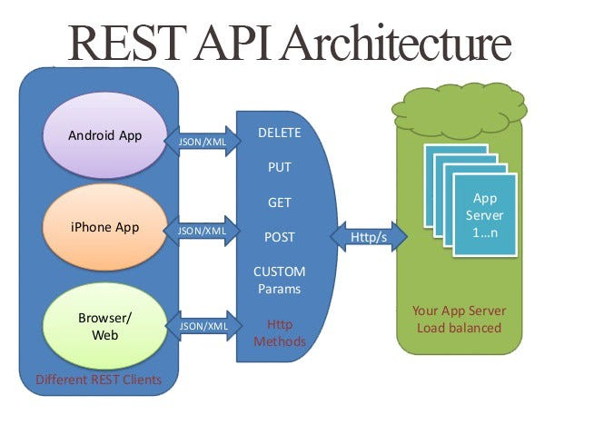

Python Frameworks

REST APIs play a crucial role in modern web applications. They enable communication between software systems over the internet using standard HTTP protocols. Python is widely used for API development because it is simple, readable, and supported by powerful frameworks.
REST APIs play a crucial role in modern web applications. They enable communication between software systems over the internet using standard HTTP protocols. Python is widely used for API development because it is simple, readable, and supported by powerful frameworks.
REST APIs play a crucial role in modern web applications. They enable communication between software systems over the internet using standard HTTP protocols. Python is widely used for API development because it is simple, readable, and supported by powerful frameworks.
REST APIs play a crucial role in modern web applications. They enable communication between software systems over the internet using standard HTTP protocols. Python is widely used for API development because it is simple, readable, and supported by powerful frameworks.
REST APIs play a crucial role in modern web applications. They enable communication between software systems over the internet using standard HTTP protocols. Python is widely used for API development because it is simple, readable, and supported by powerful frameworks.

Development Environment Setup

REST APIs play a crucial role in modern web applications. They enable communication between software systems over the internet using standard HTTP protocols. Python is widely used for API development because it is simple, readable, and supported by powerful frameworks.
REST APIs play a crucial role in modern web applications. They enable communication between software systems over the internet using standard HTTP protocols. Python is widely used for API development because it is simple, readable, and supported by powerful frameworks.
REST APIs play a crucial role in modern web applications. They enable communication between software systems over the internet using standard HTTP protocols. Python is widely used for API development because it is simple, readable, and supported by powerful frameworks.
REST APIs play a crucial role in modern web applications. They enable communication between software systems over the internet using standard HTTP protocols. Python is widely used for API development because it is simple, readable, and supported by powerful frameworks.
REST APIs play a crucial role in modern web applications. They enable communication between software systems over the internet using standard HTTP protocols. Python is widely used for API development because it is simple, readable, and supported by powerful frameworks.

Building REST API using Flask

REST APIs play a crucial role in modern web applications. They enable communication between software systems over the internet using standard HTTP protocols. Python is widely used for API development because it is simple, readable, and supported by powerful frameworks.
REST APIs play a crucial role in modern web applications. They enable communication between software systems over the internet using standard HTTP protocols. Python is widely used for API development because it is simple, readable, and supported by powerful frameworks.
REST APIs play a crucial role in modern web applications. They enable communication between software systems over the internet using standard HTTP protocols. Python is widely used for API development because it is simple, readable, and supported by powerful frameworks.
REST APIs play a crucial role in modern web applications. They enable communication between software systems over the internet using standard HTTP protocols. Python is widely used for API development because it is simple, readable, and supported by powerful frameworks.
REST APIs play a crucial role in modern web applications. They enable communication between software systems over the internet using standard HTTP protocols. Python is widely used for API development because it is simple, readable, and supported by powerful frameworks.
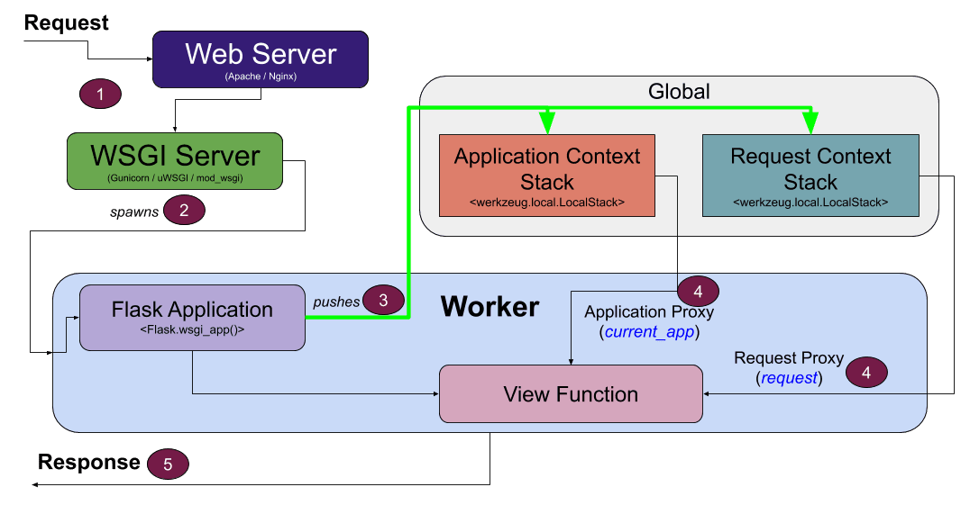

Building REST API using FastAPI

REST APIs play a crucial role in modern web applications. They enable communication between software systems over the internet using standard HTTP protocols. Python is widely used for API development because it is simple, readable, and supported by powerful frameworks.
REST APIs play a crucial role in modern web applications. They enable communication between software systems over the internet using standard HTTP protocols. Python is widely used for API development because it is simple, readable, and supported by powerful frameworks.
REST APIs play a crucial role in modern web applications. They enable communication between software systems over the internet using standard HTTP protocols. Python is widely used for API development because it is simple, readable, and supported by powerful frameworks.
REST APIs play a crucial role in modern web applications. They enable communication between software systems over the internet using standard HTTP protocols. Python is widely used for API development because it is simple, readable, and supported by powerful frameworks.
REST APIs play a crucial role in modern web applications. They enable communication between software systems over the internet using standard HTTP protocols. Python is widely used for API development because it is simple, readable, and supported by powerful frameworks.

Request and Response Format

REST APIs play a crucial role in modern web applications. They enable communication between software systems over the internet using standard HTTP protocols. Python is widely used for API development because it is simple, readable, and supported by powerful frameworks.
REST APIs play a crucial role in modern web applications. They enable communication between software systems over the internet using standard HTTP protocols. Python is widely used for API development because it is simple, readable, and supported by powerful frameworks.
REST APIs play a crucial role in modern web applications. They enable communication between software systems over the internet using standard HTTP protocols. Python is widely used for API development because it is simple, readable, and supported by powerful frameworks.
REST APIs play a crucial role in modern web applications. They enable communication between software systems over the internet using standard HTTP protocols. Python is widely used for API development because it is simple, readable, and supported by powerful frameworks.
REST APIs play a crucial role in modern web applications. They enable communication between software systems over the internet using standard HTTP protocols. Python is widely used for API development because it is simple, readable, and supported by powerful frameworks.
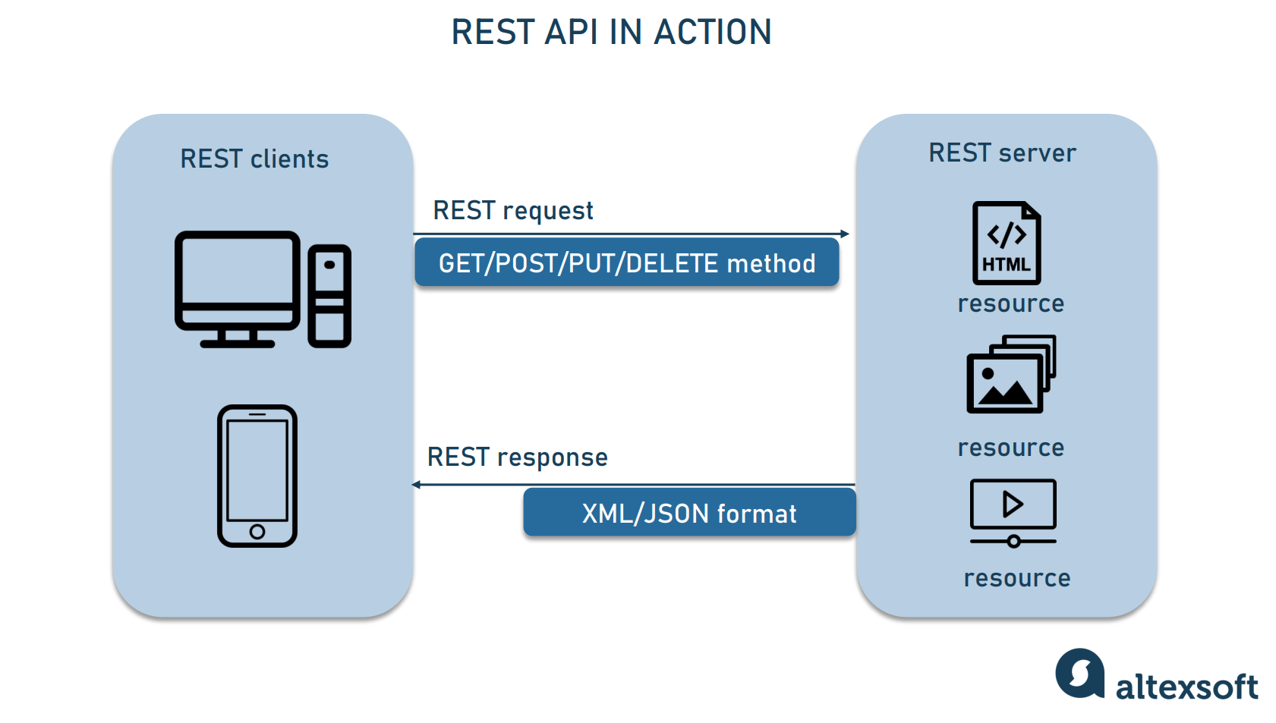

Database Integration

REST APIs play a crucial role in modern web applications. They enable communication between software systems over the internet using standard HTTP protocols. Python is widely used for API development because it is simple, readable, and supported by powerful frameworks.
REST APIs play a crucial role in modern web applications. They enable communication between software systems over the internet using standard HTTP protocols. Python is widely used for API development because it is simple, readable, and supported by powerful frameworks.
REST APIs play a crucial role in modern web applications. They enable communication between software systems over the internet using standard HTTP protocols. Python is widely used for API development because it is simple, readable, and supported by powerful frameworks.
REST APIs play a crucial role in modern web applications. They enable communication between software systems over the internet using standard HTTP protocols. Python is widely used for API development because it is simple, readable, and supported by powerful frameworks.
REST APIs play a crucial role in modern web applications. They enable communication between software systems over the internet using standard HTTP protocols. Python is widely used for API development because it is simple, readable, and supported by powerful frameworks.

API Testing

REST APIs play a crucial role in modern web applications. They enable communication between software systems over the internet using standard HTTP protocols. Python is widely used for API development because it is simple, readable, and supported by powerful frameworks.
REST APIs play a crucial role in modern web applications. They enable communication between software systems over the internet using standard HTTP protocols. Python is widely used for API development because it is simple, readable, and supported by powerful frameworks.
REST APIs play a crucial role in modern web applications. They enable communication between software systems over the internet using standard HTTP protocols. Python is widely used for API development because it is simple, readable, and supported by powerful frameworks.
REST APIs play a crucial role in modern web applications. They enable communication between software systems over the internet using standard HTTP protocols. Python is widely used for API development because it is simple, readable, and supported by powerful frameworks.
REST APIs play a crucial role in modern web applications. They enable communication between software systems over the internet using standard HTTP protocols. Python is widely used for API development because it is simple, readable, and supported by powerful frameworks.

API Security

REST APIs play a crucial role in modern web applications. They enable communication between software systems over the internet using standard HTTP protocols. Python is widely used for API development because it is simple, readable, and supported by powerful frameworks.
REST APIs play a crucial role in modern web applications. They enable communication between software systems over the internet using standard HTTP protocols. Python is widely used for API development because it is simple, readable, and supported by powerful frameworks.
REST APIs play a crucial role in modern web applications. They enable communication between software systems over the internet using standard HTTP protocols. Python is widely used for API development because it is simple, readable, and supported by powerful frameworks.
REST APIs play a crucial role in modern web applications. They enable communication between software systems over the internet using standard HTTP protocols. Python is widely used for API development because it is simple, readable, and supported by powerful frameworks.
REST APIs play a crucial role in modern web applications. They enable communication between software systems over the internet using standard HTTP protocols. Python is widely used for API development because it is simple, readable, and supported by powerful frameworks.

Error Handling

REST APIs play a crucial role in modern web applications. They enable communication between software systems over the internet using standard HTTP protocols. Python is widely used for API development because it is simple, readable, and supported by powerful frameworks.
REST APIs play a crucial role in modern web applications. They enable communication between software systems over the internet using standard HTTP protocols. Python is widely used for API development because it is simple, readable, and supported by powerful frameworks.
REST APIs play a crucial role in modern web applications. They enable communication between software systems over the internet using standard HTTP protocols. Python is widely used for API development because it is simple, readable, and supported by powerful frameworks.
REST APIs play a crucial role in modern web applications. They enable communication between software systems over the internet using standard HTTP protocols. Python is widely used for API development because it is simple, readable, and supported by powerful frameworks.
REST APIs play a crucial role in modern web applications. They enable communication between software systems over the internet using standard HTTP protocols. Python is widely used for API development because it is simple, readable, and supported by powerful frameworks.

Documentation

REST APIs play a crucial role in modern web applications. They enable communication between software systems over the internet using standard HTTP protocols. Python is widely used for API development because it is simple, readable, and supported by powerful frameworks.
REST APIs play a crucial role in modern web applications. They enable communication between software systems over the internet using standard HTTP protocols. Python is widely used for API development because it is simple, readable, and supported by powerful frameworks.
REST APIs play a crucial role in modern web applications. They enable communication between software systems over the internet using standard HTTP protocols. Python is widely used for API development because it is simple, readable, and supported by powerful frameworks.
REST APIs play a crucial role in modern web applications. They enable communication between software systems over the internet using standard HTTP protocols. Python is widely used for API development because it is simple, readable, and supported by powerful frameworks.
REST APIs play a crucial role in modern web applications. They enable communication between software systems over the internet using standard HTTP protocols. Python is widely used for API development because it is simple, readable, and supported by powerful frameworks.

Deployment

REST APIs play a crucial role in modern web applications. They enable communication between software systems over the internet using standard HTTP protocols. Python is widely used for API development because it is simple, readable, and supported by powerful frameworks.
REST APIs play a crucial role in modern web applications. They enable communication between software systems over the internet using standard HTTP protocols. Python is widely used for API development because it is simple, readable, and supported by powerful frameworks.
REST APIs play a crucial role in modern web applications. They enable communication between software systems over the internet using standard HTTP protocols. Python is widely used for API development because it is simple, readable, and supported by powerful frameworks.
REST APIs play a crucial role in modern web applications. They enable communication between software systems over the internet using standard HTTP protocols. Python is widely used for API development because it is simple, readable, and supported by powerful frameworks.
REST APIs play a crucial role in modern web applications. They enable communication between software systems over the internet using standard HTTP protocols. Python is widely used for API development because it is simple, readable, and supported by powerful frameworks.

Advantages

REST APIs play a crucial role in modern web applications. They enable communication between software systems over the internet using standard HTTP protocols. Python is widely used for API development because it is simple, readable, and supported by powerful frameworks.
REST APIs play a crucial role in modern web applications. They enable communication between software systems over the internet using standard HTTP protocols. Python is widely used for API development because it is simple, readable, and supported by powerful frameworks.
REST APIs play a crucial role in modern web applications. They enable communication between software systems over the internet using standard HTTP protocols. Python is widely used for API development because it is simple, readable, and supported by powerful frameworks.
REST APIs play a crucial role in modern web applications. They enable communication between software systems over the internet using standard HTTP protocols. Python is widely used for API development because it is simple, readable, and supported by powerful frameworks.
REST APIs play a crucial role in modern web applications. They enable communication between software systems over the internet using standard HTTP protocols. Python is widely used for API development because it is simple, readable, and supported by powerful frameworks.

Challenges

REST APIs play a crucial role in modern web applications. They enable communication between software systems over the internet using standard HTTP protocols. Python is widely used for API development because it is simple, readable, and supported by powerful frameworks.
REST APIs play a crucial role in modern web applications. They enable communication between software systems over the internet using standard HTTP protocols. Python is widely used for API development because it is simple, readable, and supported by powerful frameworks.
REST APIs play a crucial role in modern web applications. They enable communication between software systems over the internet using standard HTTP protocols. Python is widely used for API development because it is simple, readable, and supported by powerful frameworks.
REST APIs play a crucial role in modern web applications. They enable communication between software systems over the internet using standard HTTP protocols. Python is widely used for API development because it is simple, readable, and supported by powerful frameworks.
REST APIs play a crucial role in modern web applications. They enable communication between software systems over the internet using standard HTTP protocols. Python is widely used for API development because it is simple, readable, and supported by powerful frameworks.

Conclusion

REST APIs play a crucial role in modern web applications. They enable communication between software systems over the internet using standard HTTP protocols. Python is widely used for API development because it is simple, readable, and supported by powerful frameworks.
REST APIs play a crucial role in modern web applications. They enable communication between software systems over the internet using standard HTTP protocols. Python is widely used for API development because it is simple, readable, and supported by powerful frameworks.
REST APIs play a crucial role in modern web applications. They enable communication between software systems over the internet using standard HTTP protocols. Python is widely used for API development because it is simple, readable, and supported by powerful frameworks.
REST APIs play a crucial role in modern web applications. They enable communication between software systems over the internet using standard HTTP protocols. Python is widely used for API development because it is simple, readable, and supported by powerful frameworks.
REST APIs play a crucial role in modern web applications. They enable communication between software systems over the internet using standard HTTP protocols. Python is widely used for API development because it is simple, readable, and supported by powerful frameworks.

References

1. Python Official Documentation
2. Flask Documentation
3. FastAPI Documentation
4. REST API Design Best Practices

