First Terminal Examination 2081
Specification Grid

Class : Nurssery F.M. 50
Subject : English P.M. 20

S.N | Types of questions | no. of Question | Weight | Total
1. | Copy the capital letters. (Any 10) | 10 | 1 | 10
2. | Copy the small letters. (any 5) | 5 | 1 | 5
3. | Match the following. (letter to letter) | 5 | 1 | 5
4. | Circle the same letter . | 5 | 2 | 10
5. | Circle the first letter of given picture. | 5 | 2 | 10
6. | Colour the following picture. | 2 | 5 | 10
 | Total |  |  | 50

Model Questions
First Terminal Examination 2081
Class : Nursery F.M. 50
Subject : English Written P.M. 20

Q.1. Copy the capital letters. 10

A | B | C | D | E
F | G | H | I | J

Q.2. Copy the small letter. 5

a | b | c | d | e

Q.3. Match the following. 5x1=5
A B
B C
C A
D E
E D
Q.4. Circle the same letter. 5x2=10
A = A B C
B = A B C
C = B C D
D = D E F
E = E F G
Q.5. Circle the first letter of given picture . 5X2=10
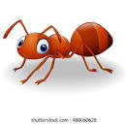
Ant Cup

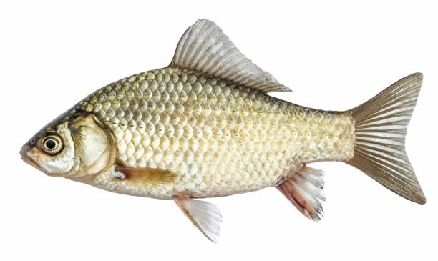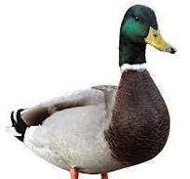
Eye Fish Duck

Q.6. Colour the following picture .


"The End"

First Terminal Examination 2081
Specification Grid
Class : Nurssery F.M. 50
Subject : English Oral P.M. 20

1. What is your name ? 5
2. Recognize the picture . 10
3. Say A-M. 13
4. Sing the rhymes. 10
5. Show the body parts name. (any 3) 6
6. In which class do you read ? 6
Second Terminal Examination 2081
Specification Grid
Class : Nurssery F.M. 50
Subject : English P.M. 20

SN | Types of questions | no. of Question | Weight | Total
1. | Copy the capital letters. (Any 10) | 10 | 1 | 10
2. | Match the following. (letter with picture) | 5 | 1 | 5
3. | Circle the same letter . | 5 | 1 | 5
4. | Circle the first letter of given picture. | 4 | 2 | 8
5. | Write A-N. | 13 | 1 | 13
6. | Copy the given word. | 2 | 2 | 4
7. | Colour the given picture. | 1 | 5 | 5
 | Total |  |  | 50

Model Questions
Second Terminal Examination 2081
Class : Nursery F.M. 50
Subject : English Written P.M. 20

Q.1. Copy the following capital letters. 10X0.5=5

M | N | O | P | Q
R | S | T | U | V

Q.2. Match the following . 5x1=5

A 
B 
C 
D 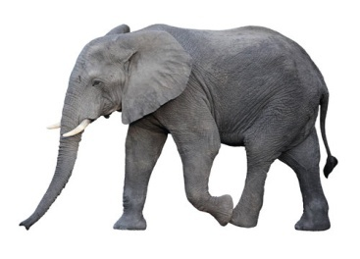
E 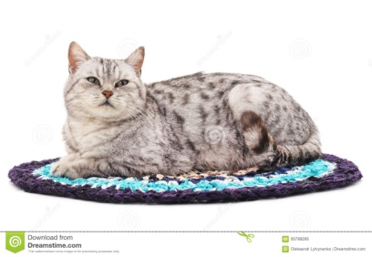

Q.3. Circle the same letters. 5x1=5

A = A B C

E = E F G

I = I J K

O = M F O

U = T U V

Q.4. Write the first letter of given . 4x2=8



…………………… ………………………


………………………… ……………………………

Q.5. Copy the given words . 2x2=4

dog | log

Q.6. Write A to N . 13

Q.7. Colour the picture . 5

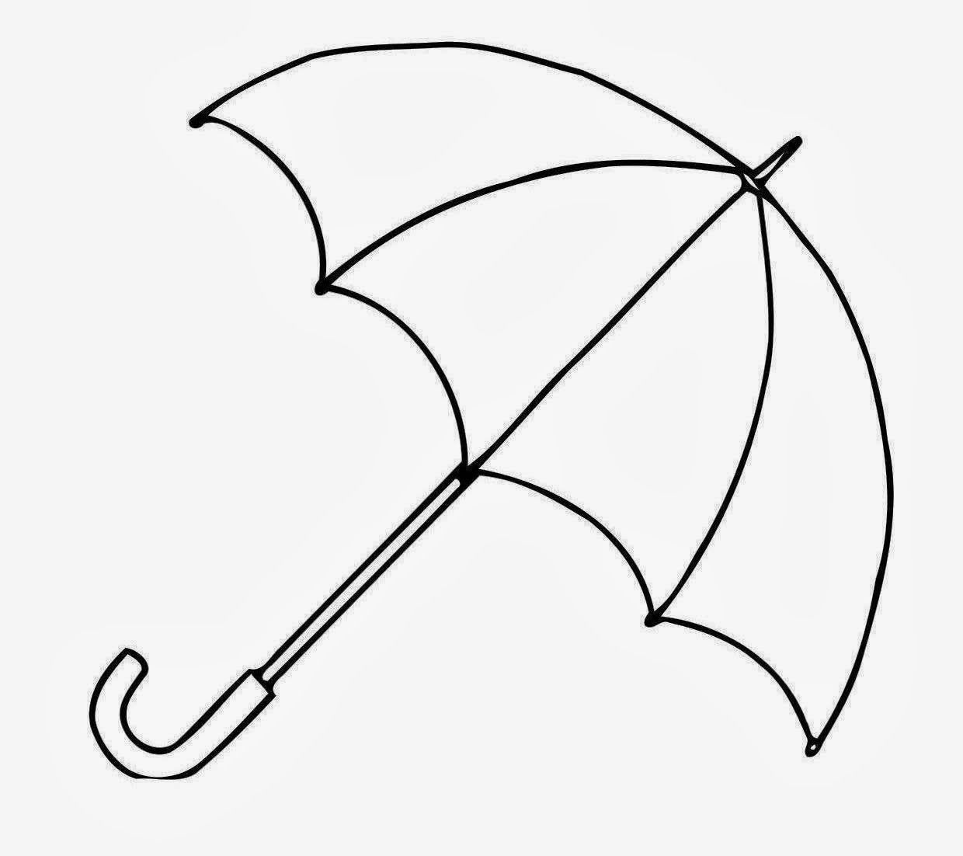

"The End"

Second Terminal Examination 2081
Specification Grid
Class : Nurssery F.M. 50
Subject : English Oral P.M. 20

1. | What is your name ? | 5
2. | In which class do you read ? | 3
3. | Say 'A' for Apple to 'z' for Zebra. | 26
4. | Recognize the picture. | 3
5. | Sing the rhymes.(English) | 5
6. | Say the days of week. | 10

Third Terminal Examination 2081
Specification Grid
Class : Nurssery F.M. 50
Subject : English P.M. 20

SN | Types of questions | no. of Question | Weight | Total
1. | Write A to z. | 26 | 0.5 | 13
2. | Copy a to z. | 26 | 0.5 | 13
3. | Name the follolwing pictures | 2 | 3 | 6
4. | Make words from given letters. (any 4) | 4 | 2 | 8
5. | Copy the following words. (any 5) | 5 | 1 | 5
6. | Colour the following picture. | 1 | 5 | 5
 | Total |  |  | 50

Model Questions
Third Terminal Examination 2081
Class : Nursery F.M. 50
Subject : English Written P.M. 20

Q.1. Write A to Z. 13

Q.2. Copy the following letter. (a to z) 13

a | b | c | d | e | f
g | h | i | j | k | l
m | n | o | p | q | r
s | t | u | v | w | x
y | z

Q.3. Name the following picture. 2x3=6
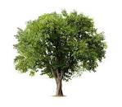
................ ................. ....................
Q.4. Make the word from given letters. 4x2=8
A =………………………….
B =……………………………
C =…………………………….
D =…………………………….

Q.5. Copy the same sentences . 5x1=5

You are my best friend.

Q.6. Colour the following picture. 5
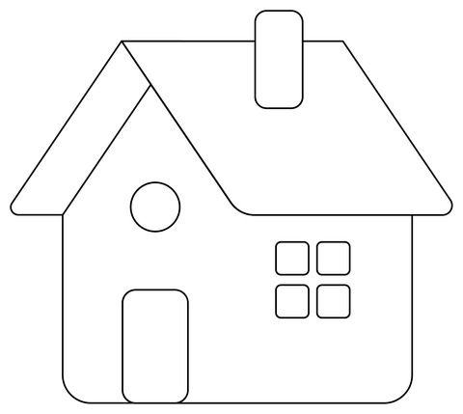

"The End"

Third Terminal Examination 2081
Specification Grid
Class : Nurssery F.M. 50
Subject : English Oral P.M. 20

1. | Answer the following question.  a. What is your name ?  b. What is your father's name ?  c. What is your mother's name ?  d. In which class do you read ? | 4x2=8
2. | Say the rhymes any 2 in english | 2x2.5=5
3. | Say 'A' to 'z' | 26x0.5=13
4. | Make words any two letters. | 2x2=4
5. | Recognize the picture. | 5x1=5
6. | Show the things in classroom. | 4x1=4
7. | Name the seven days. | 7x1=7
8. | What is your school's name ? | 1x4=4

Annual Examination 2081
Specification Grid
Class : Nurssery F.M. 50
Subject : English P.M. 20
SN | Types of questions | no. of Question | Weight | Total
1. | Write A to z. | 26 | 0.5 | 13
2. | Write a to z. | 26 | 0.5 | 13
3. | Match the following.(name with picture) | 5 | 1 | 5
4. | Make word from given letter.(any 4) | 4 | 2 | 8
5. | Name the following picture. (any 2) | 2 | 2 | 4
6. | What is your name ? | 1 | 4 | 4
7. | Colour the following picture. | 1 | 3 | 3
 | Total |  |  | 50

Model Questions
Annual Examination 2081
Class : Nursery F.M. 50
Subject : English Written P.M. 20
Q.1. Write A to Z. 26x0.5=13
Q.2. Write a to z . 26x0.5=13

Q.3. Match the following. 5x1=5

Duck 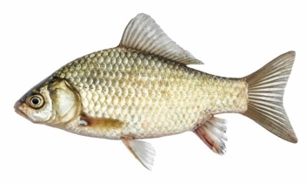
Grapes 

Fish 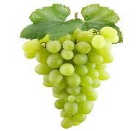
Jug 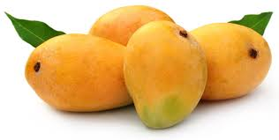
Mango 

Q.4. Make words from given letter. 4x2=8

A = …………………………

E = ………………………….

D = …………………………

I = …………………………..
Q.5. Name the following picture . 2X2=4

a.  …………………… b.  ……………………

Q.6. What is your name ? 4

Ans : My name is ………………………………………………….

Q.7. Colour the following picture. 3
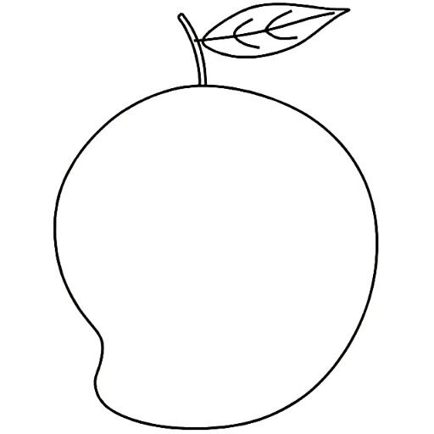

"The End "

Annual Examination 2081
Specification Grid
Class : Nurssery F.M. 50
Subject : English Oral P.M. 20

1. | Answer the following question.  a. What is your name ?  b. How old are you ?  c. Who are you ?  d. In which class do you read ?  e. Where do you live ?  f. What is your school's name ?  g. Who is your best friend ? | 7x1.5=10.5
2. | Say the rhymes in english | 1x3.5=3.5
3. | Say 'A' to 'z' | 26x1=26
4. | Recognize the capital or small letter. | 4x1=4
5. | Say the 12 month of the year/seven days. | 6

' The End '
Prepared by : Sumitra Gurung
Contact :9811910871
School : Shree Manakamana Basic School

