**Class : K.G Specification Grid F.M. : 50**

**Sub : English First Terminal Examination-2081 P.M. : 20**

|  |  |  |  |  |
| --- | --- | --- | --- | --- |
| **S.N** | **Types of questions** | **No. of questions** | **Weight** | **Total** |
| 1. | Write capital letters ( A to Z ) | 26 | 0.5 | 13 |
| 2. | Make any two words from given letters | 5 | 2 | 10 |
| 3. | Circle the vowel letters. | 5 | 1 | 5 |
| 4. | Match the following rhyming words. ex. ball, tall | 5 | 1 | 5 |
| 5. | Name the following pictures. ex. | 4 | 1 | 4 |
| 6. | Answer the following question :  i. What is your name?  Ans : My name is .........................  ii. In which class do you read?  Ans : I read in class ....................... | 2 | 2 | 4 |
| 7. | Copy the given words. ex : Apple, ball, , Cat, Dog, Eye | 5 | 1 | 5 |
| 8. | Colour the picture of 'Mango' and 'Apple' | 2 | 2 | 4 |
|  |  |  | Total | 50 |
| **Course division : Unit 1-7** | | | | |

**Class : K.G Model Questions F.M. : 50**

**Sub : English First Terminal Examination-2081 P.M. : 20**

Q.1. Write down capital letters. ( A to Z) 26x0.5=13

|  |  |  |  |  |  |  |  |  |
| --- | --- | --- | --- | --- | --- | --- | --- | --- |
|  |  |  |  |  |  |  |  |  |
|  |  |  |  |  |  |  |  |  |
|  |  |  |  |  |  |  |  |

Q.2. Make two words from given letters. 5x2=10

A = ...................., .......................

B = ...................., ........................

C = ...................., ........................

D = ...................., ........................

E = ...................., .........................

Q.3. Circle the vowel words. 5x1=5

a. apple ball

b. cat egg

c. ice dog

d. fan owl

e. uen goat

Q.4. Match the following rhyming words. 5x1=5

Man Ten

Den Pan

Ball Book

Took Call

Hive Five

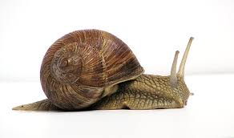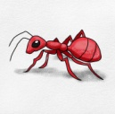Q.5. Name the following pictures. 4x1=4

.................... ................... ......................... .......................

Q.6. Answer the following question. 2x2=4

i. What is your name ?

Ans.: My name is ....................................

ii. In which class do you read ?

Ans. : I read in class ................................

Q.7. Copy the given words. 5x1=5

|  |  |  |  |  |
| --- | --- | --- | --- | --- |
| Frog | Candle | Hat | Eye | Ant |
|  |  |  |  |  |
|  |  |  |  |  |

Q.8. Colour the picture of 'Mango' and 'Apple'. 2x2=4

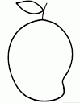

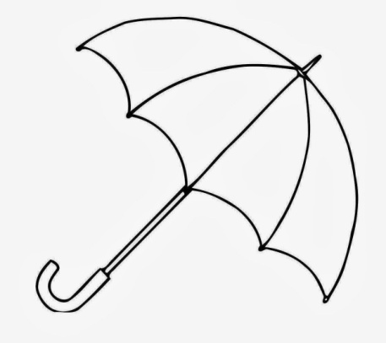

Mango Umbrella

**-The End-**

**Class : K.G Specification Grid F.M. : 50**

**Sub : English Second Terminal Examination-2081 P.M. : 20**

|  |  |  |  |  |
| --- | --- | --- | --- | --- |
| **S.N** | **Types of questions** | **No. of questions** | **Weight** | **Total** |
| 1. | Write capital letters ( A to Z ) | 26 | 0.5 | 13 |
| 2. | Name the following pictures. ex. | 5 | 1 | 5 |
| 3. | Choose the correct word from the brackets. Ex. I am ............ years old. | 5 | 1 | 5 |
| 4. | Write opposite wird. Ex. big - small | 4 | 1 | 4 |
| 5. | Write the following 'ing' add the verb. Ex. go - going | 4 | 1 | 4 |
| 6. | Match the following with vowel letters. | 4 | 1 | 4 |
| 7. | Rearrange the words. | 5 | 1 | 5 |
| 8. | Answer the following question :  i. What is your name?  Ans : My name is .........................  ii. In which class do you read?  Ans : I read in class ....................... | 2 | 3 | 6 |
| 9. | Colour the picture of 'apple' and 'ball' | 2 | 2 | 4 |
|  |  |  | Total | 50 |
| **Course division : Unit 8 - 14** | | | | |

**Class : K.G Model Questions F.M. : 50**

**Sub : English Second Terminal Examination-2081 P.M. : 20**

Q.1. Write down small letters. (a to z ) 26x0.5=13

|  |  |  |  |  |  |  |  |  |
| --- | --- | --- | --- | --- | --- | --- | --- | --- |
|  |  |  |  |  |  |  |  |  |
|  |  |  |  |  |  |  |  |  |
|  |  |  |  |  |  |  |  |

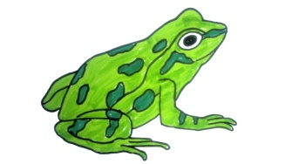Q.2. Name the following pictures. 5x1=5

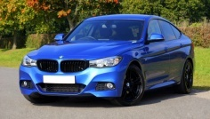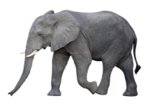

.................... ...................... ................................... ..................... ……………………………

Q.3. Choose the correct words from brackets. 5x1=5

a. Ken has a …………………. . ( men, hen)

b. The hen is Ken's …………… hen. (pet, get)

c. The hen is in the ……………. . (den, pen)

d. The hen broke it's ………… . (peg, leg)

e. Ken and Ten saw the broken ………………. leg. (pen, hen, men)

Q.4. Write opposite words. 4x1=4

a. Good = .............. b. Happy = .............. c. Boy = ............... d. In = ...................

Q.5. Write the following 'ing' add the verb. 4x1=4

a. eat = ................ b. sing = ................ c. cook = ............... d. walk = .................

Q.6. Match the following with vowel letters. 4x1=4



a

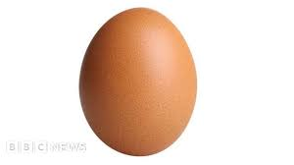

o

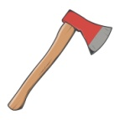

e

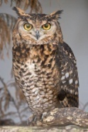

u



i

Q.7. Re-arrange the jumble words. 3x2=6

aCt - ……………. laCss - ……………….. uDck - ……………… tiKe - ………….. noiL - ………

Q.8. Answer the following question. 2x3=6

i. How old are you ?

Ans: I am .................................... years old.

ii. Is this a tree ? (yes, it is/No, it is not)

Ans : …………………………………………

iii. Is this a cup ? (yes, it is/No, it is not)

Ans : …………………………………………

Q.9. Draw the picture of Bird and colour it. 1x4=4

**"The End "**

**Class : K.G Specification Grid F.M. : 50**

**Sub : English Third Terminal Examination-2081 P.M. : 20**

|  |  |  |  |  |
| --- | --- | --- | --- | --- |
| **S.N** | **Types of questions** | **No. of questions** | **Weight** | **Total** |
| 1. | This/That | 5 | 2 | 10 |
| 2. | Make any three words from given sound. Ex. B = Ball, Bus, Bird Rhyming | 2 | 2 | 4 |
| 3. | Choose the correct words. | 5 | 1 | 5 |
| 4. | Match the oppositre words. | 5 | 1 | 5 |
| 5. | Make sentences using I. ex. I am a boy | 5 | 1 | 5 |
| 6. | Look at the pictures and write their  names. ex. house | 6 | 1 | 6 |
| 7. | Give your introduction.  My name is........................  I read in class ......................  I live in .................  I am ............... years old.  Our school's name is ..................... | 5 | 2 | 10 |
| 8. | Colour the picture of 'Umbrella' and 'Apple'. | 2 | 2.5 | 5 |
|  |  |  | Total | 50 |
| **Course division : Unit 15 -19** | | | | |

**Class : K.G Model Questions F.M. : 50**

**Sub : English Third Terminal Examination-2081 P.M. : 20**

Q.1. Write down 'This' or 'That'. 5x2=10

a. …………………….. is an apple.



b. …………………. is the star.



c. ………………… is the Sun.



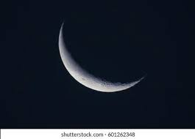d. ………………. is a pen .

e. ……………….. is the Moon.

Q.2. Write down any two rhyming words. 2x2=4

Cat = .................... ......................

Look = ................... ......................

Q.3. Choose the correct words from brackets. 5x1=5

a. I ........... food. ( eat, it )

b. Monkey has a long…………………….. . (tale, tail)

c. I am going ……………….. school. (two, to)

d. The ……………….. is hot. (Son, Sun)

e. I can …………… with my eyes. (see, she)

Q.4. Match with opposite words. 5x1=5

Day Down

Up Out

White Night

In Black

Near Far

Q.5. Make sentences using 'I am'. 5x1=5

boy -

student-

girl-

driver-

teacher-

Q.6. Name the following pictures. 6x1=6

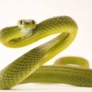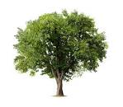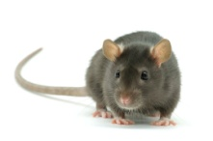

.................... ...................... ...................... ................... ..................... ……………

Q.7. Give your introduction. 5x2=10

a) My name is ....................

b) I read in class .........................

c)I live in ....................

d) I am .............. years old.

e) Our school's name is ............................

Q.8. Draw the picture of 'an apple' and 'an umbrella'. 1x3=3

"The End "

**Class : K.G Specification Grid F.M. : 50**

**Sub : English Annual Examination-2081 P.M. : 20**

|  |  |  |  |  |
| --- | --- | --- | --- | --- |
| **S.N** | **Types of questions** | **No. of questions** | **Weight** | **Total** |
| 1. | Look at the pictures and give ( ) and (x) | 5 | 1 | 5 |
| 2. | Write in, on and under. | 5 | 1 | 5 |
| 3. | Write the name of seven days. | 7 | 1 | 7 |
| 4. | Match and write sentences. | 5 | 2 | 10 |
| 5. | Complete the answer : Yes, I am.  No, I am not. | 5 | 1 | 5 |
| 6. | Tick the best answer. | 5 | 1 | 5 |
| 7. | Copy the polite sentences. | 1 | 3 | 3 |
| 8. | Name the pictures. (Shape) | 5 | 1 | 5 |
| 9. | What Should you do ? | 1 | 5 | 5 |
|  |  |  |  |  |
|  |  |  | Total | 50 |
| **Course division : Unit 20 -25** | | | | |

**Class : K.G Model Questions F.M. : 50**

**Sub : English Annual Examination-2080 P.M. : 20**

Q.1. Look at the pictures and read sentences than give ( √ ) or ( x) . 5x1=5

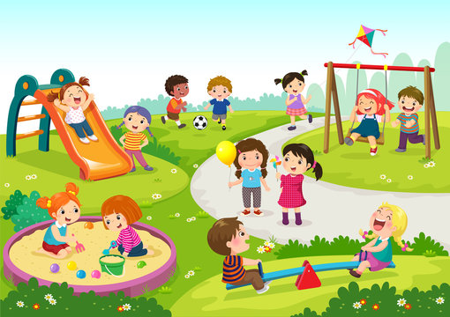

a. Children are playing.

b. Flowers are blooming.

c. Childern are very sad.

d. There is a ball .

e. There is a big kite.

Q.2. Write down in, on and under. 5x1=5

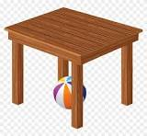

a. The ball is …………… the table.

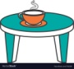

b. The cup is ………….. the table.

c. The water is …………….. the glass.

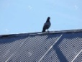d. Bird is sitting ……………. the roof.

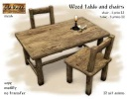

e. Candle is ……………. the table.

Q.3. Write the name of seven days. 7x1=7

........................ ............................. ............................. ........................

........................ ............................. .............................

Q.4. Match the folowing oppositewords. 5x2=10

We live book.

We go in Nepal

We eat a song

We sing to school

We read food

1. ………………………………………………………………
2. ……………………………………………………………….
3. ……………………………………………………………….
4. ……………………………………………………………….
5. ……………………………………………………………….

Q.5. Complete the answer write Yes, I am or No, I am not. 5x1=5. Are you a boy ? ……………………….

Are you a girl ? …………………………

Are you a student ? …………………….

Are you a teacher ? …………………….

Are you a father ? ………………………

Q.6. Tick the best answer (Do or Don't) . 5x1=5

a. (Do / Don't) tell lies.

b. (Do / Don't) your work ?

c. (Do / Don't) your classwork ?

d. (Do / Don't) fight with friends.

e. (Do / Don't) you love me ?

Q.7. Copy the polite sentences. 3x1=3

May I come in, please ?

……………………………………

…………………………………..

……………………………………

Q.8. Name the shapes. 5x1=5

………………………….. ………………………….. ………………….. ……………………… ……………….

Q.9. What should you do ? 5x1=5

a. Trim your ………………… . (nail, hair)

b. Brush your……………… . (teeth, face)

c. Comb your ………………. .( hair, hand)

d. Wash your ……………….. (face, floor)

e. Read your …………………. (book, look)

**"The End "**

**Prepared By : Gita Bhusal**

**Contact no. : 9815148351**

**School : Shree Manakamana Basic School, Devchuli-9, Milantole**