**Class : K.G Specification Grid F.M. : 50**

**Sub : Surrounding First Terminal Examination-2081 P.M. : 20**

|  |  |  |  |  |
| --- | --- | --- | --- | --- |
| **S.N** | **Types of questions** | **No. of questions** | **Weight** | **Total** |
| 1. | Write the name of five sense organs . | 5 | 1 | 5 |
| 2. | Write the name of five family members | 5 | 1 | 5 |
| 3. | Write the name of five living things. | 5 | 1 | 5 |
| 4. | Write the name of five wild animals. | 5 | 1 | 5 |
| 5. | Tick the big plants and cross the small  plants. | 3 | 2 | 6 |
| 6. | Fill in the blanks. | 5 | 1 | 5 |
| 7. | Write yes/no. | 5 | 1 | 5 |
| 8. | Match the following picture with their name. | 5 | 1 | 5 |
| 9. | Write 'L' for living and 'N' for non-living things. | 5 | 1 | 5 |
| 10. | Draw and colour the pictures of Grapes. | 4 | 1 | 4 |
|  |  |  | Total | 50 |
|  | | | | |

**Model Questions**

**Class : K.G First Terminal Examination-2081 F.M. : 50**

**Sub : Surrounding Time : 2 hrs. P.M. : 20**

Q.1.Write the name of any five sense organs. 5x1=5

........................... .............................. ................................

............................ ..............................

Q.2. Write the name of any five family members . 5x1=5

........................... .............................. ............................ ............................ ...........................

Q.3. Write the name of any five living things. 5x1=5

............................ ......................... ................................ ...................... ..............................

Q.4. Write the name of any five wild animals. 5x1=5

............................ .............................. ............................... ........................... ..............................

Q.5. Tick the big plants and cross the small plants. 3x2=6

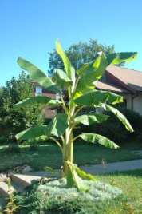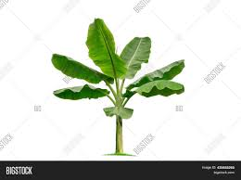

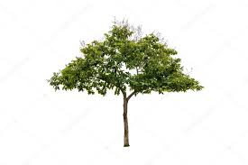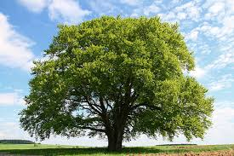

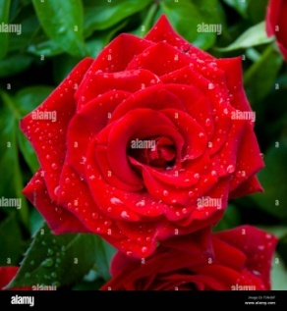

Q.6. Fill in the blanks. 5x1=5

a. N ………….. s ………… b. B ………….. g c. C ……… p d. A ……… p…….. e e. E ………. e

Q.7. Write Yes / No. 5x1=5

a. Cat is a non-living things.

b. Lion is a wild animal .

c. Parrot is a bird.

d. Fish is a domestic animal.

e. Eagle is a bird.

Q.8.Match the followimg picture with their name. 5x1=5

Carrot

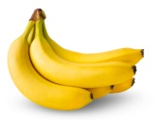

Bag

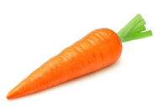

Banana



Rabbit

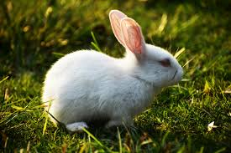

Mouth

Q.9. Write 'L' for living and 'N' for non-living things. 5x1=5

Pig = [ ] Cow = [ ] Tiger = [ ] chair = [ ] stone = [ ]

Q.10. Draw and colour the pictures of Fish. 1x5=5

**-THE END-**

**Class : K.G Specification Grid F.M. : 50**

**Sub : Surrounding Second Terminal Examination-2081 P.M. : 20**

|  |  |  |  |  |
| --- | --- | --- | --- | --- |
| **S.N** | **Types of questions** | **No. of questions** | **Weight** | **Total** |
| 1. | Write the name of five fruits. | 5 | 1 | 5 |
| 2. | Write about yourself. | 5 | 1 | 5 |
| 3. | Write the name of following parts of plants. | 5 | 1 | 5 |
| 4. | Write the name of five food. | 5 | 1 | 5 |
| 5. | Write Yes or No. | 5 | 1 | 5 |
| 6. | Cross the odd one. | 5 | 1 | 5 |
| 7. | Match the following picture with their name. | 5 | 1 | 5 |
| 8. | Fill in the blanks with missing letters. | 5 | 1 | 5 |
| 9. | Write 'D' for domestic and 'W' for wild animals. | 5 | 1 | 5 |
| 10. | Draw and colour the pictures of Flower and bird. | 2 | 2.5 | 5 |
|  |  |  | Total | 50 |
|  | | | | |

**Model Questions**

**Class : K.G Second Terminal Examination-2081 F.M. : 50**

**Sub : Surrounding Time : 2 hrs. P.M. : 20**

Q.1. Write the name of any five fruits. 5x1=5

......................... ........................... .......................... ........................... ...................

Q.2. Write about yourself. 5x1=5

My name is .......................................

I read in class ....................................

I am .............................. years old.

I live in ...........................

I am a ...............................................

Q.3. Write the name of following parts. 5x1=5

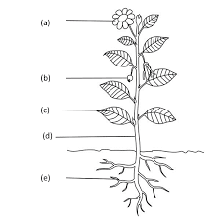

Q.4. Write the name of any five foods. 5x1=5

........................ .......................... ............................ ......................... ...........................

Q.5. Write Yes/No. 5x1=5

a. Ant is an insect. [ ]

b. Lotus is a fruit. [ ]

c. Buffalo is a domestic animal.[ ]

d. Rice is a meals. [ ]

e. Starfish is a wild animal. [ ]

Q.6. Cross the odd one. 5x1=5

a. Ant Spider Bee Mango

b. Fish Pig Whale Shark

c. Mango Papaya Dog Banana

d. Rose Lily Lotus Fish

e. Rose Bread Meat Milk

Q.7. Match the followimg picture with their name. 5x1=5



Mango

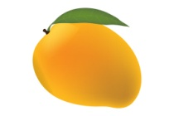

Glass

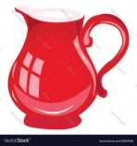

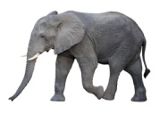 Flower

Jug

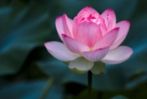

Elephant

Q.8. Fill in the blanks with missing letter. 5x1=5

a. S ....... i ........ b. P....... g c. F ........ o ……….. e …………. d. S....... a ...... e. L ...... g

Q.9. Write 'D' for domestic and 'W' for wild animals. 5x1=5

Buffalo = [ ] Lion = [ ] Goat = [ ]

Monkey = [ ] Fox = [ ]

Q.10. Draw and colour the pictures of House and Tree. 2x2.5=5

**-THE END-**

**Class : K.G Specification Grid F.M. : 50**

**Sub : Surrounding Third Terminal Examination-2081 P.M. : 20**

|  |  |  |  |  |
| --- | --- | --- | --- | --- |
| **S.N** | **Types of questions** | **No. of questions** | **Weight** | **Total** |
| 1. | Write any five good habits . | 5 | 1 | 5 |
| 2. | Write the name of five parts of body. | 5 | 1 | 5 |
| 3. | Write the name of five outdoor games. | 5 | 1 | 5 |
| 4. | Write the name of five vegetables. | 5 | 1 | 5 |
| 5. | Write Yes or No. | 5 | 1 | 5 |
| 6. | Cross out the odd one. | 5 | 1 | 5 |
| 7. | Match the following picture with their name. | 5 | 1 | 5 |
| 8. | Name the following pictures. | 5 | 1 | 5 |
| 9. | Add one more. | 5 | 1 | 5 |
| 10. | Draw a pictures of Umbrella. | 1 | 5 | 5 |
|  |  |  | Total | 50 |
|  | | | | |

**Model Questions**

**Class : K.G Third Terminal Examination-2081 F.M. : 50**

**Sub : Surrounding Time : 2 hrs. P.M. : 20**

Q.1. Write any five good habits . 5x1=5

..................... ...................... ...................................................... .....................

Q.2. Write the name of any five parts of body. 5x1=5

...................... ........................ ......................... ..................... ........................

Q.3. Write the name of any five outdoor games. 5x1=5

..................... .......................... .......................... ..................... .......................

Q.4. Write the name of any five vegetables. 5x1=5

....................... ........................ .......................... ........................ .......................

Q.5. Write Yes/No. 5x1=5

a. Pumpkin is a fruit. [ ]

b. Hen is a domestic animal. [ ]

c. Lotus is a flower. [ ]

d. Dog gives us egg . [ ]

e. Water and milk are liquid. [ ]

Q.6. Cross the odd one. 5x1=5

a. Water Milk Juice Head

b. Apple Bus Car Jeep

c. Aeroplane Dog Rocket Train

d. Bee Ball Ant Butterfly

e. Pumpkin Carrot Fish Potato

Q.7.Match the followimg picture with their name. 5x1=5



Rat



Umbrella

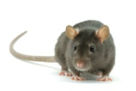

Book



Sun



House

Q.8. Name the following pictures. 5x1=5

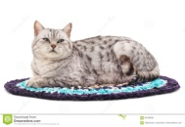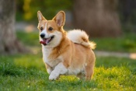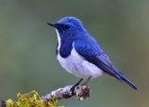

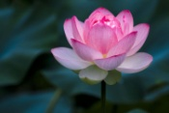

..................... ...................... .................... ..................... .......................

Q.9. Add one more. 5x1=5

a. Rose Lotus Marigold .................

b. Fish Whale Shark .................

c. Cow Dog Sheep .................

d. Ant Housefly Butterfly .................

e. Parrot Peacock Dove .................

Q.10. Draw a pictures of Mango. 1x5=5

**-The End-**

**Class : K.G. Specification Grid F.M. : 50**

**Sub : Surrounding Annual Examination-2081 P.M. : 20**

|  |  |  |  |  |
| --- | --- | --- | --- | --- |
| **S.N** | **Types of questions** | **No. of questions** | **Weight** | **Total** |
| 1. | Write the name any five communication. | 5 | 1 | 5 |
| 2. | Write the name of five non-living things/tools | 5 | 1 | 5 |
| 3. | Write the name of five festivals. | 5 | 1 | 5 |
| 4. | Write the name of any five clothes. | 5 | 1 | 5 |
| 5. | Write the name of following pictures. | 5 | 1 | 5 |
| 6. | Match the following picture with their name. | 5 | 1 | 5 |
| 7. | Cross out the odd one. | 5 | 1 | 5 |
| 8. | Write Yes or No. | 5 | 1 | 5 |
| 9. | Add one more. | 5 | 1 | 5 |
| 10. | Draw and colour the picture. | 1 | 5 | 5 |
|  |  |  | Total | 50 |
|  | | | | |

**Model Questions**

**Class : K.G Annual Examination-2081 F.M. : 50**

**Sub : Surrounding Time : 2 hrs. P.M. : 20**

Q.1. Write the name of any five communication. 5x1=5

....................... ........................... ....................... ........................ .........................

Q.2. Write the name of any five non-living things/ tools. 5x1=5

........................ ........................... ........................... ......................... ........................

Q.3. Write the name of any five festivals. 5x1=5

....................... ........................ ............................. ...................... .......................

Q.4. Write the name of any five clothes. 5x1=5

........................ ...................... ....................... ...................... ........................

Q.5. Name the following pictures.

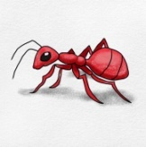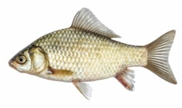

..................... ...................... .................... ..................... .......................

Q.6.Match the followimg picture with their name. 5x1=5

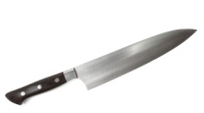

Pineapple



Knife

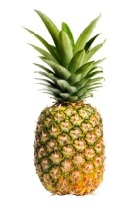

Star



Butterfly

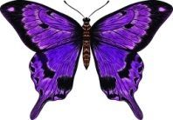

Pen

Q.7. Cross out the odd one. 5x1=5

a. Tree Stone Pig Cat

b. Potato Tomato Cauliflower Apple

c. Rose Banana Lotus Lily

d. House Fan Tree Book

e. Dashain Goat Tihar Teej

Q.8. Write Yes/No. 5x1=5

a. Lion is a living thing. [ ]

b. We use water for drinking. [ ]

c. Red light says stop. [ ]

d. Dolphin is a wild animal. [ ]

e. Cabbage is a fruit. [ ]

Q.9. Add one more. 5x1=5

a. Cricket Football Volleyball .................

b. Dashain Tihar Teej .................

c. Flower Leaf Stem .................

d. Book Pen House .................

e. Tiger lion Monkey .................

Q.10. Draw and colour the picture of Ball. 1x5=5

**-The End-**

Prepared By : Soniya Bache

Contact : 9811545643

School : Shree Manakamana Basic School