**Class : K.G Specification Grid F.M. : 50**

**Sub : Theme First Terminal Examination-2081 P.M. : 20**

|  |  |  |  |  |
| --- | --- | --- | --- | --- |
| **S.N** | **Types of questions** | **No. of questions** | **Weight** | **Total** |
| 1. | Choose the best answer. | 5 | 1 | 5 |
| 2. | Name the following pictures. | 5 | 1 | 5 |
| 3. | Match the words with pictures. | 5 | 1 | 5 |
| 4. | Fill in the blanks with missing letters. | 5 | 1 | 5 |
| 5. | Circle the odd one. | 5 | 1 | 5 |
| 6. | Re-arrange the jumbled words. | 5 | 1 | 5 |
| 7. | Write the name of five parts of body. | 5 | 1 | 5 |
| 8. | Write 'L' for living things and 'N' for non-living things. | 5 | 1 | 5 |
| 9. | Answer the following questions. | 1 | 5 | 5 |
| 10. | Draw and colour the pictures of Fish | 1 | 5 | 5 |
|  |  |  | Total | 50 |
| **Course division : Lesson 1 : 1.1, 1.2, 1.3**  **Lesson 2 : 2.1, 2.2, 2.3**  **Lesson 5 : 5.1, 5.2** | | | | |
|  | | | | |

**Model Questions**

**Class : K.G First Terminal Examination-2081 F.M. : 50**

**Sub : Theme Time : 2 hrs. P.M. : 20**

1. Choose the best answer. 5x1=5

a. We see with our ……………………….. . (eye, nose)

b. I live in a ………………. (friends, family)

c. A teacher teaches in a ………….. (school, hospital)

d. …………… is a living thing. (Cow, Book)

e. …………… is non living thing. (Dog, Pen)

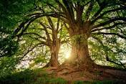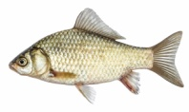2. Name the following pictures. 5x1=5

………….. ………………… ………………. …………………….. …………………..

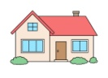3. Match the words with pictures. 5x1=5

Cat

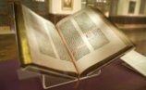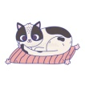House

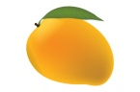 Nose

Book

Mango 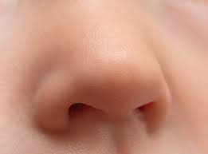

4. Fill in the blanks with missing lettes. 5x1=5

a. E ………… r b. P ………. n c. D …….. g d. B ……. s e. L ……. g

5. Circle the odd one. 5x1=5

a. Cat Dog Pig Ball

b. Pen Book House Cow

c. Nose Ear Tree Eye

d. Father Car Mother Aunt

e. Apple Mango Orange Potato

6. Re- arrange the jumbled words. 5x1=5

a. ookB - …………….. b. lepAp - ………………….. c. atC - …………….

d. raE- ………………… e. Bga - ………………

7. Write 'L' for living things and 'N' for non living things. 5x1=5

a. Cow- …………… b. Umbrella - ……….. c. Cup - ………….. d. Bird - ……….. e. Ant - ………

8. Write the name of five parts of body. 5x1=5

a. …………………………. b. ……………………………. c. …………………………………

d. …………………………… e. ……………………………..

9. Answer the following questions. 2x2.5=5

a. What is your name ?

Ans : My name is ………………………………………………………….

b. Who are you ?

Ans : I am ………………………………………………………….

10. Draw and colour the pictures of Fish. 1x5=5

**-THE END-**

**Class : K.G Specification Grid F.M. : 50**

**Sub : Theme Second Terminal Examination-2081 P.M. : 20**

|  |  |  |  |  |
| --- | --- | --- | --- | --- |
| **S.N** | **Types of questions** | **No. of questions** | **Weight** | **Total** |
| 1. | Choose the best answer. | 5 | 1 | 5 |
| 2. | Name the following pictures. | 5 | 1 | 5 |
| 3. | Match the following pictures with their name. | 5 | 1 | 5 |
| 4. | Write Yes or No. | 5 | 1 | 5 |
| 5. | Cross out the odd one. | 5 | 1 | 5 |
| 6. | Re-arrange the jumbled words. | 5 | 1 | 5 |
| 7. | Fill in the blanks with missing letters. | 5 | 1 | 5 |
| 8. | Write the name of five fruits / vegetables. | 5 | 1 | 5 |
| 9. | Write the name of five festivals. | 1 | 5 | 5 |
| 10. | Name the following parts of plant. | 1 | 5 | 5 |
|  |  |  | Total | 50 |
| **Course division : Lesson 3 : 3.1, 3.2**  **Lesson 5 : 5.1, 5.2, 5.3, 5.4, 5.5** | | | | |
|  | | | | |

**Model Questions**

**Class : K.G Second Terminal Examination-2081 F.M. : 50**

**Sub : Theme Time : 2 hrs. P.M. : 20**

1. Choose the best answer. 5x1=5

a. I love my ………………………… . ( insects, parents)

b. I help my ………………………… . (book, friends)

c. I do my …………………………… . (work, ballon)

d. I respect my …………………… . (family, trees)

e. I comb my ……………………... . (hair, nose)

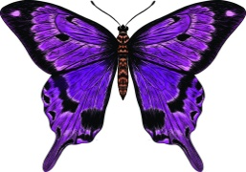2. Name the following pictures. 5x1=5

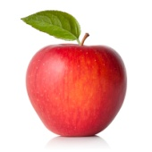

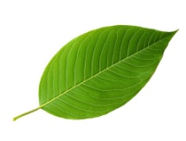

………………….. …………………….. …………………… ………………… …………….

3. Match the following pictures. 5x1=5

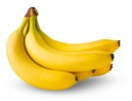

Tomato

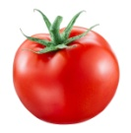

Banana



Book

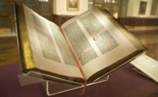 Dog

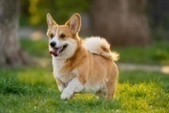

Tree

4. Write 'Yes' or 'No'. 5x1=5

a. Is a bus living thing ?

b. Is a potato vegetable ?

c. Is a banana fruit ?

d. I wash my face.

e. Is a cow non-living thing ?

5. Circle the odd one . 5x1=5

a. Potato Tomato Papaya Chilli

b. Apple Grapes Carrot Guava

c. Well Air Tap River

d. Tiger Rose Lotus Marigold

e. Ball Pen Book Dog

6. Re- arrange the jumbled words. 5x1=5

a. goD - ……… b. naF - ……………. c. seoN - …….. d. ngmao- …… e. seor - ……….

7. Fill in the blanks with missing letters. 5x1=5

a. L …….. t …….. s b. P …….. n …….. c. T ….. e….. d. M …… n……o e. T ….. m …. to

8. Write the name of five fruits. 5x1=5

a. ………………………….. b. ……………………………….. c. ………………………………

d. …………………………… e. …………………………………

9. Write the name of five festivals. 5x1=5

a. ……………………………. b. ………………………………….. c. ………………………………..

d. …………………………… e. …………………………………..

10. Write the name of following parts. 5x1=5

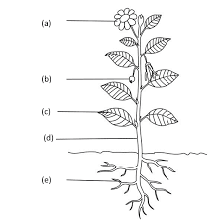

**'The End '**

**Class : K.G Specification Grid F.M. : 50**

**Sub : Theme Third Terminal Examination-2081 P.M. : 20**

|  |  |  |  |  |
| --- | --- | --- | --- | --- |
| **S.N** | **Types of questions** | **No. of questions** | **Weight** | **Total** |
| 1. | Write the name of five domestic animals. | 5 | 1 | 5 |
| 2. | Name the following pictures. | 5 | 1 | 5 |
| 3. | Match the following pictures with their name. | 5 | 1 | 5 |
| 4. | Circle the odd one. | 5 | 1 | 5 |
| 5. | Add one more. | 5 | 1 | 5 |
| 6. | Fill in the blanks with missing letters. | 5 | 1 | 5 |
| 7. | Write the name of five clothes. | 5 | 1 | 5 |
| 8. | Write 'Yes' or 'No' . | 5 | 1 | 5 |
| 9. | Write 'D' for domestic and 'W' for wild animals. | 5 | 1 | 5 |
| 10. | Write the time. | 1 | 2.5 | 2.5 |
| 11. | Draw and colour the picture. | 1 | 2.5 | 2.5 |
|  |  |  | Total | 50 |
| **Course division : Lesson 4 : 4.1, 4.2**  **Lesson 5 : 5.6, 5.7, 5.8, 5.9, 5.10, 5.11** | | | | |
|  | | | | |

**Model Questions**

**Class : K.G Third Terminal Examination-2081 F.M. : 50**

**Sub : Theme Time : 2 hrs. P.M. : 20**

1. Write the name of five domestic animals. 5x1=5

a. …………………….. b. ……………………… c. …………………….. d. ……………….. e. …………

2. Name the following pictures. 5x1=5

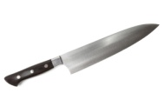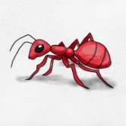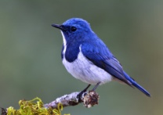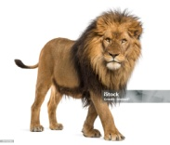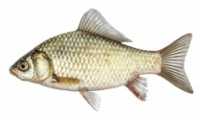

……………………. ………………… ……………………………. ……………….. …………………

3. Match the following pictures. 5x1=5

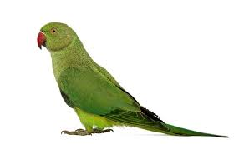

Dog

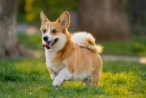

Parrot

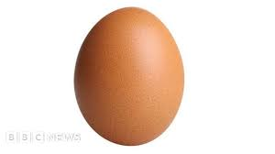

Butterfly

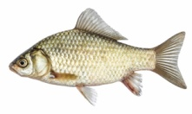

Egg

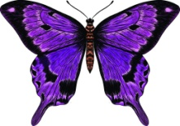

Fish

4. Cross out the odd one. 5x1=5

a. Cat Dog Pig Tiger

b. Fish Lion Whale Starfish

c. Ant Bee Parrot Spider

d. Monkey Tiger Lion Horse

e. Sunny Rainy Windy Sky

5. Add one more. 5x1=5

a. Pond River Lake .................

b. Fish Whale Shark .................

c. Parrot Peacock Dove.................

d. Ant Spider Wasp.................

e. Cow Buffalo Dog .................

6. Fill in the missing letters. 5x1=5

a. C ……… o …….. b. S …… a …… e c. S …… n ….. y d. R ……. c ……. e. S ….. i …..t

7. Write the name of five clothes. 5x1=5

a. ………………… b. …………………… c. …………………… d. ……………….. e. ……………………..

8. Write 'Yes' or 'No'. 5x1=5

a. Table is a living thing.

b. I am a non living thing.

c. We see with our eye.

d. We need water for cooking.

e. Cow is a domestic animal.

9. Write 'D' for domestic and 'W' for wild animals. 5x1=5

a. Horse - b. Tiger- c. Giraffe - d. Pig - e. Sheep -

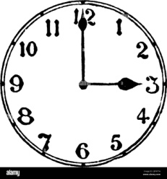10. Write the time . 1x2.5=2.5

……………………… o'clock.

10. Draw and colour the picture of Butterfly. 1x2.5=2.5

**-The End-**

**Class : K.G. Specification Grid F.M. : 50**

**Sub : Theme Annual Examination-2081 P.M. : 20**

|  |  |  |  |  |
| --- | --- | --- | --- | --- |
| **S.N** | **Types of questions** | **No. of questions** | **Weight** | **Total** |
| 1. | Write the name of four transportation. | 4 | 1 | 4 |
| 2. | Write the name of four means of communication. | 4 | 1 | 1 |
| 3. | Choose the best answer. | 4 | 1 | 4 |
| 4. | Name the following pictues. | 4 | 1 | 4 |
| 5. | Match the following picture with their name. | 5 | 1 | 5 |
| 6. | Cross out the odd one. | 5 | 1 | 5 |
| 7. | Write the name of 4 non living things. | 4 | 1 | 4 |
| 8. | Write Yes or No. | 4 | 1 | 4 |
| 9. | Add one more. | 4 | 1 | 4 |
| 10. | Re-arrange the jumbled words. | 4 | 1 | 4 |
| 11. | Write 'L' for Land vehicle and 'A' for Air vehicle. | 5 | 1 | 5 |
| 12. | Colour the traffic lights. | 1 | 3 | 3 |
|  |  |  | Total | 50 |
| **Course division : Lesson 6- 6.1,6.2**  **Lesson 7- 7.1,7.2,7.3,7.4**  **Lesson 8- 8.1** | | | | |

**Model Questions**

**Class : K.G Annual Examination-2081 F.M. : 50**

**Sub : Theme Time : 2 hrs. P.M. : 20**

Q.1. Write the name of four transportation. 4x1=4

........................... .............................. ................................ ............................ Q.2. Write the name of any four means of communication. 4x1=4

........................... .............................. ................................ ............................

Q.3. Choose the best answer. 4x1=4

a. The sun is ………………….. . (hot, cold)

b. ……………. is an insect. (Ant, Owl)

c. Buffalo is a …………… animal . (domestic, wild )

d. ……………….. is a fruit. (Mango, Chilli )

Q.4. Name the following pictures. 4x1=4

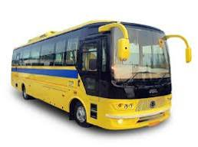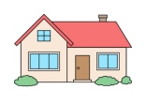



……………….. ……………….. ……………………. …………………

Q.5. Match the followimg picture with their name. 5x1=5



Umbrella



Pencil

Monkey 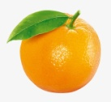

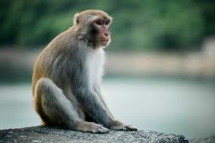 Eye

 Orange

Q.6.Cross out the odd one. 5x1=5

a. Dancing Drinking Washing Bathing

b. Bus Car Jeep Cat

c. Madal Damaru Tabala Tap

d. Cow Eye Nose Ear

e. Pen Ball Book Bird

Q.7. Write the name of four non-living things. 4x1=4

………………….. ……………………. …………………….. …………………….

Q.8. Write Yes/No. 4x1=4

a. Tomato is a fruit. [ ]

b. Goat is a domestic animal. [ ]

c. Lotus is a flower. [ ]

d. The baby of dog is called puppy. [ ]

Q.9. Re-arrange the jumbled words. 4x1=4

a. owcr - …………….. b. oved - ……………….. c. low - d. udck - …………….

Q.10. Write 'L' for Land vehicle and 'A' for Air vehicle. 1x5=5

a. Bus - b. Aeroplane - c. Car - d. helicopter - e. Jeep -

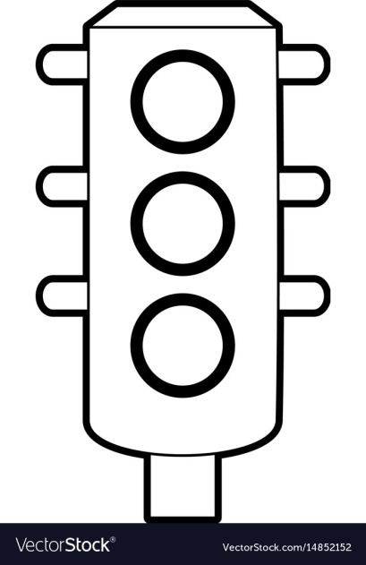11. Colour the traffic lights. 1x3=3

**-The End-**

Prepared by : Nanimaya Sinjali

Contact : 9847073028

School : Shree Manakamana Basic School