**First Terminal Examination 2081**

**Specification Grid**

Class : Nurssery F.M. 50

Subject : English P.M. 20

|  |  |  |  |  |
| --- | --- | --- | --- | --- |
| S.N | Types of questions | no. of Question | Weight | Total |
| 1. | Copy the capital letters. (Any 10) | 10 | 1 | 10 |
| 2. | Copy the small letters. (any 5) | 5 | 1 | 5 |
| 3. | Match the following. (letter to letter) | 5 | 1 | 5 |
| 4. | Circle the same letter . | 5 | 2 | 10 |
| 5. | Circle the first letter of given picture. | 5 | 2 | 10 |
| 6. | Colour the following picture. | 2 | 5 | 10 |
|  | Total |  |  | 50 |

**Model Questions**

**First Terminal Examination 2081**

Class : Nursery F.M. 50

Subject : English Written P.M. 20

Q.1. Copy the capital letters. 10

|  |  |  |  |  |
| --- | --- | --- | --- | --- |
| A | B | C | D | E |
|  |  |  |  |  |
| F | G | H | I | J |
|  |  |  |  |  |

Q.2. Copy the small letter. 5

|  |  |  |  |  |
| --- | --- | --- | --- | --- |
| a | b | c | d | e |
|  |  |  |  |  |

Q.3. Match the following. 5x1=5

A B

B C

C A

D E

E D

Q.4. Circle the same letter. 5x2=10

A = A B C

B = A B C

C = B C D

D = D E F

E = E F G

Q.5. Circle the first letter of given picture . 5X2=10

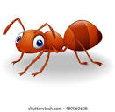 

Ant Cup

 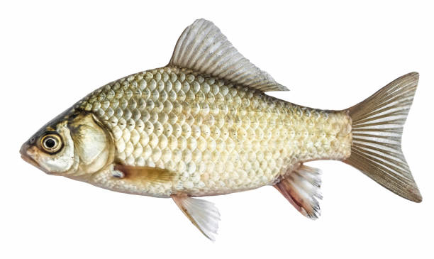 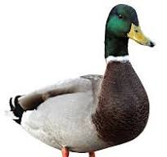

Eye Fish Duck

Q.6. Colour the following picture .



"The End"

**First Terminal Examination 2081**

**Specification Grid**

Class : Nurssery F.M. 50

Subject : English Oral P.M. 20

1. What is your name ? 5

2. Recognize the picture . 10

3. Say A-M. 13

4. Sing the rhymes. 10

5. Show the body parts name. (any 3) 6

6. In which class do you read ? 6

**Second Terminal Examination 2081**

**Specification Grid**

Class : Nurssery F.M. 50

Subject : English P.M. 20

|  |  |  |  |  |
| --- | --- | --- | --- | --- |
| SN | Types of questions | no. of Question | Weight | Total |
| 1. | Copy the capital letters. (Any 10) | 10 | 1 | 10 |
| 2. | Match the following. (letter with picture) | 5 | 1 | 5 |
| 3. | Circle the same letter . | 5 | 1 | 5 |
| 4. | Circle the first letter of given picture. | 4 | 2 | 8 |
| 5. | Write A-N. | 13 | 1 | 13 |
| 6. | Copy the given word. | 2 | 2 | 4 |
| 7. | Colour the given picture. | 1 | 5 | 5 |
|  | Total |  |  | 50 |

**Model Questions**

**Second Terminal Examination 2081**

Class : Nursery F.M. 50

Subject : English Written P.M. 20

Q.1. Copy the following capital letters. 10X0.5=5

|  |  |  |  |  |
| --- | --- | --- | --- | --- |
| M | N | O | P | Q |
|  |  |  |  |  |
| R | S | T | U | V |
|  |  |  |  |  |

Q.2. Match the following . 5x1=5

A 

B 

C 

D 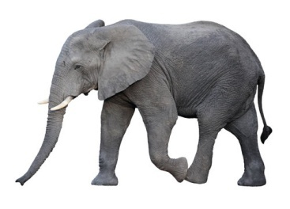

E 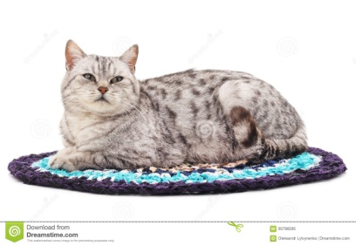

Q.3. Circle the same letters. 5x1=5

A = A B C

E = E F G

I = I J K

O = M F O

U = T U V

Q.4. Write the first letter of given . 4x2=8

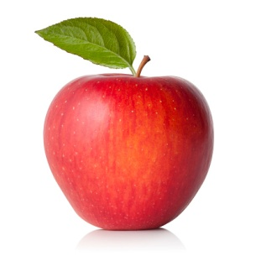 

…………………… ………………………

 

………………………… ……………………………

Q.5. Copy the given words . 2x2=4

|  |  |
| --- | --- |
| dog | log |
|  |  |
|  |  |

Q.6. Write A to N . 13

|  |  |  |  |  |  |  |
| --- | --- | --- | --- | --- | --- | --- |
|  |  |  |  |  |  |  |
|  |  |  |  |  |  |  |

Q.7. Colour the picture . 5

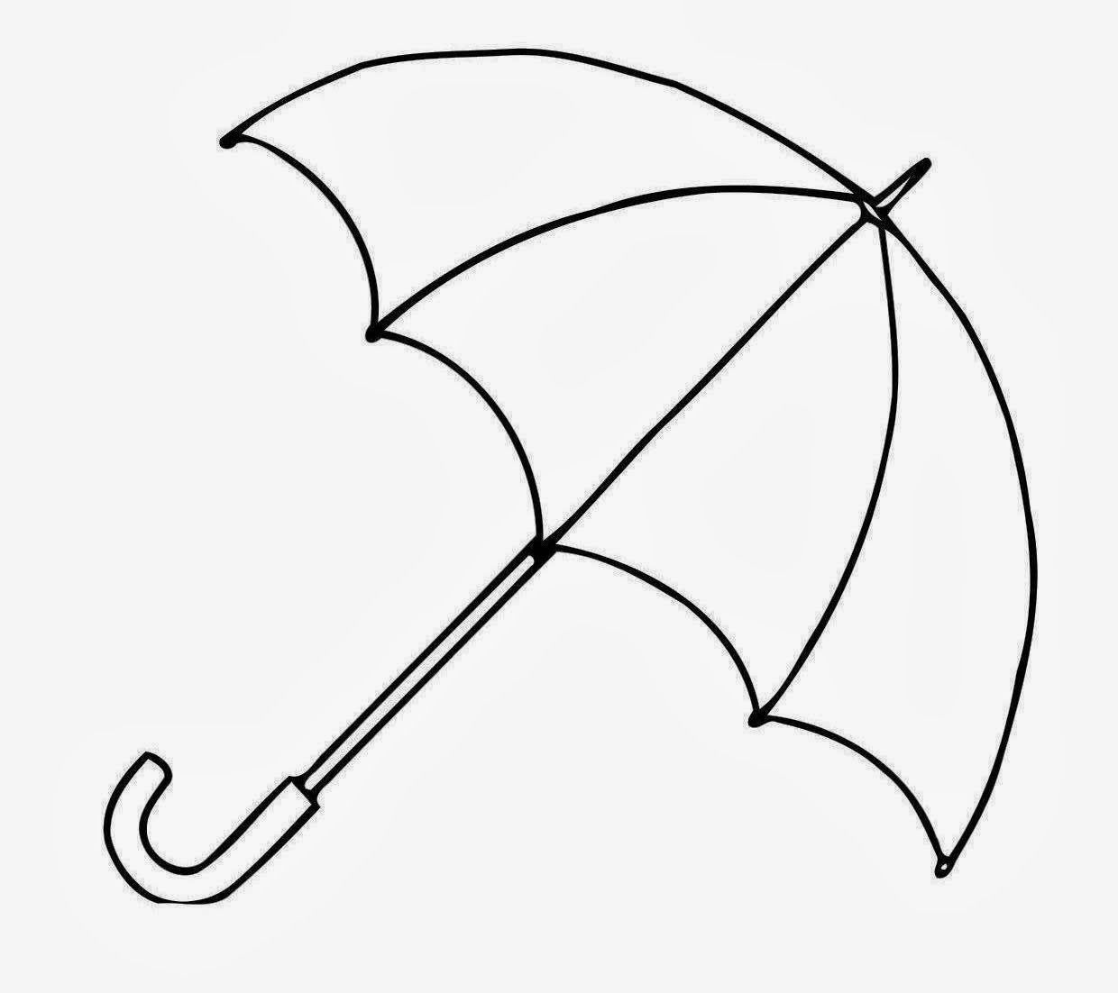

**"The End"**

**Second Terminal Examination 2081**

**Specification Grid**

Class : Nurssery F.M. 50

Subject : English Oral P.M. 20

|  |  |  |
| --- | --- | --- |
| 1. | What is your name ? | 5 |
| 2. | In which class do you read ? | 3 |
| 3. | Say 'A' for Apple to 'z' for Zebra. | 26 |
| 4. | Recognize the picture. | 3 |
| 5. | Sing the rhymes.(English) | 5 |
| 6. | Say the days of week. | 10 |

**Third Terminal Examination 2081**

**Specification Grid**

Class : Nurssery F.M. 50

Subject : English P.M. 20

|  |  |  |  |  |
| --- | --- | --- | --- | --- |
| SN | Types of questions | no. of Question | Weight | Total |
| 1. | Write A to z. | 26 | 0.5 | 13 |
| 2. | Copy a to z. | 26 | 0.5 | 13 |
| 3. | Name the follolwing pictures | 2 | 3 | 6 |
| 4. | Make words from given letters. (any 4) | 4 | 2 | 8 |
| 5. | Copy the following words. (any 5) | 5 | 1 | 5 |
| 6. | Colour the following picture. | 1 | 5 | 5 |
|  | Total |  |  | 50 |

**Model Questions**

**Third Terminal Examination 2081**

Class : Nursery F.M. 50

Subject : English Written P.M. 20

Q.1. Write A to Z. 13

|  |  |  |  |  |  |
| --- | --- | --- | --- | --- | --- |
|  |  |  |  |  |  |
|  |  |  |  |  |  |
|  |  |  |  |  |  |
|  |  |  |  |  |  |
|  |  |

Q.2. Copy the following letter. (a to z) 13

|  |  |  |  |  |  |
| --- | --- | --- | --- | --- | --- |
| a | b | c | d | e | f |
|  |  |  |  |  |  |
| g | h | i | j | k | l |
|  |  |  |  |  |  |
| m | n | o | p | q | r |
|  |  |  |  |  |  |
| s | t | u | v | w | x |
|  |  |  |  |  |  |
| y | z |
|  |  |

Q.3. Name the following picture. 2x3=6

  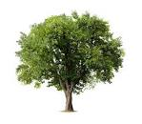

................ ................. ....................

Q.4. Make the word from given letters. 4x2=8

A =………………………….

B =……………………………

C =…………………………….

D =…………………………….

Q.5. Copy the same sentences . 5x1=5

|  |
| --- |
| You are my best friend. |
|  |
|  |
|  | |
|  | |
|  | |

Q.6. Colour the following picture. 5

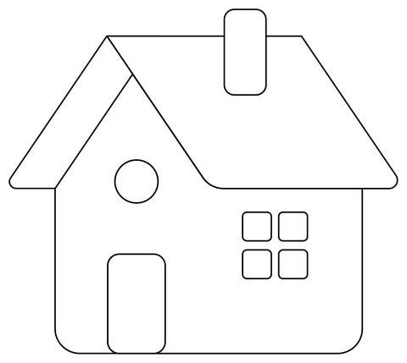

"The End"

**Third Terminal Examination 2081**

**Specification Grid**

Class : Nurssery F.M. 50

Subject : English Oral P.M. 20

|  |  |  |
| --- | --- | --- |
| 1. | Answer the following question.  a. What is your name ?  b. What is your father's name ?  c. What is your mother's name ?  d. In which class do you read ? | 4x2=8 |
| 2. | Say the rhymes any 2 in english | 2x2.5=5 |
| 3. | Say 'A' to 'z' | 26x0.5=13 |
| 4. | Make words any two letters. | 2x2=4 |
| 5. | Recognize the picture. | 5x1=5 |
| 6. | Show the things in classroom. | 4x1=4 |
| 7. | Name the seven days. | 7x1=7 |
| 8. | What is your school's name ? | 1x4=4 |

**Annual Examination 2081**

**Specification Grid**

Class : Nurssery F.M. 50

Subject : English P.M. 20

|  |  |  |  |  |
| --- | --- | --- | --- | --- |
| SN | Types of questions | no. of Question | Weight | Total |
| 1. | Write A to z. | 26 | 0.5 | 13 |
| 2. | Write a to z. | 26 | 0.5 | 13 |
| 3. | Match the following.(name with picture) | 5 | 1 | 5 |
| 4. | Make word from given letter.(any 4) | 4 | 2 | 8 |
| 5. | Name the following picture. (any 2) | 2 | 2 | 4 |
| 6. | What is your name ? | 1 | 4 | 4 |
| 7. | Colour the following picture. | 1 | 3 | 3 |
|  | Total |  |  | 50 |

**Model Questions**

**Annual Examination 2081**

Class : Nursery F.M. 50

Subject : English Written P.M. 20

Q.1. Write A to Z. 26x0.5=13

|  |  |  |  |  |  |
| --- | --- | --- | --- | --- | --- |
|  |  |  |  |  |  |
|  |  |  |  |  |  |
|  |  |  |  |  |  |
|  |  |  |  |  |  |
|  |  |

Q.2. Write a to z . 26x0.5=13

|  |  |  |  |  |  |
| --- | --- | --- | --- | --- | --- |
|  |  |  |  |  |  |
|  |  |  |  |  |  |
|  |  |  |  |  |  |
|  |  |  |  |  |  |
|  |  |

Q.3. Match the following. 5x1=5

Duck 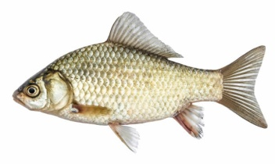

Grapes 

Fish 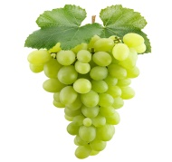

Jug 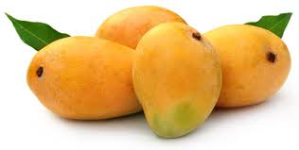

Mango 

Q.4. Make words from given letter. 4x2=8

A = …………………………

E = ………………………….

D = …………………………

I = …………………………..

Q.5. Name the following picture . 2X2=4

a.  …………………… b.  ……………………

Q.6. What is your name ? 4

Ans : My name is ………………………………………………….

Q.7. Colour the following picture. 3

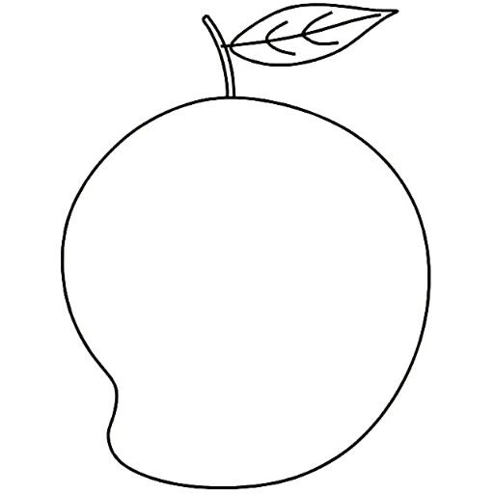

**"The End "**

**Annual Examination 2081**

**Specification Grid**

Class : Nurssery F.M. 50

Subject : English Oral P.M. 20

|  |  |  |
| --- | --- | --- |
| 1. | Answer the following question.  a. What is your name ?  b. How old are you ?  c. Who are you ?  d. In which class do you read ?  e. Where do you live ?  f. What is your school's name ?  g. Who is your best friend ? | 7x1.5=10.5 |
| 2. | Say the rhymes in english | 1x3.5=3.5 |
| 3. | Say 'A' to 'z' | 26x1=26 |
| 4. | Recognize the capital or small letter. | 4x1=4 |
| 5. | Say the 12 month of the year/seven days. | 6 |

' The End '

Prepared by : Sumitra Gurung

Contact :9811910871

School : Shree Manakamana Basic School