Assignment 3

Dinesh Adhithya

18097

DL

1. Train a DCGAN to generate images from noise. Use the MNIST database to learn the GAN

network.

Discriminator : ResNet18

Perform the following tasks:

a. Uniformly generate ten noise vectors that act as latent representation vectors, and

generate the images for these noise vectors, and visualize them at [5 + 5 + 5 marks]

n=10

i. After the first epoch.

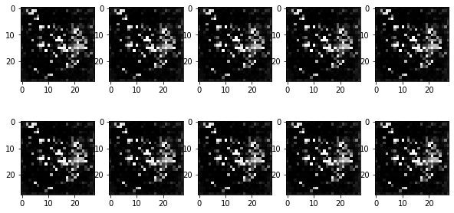

ii. After n/2 th epoch.

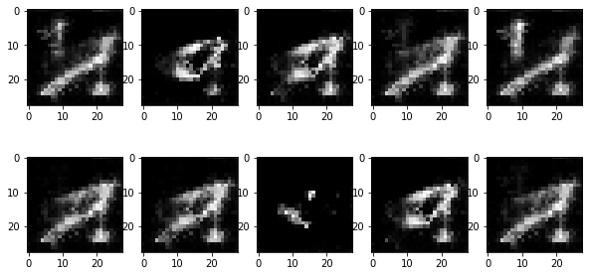

iii. After your last epoch. (say n epochs in total)

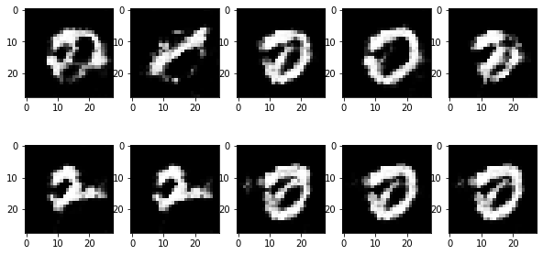

and comment on the image interpretation at (i), (ii) and (iii) and can you identify

the images? [5 marks]

As the epochs increase the images from the generator start to resemble the MNIST images much closer , the numbers are quite well visible with increasing no. of epochs. Image (i) looks like randomly generated loss , image (ii) looks more like numbers although not very clear whereas image (iii) looks very much like the MNIST images.

b. Plot generator and discriminator losses for all the iterations. [One iteration = forward pass

of a mini-batch] [10 marks]

