AWS VPC PEERING PROJECT
Private Connectivity Between Two Amazon VPCs
Project Report
Submitted by: Dinesh Baidya
Batch: AWS Internship batch 1
AWS Region: Asia Pacific (Mumbai) — ap-south-1
Completion date: 16/10/26
Prepared for the EWB Courses AWS Networking / AWS Architect Associate student project.

1. Abstract
This project demonstrates private communication between workloads placed in two separate Amazon Virtual Private Clouds (VPCs) using an AWS VPC peering connection. VPC A contains a public subnet for a bastion host and a private subnet for App-A. VPC B contains a private subnet for App-B. Route tables on both sides provide forward and return paths, while security groups restrict SSH and ICMP traffic to specific source addresses. App-B is accessed from the laptop through the bastion host using SSH ProxyJump; the private application instances are not assigned public IPv4 addresses.

2. Objectives
- Create two non-overlapping VPCs and the required public/private subnets.
- Connect the VPCs using a VPC peering connection.
- Configure the correct routes in both directions and retain the internet-gateway default route for the bastion subnet.
- Restrict access with security-group rules using specific source IPs.
- Verify two-way ICMP connectivity and SSH access to App-B through the bastion host.
- Perform a controlled ICMP failure-and-recovery test and document cleanup.

3. Architecture and Addressing
The topology below is a text summary. Replace or supplement it with a clear architecture diagram showing the actual resource IDs, subnet CIDRs, peering connection, route directions and instance private IPs.
Component | CIDR / IP | Purpose / details
VPC A | 10.10.0.0/16 | Hosts the bastion and App-A
VPC A public subnet: ewb-a-public | 10.10.1.0/24 | Bastion subnet; route to Internet Gateway and peering connection
VPC A private subnet: ewb-a-private | 10.10.2.0/24 | Private workload App-A
VPC B | 10.20.0.0/16 | Hosts private workload App-B
VPC B private subnet: ewb-b-private | 10.20.1.0/24 | Private workload App-B
Bastion: ewb-bastion | Public IP 35.154.170.65; private IP 10.10.1.39 | SSH entry point
App-A: ewb-app-a | Private IP 10.10.2.192 | Private instance in VPC A; no public IPv4
App-B: ewb-app-b | Private IP 10.20.1.96 | Private instance in VPC B; no public IPv4
VPC peering connection | pcx-0e2a0f1d635f24a36 | Private routing between VPC A and VPC B

Architecture diagram / VPC resource overview

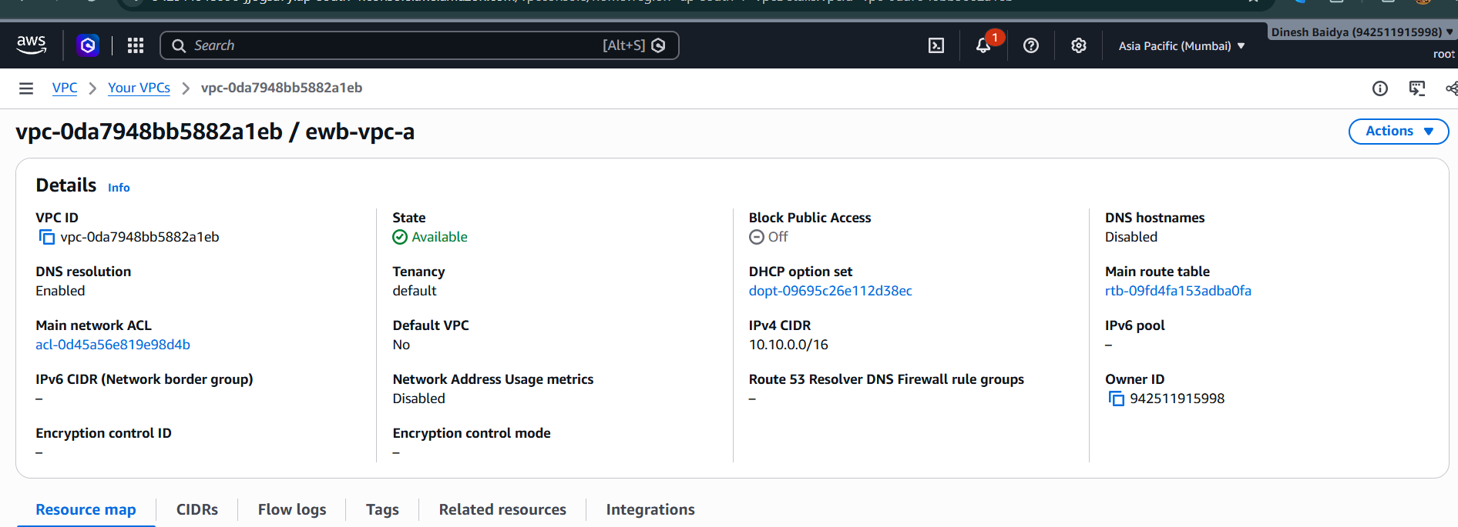
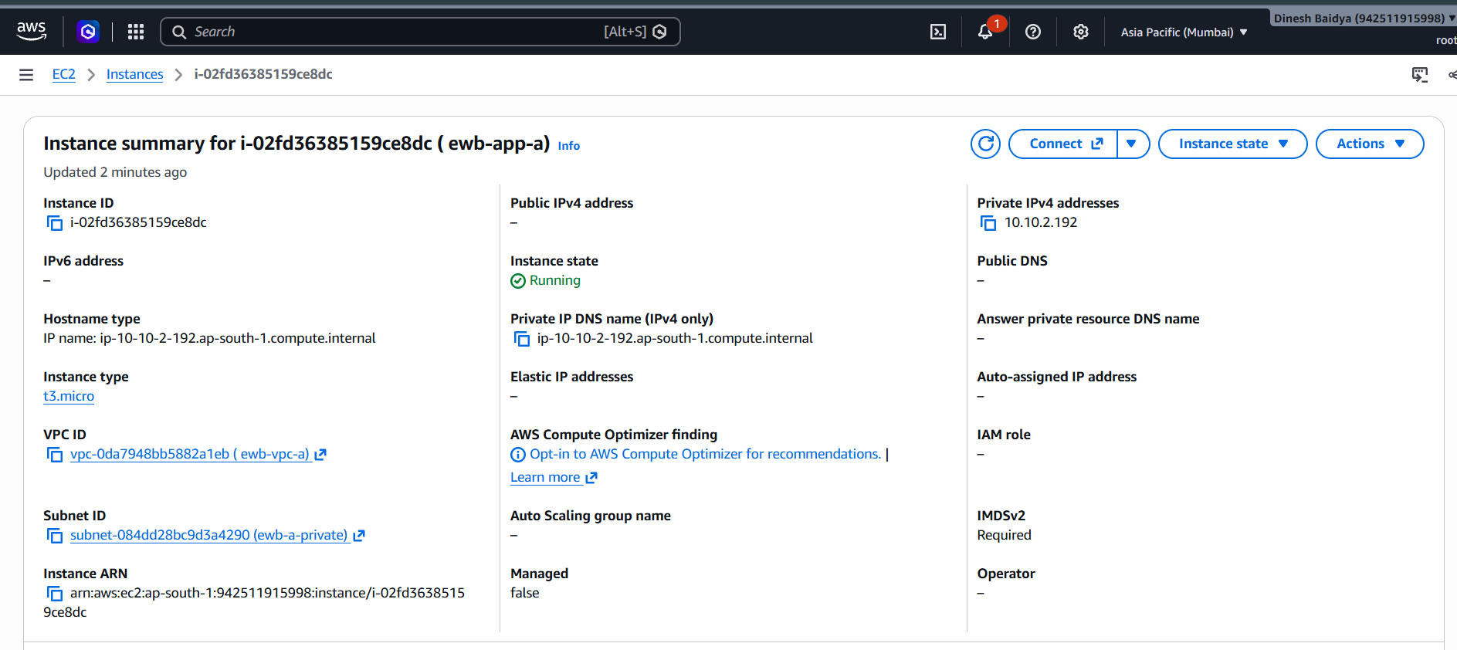
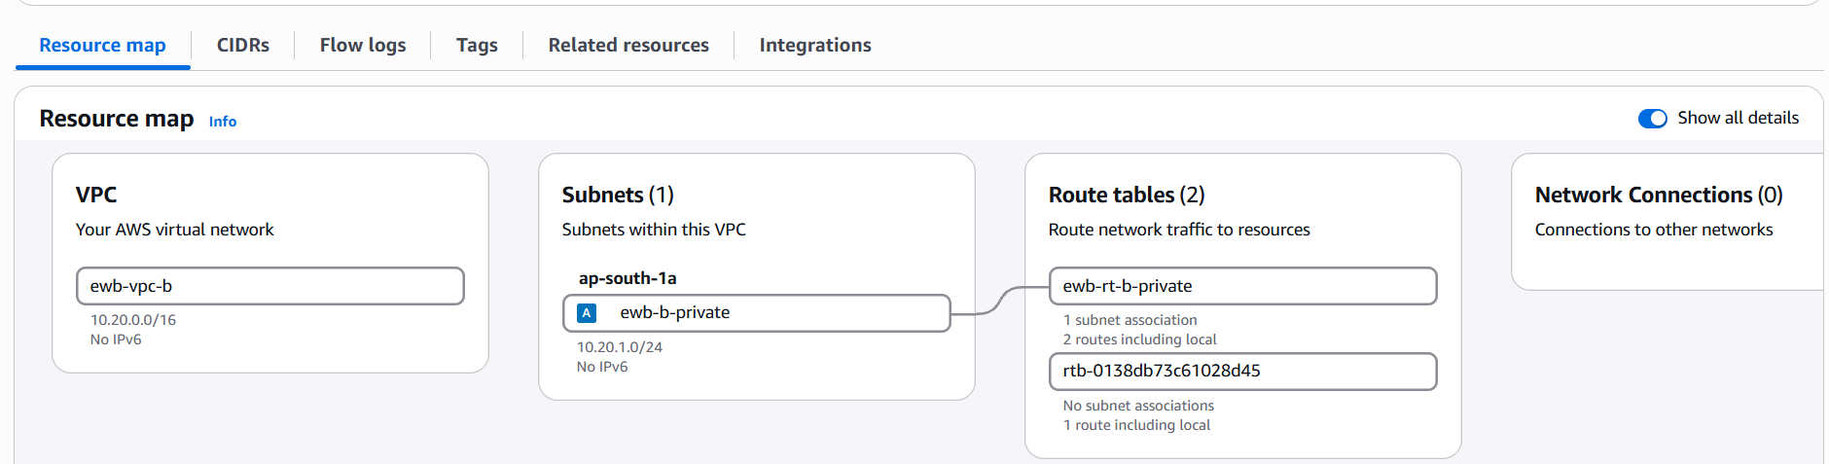
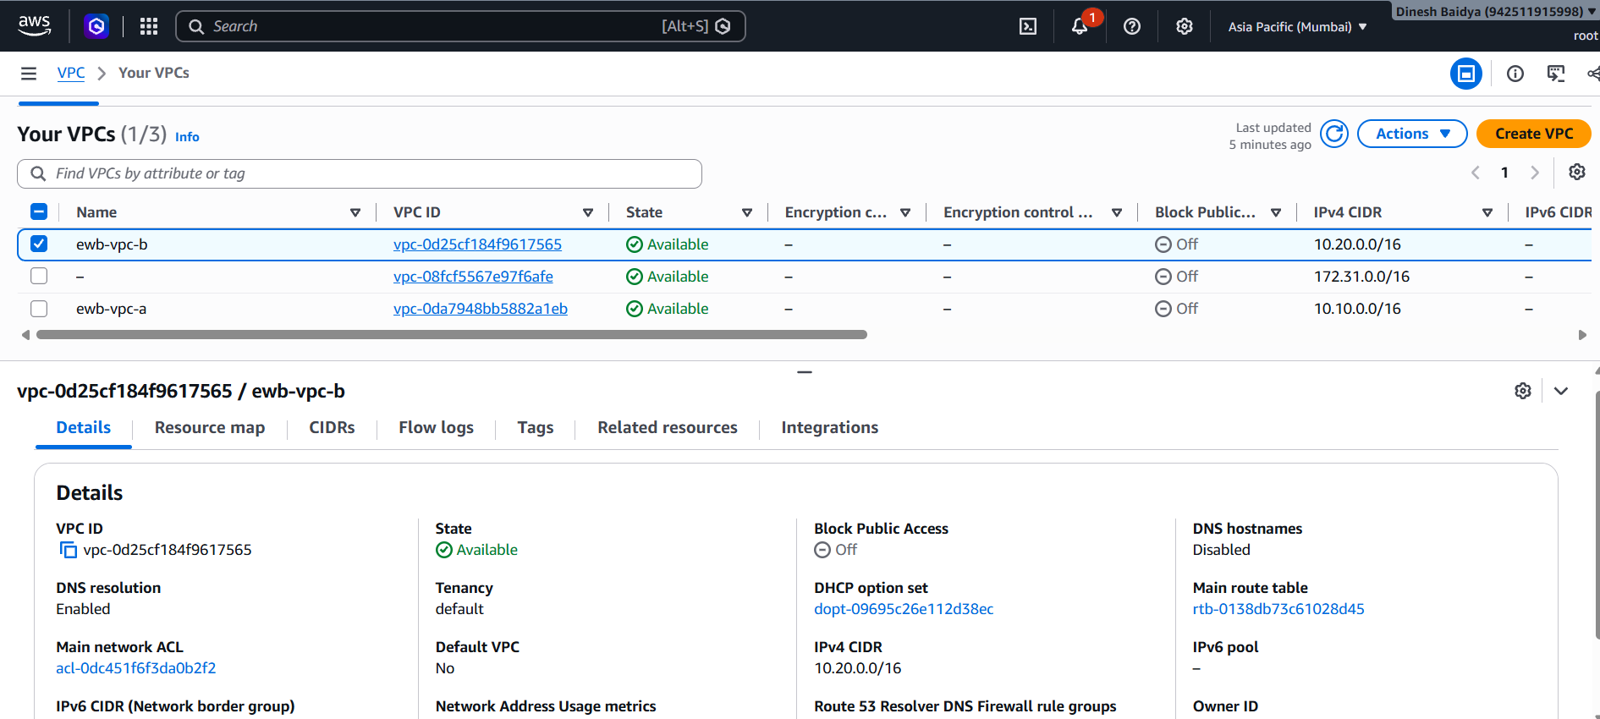
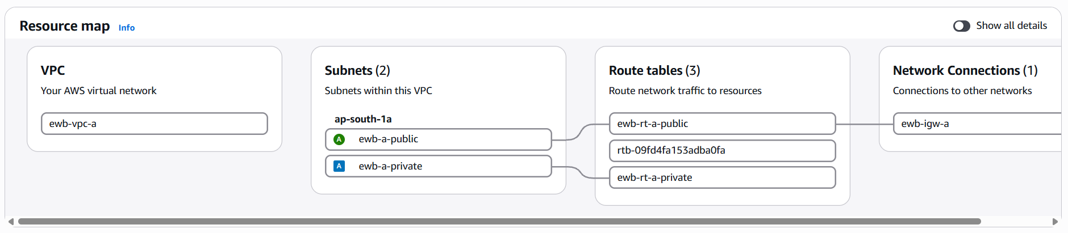

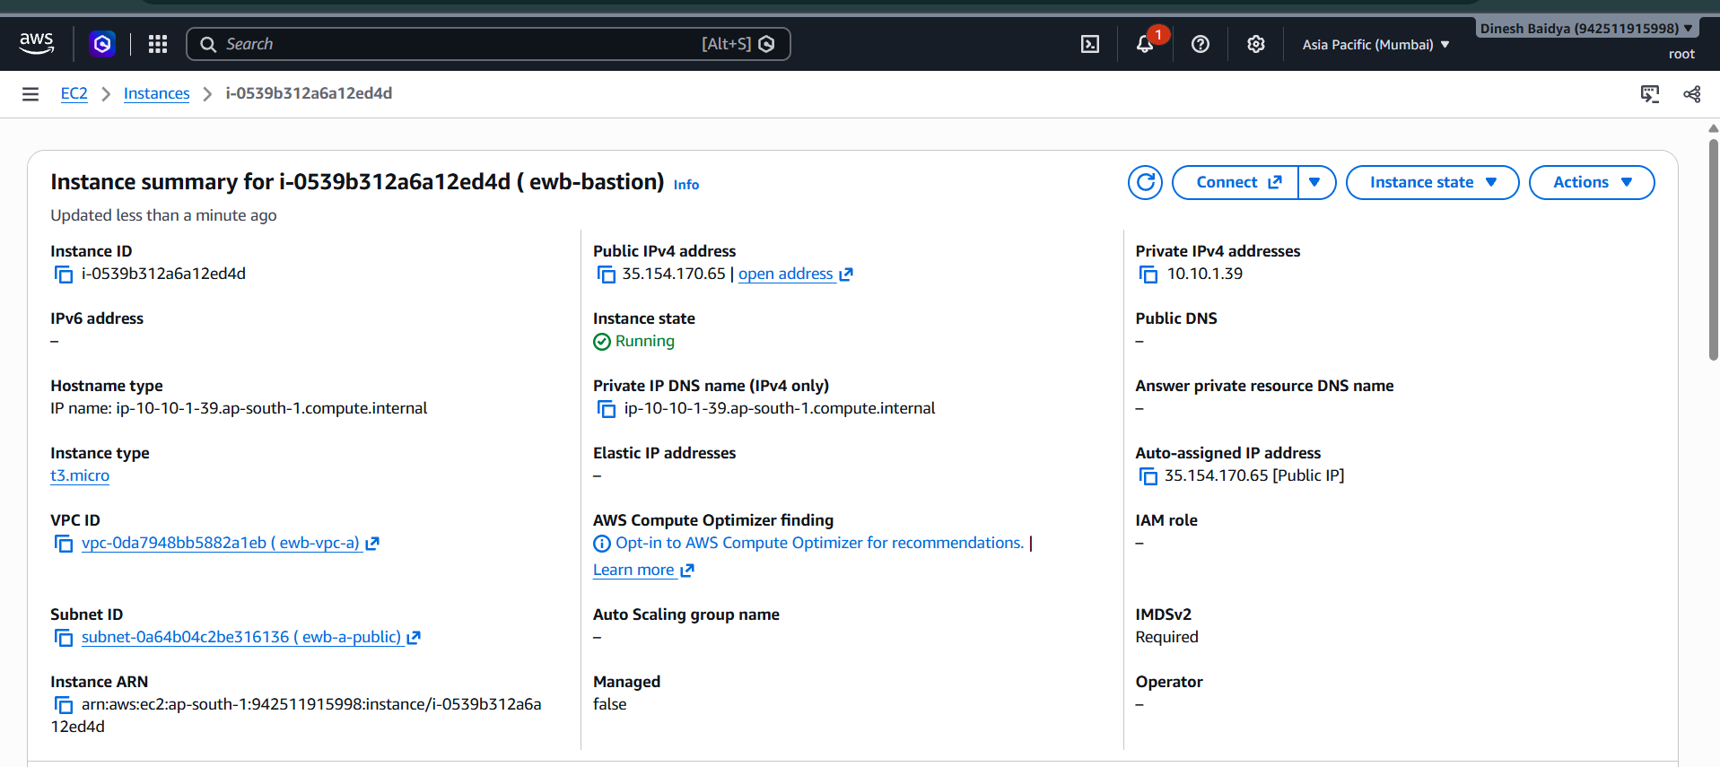
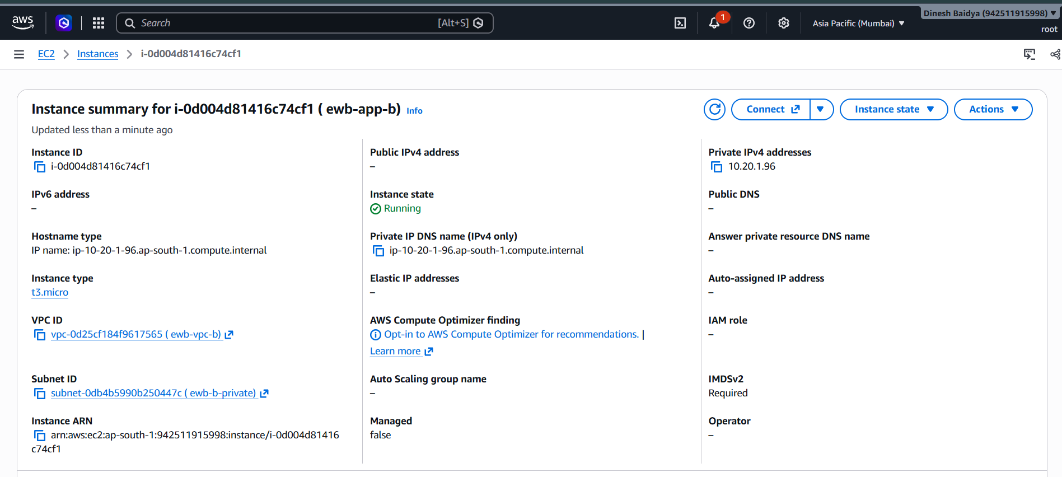

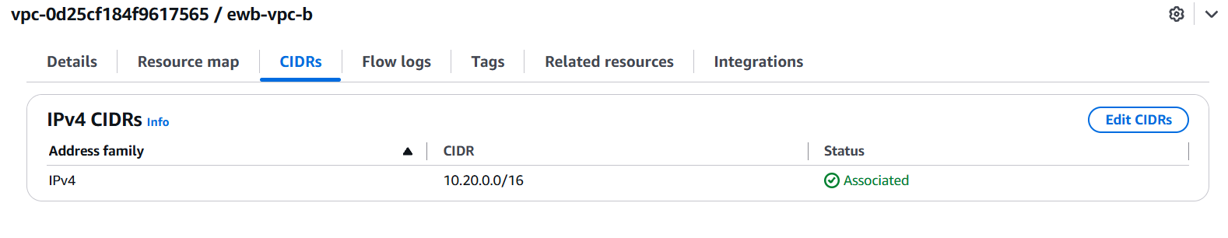
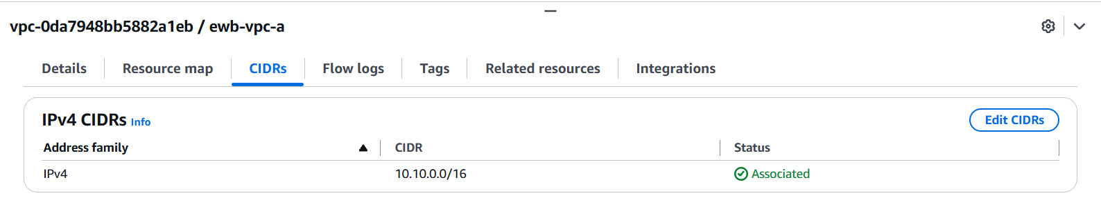

4. Resource Inventory
The values below include identifiers available from the lab session. Fill in the remaining IDs from the AWS console before submission.
Resource | Name / ID | Notes
VPC A | Name: wb-vpc-a  | VPC ID: vpc-0da7948bb5882a1eb | CIDR 10.10.0.0/16
VPC B | Name: wb-vpc-b  | VPC ID: vpc-0d25cf184f9617565 | CIDR 10.20.0.0/16
Peering | pcx-0e2a0f1d635f24a36 | Active
Bastion instance | i-0539b312a6a12ed4d | ewb-bastion; 35.154.170.65 / 10.10.1.39
App-A instance | i-02fd36385159ce8dc ( ewb-app-a) | ewb-app-a; 10.10.2.192; no public IPv4
App-B instance | i-0d004d81416c74cf1 ( ewb-app-b) | ewb-app-b; 10.20.1.96; no public IPv4
App-B subnet | subnet-0db4b5990b250447c | 10.20.1.0/24
App-B security group | sg-018b7ee83cb375164 | ewb-sg-app-b
VPC A public route table | rtb-01e3c5a7d386325a0 / ewb-rt-a-public | ewb-rt-a-public
VPC A private route table | rtb-0052937b82db323eb / ewb-rt-a-private | ewb-rt-a-private
VPC B private route table | rtb-0a5444b03c5c581a0 / ewb-rt-b-private | ewb-rt-b-private
Internet Gateway | igw-05acc7673e2ab44e6 / ewb-igw-a | Attached to VPC A
App-A security group | sg-0331abf925cc5e144 - ewb-sg-app-a | Record actual ID and inbound rules
Bastion security group | sg-018b7ee83cb375164 - ewb-sg-app-b | SSH inbound restricted to current public IP /32

5. Routing Configuration
AWS automatically creates a local route for each VPC CIDR. The additional routes below provide peering reachability. The public route table must retain its default route to the Internet Gateway; the more-specific VPC B route sends VPC B traffic over peering.
Route table | Destination | Target | Association / purpose
ewb-rt-a-public | 10.10.0.0/16 | local | ewb-a-public; VPC A local traffic
ewb-rt-a-public | 0.0.0.0/0 | ewb-igw-a (actual IGW ID) | Bastion internet access
ewb-rt-a-public | 10.20.0.0/16 | pcx-0e2a0f1d635f24a36 | Bastion-to-App-B route through peering
ewb-rt-a-private | 10.10.0.0/16 | local | ewb-a-private; VPC A local traffic
ewb-rt-a-private | 10.20.0.0/16 | pcx-0e2a0f1d635f24a36 | App-A to VPC B
ewb-rt-b-private | 10.20.0.0/16 | local | ewb-b-private; VPC B local traffic
ewb-rt-b-private | 10.10.0.0/16 | pcx-0e2a0f1d635f24a36 | Return path from App-B to VPC A

Important: capture the subnet association view as well as the route list for all three route tables.
ewb-rt-a-public routes and subnet association

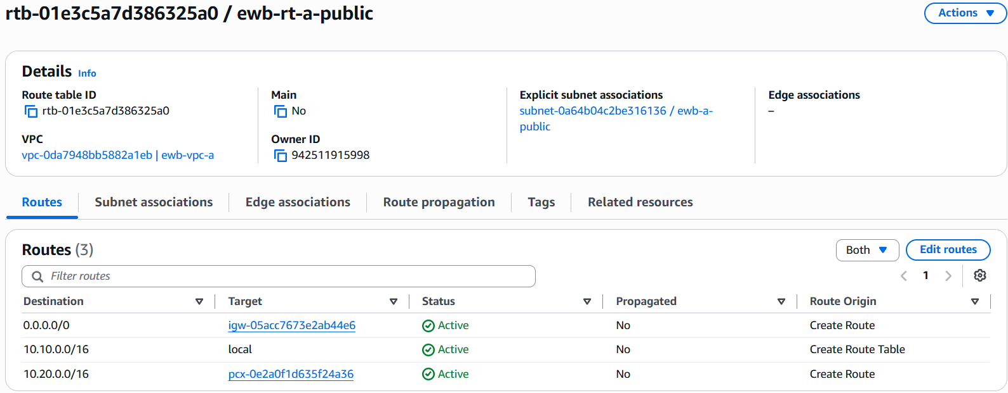

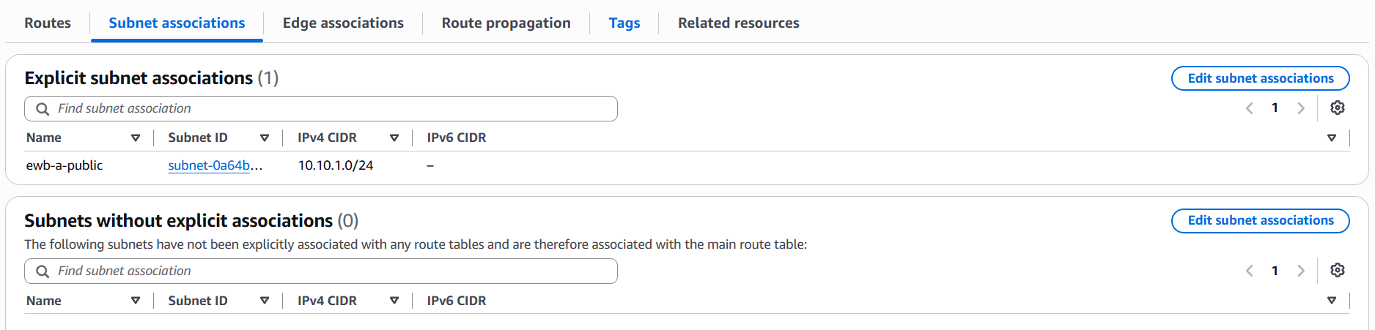
ewb-rt-a-private routes and subnet association

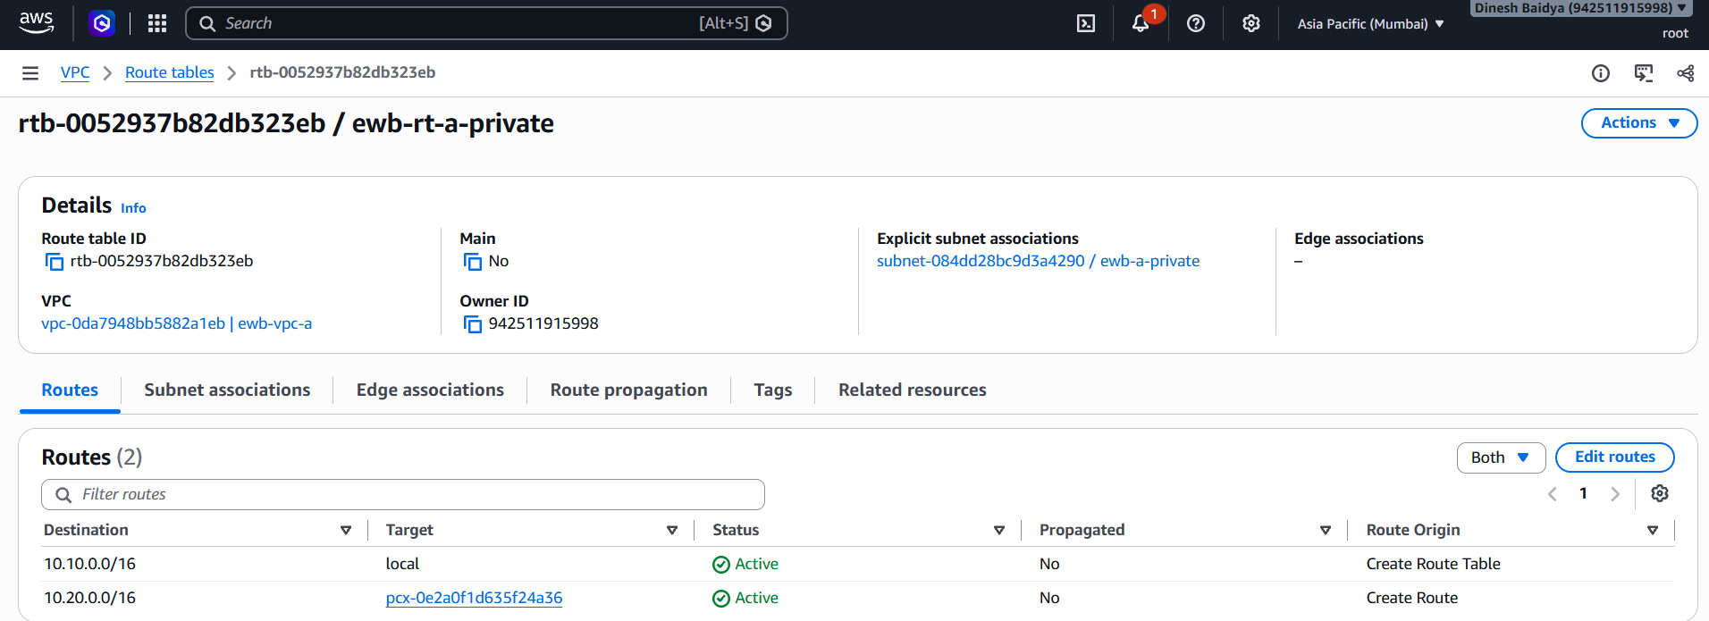
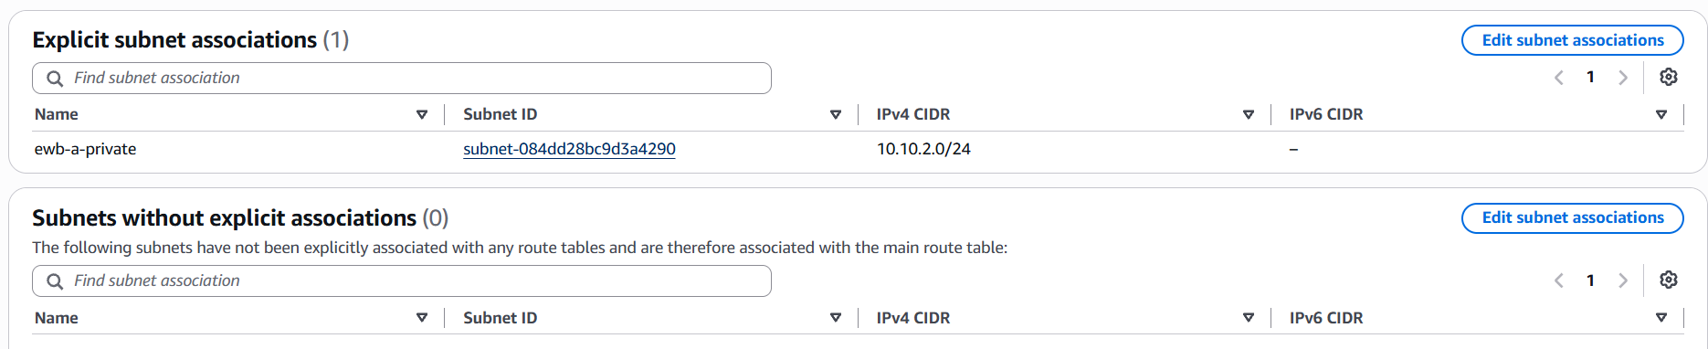
ewb-rt-b-private routes and subnet association
.
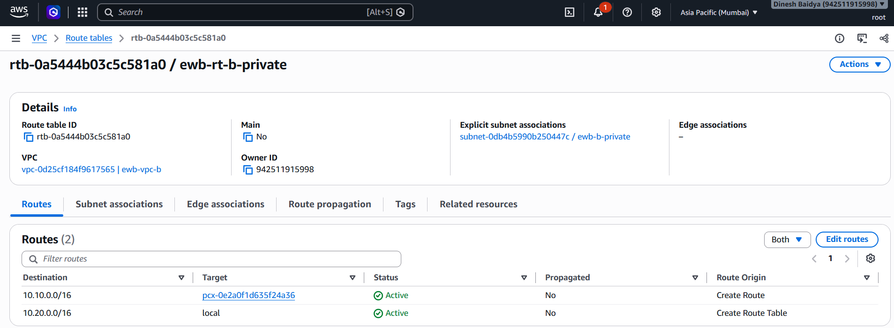

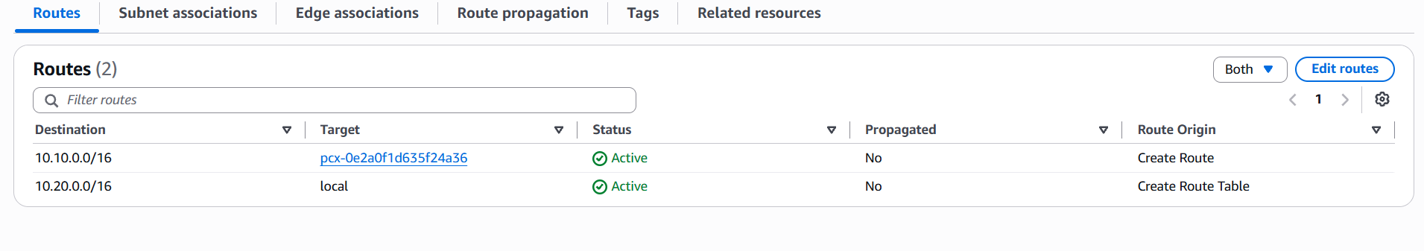
VPC peering connection showing its actual state

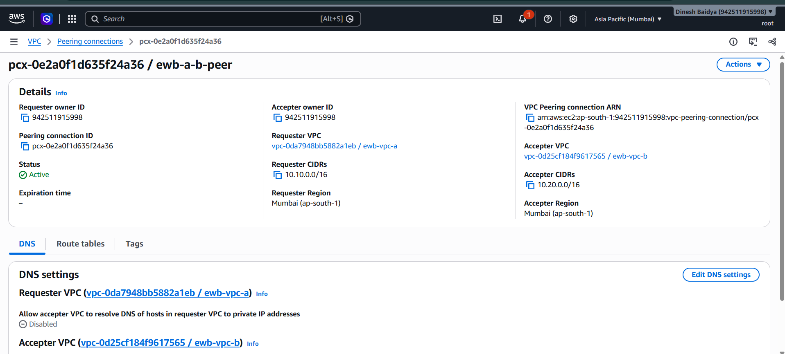

6. Security Group Rules
Security groups are stateful. The following describes the intended minimum inbound rules based on the lab configuration. Confirm the live rules and fill in any missing security-group IDs before submission.
Security group / target | Protocol / port | Source | Purpose
Bastion SG | TCP 22 (SSH) | Your current public IPv4 /32 | Laptop to bastion; source must match current public IP
App-A SG | TCP 22 (SSH) | 10.10.1.39/32 | SSH from bastion if required by lab
App-A SG | ICMP Echo request | 10.20.1.96/32 | Permit App-B to ping App-A
ewb-sg-app-b | TCP 22 (SSH) | 10.10.1.39/32 | Permit SSH from bastion to App-B
ewb-sg-app-b | ICMP Echo request | 10.10.2.192/32 | Permit App-A to ping App-B

Inbound rules for the bastion security group

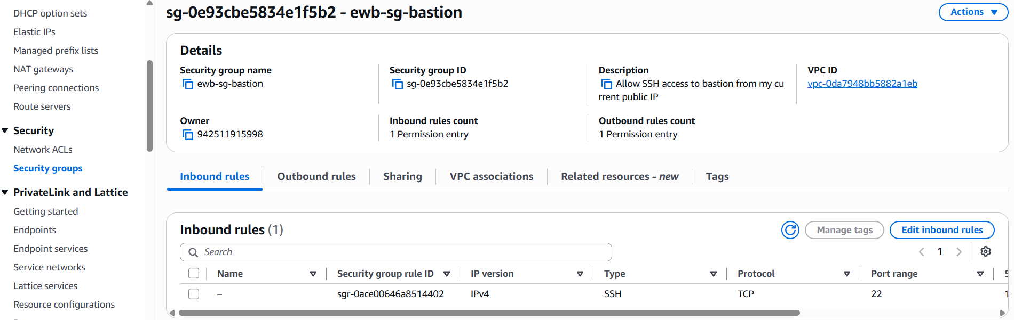

Inbound rules for the App-A security group

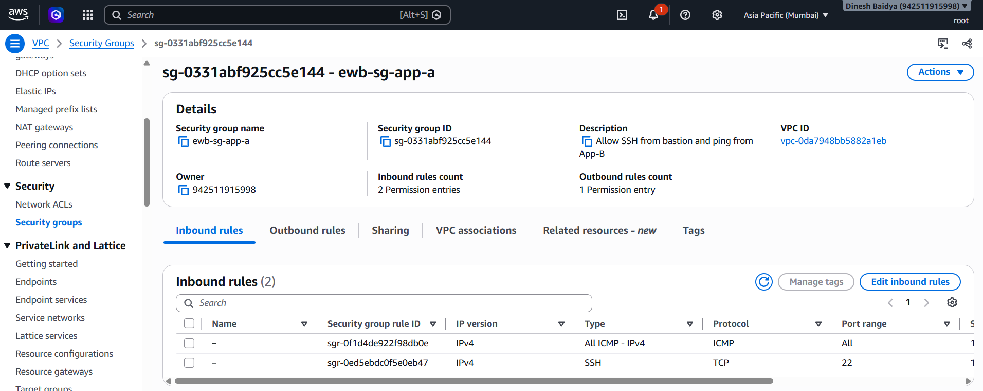

Inbound rules for ewb-sg-app-b

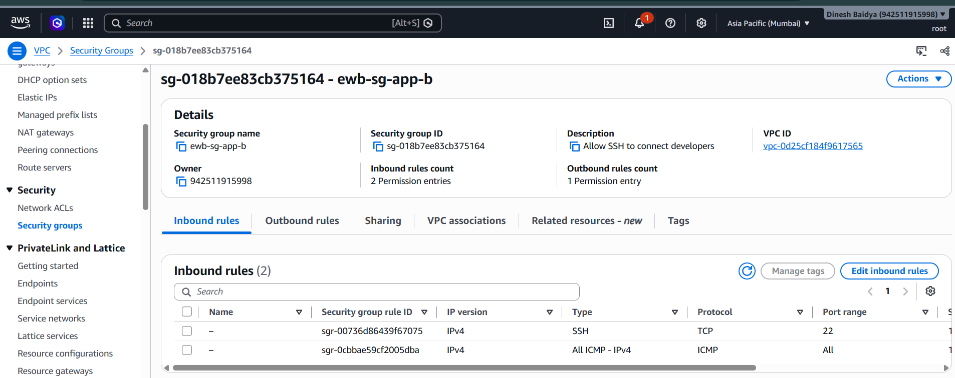

7. Verification and Test Results
The following results reflect the tests reported during the lab session. Insert your own terminal screenshots in the spaces provided. The initial baseline test must only be marked as evidenced if you actually captured it before peering/routes were configured.
Test | Command / location | Observed result | Evidence status
Forward ping | On App-A: ping -c 4 10.20.1.96 | Reported success: 4/4 replies, 0% packet loss | Insert screenshot
Reverse ping | On App-B: ping -c 4 10.10.2.192 | Reported success: 4/4 replies, 0% packet loss | Insert screenshot
Private SSH to App-B | Windows PowerShell: ssh ewb-app-b | Reported successful shell access through bastion ProxyJump | Insert screenshot
Private IP verification | On App-A and App-B: hostname; hostname -I | App-A: 10.10.2.192; App-B: 10.20.1.96; verify no public IPv4 in console | Insert screenshots
Baseline before peering | On App-A, before peering: ping -c 4 10.20.1.96 | Expected no replies; mark only if actually captured at that stage | [Insert if captured; otherwise say not captured]
Controlled ICMP failure | Temporarily remove only App-B ICMP inbound rule from 10.10.2.192/32, then ping from App-A | User reported completing the controlled failure/recovery procedure; insert the actual failure output | Insert screenshot
ICMP recovery | Restore App-B ICMP inbound rule; repeat ping from App-A | Expected successful replies after rule restoration; include actual output | Insert screenshot

App-A forward ping to App-B: ping -c 4 10.20.1.96

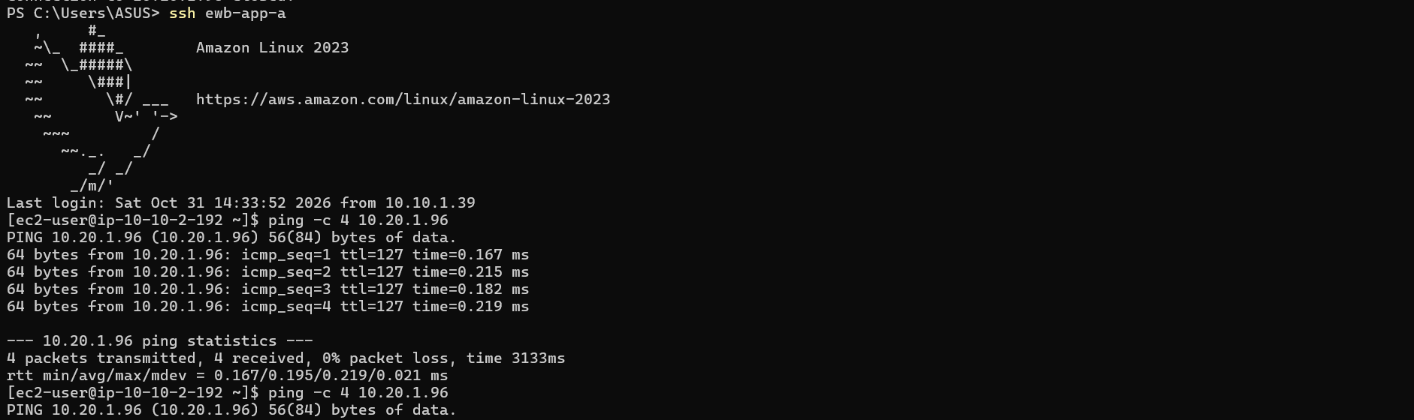
App-B reverse ping to App-A: ping -c 4 10.10.2.192

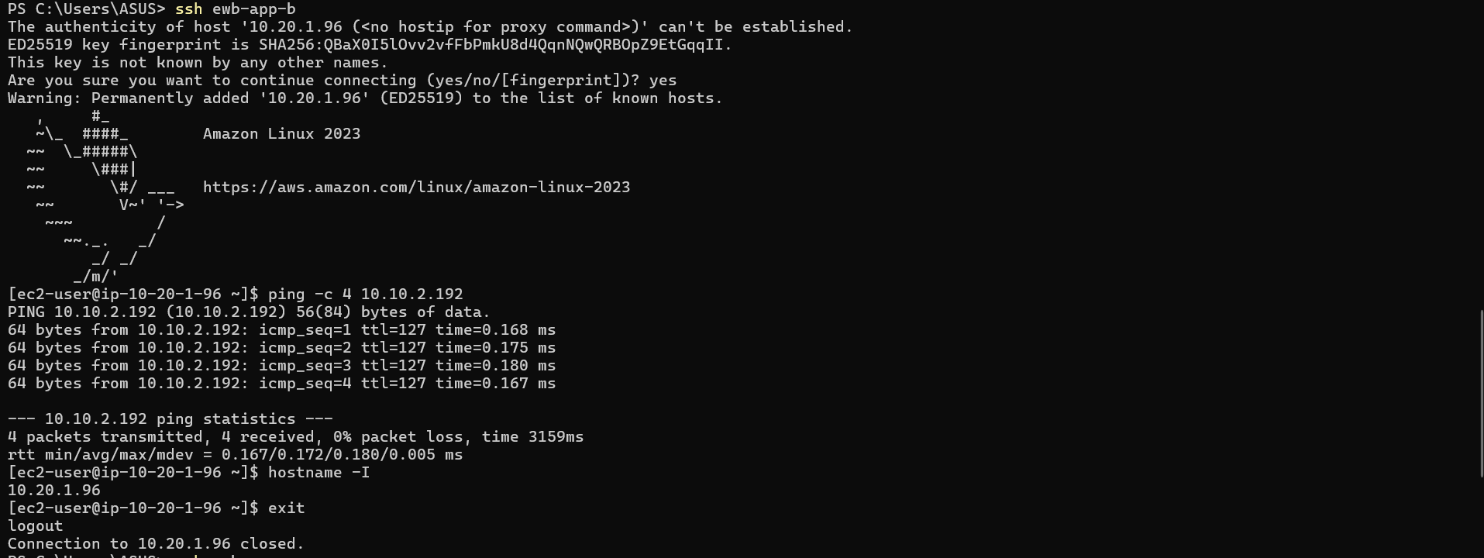

EC2 console details showing App-A and App-B have no public IPv4

Controlled failure: forward ping fails while App-B ICMP rule is removed

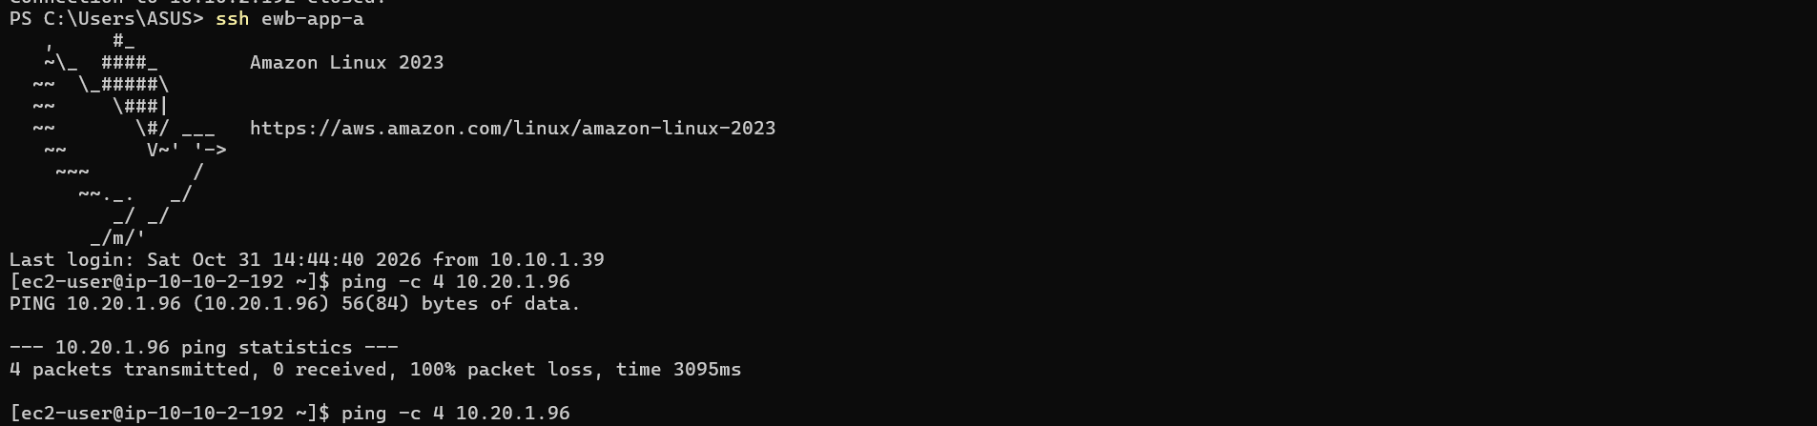

Recovery: forward ping succeeds after the ICMP rule is restored

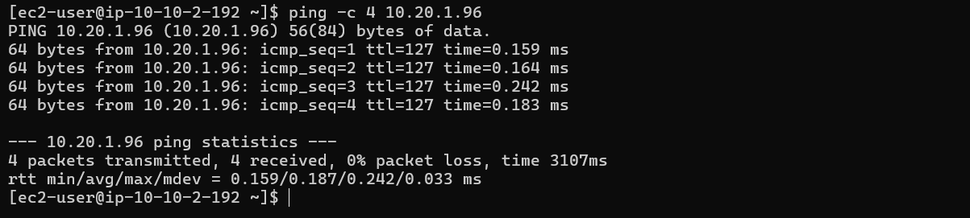

8. Traffic Flow Explanation

Forward path: App-A to App-B
App-A (10.10.2.192) sends ICMP traffic to App-B (10.20.1.96). The ewb-rt-a-private route table matches destination 10.20.0.0/16 and forwards the traffic to the VPC peering connection pcx-0e2a0f1d635f24a36. The peering connection carries the traffic to VPC B. App-B's security group must allow ICMP Echo requests from 10.10.2.192/32.

Return path: App-B to App-A
Replies travel from App-B toward 10.10.2.192. The ewb-rt-b-private route table matches destination 10.10.0.0/16 and sends traffic to the same peering connection. App-A's security group must permit the inbound ICMP request from App-B. Both route directions and the destination security group rules are required for successful communication.

SSH path to App-B
The laptop opens SSH to the public bastion. The bastion then initiates SSH to App-B's private address 10.20.1.96 using ProxyJump. The public subnet route table has a specific route for 10.20.0.0/16 to the peering connection, while its 0.0.0.0/0 route points to the Internet Gateway. App-B allows TCP 22 only from the bastion private IP 10.10.1.39/32. App-B does not need a public IPv4 address.

9. Controlled Failure and Recovery
For the controlled test, only the App-B inbound ICMP Echo request rule sourced from App-A (10.10.2.192/32) is temporarily removed. The forward ping should fail while that rule is absent. Restoring the same rule should allow the ping to succeed again. The SSH rule is kept in place throughout. This demonstrates that routing alone does not override security-group filtering. Attach screenshots showing both the failure and recovery.

10. Cleanup and Cost Control
After saving all evidence and the final report, removed resources created for this lab.
- Terminate ewb-bastion, ewb-app-a and ewb-app-b.
- Confirmed lab EBS volumes are deleted; remove leftover lab volumes or snapshots if appropriate.
- Released any Elastic IP allocated for this lab.
- Deleted the VPC peering connection and remove its routes from the lab route tables.
- After network interfaces disappear, delete lab security groups.
- Removed subnet associations as required; delete lab subnets and custom route tables.
- Detach and delete ewb-igw-a, then delete the two lab VPCs.
- Check EC2, VPC, EBS, public IPv4 allocations and Billing in ap-south-1.
Cleanup evidence: lab instances terminated

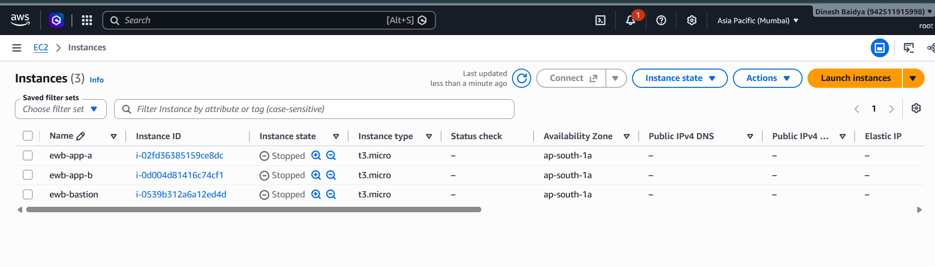

11. Learning Outcomes
This lab reinforced that VPC peering provides private connectivity but does not automatically add routes or allow traffic through security groups. Each participating subnet needs a correct route in the appropriate direction, and the return path is as important as the forward path. A bastion host can provide controlled SSH access to private instances without assigning those instances public IP addresses. A controlled security-group change is a useful way to distinguish a routing problem from a traffic-filtering problem.

12. Final Submission Checklist
- Cover page includes name, batch, project title, Region and completion date.
- Architecture diagram and actual resource inventory IDs are included.
- Subnet CIDRs and all three route tables with subnet associations are evidenced.
- Peering connection state and inbound rules for each security group are shown.
- Forward ping, reverse ping and SSH through bastion screenshots are included.
- Controlled ICMP failure and recovery are evidenced.
- Baseline failure is included only if actually captured before peering.
- Cleanup evidence and personal learning note are included.
- No private keys, passwords, access tokens or other secrets are included.

