**Explanation**

1. Find the HSV value for the object using the HSV file. Adjust the meter to get the HSV value. The value is noted and added to the speed finder program.

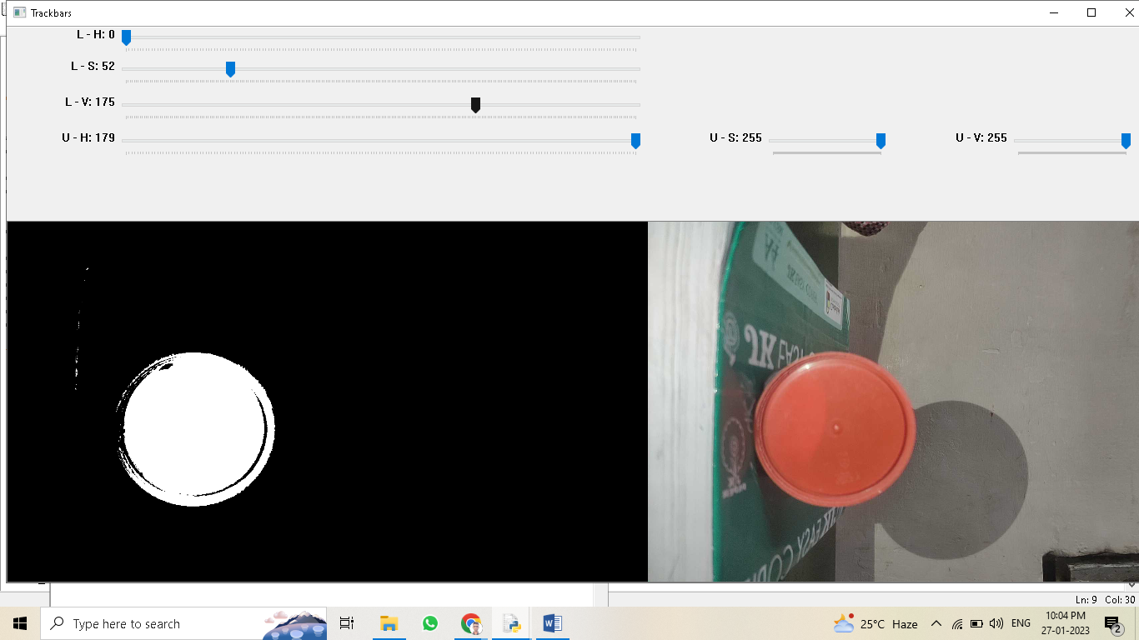

1. The width of the object is measured using the scale on the screen and converted into pixels. The width is noted in “actual_width”.

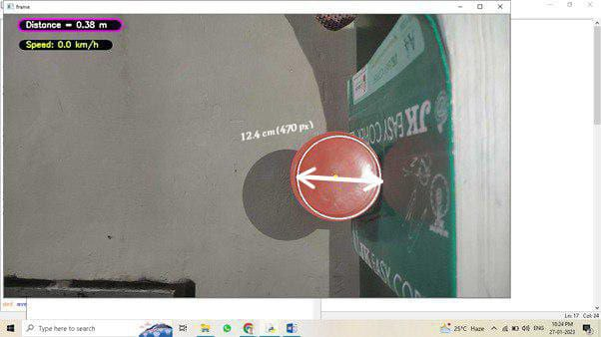

1. The distance between the camera and the object is measured using the scale and noted in “determined_distance” in cm.

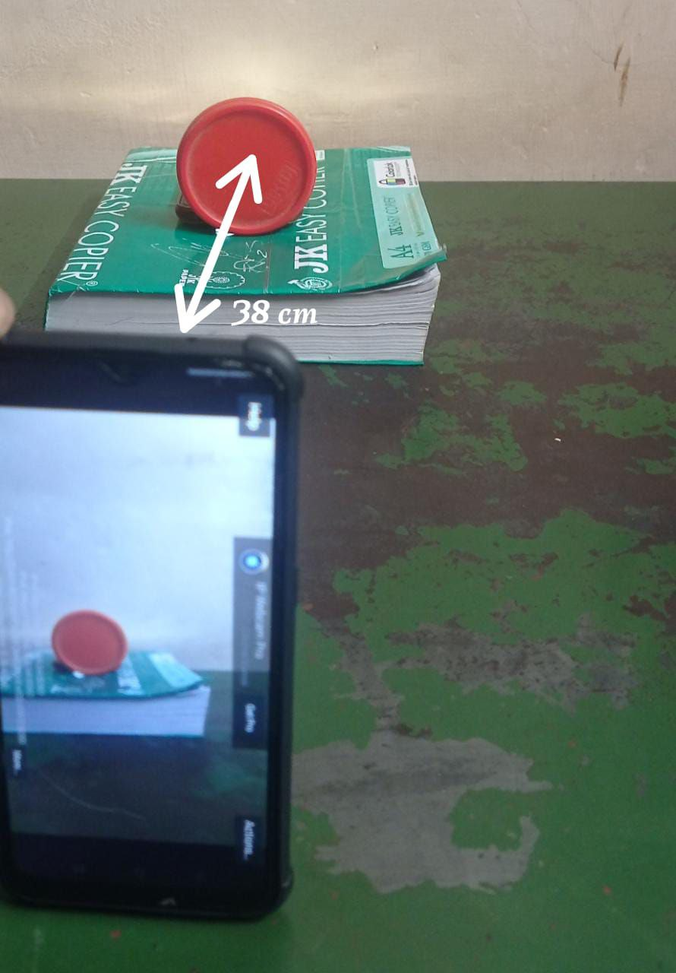

1. When the object is moved either front or back the distance and the speed is shown on the screen.
2. When the relative speed between the screen and the object is greater than or equal to 40km/hr and the distance between the screen and the object is less than or equal to 10m, a condition is applied such that a warning sound will horn.