QUICKCART ANALYTICS
Business Intelligence & Power BI Project Report
SQL Server • Power Query • DAX • Power BI

Prepared by: Dinesh

1. Executive Summary
QuickCart Analytics is a business intelligence project developed to provide an interactive view of quick-commerce order, sales, picker and delivery operations. The solution combines SQL Server analysis with Power BI reporting and DAX-based KPIs.
The final dashboard contains five pages: Executive Overview, Order & Sales Analysis, Picker Performance, Delivery Partner Performance, and Operations & Business Insights.

2. Business Problem
A quick-commerce operation generates multiple operational signals across orders, categories, pickers and delivery partners. A management team needs a single analytical view to monitor order volume, revenue, completion performance, picking time, delivery time, employee workload and operational efficiency.

3. Project Objectives
- Measure overall order and revenue performance.
- Analyze category and order-status patterns.
- Evaluate picker productivity, attendance and income.
- Evaluate delivery partner workload, speed and completion.
- Compare operational KPIs.
- Create an interactive management dashboard.
- Support data-driven insights and recommendations.

4. Tools & Technologies
Technology | Purpose
Microsoft SQL Server | Database storage and SQL analysis
SQL | Filtering, aggregation, grouping and analysis
Power Query | ETL and data transformation
Power BI Desktop | Interactive reporting and visualization
DAX | KPI and analytical measure calculations
GitHub | Version control and portfolio presentation

5. Data Model
The project uses three principal QuickCart tables:
- quickcartdb store_orders
- quickcartdb picker
- quickcartdb delivery_partner
The store-orders data supports order, category, status and revenue analysis. Picker data supports employee productivity, picking time, attendance and income analysis. Delivery-partner data supports delivery workload, delivery time and completion analysis.

6. Analytical Workflow
The project follows an end-to-end BI workflow: source data is stored and analyzed in SQL Server, prepared through ETL, modeled in Power BI, transformed into DAX measures, and presented through five interactive dashboard pages.
SQL Server → Power Query → Data Model → DAX → Power BI Visuals → Insights

7. Dashboard Pages

7.1 Executive Overview
High-level business performance using total orders, revenue, completion rate, average order amount, picking time and delivery time.
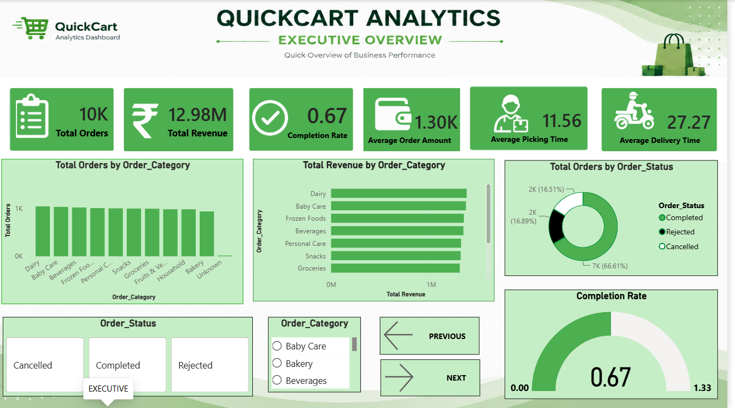
Figure: 7.1 Executive Overview

7.2 Order & Sales Analysis
Category-level order and revenue analysis with completed and rejected order KPIs, a category performance table and interactive slicers.
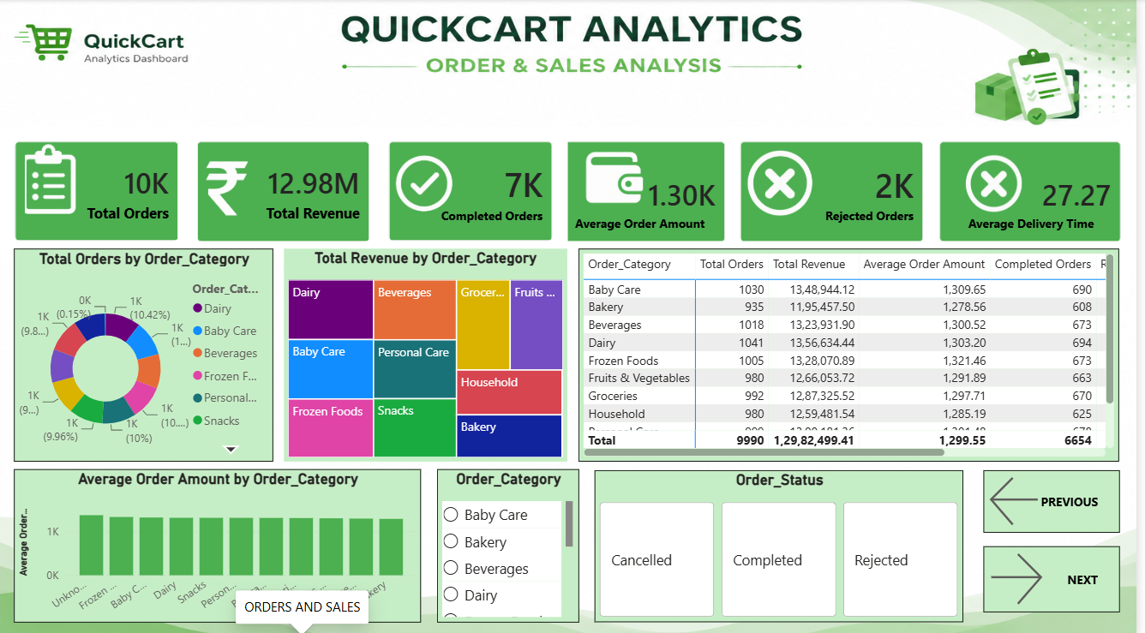
Figure: 7.2 Order & Sales Analysis

7.3 Picker Performance
Dedicated performance page covering picker workload, active pickers, picking time, attendance, income, orders per picker and employee-level analysis.
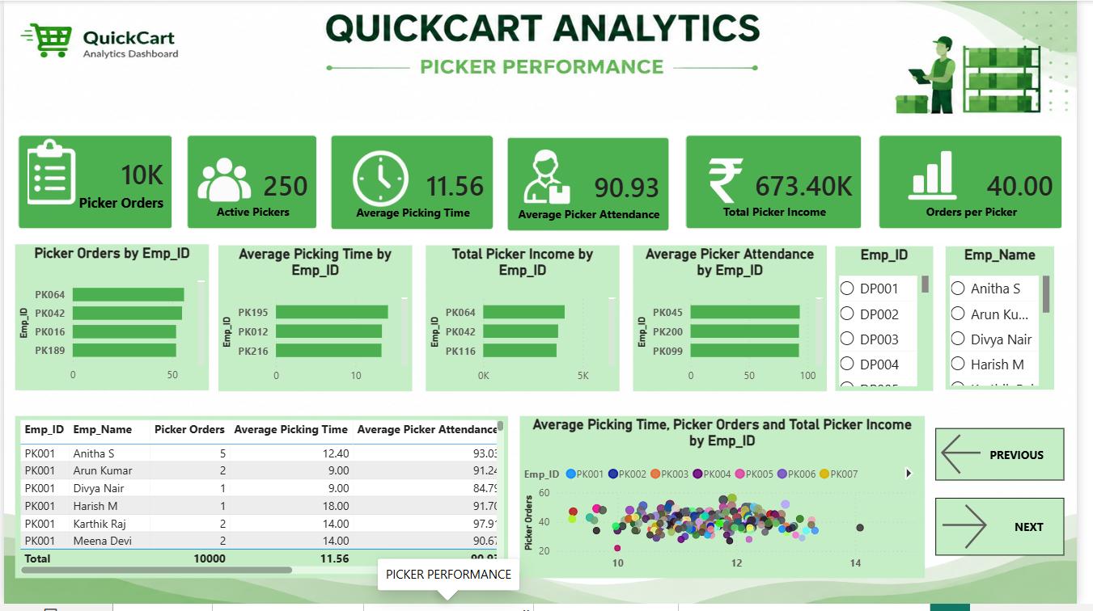
Figure: 7.3 Picker Performance

7.4 Delivery Partner Performance
Dedicated delivery performance page covering delivery orders, active partners, delivery time, completed delivery orders and completion rate.
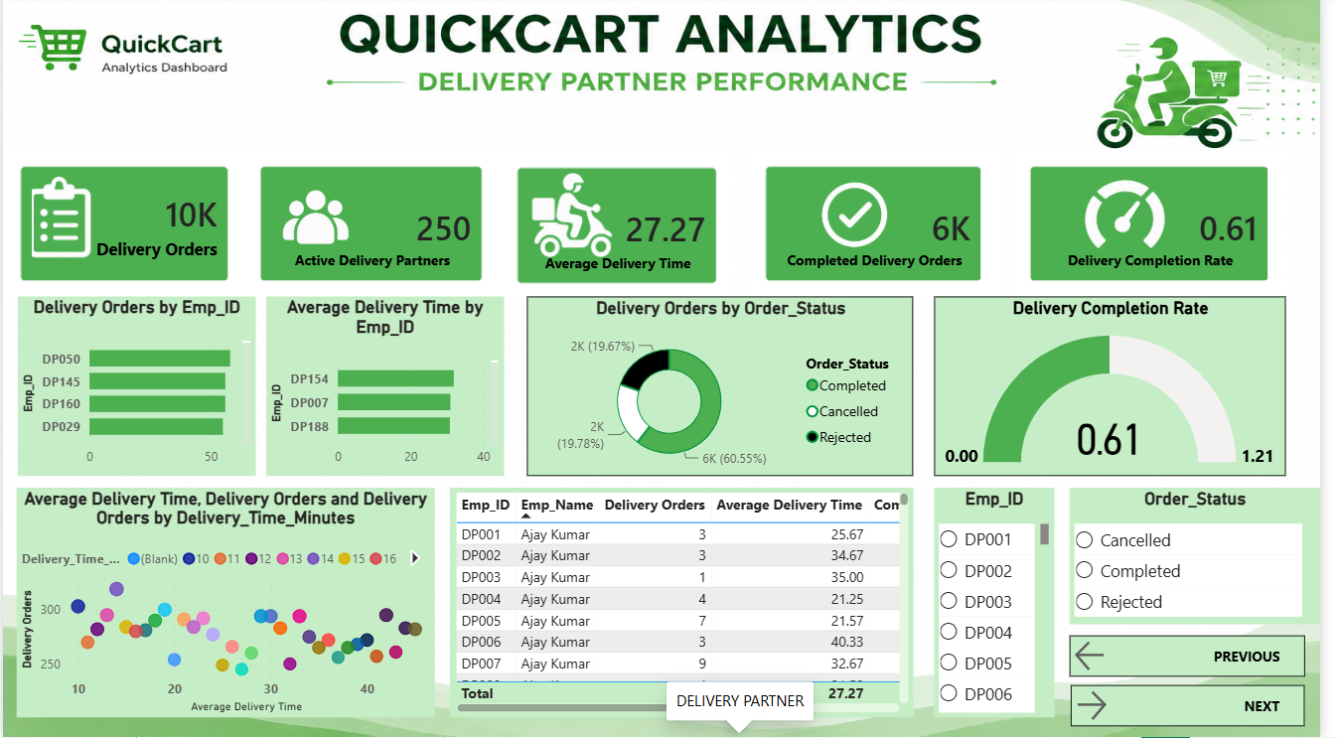
Figure: 7.4 Delivery Partner Performance

7.5 Operations & Business Insights
Management page combining completion, rejection, cancellation, picking, delivery and operational time KPIs with business-insight and recommendation sections.
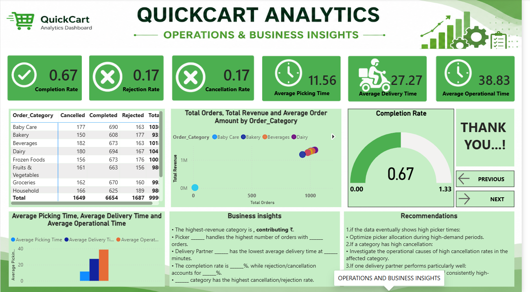
Figure: 7.5 Operations & Business Insights

8. KPI Definitions
KPI | Definition
Total Orders | Total number of orders in the model.
Total Revenue | Revenue generated across orders.
Average Order Amount | Average order value.
Completion Rate | Completed orders relative to total orders.
Rejection Rate | Rejected orders relative to total orders.
Cancellation Rate | Cancelled orders relative to total orders.
Average Picking Time | Average time used by pickers.
Average Delivery Time | Average delivery duration.
Average Operational Time | Operational duration combining picking and delivery measures.
Picker Orders | Orders handled by pickers.
Active Pickers | Number of active pickers.
Average Picker Attendance | Average picker attendance measure.
Total Picker Income | Total picker income.
Orders per Picker | Picker workload measure.
Delivery Orders | Orders handled by delivery partners.
Active Delivery Partners | Number of active delivery partners.
Completed Delivery Orders | Completed delivery workload.
Delivery Completion Rate | Delivery completion performance.

9. Business Insights & Recommendations
The Operations & Business Insights page is intended to convert the dashboard's measured results into management actions. Final insight statements should be derived from the underlying dataset rather than from assumptions. The dashboard supports analysis of category revenue, employee workload, picking efficiency, delivery speed and order-status patterns.
- Optimize picker allocation when workload or picking time indicates an operational imbalance.
- Investigate categories with unusually high rejection or cancellation levels.
- Recognize consistently strong picker and delivery-partner performance.
- Investigate operational bottlenecks reflected in high picking or delivery time.
- Use employee-level performance analysis to balance workload and improve service efficiency.

10. Portfolio Value
This project demonstrates practical skills in SQL, data modeling, ETL, DAX, data visualization, KPI design and business analysis. The dedicated Picker Performance and Delivery Partner Performance pages provide strong evidence of employee-level operational analytics.

11. Repository Structure
The GitHub repository is organized into SQL scripts, the Power BI report, dashboard screenshots, documentation and dataset folders.
QuickCart-Analytics/
├── README.md
├── SQL/
├── PowerBI/
├── Dashboard_Screenshots/
├── Documentation/
└── Dataset/

12. Conclusion
QuickCart Analytics provides a consolidated analytical view of business and operational performance. By integrating SQL Server, Power Query, DAX and Power BI, the project transforms operational data into interactive KPIs and visual analysis suitable for management decision-making and portfolio presentation.

