PROJECT DOCUMENT: Multilingual Chat Decoder using Transformer Architecture

1. PROJECT TITLE
Building a Multilingual Chatbot Decoder from Scratch using Transformer Architecture

2. OBJECTIVE
To build a Transformer-based decoder model capable of generating multilingual chatbot responses trained only on custom data across four languages (English, Hindi, Telugu, Tamil).

3. DATASET PIPELINE
3.1 Data Collection & Extraction
We used four language datasets from custom chat data:
- Hindi-English
- Telugu-English
- Tamil-English
- Plain English
Data Preprocessing Steps:
- Raw chat data from various documents were extracted.
- Irregular formatting and unwanted symbols were removed.
- Each chat line was cleaned, and user-bot dialogues were aligned properly.
3.2 Combining Text
- The cleaned files from the four languages were concatenated into one .txt file: cleaned_combined_chat_data.txt.
- This file serves as the foundation for tokenizer training.
3.3 Byte Pair Encoding (BPE)
- BPE was used to create a tokenizer that learns frequent subwords rather than individual characters.
Technical Example:
Input sentence:
What are you doing?
BPE Tokenizer Output:
['W', 'hat', 'are', 'you', 'doing', '?']
Each subword is mapped to a token ID. For example:
['W', 'hat', 'are', 'you', 'doing', '?'] → [134, 79, 23, 97, 118, 3]

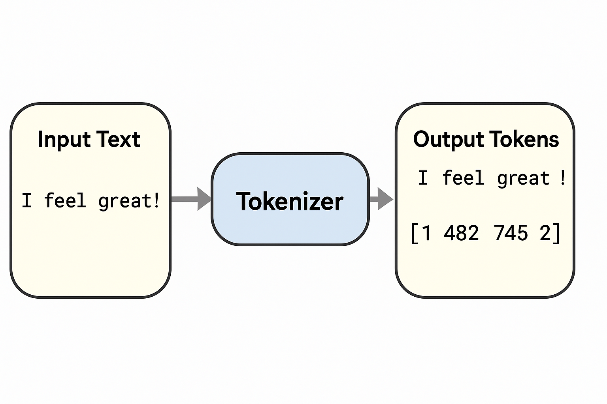

Tokenizer Illustration:
Text → [Subwords] → [Token IDs] → [Vectors]
"How are you?"
↓
['How', 'are', 'you', '?']
↓
[512, 79, 92, 3] (token IDs)
↓
Tensor of size (seq_len, embedding_dim)

4. TOKENIZATION TO ENCODING
Each sentence is tokenized and then encoded to token IDs. These token IDs are then converted to embedding vectors for model input.
Technical Example:
# Convert to token IDs
ids = tokenizer.encode("What are you doing?").ids

# Convert to tensors
tensor = torch.tensor(ids) # Shape: [seq_length]

5. MODEL ARCHITECTURE
The model is a Transformer Decoder built from scratch using PyTorch.
5.1 Architecture Overview:
- Token Embedding
- Positional Embedding
- 6 Transformer Decoder Blocks:
  - Multi-Head Self-Attention (8 heads)
  - LayerNorm
  - FeedForward Network
  - Dropout
- Final LayerNorm
- Linear Output Head
5.2 Architecture Diagram:
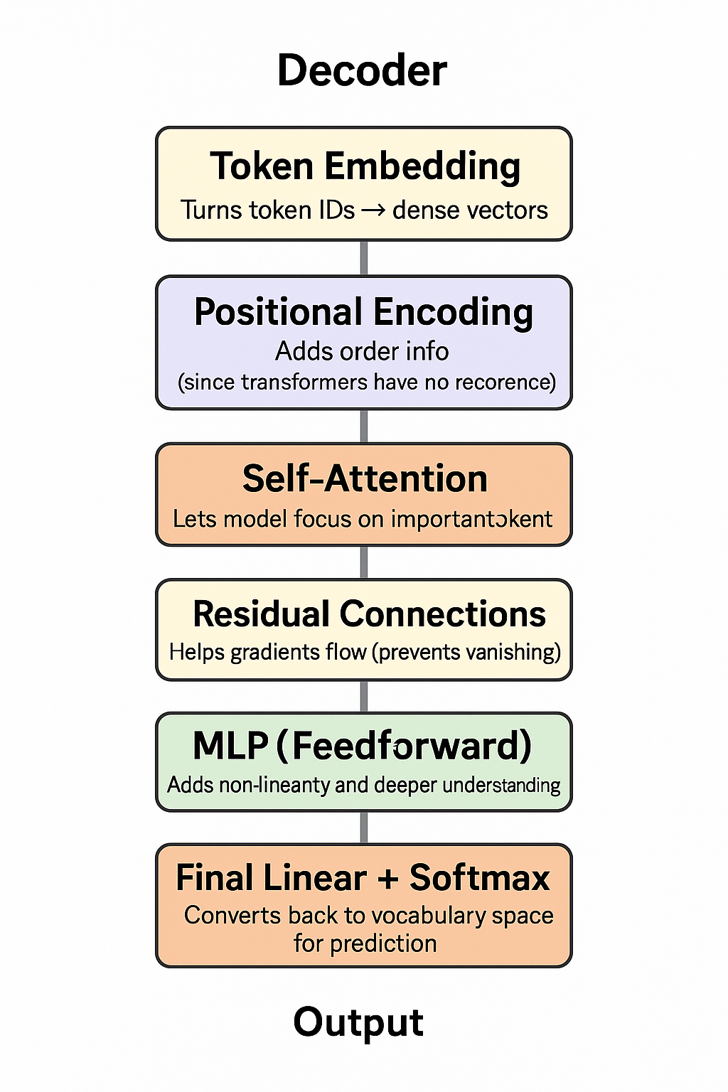
Model Size:
- Parameters: ~29.29M
- Vocab Size: 10,000
- Layers: 6
- Heads: 8
- Embedding Dim: 512
This qualifies as a Mini LLM suitable for targeted multilingual chatbot deployment!

6. TRAINING PIPELINE
6.1 Dataset Preparation
- After BPE tokenization, the sequences were saved as:
np.savez("chat_data_sequences.npz", inputs=inputs, targets=targets)
6.2 Training Setup
model = TransformerDecoderModel(config)
optimizer = torch.optim.AdamW(model.parameters(), lr=3e-4)
6.3 Loss Function
- CrossEntropyLoss (ignoring padding token 0)
- Input and Target tensors are flattened:
logits = logits.reshape(-1, vocab_size)
targets = targets.reshape(-1)
6.4 Output
Model saved as:
torch.save(model.state_dict(), "trained_decoder_model.pth")

7. GENERATION MODULE (generate.py)
The model is evaluated using a generate loop.
input_ids = tokenizer.encode(prompt).ids
for _ in range(max_length):
logits = model(input_tensor)
next_token = sample_from(logits)
input_tensor = torch.cat([input_tensor, next_token], dim=1)

8. STREAMLIT DEPLOYMENT
8.1 Interface Setup
st.title("Multilingual Chatbot")
user_input = st.text_input("You:")
if st.button("Generate"):
response = generate_text(user_input)
st.write(f"Bot: {response}")
8.2 Hosting
- Run using streamlit run app.py
- Can be deployed on platforms like Streamlit Cloud or Vercel
Output:
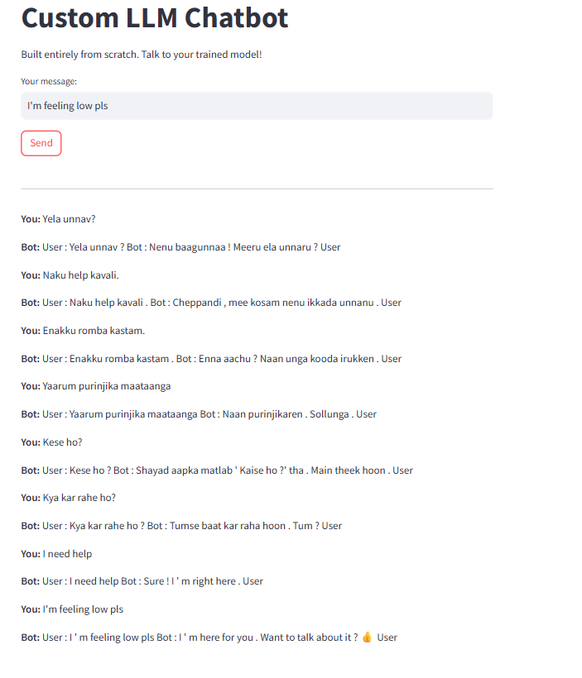

9. FILE STRUCTURE
project/
├── cleaned_combined_chat_data.txt
├── bpe_tokenizer.json
├── chat_data_sequences.npz
├── transformer_decoder_model.py
├── trained_decoder_model.pth
├── generate.py
├── app.py (Streamlit Interface)

10. CONCLUSION
This multilingual chatbot decoder is custom-built from scratch using a transformer decoder architecture, trained solely on custom chat data in 4 languages. It is lightweight, flexible, and suited for edge use-cases like low-resource NLP applications.
It is a Mini LLM, trained only on task-specific multilingual chatbot data, and small enough to run without cloud GPUs.

Prepared by: Dinesh Narasimhan
Technologies Used: PyTorch, Tokenizers, NumPy, Streamlit

