DESIGN SYSTEM V2
Production Alignment Plan
A simple team-review guide for moving the target UI into production without carrying static data, mock APIs, or outdated business logic.
Status | Draft for team review
Date | 24 August 2026
Decision needed | Approve the migration approach before implementation
ONE DECISION: The latest main branch remains the production foundation. The feature branch is the target UI and design reference. We will not merge the feature branch wholesale.

1. What we are trying to achieve
The final product must look and behave like feat/design-system-v2-migration, while continuing to use the architecture, real CMS data, real APIs, stores, containers, and production fixes from main.
Keep from main | Bring from feature branch | Do not ship to production
Real CMS/API flow | Theme tokens and ThemeProvider | Static brand CMS fixtures
Stores, containers, routes | DS primitives and components | Mock API servers
Business rules and fixes | Approved DS UI variants | Gallery preview/sample data
Current production contracts | Required new production modules | Brand switcher in production

2. The complete flow
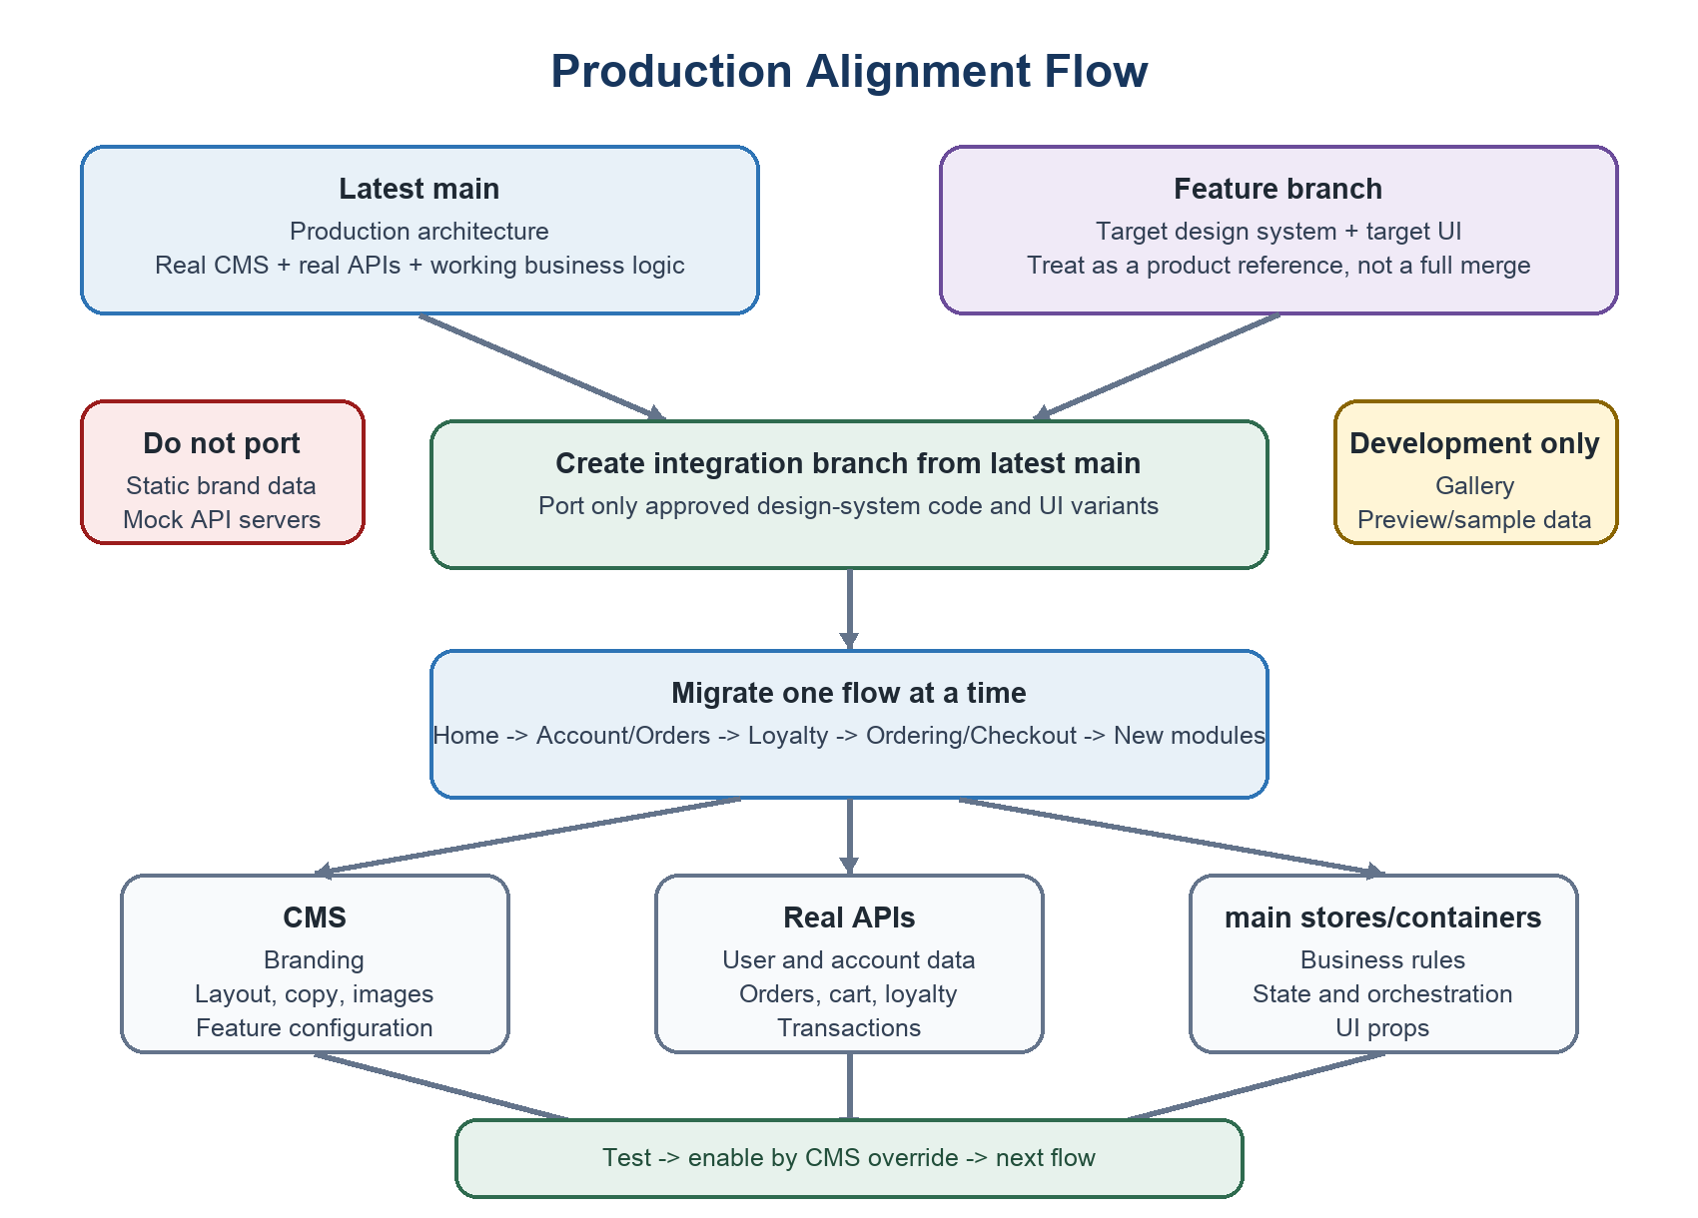
Figure 1. Start from main, port the UI, replace every static source, and enable one verified flow at a time.

3. Where every type of data must come from
Use this rule whenever a component currently contains static values or mock responses.
Data type | Production owner | Examples | Rule
Brand/content configuration | CMS | Colors, fonts, copy, images, layout, component selection | Never hardcode in production UI.
Business/user data | Real backend API | Profile, cart, orders, loyalty, rewards, inbox messages | Never read from fixtures or mock servers.
Application state | lib-core store/container | Loading, selection, session, orchestration, cached API state | UI receives plain props.
UI-only state | lib-rn component | Open/closed, active tab, animation progress | No business rules or API calls.
STOP RULE: If a screen has no real CMS model or backend API, do not migrate that screen to production yet. Create the contract and real integration first.

4. Where bugs, crashes, and logic fixes must be made
Issue found | Fix location | When | Reason
Existing production/business-logic bug | main | Immediately, before migrating that flow | main owns production behavior.
Design-system/theme/UI bug | integration branch | While porting that component | The issue belongs to the new UI.
CMS/API/store-to-DS connection bug | integration branch | During flow integration | It only exists at the new boundary.
Static fixture or mock-server bug | Usually do not fix | Remove/replace during migration | The mock code will not ship.
New module without a real API | Backend/CMS first | Before UI migration | Production UI cannot depend on mock data.
Critical production crash also present in main | main first, then port/retest | Highest priority | Avoid two conflicting fixes.

Simple issue decision
- Does the same bug exist in main? Fix it in main first.
- Does it exist only in the DS component? Fix it in the integration branch.
- Is it caused by static or mock data? Replace the data source; do not repair the mock as production code.
- Does the feature have no real API or CMS model? Stop and build that contract first.

5. Step-by-step execution plan

Step 1 - Prepare
Create a new integration branch from the latest main. Freeze direct feature work during the first inventory. Record every static fixture, mock API, hardcoded component value, known crash, and missing main commit.

Step 2 - Stabilize main
Fix existing business-logic and production crashes in main. Confirm current CMS/API behavior. Merge and test those fixes before porting the affected DS flow.

Step 3 - Port the DS foundation
Move only the theme contracts, resolver, ThemeProvider, DS primitives, shared components, and focused tests. Do not port BrandRuntime, brand fixtures, mock backends, or gallery preview data into the production entrypoint.

Step 4 - Migrate one flow
Connect the selected DS variant to main containers, stores, routes, CMS models, and backend APIs. Preserve the current prop and behavior contract wherever possible.

Step 5 - Test and enable
Test real loading, empty, success, error, offline, signed-in, and signed-out states. Enable the DS variant with a CMS component override only after it matches main behavior.

Step 6 - Repeat
Move to the next flow only after the current flow passes its exit gate. Do not migrate multiple high-risk flows together.

Step 7 - Production hardening
Disable/remove all production mock switches, verify no static business data remains, run builds and regression tests, execute a staged rollout, and retain the legacy component override as rollback.

6. Recommended flow order
Order | Flow | Why now | Risk
1 | DS foundation and base components | Required by every migrated screen | Medium
2 | Home | Mostly read-only CMS-driven composition | Medium
3 | Account and Orders | Good validation of auth/read-only API flows | Medium
4 | Loyalty | More business rules and conditional states | High
5 | Ordering, Cart, Checkout, Payment | Money and transaction critical | Critical
6 | Inbox, Market, Stories, Passport, Promos, Earn | Only after real CMS/API readiness | Variable

7. The migration loop for every flow
- Select one screen or component family.
- Write down its current main behavior and data sources.
- Identify every static value or mock response used by the feature version.
- Map configuration/content to CMS and business/user data to a real API.
- Connect main stores and containers to the DS component through typed props.
- Fix main bugs in main; fix DS/integration bugs in the integration branch.
- Test all real states and compare with main behavior.
- Enable through CMS override for a limited rollout.
- Monitor, then keep or roll back the override.

Flow exit gate
- No static business/content data in the production path.
- No mock API called by the production path.
- CMS and backend contracts are documented and implemented.
- Main behavior and business rules are preserved or intentionally approved.
- Loading, empty, error, offline, auth and success states work.
- Type checks, package boundaries, builds and focused tests pass.
- CMS override can enable and roll back the new component safely.

8. Team ownership
Owner | Responsible for | Must provide before UI enablement
CMS + Backend | CMS models/content plus real endpoints, authorization and transactional rules | Published schemas, real data, API contracts and test environment
lib-core + lib-rn/DS | Stores, containers, routing, typed props, tokens, components and accessibility | Working integration that preserves behavior and contains no UI-side API logic
QA + Product | Parity, regression, failure states, rollout and release acceptance | Signed exit gate and rollout approval

9. Final definition of done
FINAL PRODUCT: Latest main architecture + real CMS + real APIs + main business logic + Design System v2 UI. No production mocks, no static business data, no production gallery/switcher, and no loss of current behavior.

- The approved feature-branch design is delivered using real production contracts.
- All critical main fixes are present and every value has a CMS, API, store, or UI-only owner.
- The release is approved, monitored, and safely reversible through CMS component overrides.

