

**CrunchyStreamDB**

**Anime Streaming Platform Database System**

**Dinesh Saladi**

**Project Overview**

The goal of this project is to design and implement an Anime Streaming Platform Database System (CrunchyStreamDB) that:

* Provides secure and centralized management of anime content, users, reviews, and viewing history.
* Maintains detailed records of anime series, seasons, episodes, audio tracks, and associated metadata.
* Enables users to stream episodes and automatically track watch history.
* Supports multi-language audio tracks and organizes anime into structured seasons and episodes.
* Allows users to write reviews and assign ratings to anime titles.
* Manages subscription-based access and validates user activity based on their subscription level.
* Facilitates admin control for adding new anime, episodes, and studio details.
* Ensures efficient content search and recommendation features based on watch history and reviews.
* Restricts system access to authenticated users and supports role-based access (admin, user).
* Provides a scalable structure to handle millions of users and an ever-growing anime library.

The proposed system aims to replicate the functionality of major streaming platforms by maintaining robust relational integrity, reducing data redundancy, and improving accessibility to anime content. The database supports content discovery, user interaction, and personalized experience.

**Scope and Benefits:**

* The system allows management of Users, Anime Titles, Seasons, Episodes, Studios, Audio Tracks, Reviews, and Watch History.
* Weak entities like Episode, Season, AudioTrack depend on parent entities with composite keys for uniqueness.
* Relationship attributes capture metadata like timestamped watch history and user-submitted reviews.
* The design supports multi-season, multi-language streaming and episode-level interactions, crucial for large anime platforms.

The final solution is presented as:

* An Entity-Relationship (ER) Diagram to model the relationships and dependencies between entities.
* A Relational Database Implementation using Oracle SQL with support for indexing, triggers, and constraints for consistency and performance.

**Scalability and Future Scope:**

CrunchyStreamDB is built to scale with content expansion and user growth. Future enhancements could include:

* Genre-based classification and filtering.
* Recommendation systems using collaborative filtering.
* Live streaming events and simulcast support.
* Integration with payment gateways for premium subscriptions.
* Analytics dashboards for content performance and user engagement.

This is not a final database system but a foundational structure that is **flexible and extensible**. As a core part of an anime streaming ecosystem, CrunchyStreamDB offers a reliable and efficient backend for delivering high-quality streaming experiences.

**ENTITY RELATIONSHIP DIAGRAM**

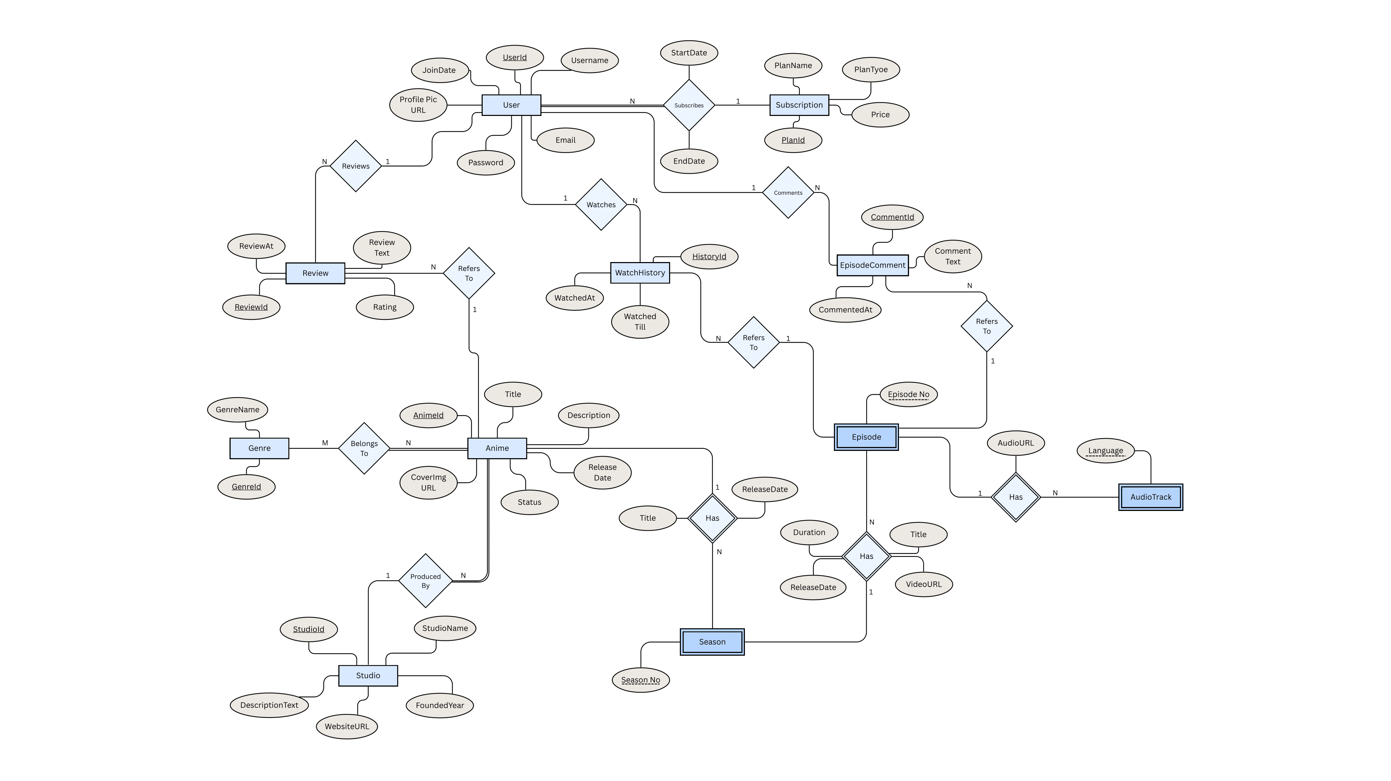

**Entities**

* **User**

Stores information about users such as username, email, and profile details.

* **Subscription**

Contains subscription plan details like name, type (Fan, Mega Fan), and price.

* **Anime**

Stores metadata about each anime like title, release date, and status.

* **Genre**

Represents different genres like Action, Fantasy, Drama, etc.

* **Studio**

Represents studios responsible for producing anime, with details and website.

* **Season**

Weak entity representing a season of an anime (SeasonNo per AnimeId).

* **Episode**

Weak entity representing an episode in a season of an anime.

* **AudioTrack**

Weak entity representing different language audio tracks per episode.

* **WatchHistory**

Logs episodes watched by users with timestamp and duration progress.

* **Review**

Stores user-written reviews and ratings for animes.

* **EpisodeComment**

Allows users to comment on specific episodes of anime.

**Relationships**

* **User subscribes to Subscription (M:N)**  
  A user can subscribe to multiple plans over time (history), and each subscription plan can be used by many users. Tracked via the Subscribes relationship with StartDate and EndDate.
* **User watches Episode (via WatchHistory) (1:N)**A user can watch many episodes at different times, but each watch history record belongs to only one user.
* **WatchHistory refers to Episode (N:1)**Each watch record is for a specific episode, but each episode can appear in many users' watch histories.
* **User writes Review (1:N)**A user can write many reviews, each tied to one anime.
* **Review refers to Anime (N:1)**Each review is about one anime, but an anime can have many reviews.
* **User posts EpisodeComment (1:N)**A user can post multiple comments, but each comment is made by one user.
* **EpisodeComment refers to Episode (N:1)**A comment is attached to a specific episode, but an episode can have many comments.
* **Anime has Season (1:N)**Each anime can have multiple seasons. A season belongs to one anime only.
* **Season has Episode (1:N)**A season contains many episodes. Each episode belongs to exactly one season.
* **Episode has AudioTrack (1:N)**Each episode can have multiple audio tracks (e.g., English, Japanese). One audio track is for a specific episode only.
* **Anime belongs to Genre (via Belongs To) (M:N)**  
  An anime can belong to multiple genres, and a genre can include multiple anime titles.
* **Anime is produced by Studio (N:1)**  
  Each anime is produced by one studio, but one studio can produce many animes.