Alumni Influencers API
Endpoint Documentation

Version 1.0.0
Developer: Phantasmagoria Ltd
Base URL: http://localhost:3000/api
1. System Overview 4
2. Authentication & Security 6
2.1 Bearer JWT Token 6
2.2 API Key 6
2.3 Email Verification 6
2. Authentication Endpoints 7
2.1 Register 7
Validation Rules 7
Request Body 7
Response — 200 OK 7
Error Responses 7
2.2 Login 8
Request Body 8
Response — 200 OK 8
Error Responses 8
3. Profile Management 9
3.1 Get My Profile 9
Authentication 9
Response — 200 OK 9
3.2 Create / Update Profile 10
Authentication 10
Supported Fields 10
Degree Object 10
3.3 Upload Profile Photo 10
Authentication 10
Request 10
Constraints 11
4. Bidding System 11
4.1 Place / Increase Bid 11
Authentication 11
Request Body 11
Request Parameters 11
Response — Winning Bid (200 OK) 11
Response — Outbid (200 OK) 12
4.2 Check Bid Status 12
Authentication 12
Response Fields 12
4.3 Bid History 13
Authentication 13
5. Public Client API (AR Client) 13
5.1 Get Alumni of the Day 13
Authentication 13
Response — 200 OK 13
Error Responses 14
6. Admin Management 14
6.1 Generate API Key 14
Authentication 14
Request Body 14
Response — 201 Created 14
6.2 List All API Keys 15
Authentication 15
Response — 200 OK 15
6.3 Deactivate (Revoke) API Key 15
Authentication 15
Path Parameters 15
Response — 200 OK 15
6.4 Activate API Key 16
Authentication 16
Path Parameters 16
Response — 200 OK 16
6.5 Get API Key Usage Stats 16
Authentication 16
Path Parameters 16
Response — 200 OK 16
6.6 List Global Usage Logs 17
Authentication 17
Response — 200 OK 17
7. Standard Error Codes 17
8. Endpoint Quick Reference 18

System Overview
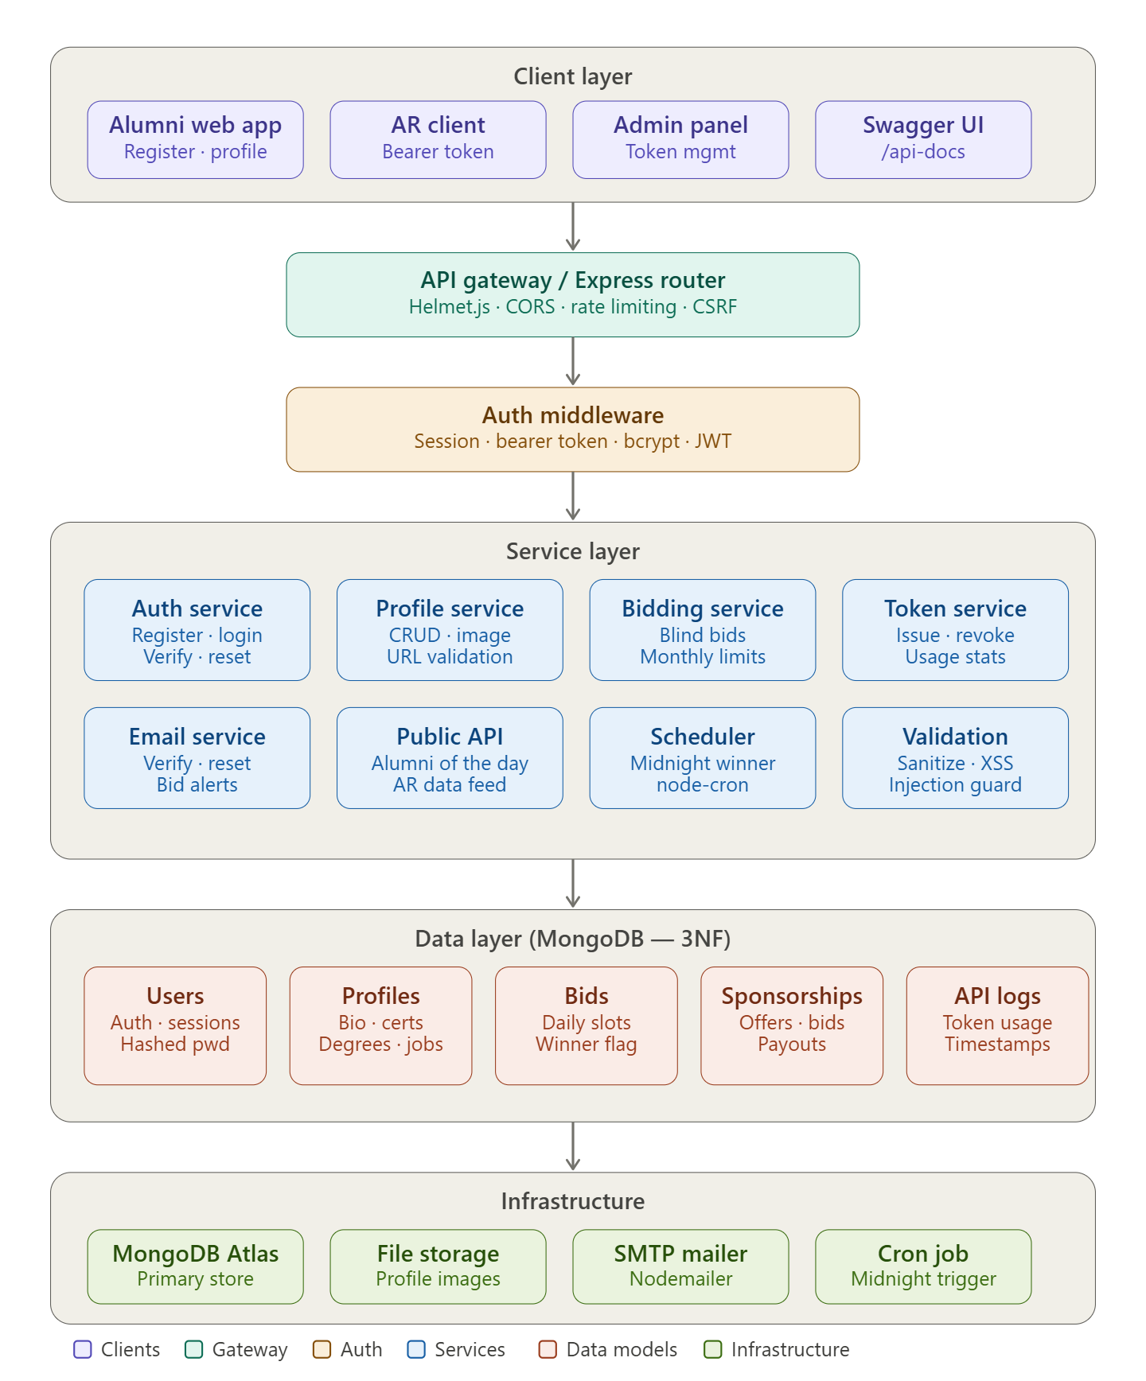

Client layer — four distinct consumer types: the alumni web app (for registration and profile management), the AR client (the external consumer that uses bearer tokens), an admin panel for token management and usage stats, and Swagger UI for the public developer API at /api-docs.
API gateway — all requests pass through Express middleware enforcing Helmet.js security headers, CORS configuration, rate limiting on sensitive endpoints, and CSRF protection. This maps directly to the Security Implementation section.
Auth middleware — sits between the gateway and the services, handling session validation, bearer token verification, bcrypt password checks, and JWT processing. Every service call is authenticated before it proceeds.
Service layer — the business logic split across eight focused services. Notably the Bidding service encapsulates blind-bidding logic (no highest bid exposed), monthly limit tracking, and the Scheduler service runs a node-cron job at midnight to automatically select the winner and mark their profile.
Data layer — five MongoDB collections are structured to 3NF as required. The Bids collection carries the winner flag used by the public API. API Logs tracks token usage, endpoints accessed, and timestamps for the admin stats view.
Infrastructure — the supporting services including MongoDB for persistence, a file store for profile image uploads, Nodemailer for the email verification/reset/notification flows, and the cron trigger for automated winner selection.

Authentication & Security
The API uses two types of authentication depending on the endpoint:

2.1 Bearer JWT Token
Most protected endpoints require a JSON Web Token (JWT) passed in the Authorization header.
Obtain via: POST /auth/login
Header: Authorization: Bearer <your_token>

2.2 API Key
Used specifically for the Public Client API (e.g., AR application). API keys are generated by administrators.
Obtain via: POST /admin/apikeys (Admin only)
Header: x-api-key: <your_api_key>

2.3 Email Verification
All newly registered accounts must verify their email address before being permitted to log in. Verification emails are sent automatically upon registration and must originate from a recognised university domain.

2. Authentication Endpoints
These endpoints handle user registration, login, and account verification. No authentication token is required to access them.

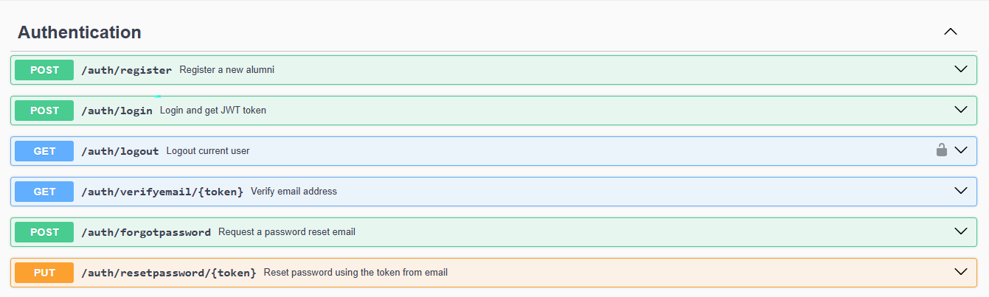

2.1 Register
[POST] /auth/register
Creates a new user account. A verification email is automatically sent on success.

Validation Rules
- Email must be a recognised university address (.ac.uk or .edu domain)
- Password must contain at least one uppercase letter, one number, and one special character

Request Body
Field | Example | Required
email | john.smith@eastminster.ac.uk | Yes
password | Secure@Pass1! | Yes

Response — 200 OK
{
"success": true,
"message": "Registration successful. Please check your email to verify your account."
}

Error Responses
Status | Description | Notes
400 | Invalid email domain or password format | -
409 | Email address already registered | -

2.2 Login
[POST] /auth/login
Authenticates a verified user and returns a JWT bearer token.

Request Body
Field | Example | Required
email | john.smith@eastminster.ac.uk | Yes
password | Secure@Pass1! | Yes

Response — 200 OK
{
"success": true,
"token": "eyJhbGciOiJIUzI1NiIsInR5cCI6IkpXVCJ9..."
}

Error Responses
Status | Description | Notes
401 | Invalid credentials | -
403 | Account not yet verified | -

3. Profile Management
All profile endpoints are protected and require a valid Bearer JWT token. These endpoints allow users to view and update their public alumni profile, including degrees, employment history, and profile photo.

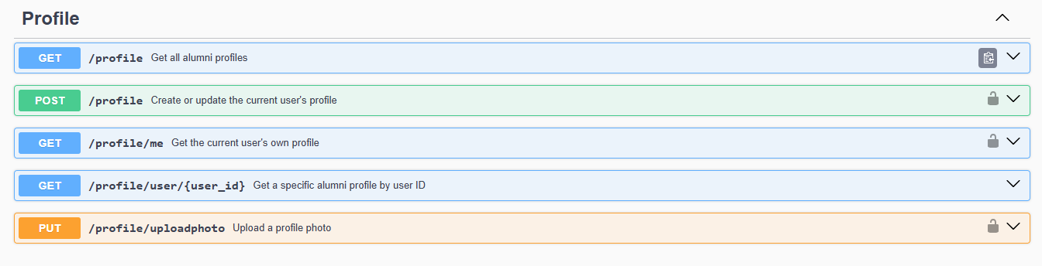

3.1 Get My Profile
[GET] /profile/me
Returns the full profile and appearance history of the currently authenticated user.

Authentication
Bearer Token required.

Response — 200 OK
{
"success": true,
"data": {
"firstName": "John",
"lastName": "Smith",
"bio": "Software Engineer specialized in AI.",
"profileImage": "http://localhost:3000/uploads/file-123.jpg",
"appearanceCount": 3,
"bonusSlotAvailable": false,
"degrees": [
{
"degreeTitle": "BSc Computer Science",
"university": "University of Eastminster",
"completionDate": "2022-06-15"
}
]
}
}

3.2 Create / Update Profile
[POST] /profile
Creates or updates the authenticated user's profile. Supports nested objects for degrees and employment history.

Authentication
Bearer Token required.

Supported Fields
Field | Example | Required
firstName | John | Yes
lastName | Smith | Yes
bio | Software Engineer specialized in AI. | No
degrees | Array of degree objects | No
employment | Array of employment objects | No

Degree Object
Field | Example | Required
degreeTitle | BSc Computer Science | Yes
university | University of Eastminster | Yes
completionDate | 2022-06-15 | Yes

3.3 Upload Profile Photo
[PUT] /profile/uploadphoto
Uploads or replaces the authenticated user's profile image. Uses multipart/form-data encoding.

Authentication
Bearer Token required.

Request
Field | Accepted Types | Required
file | image/jpeg, image/png | Yes

Constraints
- Maximum file size: 1 MB
- Field name must be: file
- Content-Type header must be: multipart/form-data

4. Bidding System
The bidding system allows authenticated alumni to compete for the coveted "Alumni of the Day" spotlight slot. Bidding is blind — participants cannot see competing bids. The highest bidder at the daily cut-off wins the slot for the following day.

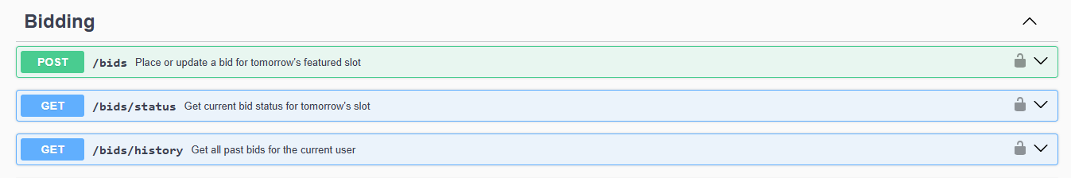

4.1 Place / Increase Bid
[POST] /bids
Places a new bid or increases an existing bid for tomorrow's Alumni of the Day slot. Each user may only hold one active bid at a time; submitting a higher amount replaces the previous bid.

Authentication
Bearer Token required.

Request Body
{ "amount": 250.00 }

Request Parameters
Field | Example | Required
amount | 250.00 | Yes

Response — Winning Bid (200 OK)
{
"success": true,
"data": {
"bidAmount": 250.0,
"currency": "GBP",
"bidStatus": "Winning",
"message": "You are currently the highest bidder for tomorrow's slot!",
"remainingWinsThisMonth": 2
}
}

Response — Outbid (200 OK)
{
"success": true,
"data": {
"bidAmount": 250.0,
"currency": "GBP",
"bidStatus": "Outbid",
"message": "Your bid has been placed but you are currently outbid.",
"remainingWinsThisMonth": 2
}
}

4.2 Check Bid Status
[GET] /bids/status
Returns the authenticated user's current bid status for tomorrow's slot without placing or modifying a bid.

Authentication
Bearer Token required.

Response Fields
Field | Example | Description
bidStatus | Winning / Outbid / NoBid | Current position in the blind auction
bidAmount | 250.00 | User's current bid in GBP
remainingWinsThisMonth | 2 | How many more wins are allowed this month

4.3 Bid History
[GET] /bids/history
Returns a full list of all previous bids placed by the authenticated user, including outcomes.

Authentication
Bearer Token required.

5. Public Client API (AR Client)
These endpoints are designed for consumption by external client applications such as the AR (Augmented Reality) kiosk. Authentication is performed via an API key rather than a user JWT token.

5.1 Get Alumni of the Day
[GET] /client/alumni-of-the-day
Returns the current day's winning alumnus profile for display in client applications.

Authentication
API Key required in request header:
x-api-key: <your_api_key>

Response — 200 OK
{
"success": true,
"data": {
"firstName": "John",
"lastName": "Smith",
"bio": "Software Engineer specialized in AI.",
"profileImage": "http://localhost:3000/uploads/file-123.jpg",
"degrees": [
{
"degreeTitle": "BSc Computer Science",
"university": "University of Eastminster",
"completionDate": "2022-06-15"
}
]
}
}

Error Responses
Status | Description | Notes
401 | Missing or invalid API key | -
404 | No alumni of the day found for today | -

6. Admin Management
Admin endpoints are restricted to users with the administrator role. These endpoints allow management of API keys issued to client applications and provide usage analytics.

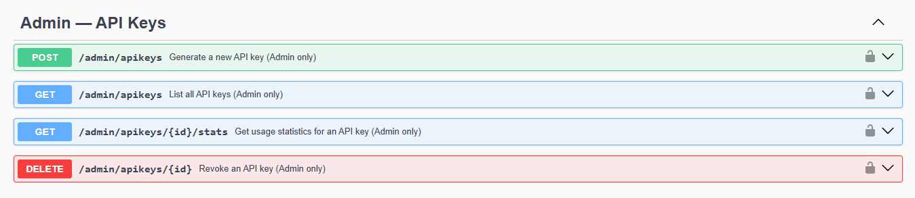

6.1 Generate API Key
[POST] /admin/apikeys
Generates a new API key that can be issued to a client application (e.g., AR kiosk).

Authentication
Bearer Token required (Admin role).

Request Body
Field | Example | Required
label | AR Kiosk - Main Hall | Yes
expiresAt | 2026-12-31 | No

Response — 201 Created
{
"success": true,
"data": {
"id": "key_abc123",
"apiKey": "pk_live_xxxxxxxxxxxxxxxx",
"label": "AR Kiosk - Main Hall",
"createdAt": "2025-01-15T10:30:00Z"
}
}

6.2 List All API Keys
[GET] /admin/apikeys
Returns a list of all generated API keys and their current activation status.

Authentication
Bearer Token required (Admin role).

Response — 200 OK
{
"success": true,
"data": [
{
"_id": "69a2ba49dc1074d860c1e975",
"name": "AR Mobile Client",
"isActive": true,
"createdAt": "2026-02-28T09:00:00.000Z"
}
]
}

6.3 Deactivate (Revoke) API Key
[DELETE] /admin/apikeys/:id
Immediately disables an API key. Any subsequent requests using this key will be rejected.

Authentication
Bearer Token required (Admin role).

Path Parameters
Parameter | Example | Required
:id | 69a2ba49dc1074d860c1e975 | Yes

Response — 200 OK
{
"success": true,
"message": "API Key revoked"
}

6.4 Activate API Key
[PUT] /admin/apikeys/:id/activate
Re-enables a previously revoked API key, restoring access for the associated client application.

Authentication
Bearer Token required (Admin role).

Path Parameters
Parameter | Example | Required
:id | 69a2ba49dc1074d860c1e975 | Yes

Response — 200 OK
{
"success": true,
"message": "API Key activated"
}

6.5 Get API Key Usage Stats
[GET] /admin/apikeys/:id/stats
Returns hit counts, timestamps, and IP addresses for a specific API key.

Authentication
Bearer Token required (Admin role).

Path Parameters
Parameter | Example | Required
:id | 69a2ba49dc1074d860c1e975 | Yes

Response — 200 OK
{
"success": true,
"data": {
"name": "AR Client v1",
"usageCount": 142,
"usageStats": [
{
"date": "2026-02-28T10:00:00.000Z",
"endpoint": "/api/client/alumni-of-the-day",
"method": "GET"
}
]
}
}

6.6 List Global Usage Logs
[GET] /admin/logs
Returns centralised usage logs for all API keys across the platform.

Authentication
Bearer Token required (Admin role).

Response — 200 OK
{
"success": true,
"count": 100,
"data": [
{
"apiKey": "69a2ba49dc1074d860c1e975",
"endpoint": "/api/client/alumni-of-the-day",
"method": "GET",
"timestamp": "2026-02-28T10:00:00.000Z"
}
]
}

7. Standard Error Codes
All endpoints return errors in a consistent JSON format. The table below summarises the common HTTP status codes used throughout the API.

Code | Status | Description
200 | OK | Request completed successfully.
201 | Created | Resource was created successfully.
400 | Bad Request | Missing or invalid request data.
401 | Unauthorized | Missing, expired, or invalid authentication credential.
403 | Forbidden | Authenticated but insufficient permissions.
404 | Not Found | The requested resource does not exist.
409 | Conflict | Resources already exist (e.g. duplicate email).
413 | Payload Too Large | Uploaded file exceeds the maximum size limit.
500 | Internal Server Error | An unexpected server-side error occurred.

8. Endpoint Quick Reference
The table below summarizes all available endpoints, their HTTP methods, authentication requirements, and a brief description.

Method | Endpoint | Auth | Description
POST | /auth/register | None | Register new user account
POST | /auth/login | None | Login and receive JWT token
GET | /profile/me | Bearer Token | Get own profile + history
POST | /profile | Bearer Token | Create or update profile
PUT | /profile/uploadphoto | Bearer Token | Upload profile photo
POST | /bids | Bearer Token | Place or increase bid
GET | /bids/status | Bearer Token | Check current bid status
GET | /bids/history | Bearer Token | View all previous bids
GET | /client/alumni-of-the-day | API Key | Get today's winning alumni
POST | /admin/apikeys | Bearer Token (Admin) | Generate new API key
GET | /admin/apikeys | Bearer Token (Admin) | List all API keys
DELETE | /admin/apikeys/:id | Bearer Token (Admin) | Revoke an API key
PUT | /admin/apikeys/:id/activate | Bearer Token (Admin) | Activate a revoked key
GET | /admin/apikeys/:id/stats | Bearer Token (Admin) | View API key usage stats
GET | /admin/logs | Bearer Token (Admin) | List global usage logs

