Mini Project Report
SRM INSTITUTE OF SCIENCE AND TECHNOLOGY
College of Engineering and Technology
Department of Electronics and Communication Engineering
21ECC211L / Devices and Digital IC Lab
III Semester, 2025- 26 (Odd Semester)

Lab code & Title: 21ECC211L/ Devices and Digital IC Lab

Year & Semester: 2nd year & 3rd semester

Project Title: Water Level Indicator using NOT Gate

Lab Supervisor: Dr. Debanjan Sarkar

Team Members Registration No & Name: S Pradeep Kumar - RA2411053010086, M Dinesh Kumar – RA2411053010096, K U Ranjith Kumar – RA2411053010102

Reg. No & Name | S PRADEEP KUMAR  RA2411053010086 | M DINESH KUMAR  RA2411053010096 | K U RANJITH KUMAR  RA2411053010102
Mark split up | S PRADEEP KUMAR  RA2411053010086 | M DINESH KUMAR  RA2411053010096 | K U RANJITH KUMAR  RA2411053010102
Novelty of the project
(10 marks)
Level of understanding of the Project (5 marks)
Contribution of the
Project Work (5 Marks)
Project Report
(10 Mark)
Total (30 Marks)

REPORT VERIFICATION

Date: Signature of Lab Supervisor

ABSTRACT:
The Water Level Indicator using NOT Gate is a simple, yet effective electronic project designed to monitor and indicate the level of water in a tank. The circuit utilizes the inverting property of the NOT gate (IC 7404) to detect and display different water levels through LED indicators. When the water reaches specific probe levels inside the tank, the NOT gate changes its output state, activating corresponding LEDs to show whether the tank is low, half-filled, or full.
This project demonstrates the practical application of digital logic gates in real-life automation systems. It helps prevent water wastage by providing a clear indication of the water level, allowing users to manually or automatically control the water pump. The circuit is cost-effective, easy to construct, and serves as a valuable learning tool for understanding the basic principles of logic gates and their applications in electronic control systems.
INTRODUCTION:
Water is one of the most essential resources in our daily life. However, excessive wastage often occurs due to overflow of tanks. To prevent this, a Water Level Indicator circuit can be used to automatically indicate the water level in a tank using logic gates.
Water is one of the most essential resources in our daily life. However, excessive wastage often occurs due to overflow of tanks. To prevent this, a Water Level Indicator circuit can be used to automatically indicate the water level in a tank using logic gates.
CIRCUIT DIAGRAM:
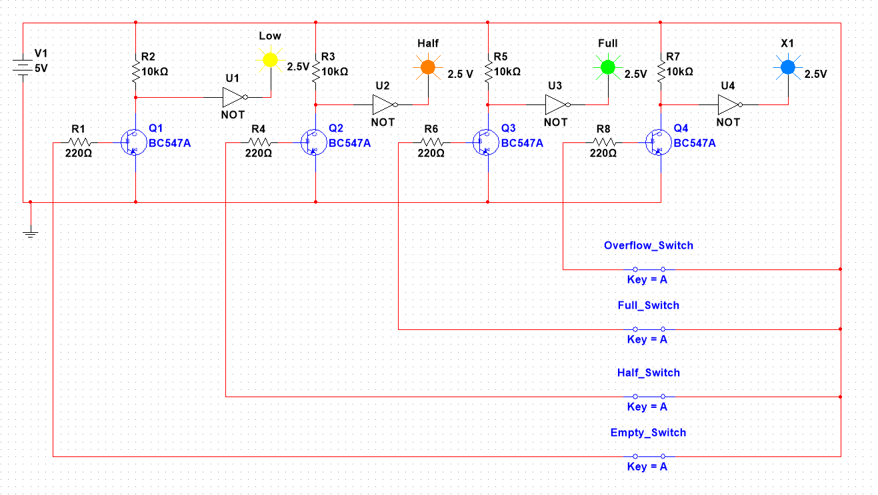
FIGURE.01 Circuit Diagram of Water level indicator with NOT gate
HARDWARE COMPONENTS:
1) IC 7404
2) BC 547 Transistor x 4
3) Resistor (10k-ohm x 4, 220-ohm x 4)
4) Breadboard.
5) Jumper Wire.
6) LED x 4
7) 9V Battery
8) 7805 Voltage Regulator

WORKING PRINCIPLES:
The circuit works on the inverting property of the NOT gate.
- The probes are placed at different water levels (Low, Medium, and High).
- When the water touches a probe, it completes the circuit through the water’s conductivity, providing a logic HIGH signal.
- The NOT gate inverts this signal to logic LOW, which turns ON the LED to indicate the presence of water.
- When water does not touch the probe, the input remains LOW and the NOT gate output is HIGH (LED OFF).
Thus, LEDs glow according to the level of water — showing which level has been reached.

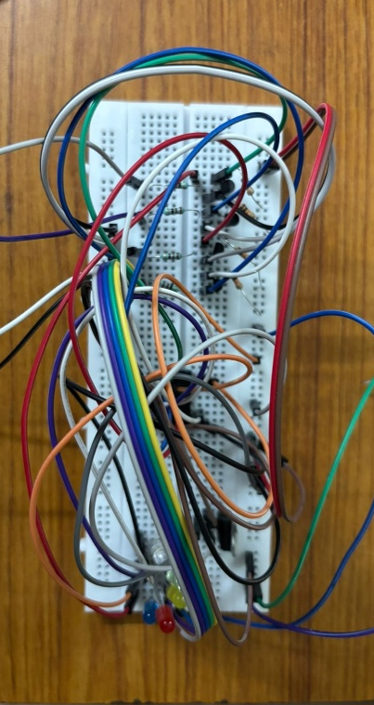
FIGURE.02 Working Model using Breadboard

APPLICATIONS:
• Used in household water tanks to indicate water level.
• In industrial tanks to monitor chemical or liquid levels.
• Prevents overflow and wastage of water.
• Helps in automatic motor control systems (when combined with relays).
ADVANTAGES:
The Water Level Indicator using NOT Gate offers several significant advantages. It is a simple, low-cost, and reliable circuit that can be easily constructed using basic electronic components. Since it operates on low voltage and consumes very little power, it is highly energy-efficient and safe to use. The circuit provides a clear visual indication of water levels, which helps users prevent tank overflow and unnecessary wastage of water. Its design is compact and easy to install, making it suitable for both household and industrial applications. Moreover, the project serves as an excellent learning experiment for understanding logic gate operations and digital circuit applications in practical systems.

REAL LIFE CONSTRAINTS:
While the Water Level Indicator using NOT Gate is a simple and effective circuit, it faces certain real-life constraints during practical implementation. The system depends on the conductivity of water to complete the sensing circuit, which means it may not function properly with non-conductive or highly purified water. Over time, corrosion or scaling can occur on the probe surfaces due to constant contact with water, leading to inaccurate readings or malfunction. The circuit also requires a stable DC power supply, and voltage fluctuations may affect its operation. Environmental factors such as temperature, humidity, and impurities in water can influence the sensing accuracy. Additionally, the system lacks automatic control; it only provides an indication without directly switching the motor on or off. Therefore, to overcome these limitations, regular maintenance and potential upgrades (like sensor-based or microcontroller control) are necessary for long-term, real-world use.

RESULT:

The Water Level Indicator using NOT Gate provides an efficient and reliable method to monitor water levels using basic logic circuits. It demonstrates how simple digital components can solve practical real-world problem.
This project enhances understanding of logic gates, digital circuits, and their real-life applications.

REFERENCES:

- M. Morris Mano, Digital Logic and Computer Design, Prentice Hall of India, 2017.
- R.P. Jain, Modern Digital Electronics, McGraw Hill Education, 4th Edition, 2010.
- Sedra, A.S. and Smith, K.C., Microelectronic Circuits, Oxford University Press, 7th Edition, 2015.
- Electronics Tutorials – “Logic Gates and Truth Tables.” [Online] Available at: https://www.electronics-tutorials.ws/logic/logic_1.html
- Elprocus – “Water Level Indicator Circuit using NOT Gate.” [Online] Available at: https://www.elprocus.com
- All About Circuits – “NOT Gate (Inverter) Logic Gate Tutorial.” [Online] Available at: https://www.allaboutcircuits.com

