**CLOUD PROJECT**

**Name: Dinesh.R**

**Dept: CSE**

**Git Hub:** [**https://github.com/Dinesh020604/project1/**](https://github.com/Dinesh020604/project1/)

**Step1:**

**Create a Python Program to get the user input and print it to the console. Name the file as print_text.py**

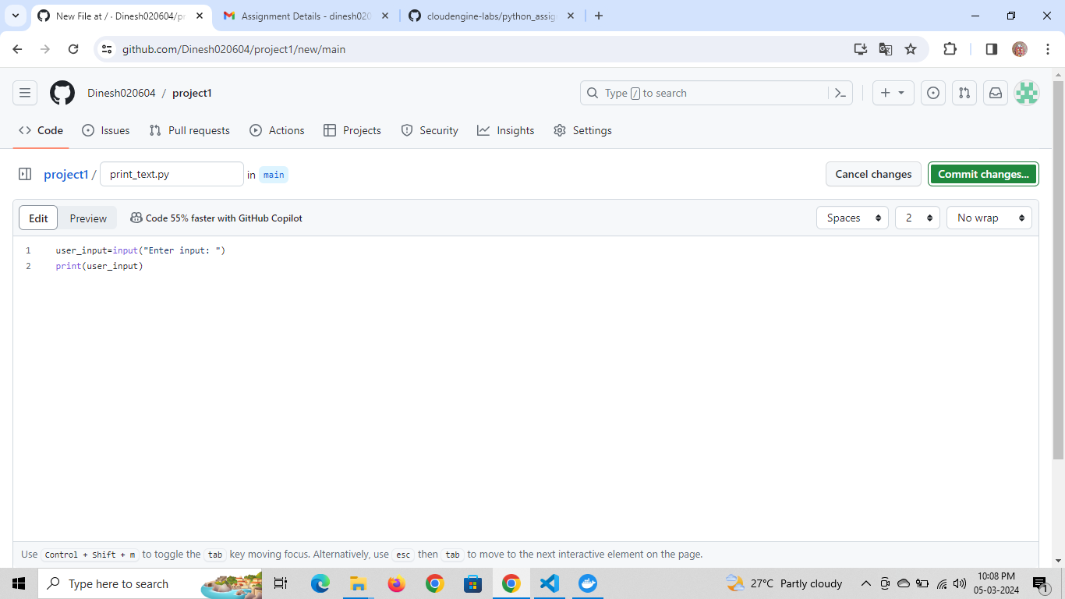

**Step 2:**

**Create a Dockerfile to create a container image for the program created in *step 1* and use the alpine version of base image in Dockerfile**

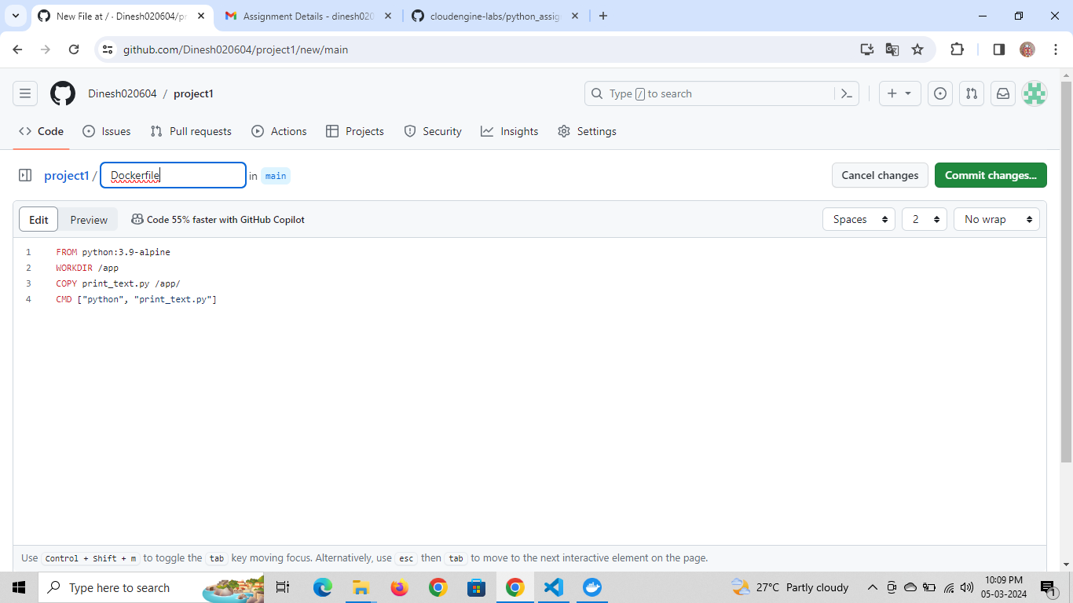

**Step 3: Test the Dockerfile by building the image**

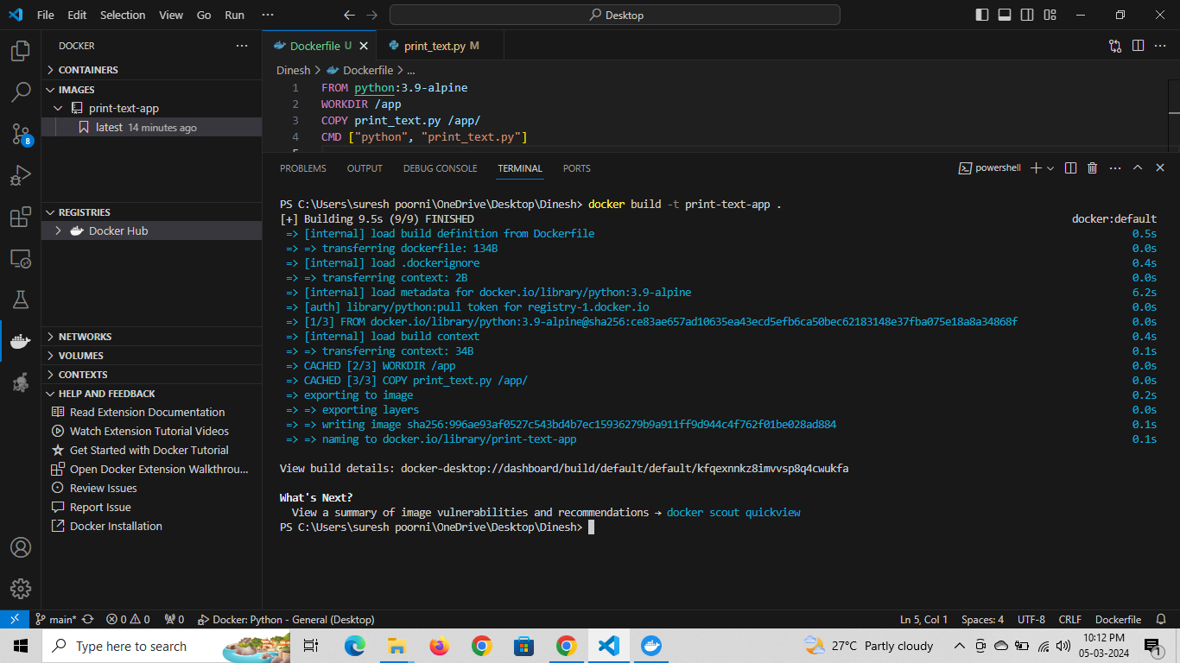

**Step 4: Run the image as a container. Capture console output and save it in a text file**

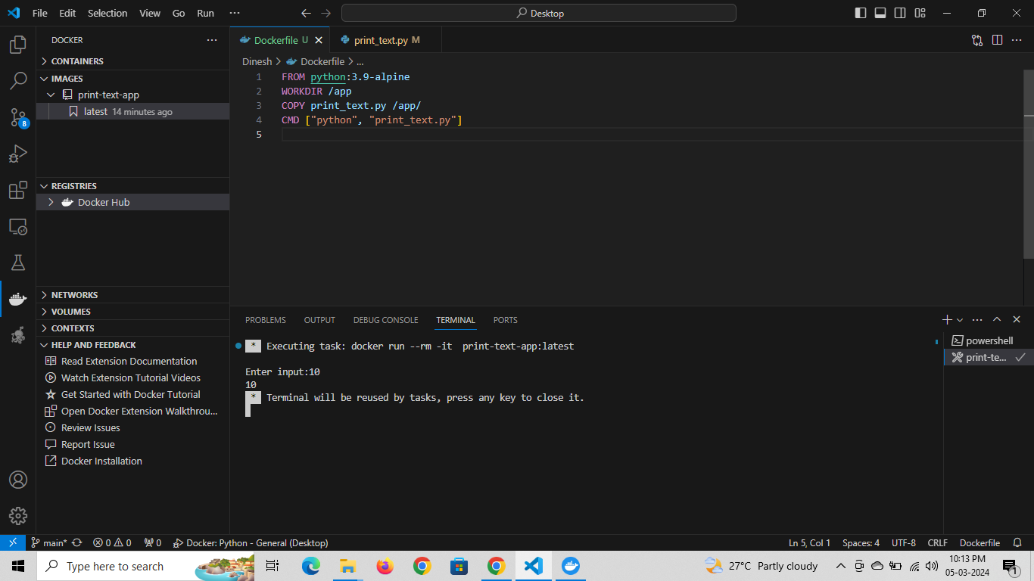

* **Step 5: Commit and Push the updated code into your GitHub repo**
* 