KPR INSTITUTE OF ENGINEERING AND TECHNOLOGY
Department of Artificial Intelligence and Data Science
ASSIGNMENT II
EXPLORATORY DATA ANALYSIS AND VISUALIZATION
Telco Customer Churn Analysis Using EDA and Deep Learning

Detail | Information
Course code and title | U21ADP05 — Exploratory Data Analysis and Visualization
Name | DINESH S
Roll number | 24AD030
Department | Artificial Intelligence and Data Science
Year / Semester | III-YR/V Semester
Academic year | 2026–2027 (Odd Semester)
Submission date | 15 October 2026

Abstract
This project presents exploratory data analysis and visualization of the Telco Customer Churn dataset to identify patterns associated with customer retention. The dataset contains 7,043 customer records and 21 columns describing demographics, subscribed services, contracts, and billing information. Preprocessing included converting TotalCharges to numeric format, handling confirmed blank charge entries associated with zero-tenure customers, checking duplicates and potential outliers, encoding categorical variables, and scaling numerical inputs. Eight EDA visualizations and descriptive statistics were used to examine distributions and relationships. A Multilayer Perceptron (MLP) model was trained and compared using validation data. The selected model achieved 79.94% test accuracy and a ROC-AUC of 0.8412. Churn recall was 49.82%, indicating that additional work is needed to identify more customers who leave. Permutation importance ranked tenure and contract type as the most influential original features.
Keywords: exploratory data analysis, customer churn, data visualization, MLP, Deep Learning, permutation importance.

Report Organization
- 1. Introduction and Objectives
- 2. Dataset Description
- 3. Data Understanding and Preprocessing
- 4. Exploratory Data Analysis and Visualization
- 5. Deep Learning Model Development
- 6. Model Evaluation and Results
- 7. Conclusion and Future Scope
- 8. Literature Review
- 9. References
- Appendix A. Code and Reproducibility

1. Introduction and Objectives

1.1 Introduction
Customer churn occurs when a customer stops using a company’s service. For a telecommunications provider, understanding customer churn can support customer-retention planning, service improvement, and more focused outreach. The selected Telco Customer Churn dataset contains customer demographics, service subscriptions, account details, contract information, and billing variables. The Churn field identifies whether a customer left within the period described by the dataset [1].

1.2 Problem Statement
The project investigates patterns associated with customer churn and develops a Deep Learning classifier that estimates whether a customer is likely to churn. The analysis must explore data quality, variable distributions, relationships between variables, and the predictive performance and limitations of the selected model.

1.3 Aim
To apply exploratory data analysis, statistical analysis, data visualization, and a Deep Learning model to a real-world customer dataset and derive evidence-based insights related to customer churn.

1.4 Objectives
- Inspect the dataset structure, fields, data types, and statistical summaries.
- Handle blank values and check duplicate records and potential outliers.
- Explore numerical distributions, categorical frequencies, and relationships between features.
- Create at least five meaningful data visualizations and explain each one.
- Prepare train, validation, and test partitions with suitable categorical encoding and numerical scaling.
- Develop and compare MLP configurations using validation data.
- Evaluate final test performance using accuracy, precision, recall, F1-score, ROC-AUC, and a confusion matrix.
- Identify influential features and discuss limitations and future improvements.

2. Dataset Description
The project uses the Telco Customer Churn dataset published on Kaggle by BlastChar [1]. The source describes each row as a customer record and includes service usage, account information, demographic fields, and the Churn target. The downloaded data contained 7,043 rows and 21 columns.
Item | Description
Dataset name | Telco Customer Churn
Source | Kaggle — https://www.kaggle.com/datasets/blastchar/telco-customer-churn
Rows / records | 7,043
Columns / fields | 21
Original identifier | customerID (excluded from model input)
Target variable | Churn: No / Yes
Task | Binary classification
Data type | Structured/tabular, with numerical and categorical fields

2.1 Main Feature Groups
Feature group | Examples | Data type / role
Customer demographics | gender, SeniorCitizen, Partner, Dependents | Categorical / binary
Service subscriptions | PhoneService, InternetService, OnlineSecurity, TechSupport, StreamingTV | Categorical
Account and contract | tenure, Contract, PaperlessBilling, PaymentMethod | Numerical and categorical
Billing | MonthlyCharges, TotalCharges | Numerical after conversion
Target | Churn | Binary label: No / Yes

The customerID column was retained for record identification and duplicate checks but excluded from the model predictors because it is an identifier rather than a meaningful customer characteristic.

3. Data Understanding and Preprocessing

3.1 Data Inspection
The dataset shape, column names, data types, missing-value counts, duplicate records, and descriptive statistics were inspected with Pandas. The final cleaned dataset retained 7,043 records and 21 columns.

3.2 Missing Values and Type Conversion
The TotalCharges field was initially stored as text. Blank entries were converted to missing values during numeric conversion. The blank entries associated with customers having zero tenure were assigned a value of 0 after inspection, consistent with no accumulated tenure-based charges in those records. After cleaning, the final missing-value check reported zero missing values.

3.3 Duplicates and Outliers
Exact duplicate rows were checked and the drop_duplicates operation was applied. The final record count remained 7,043. Potential outliers in tenure, MonthlyCharges, and TotalCharges were examined using the interquartile range (IQR) rule. Potentially extreme values were not automatically removed because high charges or long tenures may be valid customer records.

3.4 Feature Encoding, Scaling, and Data Split
The Churn target was mapped to binary labels (No = 0 and Yes = 1). Categorical predictors were transformed using one-hot encoding and numerical predictors were standardized using StandardScaler. A ColumnTransformer was fitted only on the training partition and then applied to validation and test partitions to prevent preprocessing leakage. The 19 original predictors expanded to 45 processed input features.
Partition | Rows | Purpose
Training set (70%) | 4,930 | Fit model parameters
Validation set (15%) | 1,056 | Select model configuration and monitor training
Test set (15%) | 1,057 | Final evaluation on held-out records

Stratified splitting preserved the churn proportion approximately across partitions: 26.53% in training, 26.52% in validation, and 26.58% in test. The processed arrays had shapes (4930, 45), (1056, 45), and (1057, 45), with zero NaN values reported in each partition.

4. Exploratory Data Analysis and Visualization
Exploratory analysis was conducted to summarize individual features and examine relationships associated with Churn. The project includes eight EDA visualizations, exceeding the assignment minimum of five. Each figure should be read together with its caption and interpretation.

4.1 Churn Distribution
The target contained 5,174 customers who stayed (73.46%) and 1,869 customers who churned (26.54%). Retained customers therefore formed the majority class. This class imbalance makes it important to examine recall, precision, F1-score, and ROC-AUC in addition to accuracy.
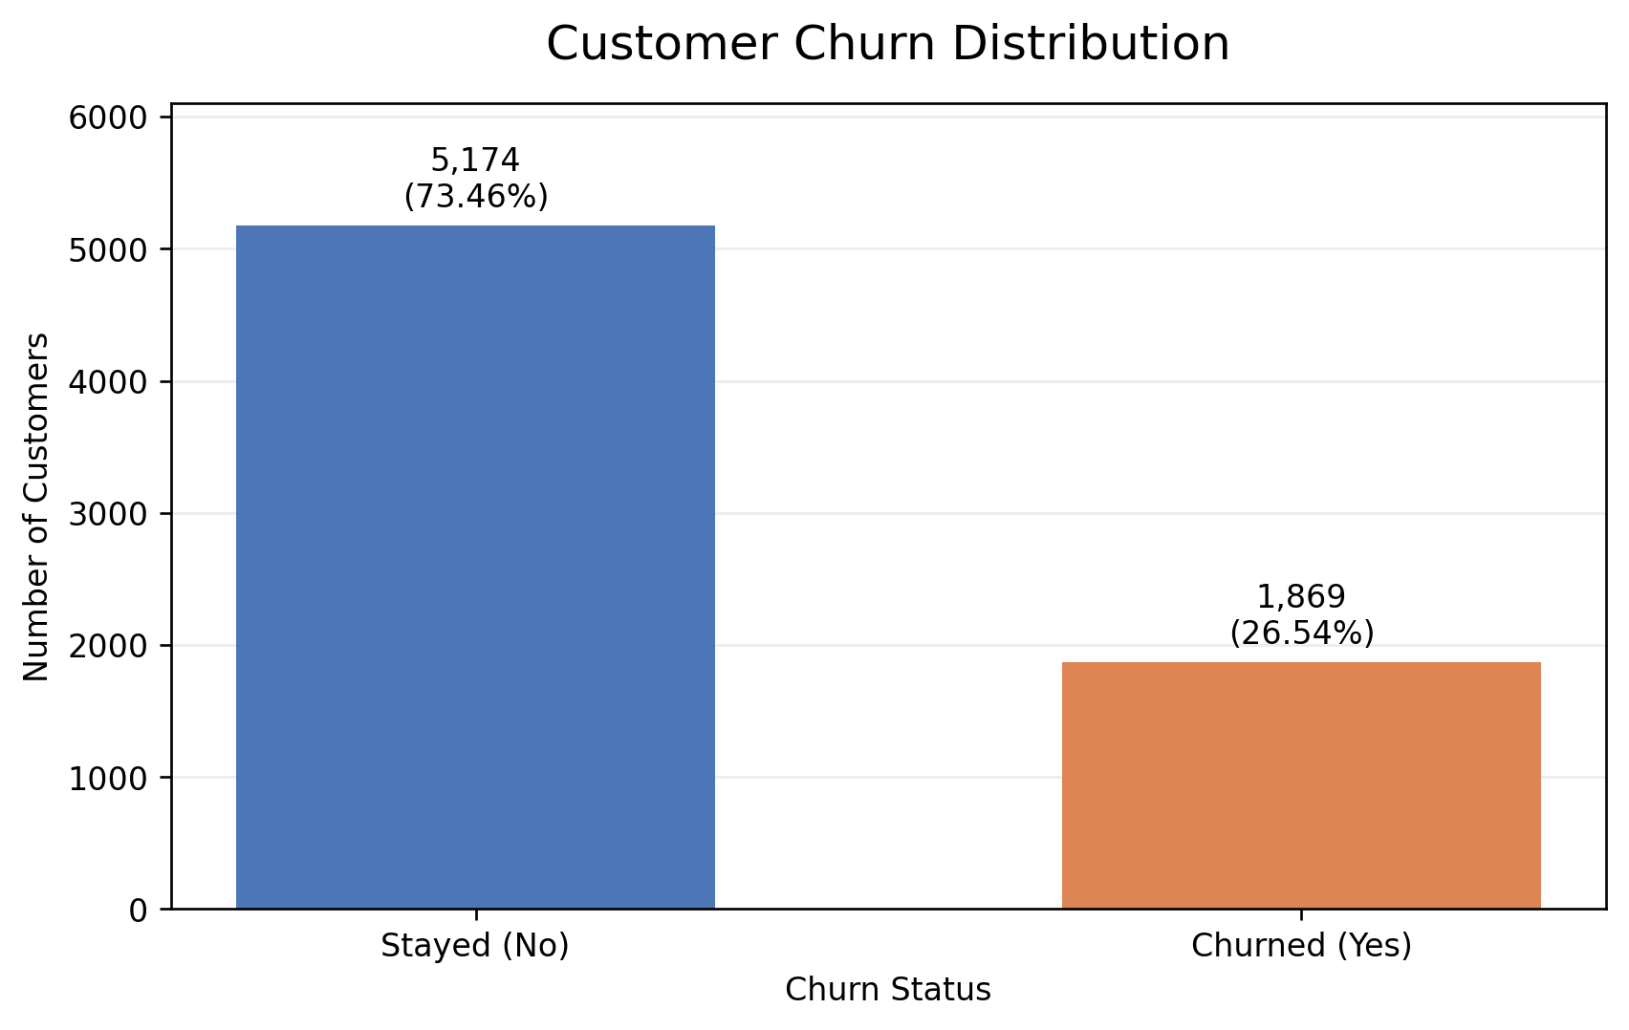
Figure 1. Count and percentage distribution of the Churn target.

4.2 Tenure Distribution
Tenure measures the number of months a customer remained with the service. Its mean was 32.37 months, median was 29 months, and range was 0 to 72 months. The histogram is used to examine how records are spread across tenure values and to identify concentrations or possible skewness.
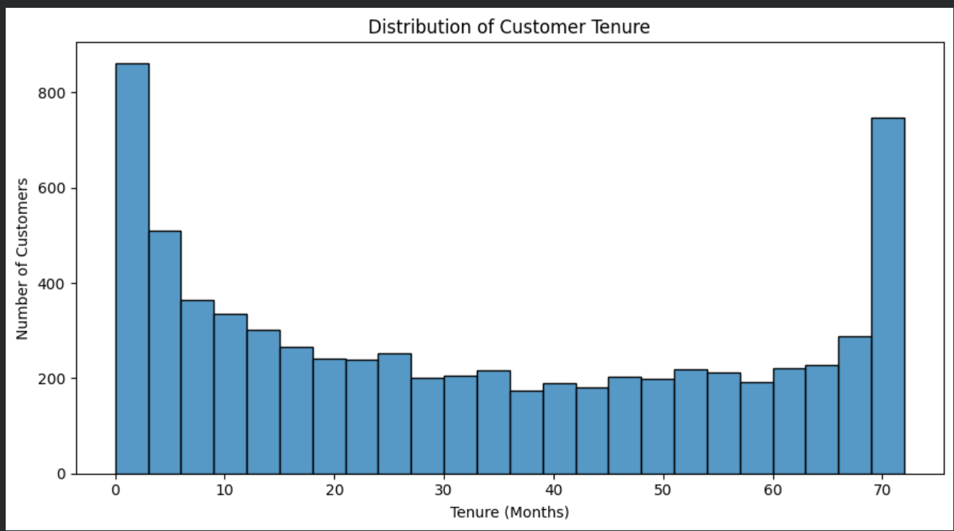
Figure 2. Distribution of customer tenure.

4.3 Monthly Charges Distribution
MonthlyCharges had a mean of 64.76, a median of 70.35, a standard deviation of 30.09, and a range from 18.25 to 118.75 in the dataset’s monetary units. The histogram with a density curve helps inspect concentration, spread, and the empirical shape of this continuous numerical variable.

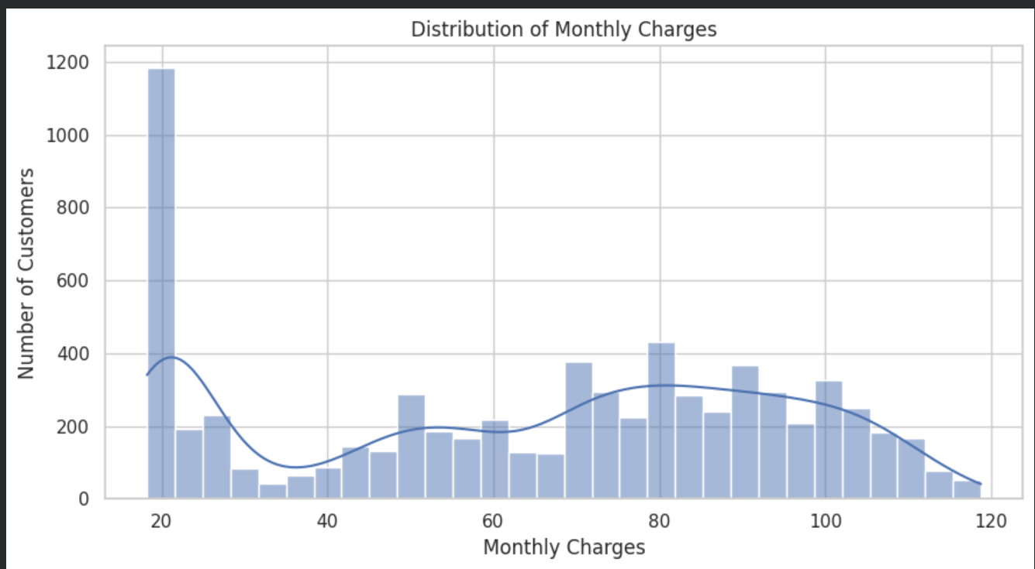
Figure 3. Distribution of monthly charges.

4.4 Monthly Charges by Churn Status
A boxplot compares the distribution of monthly charges for customers who stayed and customers who churned. The grouped statistics showed mean MonthlyCharges of 61.27 for retained customers and 74.44 for churned customers. The medians were 64.43 and 79.65, respectively. This indicates that, in this dataset, the churned group had higher typical monthly charges; this is an association and does not establish causation.
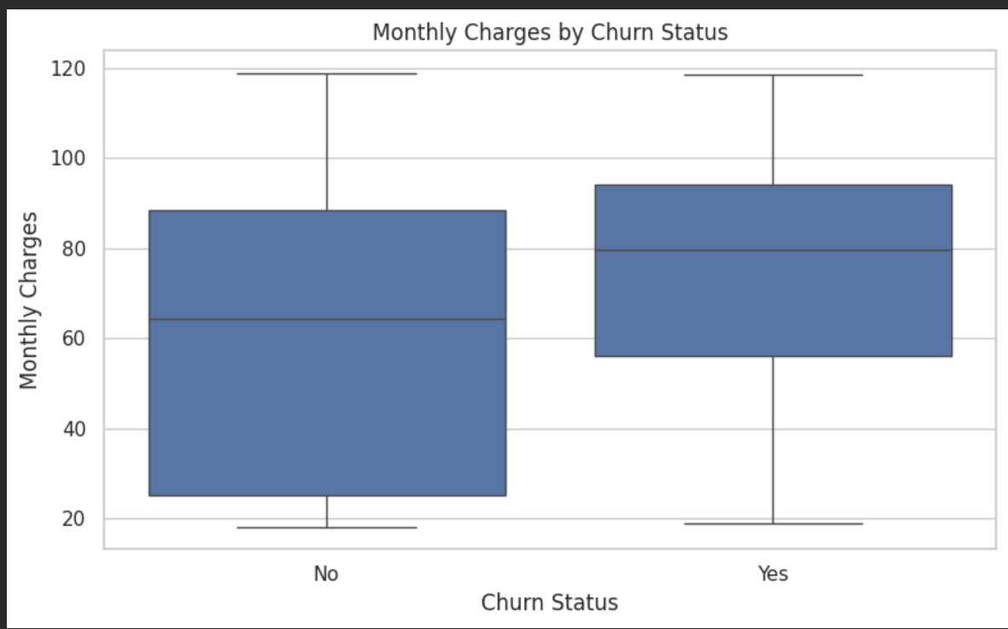
Figure 4. Monthly charges grouped by churn status.

4.5 Contract Type and Churn Rate
Contract type showed a substantial difference in observed churn rates. The month-to-month group had a churn rate of 42.71%, the one-year group 11.27%, and the two-year group 2.83%. The percentage chart makes group rates comparable despite different category sizes. This pattern suggests an association between contract duration and retention; it does not prove that contract type alone causes churn.
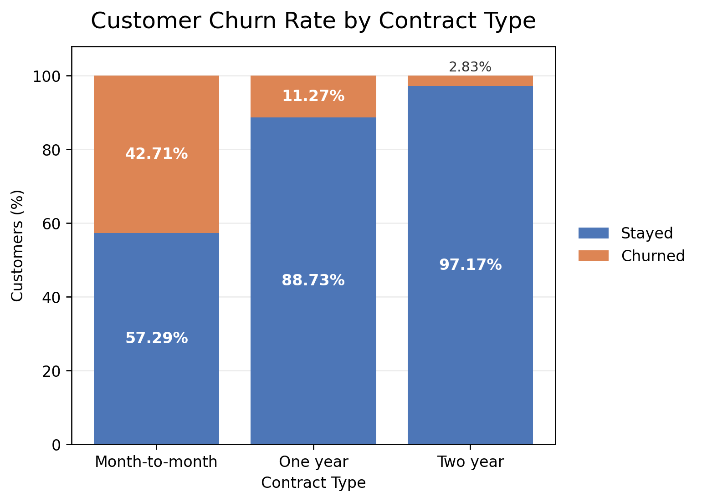
Figure 5. Percentage of customers who stayed or churned by contract type.
Contract type | Stayed (%) | Churned (%)
Month-to-month | 57.29 | 42.71
One year | 88.73 | 11.27
Two year | 97.17 | 2.83

4.6 Correlation Heatmap
The correlation heatmap compares numerical variables, including SeniorCitizen, tenure, MonthlyCharges, and TotalCharges. Correlations indicate the direction and strength of linear relationships between numerical variables. In the final report, identify the strongest positive and negative correlation visible in your generated heatmap and explain that correlation does not imply causation.

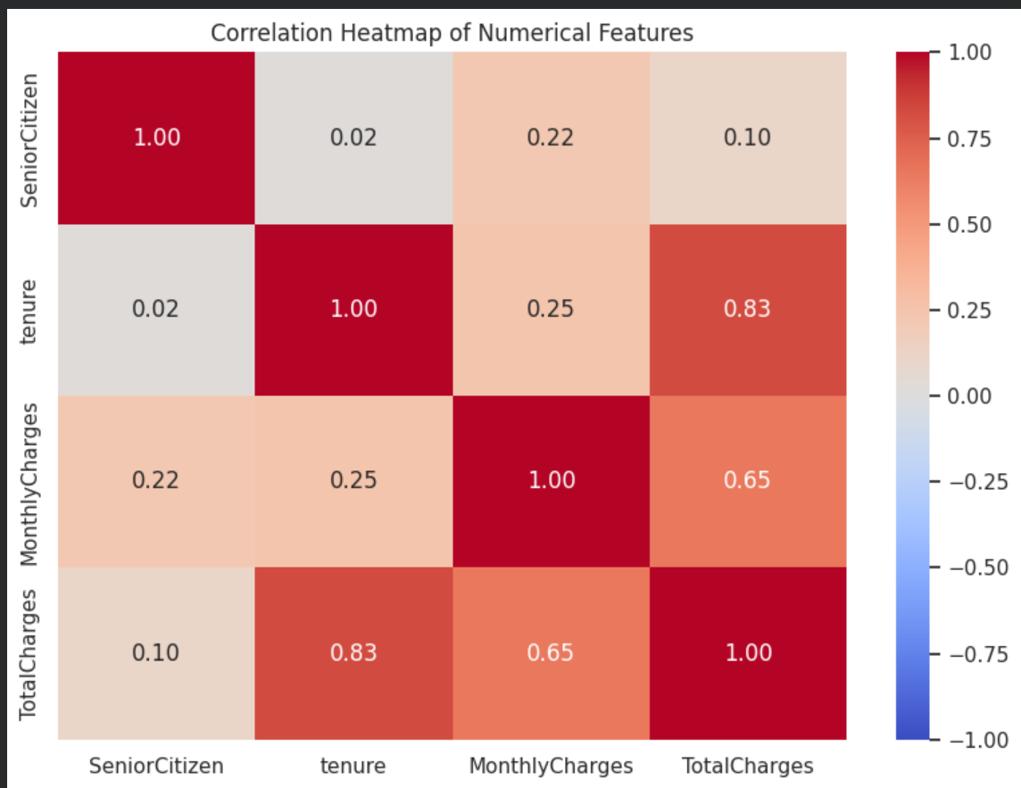
Figure 6. Correlation heatmap of numerical features.

4.7 Tenure versus Monthly Charges
The scatterplot explores tenure and MonthlyCharges together, with points coloured by Churn. Grouped statistics showed that churned customers had mean tenure of 17.98 months, compared with 37.57 months for retained customers. Churned customers also had higher mean monthly charges (74.44 versus 61.27). The scatterplot helps inspect how much the two groups overlap and whether patterns differ across the feature space.

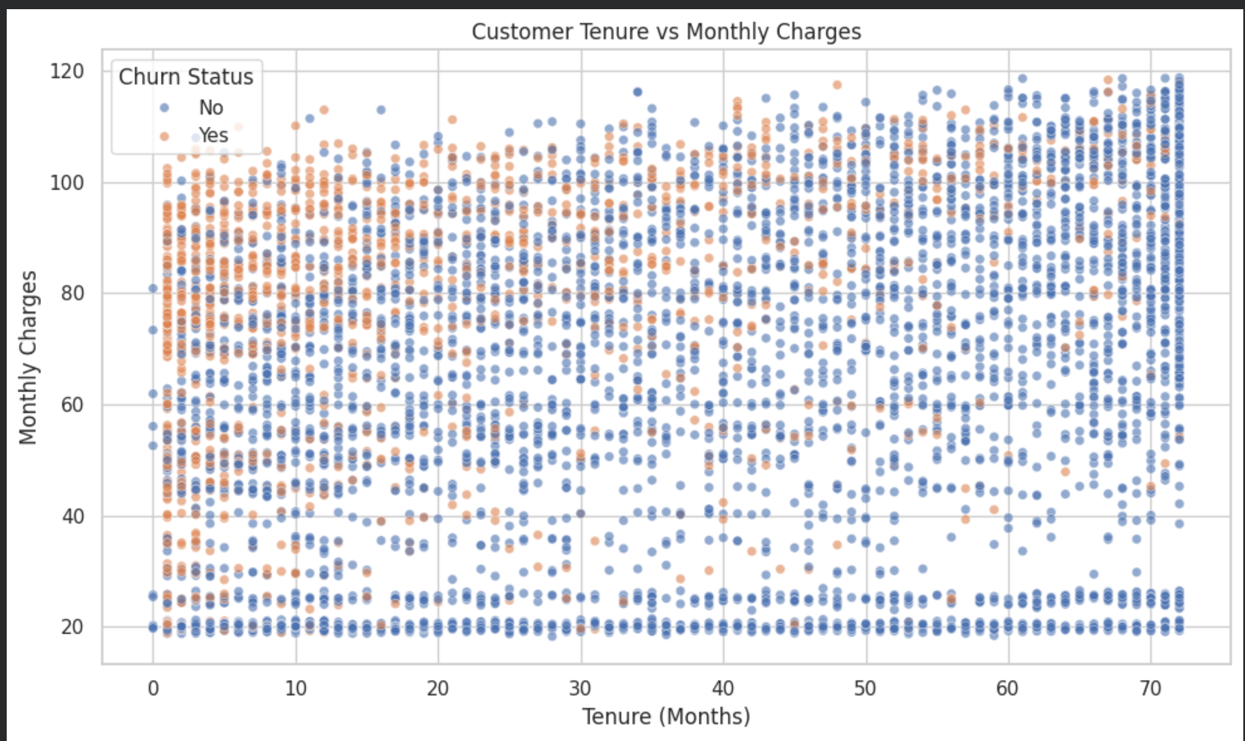
Figure 7. Tenure versus monthly charges by churn status.

4.8 Payment Method and Churn Rate
A 100% stacked bar chart compares the percentage of customers who stayed or churned within each payment-method category. Using percentages instead of counts makes the categories easier to compare when group sizes differ. In the final version, identify the payment-method group with the highest observed churn percentage from the output table generated by Colab.
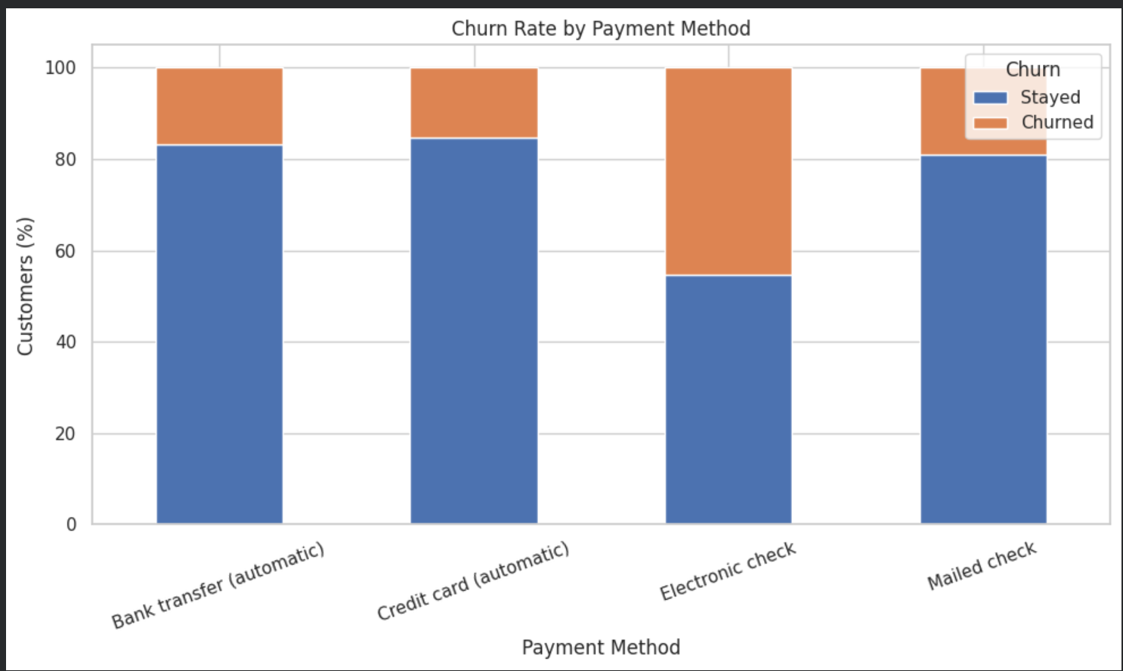

Churn percentage by payment method:
PaymentMethod | No | Yes
Bank transfer (automatic) | 83.29 | 16.71
Credit card (automatic) | 84.76 | 15.24
Electronic check | 54.71 | 45.29
Mailed check | 80.89 | 19.11

Figure 8. Churn rate by payment method.

4.9 Descriptive Statistical Summary
Statistic | Tenure (months) | MonthlyCharges | TotalCharges
Count | 7,043 | 7,043 | 7,043
Mean | 32.37 | 64.76 | 2,279.73
Standard deviation | 24.56 | 30.09 | 2,266.79
Minimum | 0.00 | 18.25 | 0.00
25th percentile | 9.00 | 35.50 | 398.55
Median (50th percentile) | 29.00 | 70.35 | 1,394.55
75th percentile | 55.00 | 89.85 | 3,786.60
Maximum | 72.00 | 118.75 | 8,684.80

4.10 Visualization Stages
The seven-stage visualization workflow described by Fry [2] was mapped to this case study as follows:
Stage | Application in this project
1. Acquire | Obtain the customer churn CSV from the documented Kaggle source.
2. Parse | Load the CSV with Pandas and inspect rows, columns and data types.
3. Filter | Inspect and clean blanks, duplicate rows, data types and invalid values.
4. Mine | Calculate descriptive statistics, churn rates, group comparisons and correlations.
5. Represent | Select bar charts, histograms, boxplots, a heatmap and scatterplots.
6. Refine | Add clear titles, axes, labels, legends and appropriate scales.
7. Interact | Use an interactive Plotly scatterplot with hover details for customer features.

5. Deep Learning Model Development

5.1 Task and Model Choice
The task is binary classification: predict Churn = Yes or No. A Multilayer Perceptron (MLP) was selected because the dataset is structured tabular data. The model consists of fully connected layers with ReLU activations, dropout for regularization, and a one-neuron sigmoid output that estimates the probability of churn. The Sequential API supports stacking layers in a linear sequence [3].

5.2 Model Configurations
Parameter | Model A | Model B (selected)
Hidden layers | 64, 32 neurons | 32, 16 neurons
Activation | ReLU | ReLU
Dropout rate | 0.20 | 0.30
Optimizer | Adam | Adam
Learning rate | 0.001 | 0.0005
Loss function | Binary cross-entropy | Binary cross-entropy
Batch size | 32 | 32
Maximum epochs | 50 | 50
Early stopping | Patience = 5 on validation loss | Patience = 5 on validation loss

5.3 Hyperparameter Comparison
Model | Best epoch by validation loss | Best validation loss | Validation AUC at that epoch
Model A | 2 | 0.4207 | 0.8438
Model B | 31 | 0.4197 | 0.8450

Model B was selected because it achieved a slightly lower best validation loss and a slightly higher validation AUC at the epoch with minimum validation loss. The differences are small; selection was made using validation performance rather than test performance.

5.4 Training Curves
Training and validation loss generally decreased and approached a similar range during the selected model’s training. Validation accuracy settled around 0.80. These plots are used to check learning progress and look for signs of overfitting. They should be included as a clean chart export from Colab.
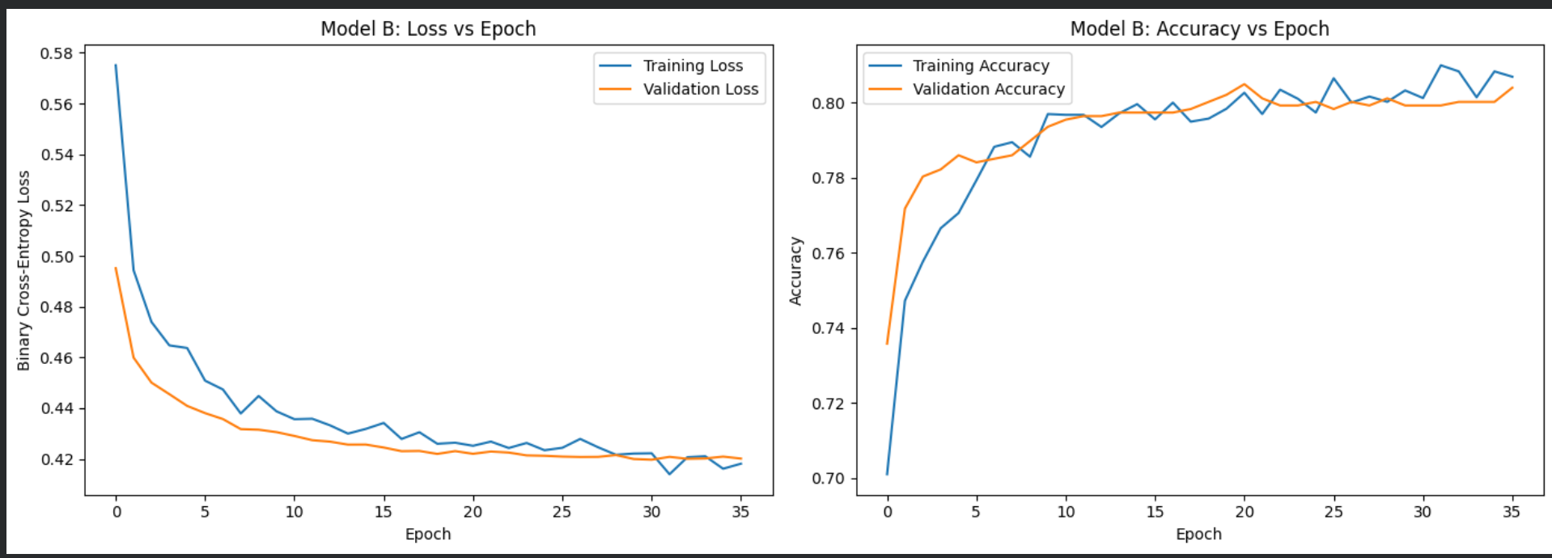
Figure 9. Model B training and validation loss / accuracy versus epoch.

6. Model Evaluation and Results

6.1 Final Test Metrics
After selecting the configuration using validation data, Model B was evaluated on the held-out test partition of 1,057 records. The reported metrics are based on the default probability threshold of 0.50.
Metric | Test score | Interpretation
Accuracy | 0.7994 (79.94%) | Correct classifications divided by all test records.
Precision (Churn = Yes) | 0.6635 (66.35%) | About two-thirds of predicted churn cases were actual churn cases.
Recall (Churn = Yes) | 0.4982 (49.82%) | The model identified 140 of the 281 customers who actually churned.
F1-score (Churn = Yes) | 0.5691 (56.91%) | Harmonic mean of churn precision and recall.
ROC-AUC | 0.8412 | Measures ranking/discrimination across classification thresholds [5].

6.2 Confusion Matrix
The confusion matrix contains 705 true negatives (retained customers correctly classified as stayed), 71 false positives (retained customers predicted to churn), 141 false negatives (churned customers predicted to stay), and 140 true positives (churned customers correctly identified). The high number of false negatives is consistent with the churn recall of 49.82%.
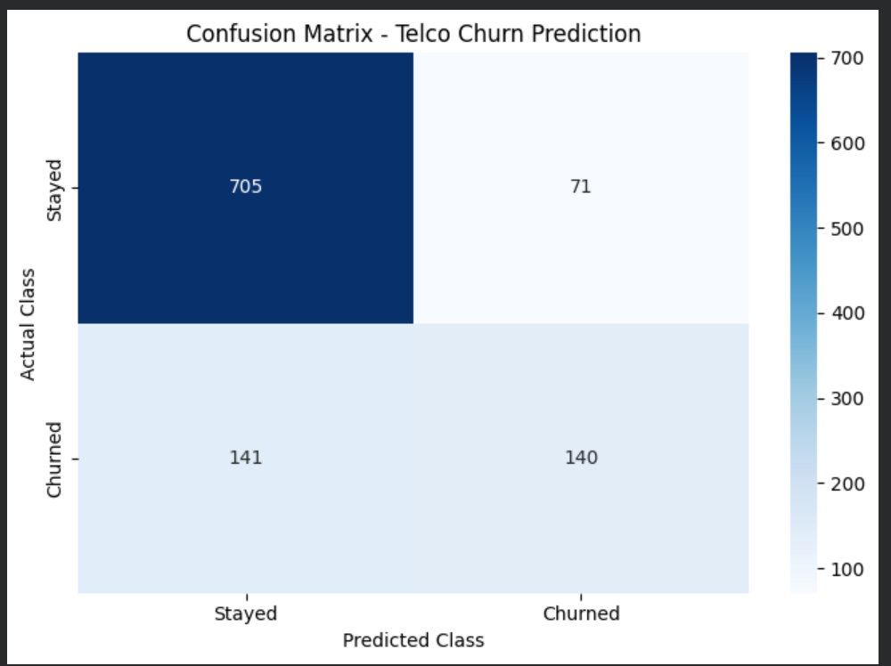
Figure 10. Confusion matrix on the held-out test set (rows = actual class, columns = predicted class).

Actual / Predicted | Stayed | Churned
Stayed | 705 (true negative) | 71 (false positive)
Churned | 141 (false negative) | 140 (true positive)

6.3 ROC Curve and AUC
The ROC curve plots the true-positive rate against the false-positive rate as the classification threshold changes. The test ROC-AUC was 0.8412. This indicates useful discriminative ability in the test sample, although the default threshold does not identify all customers who churn. ROC-AUC assesses ranking across thresholds and does not by itself specify the operating threshold [5].
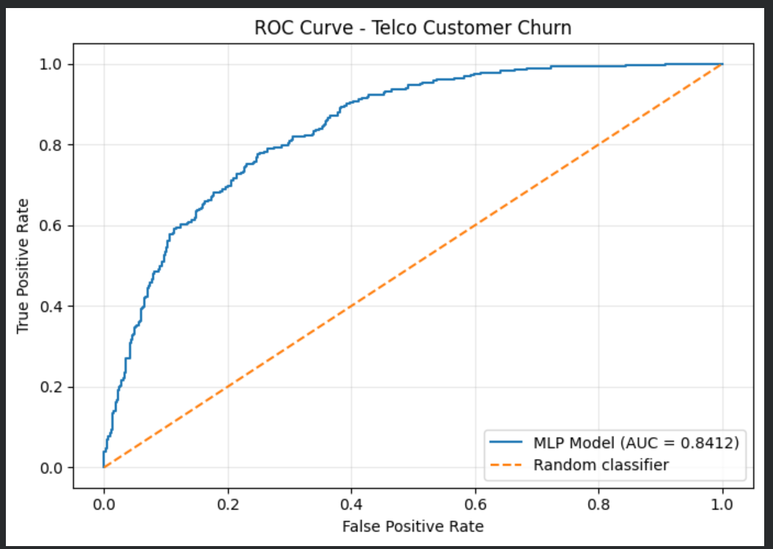
Figure 11. ROC curve for Model B on the test set (AUC = 0.8412).
6.4 Permutation Feature Importance
Permutation importance was calculated on validation data by shuffling one original feature at a time and measuring the decrease in validation ROC-AUC. This approach estimates the extent to which the fitted model relies on a feature, rather than demonstrating a causal relationship [4]. The baseline validation ROC-AUC reported during this analysis was 0.8448.

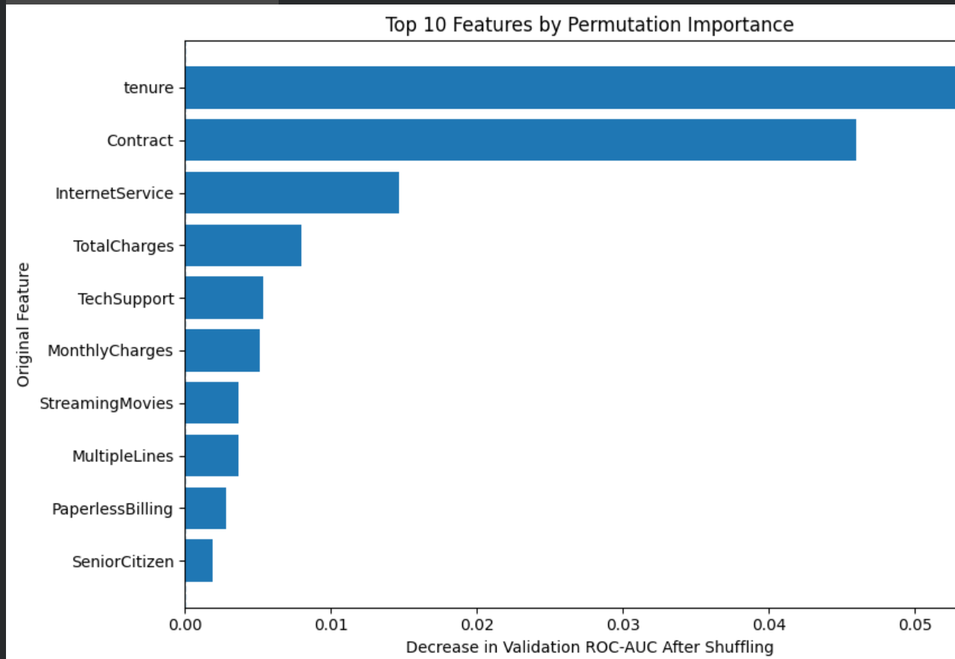
Figure 12. Ten leading original features ranked by decrease in validation ROC-AUC after shuffling.

Rank | Feature | Importance
1 | tenure | 0.0528
2 | Contract | 0.0460
3 | InternetService | 0.0147
4 | TotalCharges | 0.0080
5 | TechSupport | 0.0053
6 | MonthlyCharges | 0.0051
7 | StreamingMovies | 0.0037
8 | MultipleLines | 0.0036
9 | PaperlessBilling | 0.0028
10 | SeniorCitizen | 0.0019

Tenure and contract type were the two leading features. The ranking is specific to this fitted model and validation dataset. Importance values close to zero or negative should be interpreted cautiously, especially when predictors contain overlapping information.

7. Conclusion and Future Scope

7.1 Conclusion
This project applied exploratory data analysis, statistical analysis, visualization, preprocessing and Deep Learning to a real-world Telco Customer Churn dataset. Of 7,043 customers, 1,869 (26.54%) had churned. The observed churn rate was highest for month-to-month contracts (42.71%) and lowest for two-year contracts (2.83%). Churned customers had a lower mean tenure (17.98 months compared with 37.57 months for retained customers) and higher mean monthly charges (74.44 compared with 61.27).
The selected MLP model achieved 79.94% test accuracy and a test ROC-AUC of 0.8412. However, churn recall was 49.82%, and the model missed 141 of the 281 churned customers in the test set. Permutation importance ranked tenure and contract type as the most influential features. The project demonstrates how EDA and a Deep Learning model can surface useful patterns, while also showing that accuracy alone is not sufficient to judge a churn model.

7.2 Challenges and Limitations
- The target classes are imbalanced: 73.46% stayed and 26.54% churned.
- At the default 0.50 threshold, recall for the churn class was below 50%, leaving many churned customers undetected.
- The dataset represents a particular business context and may not generalize to other telecom companies or later periods.
- EDA associations and permutation importance do not establish causation.
- Correlated features can share predictive information and reduce individual permutation importance values.

7.3 Future Scope
- Choose a decision threshold using validation data to better balance churn recall and false-positive rate.
- Experiment with class weighting or resampling methods to improve detection of the minority churn class.
- Compare the MLP against logistic regression, random forest, and gradient-boosted tree baselines.
- Tune architecture, learning rate, dropout and training settings using a structured validation procedure.
- Collect newer and additional customer data and validate the selected approach on an independent time period.

8. Literature Review
The selected Kaggle dataset is designed for customer-retention analysis and provides demographic, service, account, contract, and billing attributes together with the Churn target [1]. These fields allow both univariate and multivariate exploration and make the dataset suitable for a binary-classification case study.
Fry’s visualization workflow describes stages from acquiring and parsing data through filtering, mining, representing, refining, and interacting with the result [2]. The project mapped these stages to data acquisition, Pandas inspection, data cleaning, statistical calculations, chart selection and refinement, and a Plotly interactive visualization.
The MLP was implemented with the TensorFlow/Keras Sequential API, which organizes layers into a linear stack [3]. Model configurations were compared using validation data, and the final model was assessed with standard classification metrics and ROC-AUC [5]. Permutation importance was used to estimate the change in validation ROC-AUC after shuffling individual features; this method measures model reliance rather than causal influence [4].

9. References
- BlastChar. (n.d.). Telco Customer Churn [Data set]. Kaggle. https://www.kaggle.com/datasets/blastchar/telco-customer-churn
- Fry, B. (2008). Visualizing Data: Exploring and Explaining Data with the Processing Environment. O’Reilly Media. https://www.oreilly.com/library/view/visualizing-data/9780596514556/ch01.html
- TensorFlow. (n.d.). tf.keras.Sequential. TensorFlow API documentation. https://www.tensorflow.org/api_docs/python/tf/keras/Sequential
- scikit-learn developers. (n.d.). Permutation feature importance. scikit-learn documentation. https://scikit-learn.org/stable/modules/permutation_importance.html
- scikit-learn developers. (n.d.). roc_auc_score. scikit-learn documentation. https://scikit-learn.org/stable/modules/generated/sklearn.metrics.roc_auc_score.html

Appendix A. Code Section and Reproducibility
The complete, commented Python code is provided in the accompanying EDA_Telco_Customer_Churn.ipynb notebook. The notebook includes data loading, inspection, cleaning, EDA charts, preprocessing, data splitting, MLP training and comparison, model evaluation, visualizations, and feature-importance analysis. The following excerpt summarizes the central modelling pipeline; the notebook is the authoritative full source code.
# Target and predictors
X = df.drop(columns=["customerID", "Churn"]).copy()
y = df["Churn"].map({"No": 0, "Yes": 1})
# Stratified 70% / 15% / 15% split
X_train, X_temp, y_train, y_temp = train_test_split(X, y, test_size=0.30, random_state=42, stratify=y)
X_val, X_test, y_val, y_test = train_test_split(X_temp, y_temp, test_size=0.50, random_state=42, stratify=y_temp)
# Fit preprocessing on training only; transform validation and test
X_train_processed = preprocessor.fit_transform(X_train)
X_val_processed = preprocessor.transform(X_val)
X_test_processed = preprocessor.transform(X_test)
# Selected Model B: MLP with 32 and 16 hidden units
model = keras.Sequential([
keras.Input(shape=(X_train_processed.shape[1],)),
keras.layers.Dense(32, activation="relu"),
keras.layers.Dropout(0.30),
keras.layers.Dense(16, activation="relu"),
keras.layers.Dropout(0.30),
keras.layers.Dense(1, activation="sigmoid")])
model.compile(optimizer=keras.optimizers.Adam(learning_rate=0.0005), loss="binary_crossentropy", metrics=["accuracy", keras.metrics.AUC(name="auc")])
# Model was trained with validation monitoring and EarlyStopping.

