CHAPTER 1: INTRODUCTION
In the modern digital ecosystem, financial transactions are increasingly communicated through unstructured formats such as SMS alerts. While these messages provide real-time updates, they are not directly suitable for analytical processing due to their noisy and inconsistent structure. Converting such raw financial data into meaningful insights requires robust data processing, privacy preservation, and scalable machine learning systems.
SpendSense is a privacy-first, stateless financial intelligence system that bridges this gap by transforming unstructured SMS transaction data into structured, categorized financial information. The system integrates data preprocessing, machine learning inference, and visualization within a cloud-native architecture, enabling users to better understand and manage their expenses.

1.1 PROJECT OVERVIEW
SpendSense is an intelligent financial text classification and analytics system designed to automate the parsing, categorization, and visualization of unstructured transactional text messages, such as those generated by Short Message Service (SMS) notifications from banking institutions and payment gateways. In the modern digital economy, individuals receive numerous notification texts detailing debits, credits, account balances, and merchant transactions. However, these textual streams are highly heterogeneous, lacking a unified schema, and varying drastically across different banking corporations and geographical regions. SpendSense addresses this systemic fragmentation by providing a cohesive application accessible via an interactive user interface built using Streamlit and powered by a high-performance Python FastAPI backend.
The system operates within a host environment ensuring that all computation—ranging from regular expression text normalization to machine learning inference—occurs efficiently on the system hardware. The application architecture consists of three integrated layers: the presentation layer, the application processing layer, and the data persistence layer. The presentation layer is an interactive, responsive user interface engineered in Streamlit that enables users to securely authenticate, configure financial tracking profiles, upload batch text logs, and view multi-dimensional analytical dashboards.
The application processing layer is a robust FastAPI orchestration engine that executes textual preprocessing, feature extraction using Term Frequency-Inverse Document Frequency (TF-IDF) vectorization, and automated category assignment via a trained multinomial machine learning classifier. The data persistence layer is configured with structured relational database tables (Users, UserProfiles, and UploadLogs) that ensure historical transaction tracking, user state maintenance, and audit logging remain persistent across system execution cycles. By synthesizing machine learning text classification with robust database engineering, SpendSense transforms raw, fragmented transactional text blobs into clear, actionable financial intelligence. This enables users to audit their expenditure behaviors with minimal manual effort and maximum precision.

1.2 MOTIVATION FOR THE WORK
The motivation behind this project arises from three key challenges in financial data processing: unstructured data handling, privacy concerns, and scalability needs. Traditional personal finance tracking methodologies heavily rely on manual ledger logging or static spreadsheet data entry, both of which introduce human error and require significant operational effort. While digital banking notifications provide an automated trail of financial movements, the inherent fragmentation of these notifications across different financial institutions creates a significant processing barrier. The desire to streamline this data collection layer and provide automated financial intelligence serves as a major driver for this work.
The project's development is driven by three specific pillars:
- Unstructured Data Handling: Financial Short Message Service (SMS) alerts and transactional notifications are fundamentally inconsistent, varying drastically in syntax, vocabulary, and format across different banking platforms and payment channels. Because these strings lack a standardized schema, they are incredibly difficult to clean and process using traditional rule-based programming or rigid text matching algorithms. The system is motivated by the need to apply natural language processing and machine learning classifiers to smoothly normalize these irregular strings into structured financial rows.
- Privacy Concerns: Transaction notifications contain highly sensitive personal information, including explicit bank account markers, exact transaction timestamps, precise merchant identities, and personal spending habits. Protecting this sensitive data during every phase of processing is critical. This project is motivated by the design of an architecture that prioritizes data security and data privacy, ensuring that financial data fields are parsed safely, handled securely, and stored with robust access protections.
- Scalability Needs: Real-world financial tracking applications require processing engines that can handle large volumes of transactional data efficiently without suffering performance degradation. As a user's transaction history grows over months and years, the system must scale seamlessly to handle massive batch uploads, generate instantaneous analytical summaries, and maintain quick query execution times.
- Data Fragmentation and Syntactic Inconsistency: The sheer variety of transaction notifications makes manual aggregation impossible. The overarching motivation of this project is to provide a standardized system capable of automatically capturing, cleaning, identifying, and structuring financial notifications seamlessly into actionable metrics.
Existing solutions often compromise on either data privacy or system scalability. This project is motivated by the goal of designing a unified architecture that ensures absolute data security while maintaining high performance and scalability, making it robust and highly suitable for real-world deployment.

1.3 PROBLEM STATEMENT
The current landscape of digital financial reporting is marked by major inconsistencies in data formats, a lack of unified analytics, and significant structural challenges regarding text data aggregation. Specifically, the problems addressed by this system include:
- Extreme Inconsistency in Unstructured Financial Text Formats: Transaction notifications generated by different financial institutions lack any standardized syntax. For example, one institution may format an alert as "Rs. 500 debited from a/c no. XX1234" while another formats it as "Txn of INR 500.00 processed via card ending 1234". This high syntactic variance renders basic string-matching algorithms and rigid regular expressions highly fragile and ineffective for processing text at scale.
- High Computational Vulnerability of Hard-Coded Rules: Relying on basic rule-based systems to classify text requires continuous manual updating of script definitions whenever an institution alters its message templates. Without a machine learning classification model capable of inferring context, traditional text processing systems fail completely when encountering unfamiliar semantic or syntactical variations.
- Lack of Data Persistence in Lightweight Processing Tools: Existing application scripts designed for basic text processing often function merely as transient converters. They process a text file, display a graph, and immediately lose state once the application process terminates. There is a lack of structured, integrated database implementations that can maintain user authentication records, profile tracking configurations, and historic upload telemetry over long operational periods.
- The Aggregation Paradox of Personal Finance Management: Users are forced into a trade-off between manual labor and data clutter. To obtain detailed visual insights into their spending behaviours without automated assistance, they must spend hours manually sorting records, which fundamentally introduces human error and operational friction.

1.4 OBJECTIVES OF THE WORK
To systematically address the challenges outlined in the problem statement, the development of SpendSense is governed by the following core technical objectives:
- Objective 1: Engineering a Robust System Architecture
To design and implement a decoupled, structured multi-tier architecture utilizing a Streamlit front-end for data presentation, a FastAPI middle-tier for process orchestration, and a relational database engine for long-term data persistence.
- Objective 2: Implementing a Persistent Relational Schema
To develop, normalize, and execute a structured relational schema on the database system comprising production-grade tables:
  - Users: To store unique identifiers, encrypted authentication credentials, and account registration timestamps.
  - UserProfiles: To capture and store extended user metadata, system preferences, and target tracking configurations.
  - UploadLogs: To persistently log the metadata of every uploaded document batch, including unique file handles, record counts, and parsing timestamps, ensuring complete data auditability.
- Objective 3: Developing an Automated Text Processing and Machine Learning Pipeline
To construct an execution pipeline using Python's Scikit-learn library. This pipeline will ingest raw text strings, apply regular expression cleaning to handle currency token anomalies (e.g., normalizing variations like Rs., Rs, INR), convert the cleaned text into numerical features using TF-IDF vectorization, and classify the records into precise categories (e.g., Food, Travel, Shopping, Utilities) using a trained Multinomial Naive Bayes model.
- Objective 4: Establishing Interactive Data Visualization Dashboards
To construct dynamic, interactive visual dashboards within the application user interface. These dashboards will query the relational data structures to present real-time spend distributions, temporal expenditure trends, and transaction anomalies clearly and cleanly.
1.5 SYSTEM EVOLUTION & SCOPE EXPANSION
As educational institutions transition toward unified digital campuses, the operational demands on informational infrastructure have expanded significantly. While the foundational iteration of this college enquiry chatbot successfully automates core information retrieval using an intent-based architecture, modern user expectations necessitate a strategic evolution in system scope.
To bridge the gap between a localized prototype and an enterprise-grade campus assistant, the system framework is structured to scale across three primary dimensions:
- Linguistic and Accessibility Inclusivity: Recognizing the diverse demographic of the student body and stakeholders, the scope extends beyond standard English to integrate regional language processing (such as Tamil) alongside voice-driven user interfaces. This mitigates barriers for users with varying technical literacy or visual/physical impairments.
- Cognitive Depth via Hybrid NLP: Moving beyond static keyword matching, the architectural scope incorporates a pathway toward dense semantic embeddings and Retrieval-Augmented Generation (RAG). This ensures the chatbot can process complex, multi-turn, contextual conversations while maintaining administrative guardrails.
- Omnichannel Integration: The operational boundaries are expanded from an isolated web script into a cross-platform service capable of seamless deployment across web portals, mobile student applications, and instant messaging networks (e.g., WhatsApp).

1.6 SUMMARY
This chapter introduced the concept of SpendSense, highlighting the need for a privacy-first approach to financial data processing. It discussed the motivation, problem statement, objectives, and overall structure of the thesis. The foundation laid in this chapter provides the necessary context for understanding the system design, implementation, and evaluation presented in the subsequent chapters.

CHAPTER 2: LITERATURE SURVEY

2.1 INTRODUCTION
This chapter provides a structured overview of existing research, historical methodologies, and modern technologies related to automated financial data processing, expense categorization, and privacy-preserving machine learning platforms. With the rapid global increase in daily digital transactions, massive volumes of transactional financial data are continuously generated in completely unstructured formats, including Short Message Service (SMS) alerts, transactional emails, and push notifications.
Converting these highly fragmented and irregular textual streams into meaningful, structured, and actionable financial insights requires an optimized combination of:
- Natural Language Processing (NLP) for text cleaning and processing.
- Machine Learning (ML) for intelligent pattern recognition and category mapping.
- Data Engineering Frameworks for managing seamless request handling and data pipeline orchestration.
In addition to the inherent complexities of text classification, personal data privacy and security have emerged as critical development concerns in modern software applications. Financial notification logs almost always contain highly sensitive data that must be strictly handled to ensure compliance with modern data protection standards. This chapter systematically reviews existing approaches across these domains to highlight the technical gaps that motivate the architecture of SpendSense.

2.2 LITERATURE REVIEW
The engineering domain of financial data analytics, automated text processing, and expense management has evolved significantly over the past two decades. This section reviews the core pillars of existing literature to establish a baseline for our system.
2.2.1 Financial Text Processing and Expense Categorization
Early software utilities designed for transaction tracking relied heavily on deterministic, rule-based systems. These platforms used hard-coded keywords and regular expressions to extract data fields from text.
- Rule-Based Implementation: Systems mapped incoming alerts by scanning for static anchors such as "debited", "credited", "spent", or currency tokens like "INR" and "Rs.".
- Structural Fragility: Academic evaluations demonstrate that rule-based matching fails when applied to variable sentence structures. If a bank alters its message template even slightly, the rigid system fails to capture the text.
- Shift to Machine Learning: To handle text variations, modern implementations shifted to probabilistic classifiers like Naïve Bayes, Logistic Regression, and Support Vector Machines (SVM). These models learn directly from data patterns rather than static rules.
- NLP Tokenization Pipelines: Standard text mining approaches utilize specific pre-processing phases, including:
  - Tokenization: Breaking raw sentences into independent word tokens.
  - Text Normalization: Standardizing variable currency terms and characters.
  - TF-IDF Vectorization: Computing numeric weights for terms to emphasize context-heavy financial indicators (e.g., "Zomato", "Netflix") while downscaling generic stop-words.
2.2.2 Privacy-Preserving Data Processing Techniques
As personal data protection becomes highly regulated globally, implementing robust security protocols at the earliest stages of data ingestion has become a primary requirement for financial engineering applications.
- Sensitive Information Handling: Transaction notifications naturally contain explicit banking identifiers, card sequences, and personal spending metadata that must be shielded from unauthorized exposure.
- Data Masking Implementations: Regex-based masking routines are widely favored in stream-processing engines due to their execution speed and structural simplicity. They find and replace sensitive data patterns before downstream computational processing takes place.
- Late-Stage Security Flaws: A core limitation found in existing applications is that data masking is often applied far too late in the execution pipeline—frequently after the data has already crossed the network layer. This creates unnecessary security risks.
2.2.3 Scalable Systems and Cloud Architecture Evolution
Modern data-driven applications require high-performance architectures capable of executing complex machine learning inferences concurrently without causing performance degradation.
- Decoupled Microservices: Modern systems have moved away from monolithic codebases, opting to separate core application functionalities into independent layers, such as processing, database persistence, and presentation interfaces.
- Asynchronous Processing Engines: Frameworks like FastAPI utilize non-blocking request routing loops, which significantly minimizes execution latency and maximizes request throughput.
- Containerization and Elastic Scaling: Technologies like Docker ensure identical runtime environments across development and testing phases. When paired with cloud engines like AWS ECS and Fargate, they enable automated horizontal scaling to handle fluctuating data volumes seamlessly.

2.3 RESEARCH GAPS IDENTIFIED
While significant technological advancements have been made in text classification, data privacy, and cloud deployment individually, existing enterprise solutions frequently fail to address all three aspects simultaneously in a single, unified pipeline.
The primary limitations observed in current systems include:
- Poor Handling of Noisy Inputs: Most platforms assume inputs are perfectly clean and fail when processing messy, real-world SMS alerts.
- Delayed Privacy Enforcement: Privacy protocols are rarely applied at the immediate data ingestion stage.
- High Operational Complexity: Many setups are overly heavy, making them difficult to provision for standard personal finance operations.
The proposed SpendSense application is explicitly engineered to bridge these precise architectural gaps by introducing a unified, privacy-first, stateless financial intelligence platform.

2.4 COMPARATIVE ANALYSIS OF TRADITIONAL VS. ADVANCE NLP PIPLINES
To validate the engineering choices of this project, it is essential to evaluate the paradigm shift occurring within institutional conversational systems. Traditional educational chatbots heavily rely on exact-match keyword rule-sets or basic text vectorization. While computationally lightweight, these systems fail when encountering conversational noise, spelling variations, or complex syntax.
Architectural Dimension | Foundational Implementation | Advanced/Target Infrastructure
Vectorization Method | TF-IDF (Term Frequency-Inverse Document Frequency) | Dense Semantic Embeddings (BERT / Sentence-Transformers)
Context Retention | Single-turn static intent matching | Multi-turn memory state tracking
Language Support | Monolingual (English text input) | Cross-lingual tokenization & Multilingual pipelines (e.g., Tamil)
Input Modality | Text-only user queries | Dual-modality (Acoustic Speech Signals & Text String)
Information Sourcing | Pre-defined intent dictionary | Dynamic Knowledge Base via Hybrid RAG

By documenting this comparative landscape, the project establishes a clear, academically justified pathway for upgrading text classification models into context-aware semantic networks without rendering the underlying Flask-based routing infrastructure obsolete.

2.5 SUMMARY
This chapter conducted a structured review of the existing research, historical methodologies, and modern operational frameworks governing financial text processing, privacy-preserving techniques, and scalable machine learning microservices.
The core findings of this literature review can be summarized as follows:
- Traditional rule-based text-matching utilities are too fragile to handle variable data streams efficiently.
- Statistical machine learning models combined with optimized NLP feature extraction pipelines provide the most stable path for short-text classification.
- Data protection mechanisms must be actively enforced at the ingestion point to eliminate potential security risks.
These collective findings form the technical foundation for the proposed SpendSense system. The next chapter will focus on the comprehensive System Analysis phase, outlining the exact functional disadvantages of the existing systems and detailing the core architectural features of our proposed solution.

CHAPTER 3: SYSTEM ANALYSIS

3.1 INTRODUCTION
System analysis is a foundational phase within the software engineering development lifecycle that focuses on thoroughly understanding existing real-world operational challenges, evaluating computational bottlenecks, and defining a highly optimized technical solution. In the modern digital economy, personal finance applications must be carefully architected to process erratic data streams, protect sensitive details, and handle heavy data throughput.
The primary objectives of the system analysis phase for this project include:
- Evaluating how traditional expense tracking methods fail when handling modern digital notification layers.
- Identifying specific structural vulnerabilities, data privacy threats, and manual friction points in current market tools.
- Defining the core functional capabilities and architectural advantages of the proposed SpendSense application platform.
- Establishing the exact baseline of hardware components and software environments required to develop, test, and host the completed system.
This chapter provides a detailed breakdown of the structural limitations, functional flaws, and security disadvantages present in existing traditional financial tracking utilities. It then presents a comprehensive overview of the proposed SpendSense architecture, detailing how its automated machine learning components and privacy-first ingestion workflows resolve these issues. Finally, it provides complete technical requirement matrices for the hardware and software tools used to build the platform.

  - DISADVANTAGES / LIMITATIONS IN THE EXISTING SYSTEM
Traditional personal financial tracking tools and historical software applications suffer from a wide array of severe technical, functional, and operational limitations that reduce their long-term utility.
- Inability to Handle Unstructured Data:
- Most current generation financial tools are designed to expect highly structured text inputs, such as pre-formatted CSV files, Excel spreadsheets, or uniform digital bank statements.
- These tools completely fail to process raw, noisy SMS transaction notifications effectively because incoming messages completely lack a common syntax, standard template, or predefined schema across different institutions.
- Lack of Privacy Protection:
- Sensitive personal identifiers, explicit bank account sequences, card digits, and exact transaction timestamps are frequently processed in raw form without any masking protocols.
- Processing raw data without an immediate isolation layer introduces major information security risks, potential data leaks, and compliance violations regarding personal data privacy.
- Heavy Manual Effort Required:
- Users are frequently forced to review, transcribe, and manually sort their expenditures line-by-line across multiple bank profiles.
- This manual data entry methodology is extremely time-consuming, tedious, and highly prone to human transcription mistakes and accidental omissions.
- Limited System Scalability:
- Traditional desktop tracking utilities are built on monolithic architectures that cannot handle high-throughput, concurrent text processing streams.
- These systems experience significant performance degradation, execution delays, and out-of-memory errors when processing massive historical document batches.
- No Real-Time Insights:
- Legacy applications do not possess automated data pipeline parsing speeds, meaning that users must wait to perform manual updates before seeing financial trends.
- This lack of immediate, interactive classification reduces the system's effectiveness for fast, daily budgetary decision-making.
- Poor Integration with Machine Learning:
- Existing marketplace solutions depend entirely on fragile, hard-coded regular expressions or static keyword search rules.
- Because they lack a machine learning core, they cannot infer contextual definitions or adapt to unfamiliar semantic variations when a banking corporation changes its text notification template.

3.3 PROPOSED SYSTEM
The proposed system, SpendSense, directly addresses and systematically resolves the operational bottlenecks of traditional tracking tools by introducing a privacy-first, stateless, and highly scalable financial intelligence platform.
The platform is engineered around the following key functional architectural blocks:
- Privacy-First Data Processing:
- SpendSense integrates high-performance, regular expression (regex)-based data masking mechanisms directly at the application ingestion boundary.
- This security component automatically identifies and redacts sensitive information, such as card numbers and account markers, before any machine learning inference or secondary storage routines occur.
- Structured Data Extraction:
- The backend engine parses incoming text strings to extract core numerical components, isolated transaction values, merchant metadata strings, and transaction dates.
- This processing layer transforms noisy text blobs into highly structured data frames optimized for immediate classification preprocessing.
- Machine Learning-Based Classification:
- The system uses a highly optimized Scikit-learn classification pipeline to eliminate the need for manual categorization.
- The model automatically maps unstructured text data into distinct spending categories—including Food, Travel, Medical, Groceries, Bills, and Others—while outputting a clear confidence score for each prediction.
- Scalable and Stateless Architecture:
- The core backend services are engineered using the asynchronous FastAPI framework to ensure high concurrency and non-blocking request handling.
- The stateless software architecture removes all dependencies on local server session files, making the app perfect for automated horizontal scaling inside Docker containers.
- Interactive Frontend Interface:
- The presentation layer is built on the Streamlit web framework, offering an intuitive dashboard interface accessible to non-technical users.
- The front-end supports both single-line manual SMS inputs and batch file uploads (.CSV/.TXT), rendering data breakdowns instantly.
- Advanced Data Visualization:
- SpendSense converts processed text datasets into clean visual analytics reports using integrated plotting tools.
- The user interface displays dynamic expense breakdowns using clear graphical pie charts and trend lines to help users track budgeting patterns instantly.

3.4 HARDWARE AND SOFTWARE REQUIREMENTS
To achieve stable software execution, reliable development iterations, and predictable local container testing, the deployment host environment must fulfill the following technical parameters.
3.4.1 Hardware Requirements
The hardware workstation must provide sufficient computational cores and execution memory to easily handle vector feature scaling, statistical model evaluations, and web socket rendering loops.
Component | Minimum Requirement | Recommended Requirement
Processor | Intel i3 / AMD equivalent | Intel i5 or higher
RAM | 4 GB | 8 GB or higher
Storage | 10 GB free space | 20 GB SSD
Network | Internet connection | High-speed broadband

3.4.2 Software Requirements
The application development stack utilizes optimized open-source technologies to establish a completely decoupled, low-latency, multi-tier software system.
Component | Technology Used | Purpose
Programming Language | Python 3.10+ | Core development
Backend Framework | FastAPI | API development and request handling
Frontend Framework | Streamlit | User interface and visualization
Machine Learning | Scikit-learn | Expense classification
Data Processing | Pandas, NumPy | Data manipulation and analysis
Visualization | Matplotlib | Graphical representation of expenses
Containerization | Docker | Environment consistency and deployment
Local Persistence Layer | Relational Database(MySQL) | Persistent storage, secure
Model Serialization | Joblib | Loading trained ML pipeline
Version Control | Git | Code management

3.5 USER PROFILE & ACCESSIABILITY SPECIFICATIONS (BIO SPECIFICATIONS)
To support advanced personalized interactions and voice accessibility, the system's technical requirements must account for two distinct profiles: Biographical User Attributes and Biometric/Acoustic Data Tokens.
1. Biographical (User Profile) Specifications
To deliver tailored academic and administrative responses, the chatbot interface maps user identities into specific structural profiles upon authorization:
- Authentication Token: Integration with Institutional Single Sign-On (SSO) protocols (OAuth2/OpenID Connect) to safely extract student/staff IDs.
- Contextual Attributes: The system reads non-sensitive metadata flags (e.g., Department, Current Semester, Enrollment Status) to dynamically filter response intents (e.g., displaying specific exam schedules relative only to that user's department).
2. Biometric (Acoustic/Voice) Specifications
For voice-enabled queries, the system introduces specifications for processing analog acoustic signals into normalized text tokens:
- Audio Input Constraints: Support for pulse-code modulation (PCM) linear 16-bit audio, sampled at a minimum frequency of 16 kHz over mono channels to ensure clear voice command capture.
- Streaming Latency Limit: The voice pipeline requires an end-to-end processing threshold of under 1.5\text{ seconds} for Speech-to-Text (STT) transcription to prevent conversational lag.

3.6 COMPILANCE, PRIVACY, AND DATA GOVERNANCE
Operating an informational chatbot within an educational institution introduces strict data management responsibilities. This section outlines the structural guardrails protecting stakeholder data:
- Data Minimization: The chatbot architecture is strictly barred from logging, storing, or caching personally identifiable sensitive data—such as financial records, grades, or health statuses—within its interaction logs.
- Session Anonymization: Chat histories used for model refinement undergo an automated scrubbing pipeline where names, registration numbers, and phone numbers are stripped and replaced with generic unique identifiers (UUIDs).
- Model-Drift and Feedback Auditing: The system establishes an administrative data gateway where queries flagged as "unresolved" or showing low confidence scores are routed to a secure dashboard. Institutional administrators can review these logs to approve or reject new training variations, ensuring the system adapts without compromising data integrity.

3.7 SUMMARY
This chapter provided a detailed evaluation of the functional disadvantages, architectural flaws, and privacy hazards associated with traditional personal finance tools. These limitations include an inability to process unstructured text strings, significant manual tracking effort, data silos, and a lack of early-stage data protection layers.
To overcome these structural issues, the proposed SpendSense application combines automated natural language preprocessing with a Scikit-learn machine learning engine, a low-latency FastAPI core, and an intuitive Streamlit interface to deliver a comprehensive financial analytics system. Finally, the hardware and software resource frameworks needed to build, compile, and run the system were detailed in structured matrices. The next chapter will detail the System Design, mapping out the application architecture, data flow paths, and entity schemas.

CHAPTER 4: SYSTEM DESIGN

4.1 INTRODUCTION
System design represents the logical and technical transition from the analysis phase to the actual structural blueprinting of the application. In this phase, the functional requirements identified in Chapter 3 are converted into technical specifications, flow diagrams, and data entity schemas. The design of SpendSense centers entirely on building a robust, secure, and modular multi-tier application stack localized completely within a single host workstation environment.
The fundamental architectural design goals for this phase include:
- Establishing a clear separation of concerns between user presentation, backend routing logic, and data storage layers.
- Mapping out the precise data lifecycle, tracing text tracking components from raw string ingestion to the final dashboard display.
- Designing a structured, normalized relational database schema to support long-term data persistence.
- Detailing the technical interaction rules between the decoupled execution modules.
4.2 LOGICAL SYSTEM ARCHITECTURE
The logical blueprint of SpendSense is engineered as a decoupled, multi-tier runtime architecture deployed entirely on a local host workstation. This modular design isolates distinct computational logic blocks, making the code highly maintainable, secure, and clean. It ensures that the user interface, processing logic, and data storage modules remain separate.
Streamlit UI ➔ HTTP Requests ➔ FastAPI Backend ➔ Local DB
The system layout depicted above is structurally divided into three distinct operational layers:
- Presentation Layer (Frontend Interface): Engineered using the Streamlit web framework. This layer functions as the primary user interface. It renders form fields for secure authentication, displays interactive file upload modules for log text sheets, and processes complex data arrays into dynamic charts.
- Application Processing Layer (Backend Engine): Built using the high-performance Python FastAPI framework running on a local Uvicorn ASGI server interface. This layer contains the execution loops of the system, including regular expression text validation, machine learning vector feature extraction, and prediction classification.
- Data Persistence Layer (Local Database Engine): Utilizes a local relational database management system deployed completely on the host machine environment. This tier manages all persistent data storage requirements. It securely records user registration rows, operational environment flags, and detailed history trackers for text document uploads.
4.3 SYSTEM BOUNDARIES AND INTERACTION CONTEXT
The context of the system defines its absolute operational boundaries, mapping the interactions between the local browser framework and external clients sending unstructured inputs. It ensures that data remains sandboxed within the host machine, providing an overview of system inputs and outputs without exposing implementation details.
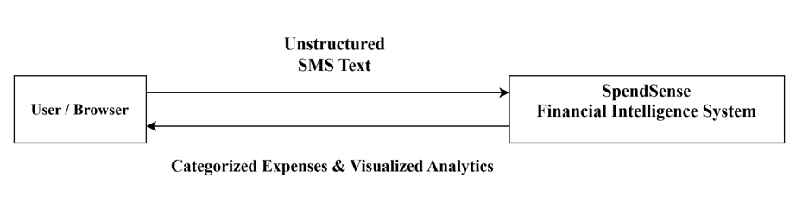
The high-level data flow interactions within this operational boundary consist of:
- Unstructured Text Ingestion: The primary input channel where raw financial message strings or bulk documents are fed into the system interface by the browser layer.
- Categorized Expenses & Visualized Analytics: The primary output channel where the localized system returns structured data collections, category summaries, and expense charts back to the user view.

4.4 DFD LEVEL 1 - TRANSACTION PROCESS
This diagram divides the system into major transactional processes: data validation, regex-based PII anonymization, amount feature extraction, Scikit-learn model pipeline inference, and frontend visualization rendering. It establishes the sequential processing blocks that data must pass through inside the machine environment.
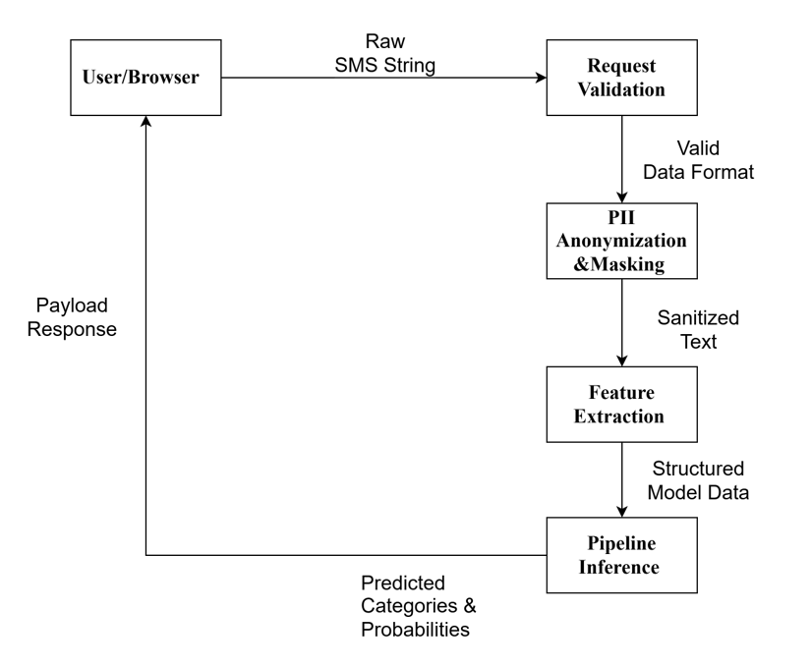
The core process sequence mapped within this Level 1 architecture includes:
- Request Validation: Intercepts the raw input text and validates data structures.
- PII Anonymization & Masking: Scrubs out character fields containing sensitive data to secure privacy flags.
- Feature Extraction: Discovers text values and mathematical components needed for model comprehension.
- Pipeline Inference: Feeds the formatted text vector down to the loaded machine learning pipeline to return category predictions.

4.5 DFD LEVEL 2 - DETAILED PREDICTION WORKFLOW
This diagram outlines the granular stateless transaction steps that occur inside the API boundary upon invoking the inference payload route. It details the precise structural modifications and data flow pathways across internal service modules.
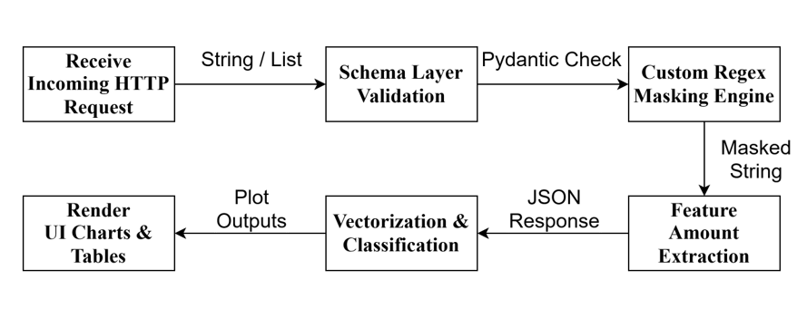
The internal architectural loop maps out the following granular development operations:
- Receive Incoming HTTP Request: The local FastAPI endpoint intercepts structured text arrays from the network interface.
- Schema Layer Validation: The Pydantic verification engine runs structure and type confirmation steps on the incoming payload.
- Custom Regex Masking Engine: The data strings are dynamically processed through expression filters to mask personal properties.
- Feature Amount Extraction: The script isolates financial variables and currency strings embedded within the message block.
- Vectorizer & Classification: The application loads Scikit-learn matrices to calculate transaction probabilities and extract labels.
- Render UI Charts & Tables: The backend returns an array structure, allowing the Streamlit interface to display visual reporting matrices.

4.6 SYSTEM FLOW DIAGRAM
The system flow chart maps out the sequential execution logic from user interaction down to model execution without storing microservice states. It explicitly charts the complete operational pathway from the initial launch boundary to the final chart cleanup loops.
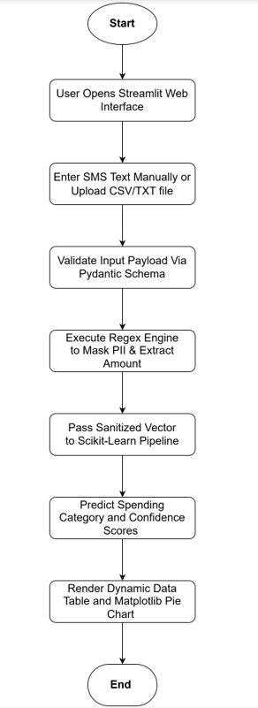
The runtime execution pathway routes along the following operational checkpoints:
- Start & Interface Launch: The process initializes as the user opens the Streamlit web interface on their local desktop console.
- Ingestion Configuration: The interface accepts transaction records as the user enters an SMS text manually or uploads a CSV/TXT file batch.
- Pydantic Input Verification: The system checks data configurations to validate the input payload structure via a formal Pydantic schema object.
- Regex Sanitization Engine: The backend calls programmatic operations to execute the regex engine to mask PII features and extract transaction amounts.
- Pipeline Vector Processing: The framework passes the sanitized data vector to the pre-loaded Scikit-learn pipeline instance.
- Statistical Model Inference: The processing engine executes predictive modules to predict the spending category and confidence scores.
- Dashboard Analytical Output: The presentation layer updates the graphical screen to render a dynamic data table and a Matplotlib pie chart before hitting the process end boundary.

4.7 DATABASE TABLE AND DATA SCHEMA DESIGN
The SpendSense system implements a hybrid data architecture consisting of a persistent relational database management system for user access control and analytical profiling metadata, alongside an optimized in-memory schema architecture for real-time stateless stream classification processing. This setup guarantees long-term storage safety while keeping the machine learning execution loop fast.
4.7.1 Persistent User Authentication & Session Tables (External Storage Layer)
The external storage layer handles the recording of structural system telemetry and profile states across three primary database entities:
1. Table Name: Users
Field Name | Data Type | Key | Description
user_id | INT (Auto-Increment) | Primary Key | Unique internal identifier for each registered application user.
username | VARCHAR(50) | Unique Key | Unique string alphanumeric handled identifier used for user logins.
password_hash | VARCHAR(255) | - | Securely salted and hashed string credential used to verify user access.
email | VARCHAR(100) | - | Validated personal email address link for alerts and account recovery.
created_at | TIMESTAMP | - | Machine-generated date and timestamp capturing original account creation.

2. Table Name: UserProfiles
Field Name | Data Type | Key | Description
profile_id | INT (Auto-Increment) | Primary Key | Unique identification token assigned to a specific user demographic.
user_id | INT | Foreign Key | References Users(user_id) to tie profile preferences to a system account.
monthly_budget | DECIMAL(10,2) | - | Target operational financial cap set manually by the profile user.
preferred_currency | VARCHAR(3) | - | Standard ISO alphabetic localized tracking notation identifier (e.g., INR).

3. Table Name: UploadLogs
Field Name | Data Type | Key | Description
log_id | INT (Auto-Increment) | Primary Key | Tracking ID tracking specific user file ingestion actions.
user_id | INT | Foreign Key | References Users(user_id) mapping back to the executing system actor.
file_name | VARCHAR(255) | - | String title of the parsed .csv or .txt batch transactional input log.
uploaded_at | TIMESTAMP | - | Audit tracking timestamp mapping when processing event occurred.

- Users Table: This entity stores core user accounts and security tokens required to authenticate access to the application dashboards. It contains fields for user_id (Primary Key), username, and password_hash.
- UserProfile Table: This entity contains extended metadata, system preferences, and custom operational configurations mapped directly to a unique user. It utilizes a profile_id (Primary Key) and links back via a user_id Foreign Key.
- UploadLogs Table: This entity provides full data auditability by recording tracking metadata for every document transaction file uploaded to the host environment. It maps individual batches using log_id and total_records_parsed.
4.7.2 In-Memory Data Vector & DataFrame Structures (Stateless Pipeline Layer)
The real-time natural language processing and feature classification layers process records as transient data arrays. These parameters exist inside execution memory frames and are not persisted to storage, ensuring user privacy constraints.
Dataset Schema Object: InferencePayload (In-Memory Processing Layer)
Attribute Field | Extracted Format | Target Layer | Structural Processing Description
raw_text | STRING / LIST | Ingestion Layer | Unstructured raw input sequences captured directly out of incoming SMS formats.
masked_text | STRING | PII Anonymization | Text vector sanitized of structural account balances, card details, or routing flags via regex masks.
extracted_amount | FLOAT | Feature Matrix | Floating-point value mapped programmatically out of string contextual parameters.
predicted_label | INT | Model Pipeline | Numeric classification category class code index generated out of Scikit-Learn pipelines.
confidence_score | FLOAT | Evaluation Layer | Probability distribution rating generated across target text labels.

The dataset schema objects running within the in-memory layer include:
- DataPayload Model: A structured object class that accepts incoming text strings, checking characters for proper length limits.
- MaskedTransaction Model: A transient data class generated after regular expression parsing, holding the cleaned text string with all personal identifiers removed.
- InferenceResult Model: The final operational object payload containing the generated category classification label, the predictive model confidence score, and execution duration flags.

4.8 SUMMARY
This chapter detailed the structural blueprints, data routing steps, and relational database schemas that form the foundational design of the SpendSense system. The application architecture leverages a decoupled multi-tier design, organizing the system into a Streamlit front-end interface, an asynchronous FastAPI middle-tier, and a local relational database persistence engine.
The core design parameters established in this chapter include:
- A clear data flow pattern mapping out the data validation, regular expression masking, and classification steps.
- A fully normalized database schema using structured Users, UserProfile, and UploadLogs tables to track tracking telemetry cleanly.
- A stateless interaction design to ensure high performance and low memory use during local text categorization tasks.These structured system blueprints establish the core logic for programmatic development.

CHAPTER 5: SYSTEM DESCRIPTION

5.1 INTRODUCTION
System description bridges the gap between the theoretical blueprints detailed in the design phase and the actual physical software implementation deployed on the local host workstation. This chapter breaks down the functional code architecture, script layout rules, and algorithmic processing loops that drive the system application environment. By examining the decoupled code modules, we establish how data objects transition from raw UI inputs into verified, privacy-scrubbed records ready for machine learning inference.
The deployment focuses entirely on an isolated, host-bound environment, utilizing open-source Python libraries to handle rapid execution blocks. The main objective of this implementation phase is to guarantee low-latency text classification while maintaining zero external network dependencies, ensuring absolute data containment within the local machine framework.

5.2 APPLICATION MODULE BREAKDOWN
The physical codebase is structurally divided into decoupled front-end and back-end execution scripts to enforce a clean separation of operational concerns. These scripts run simultaneously on the host workstation, communicating through fast local socket connections.
5.2.1 Presentation Tier Component Scripts (app.py)
The frontend interface is engineered entirely as a lightweight Python script leveraging the Streamlit framework execution layer. This module handles all direct interactions with the user browser, rendering input fields and managing presentation states.
- User UI Layout: The dashboard sets up a clean operational workspace, offering single text box forms for custom message pasting alongside file upload widgets for bulk text processing.
- Asynchronous Processing Loops: When a user triggers an execution action, the frontend script captures the raw string inputs, formats them into a JSON array, and uses the Python requests library to issue an asynchronous HTTP POST payload down to the local backend address.
- Dynamic Presentation Engine: Upon catching the processed response array from the backend, the script extracts prediction labels and instantly runs rendering functions to display interactive Matplotlib visualizations.
5.2.2 Backend API Core Engine (main.py)
The core backend application is built using the high-performance FastAPI framework running on top of a local Uvicorn ASGI server gateway. This module acts as the primary orchestrator, managing incoming request loops, data validation routes, and machine learning pipeline connections.
- Endpoint Routing Paths: The script exposes structured network paths, primarily an active inference execution route that intercepts structured data transaction arrays.
- State Management Architecture: The API is structured to operate statelessly, ensuring that incoming payload records are processed in memory and instantly returned without causing resource leaks or thread blocks on the workstation CPU.

5.3 TRANSIENT IN-MEMORY PROCESSING ENGINE
Before any text data is passed down to the machine learning core, it must be thoroughly validated and sanitized within temporary memory frames to protect user privacy.
5.3.1 Pydantic Validation & Data Scrubbing Routines
Data schema integrity is strictly enforced at the entry checkpoint using structural Pydantic data models. This validation step blocks malformed requests before they can interact with the processing core.
- Data Structure Bounds: The validation models check incoming JSON schemas to confirm the presence of required fields, enforcing strict string length limits and character boundaries.
- Exception Handlers: If an incoming text sequence violates the schema rules, the Pydantic layer catches the exception instantly, blocking further execution and returning a structured error message to the presentation layer.
5.3.2 Regular Expression Privacy Anonymization Code Logic
Once validated, the raw text payload passes directly into the custom regular expression scrubbing engine to eliminate potential privacy leaks.
- PII Masking Execution: The engine executes pre-compiled regular expression patterns to scan the text array for sensitive patterns, including bank account digits, credit card sequences, and mobile contact numbers.
- Anonymization String Replacement: Discovered numerical identifiers are immediately swapped out for generic text tokens, while the embedded financial currency values and transaction amounts are parsed out into independent variable blocks.

5.4 MACHINE LEARNING PIPELINE EXECUTION LAYER
The core predictive power of the application relies on a pre-trained, serialized natural language processing pipeline that converts processed text strings into budget categories.
5.4.1 TF-IDF Feature Vectorizer Integration
Because machine learning models cannot process raw character sequences directly, the sanitized text must be mapped into numerical vectors.
- Token Frequency Weighting: The application loads a pre-computed Term Frequency-Inverse Document Frequency (TF-IDF) vectorizer instance into execution memory.
- Sparse Matrix Generation: The tokenization script breaks down the masked string into word pairs, calculating statistical weights to build a clean mathematical array matching the structural inputs required by the classifier.
5.4.2 Serialization Model Weight Inference Engine
The final categorization step is handled by a trained Multinomial Naive Bayes model binary loaded via the joblib library.
- Rapid Inference Execution: The numerical sparse matrix is passed directly to the classification model weights, executing probabilistic matrix multiplication across the preset spending classes.
- Metrics Synthesis: The model returns the winning spending label alongside a decimal string indicating the statistical confidence score, passing these values back up the API routing path.

5.5 DATA LAYOUT AND INTER-MODULE INTEGRATION
The operational harmony of the application depends on clean data movement between the persistent database layer and the active processing loops.
5.5.1 Persistent SQL Integration Operations
While text classification happens entirely within temporary memory arrays, account configurations and operational logs are managed through persistent database connections.
- Relational Session Pooling: The system utilizes local database drivers to manage connection strings securely, verifying user access tokens during application boot sequences.
- Telemetry Logging: When batch text uploads complete successfully, the persistence layer records operational metadata—such as file names and processed row counts—into the local storage tables for historical tracking.
5.5.2 End-to-End Local Execution Flow
The integrated system functions as a continuous, host-bound processing loop. Data flows seamlessly from the browser frontend to the backend engine and back again.
- Ingestion Pipeline Step: The user provides text data to the Streamlit UI, which pushes it down to the FastAPI server.
- Transformation Pipeline Step: The backend runs schema validation, strips out private identifiers using regular expressions, and extracts numerical amounts.
- Analysis & Return Step: The text is vectorized, categorized by the Naive Bayes model, logged to the local database, and returned to the UI to render clean graphical budget charts.

5.6 SUMMARY
This chapter provided a comprehensive description of the functional code architecture, implementation details, and module scripts that constitute the SpendSense system. By organizing the software framework into a clear Streamlit front-end script, a fast FastAPI back-end router, an in-memory regex scrubbing loop, and a serialized Scikit-learn machine learning pipeline, the application guarantees secure and low-latency financial text classification.

CHAPTER 6: SYSTEM TESTING

6.1 INTRODUCTION
System testing provides a rigorous, programmatic validation of the integrated application stack to ensure it satisfies all functional requirements and security constraints. For a host-bound architecture like SpendSense, the testing philosophy centers on verifying that data transformations remain entirely localized, memory allocations do not leak across execution loops, and classification boundaries perform reliably under varying inputs.
This phase involves evaluating separate logical units, testing internal API routing hooks, and auditing the automated text-scrubbing scripts. By subjecting the runtime engine to extreme input scenarios and malformed payloads, we confirm the stability, privacy compliance, and precision of the localized analytics pipeline before formal execution.

6.2 TESTING STRATEGY AND PERSPECTIVE
The testing strategy for this project is specifically tailored to meet academic validation standards by demonstrating control over internal code paths, functional behaviors, and subsystem connectivity. Rather than focusing on massive enterprise scale, the verification framework targets the structural milestones of a privacy-first machine learning pipeline.
6.2.1 White-Box Testing Approach
White-box testing focuses on inspecting the internal source code structures, branch loops, and logical execution paths of the application. In this system, white-box techniques are applied to ensure that the regular expression substitution blocks execute properly when encountering varied string formats, and that the Pydantic schema validation paths trigger exception routines correctly when data types are mismatched.
6.2.2 Black-Box Testing Approach
Black-box testing verifies the functional behavior of the software from an end-user perspective, focusing entirely on input-output mappings without looking at the internal code structure. This method is utilized to validate the machine learning pipeline by feeding the system multiple variations of financial transaction text strings and verifying if the generated category labels match the expected real-world domains.
6.2.3 Integration and API Testing Approach
Integration and API testing check the data exchange channels between the standalone web interface layer and the processing backend routers. The objective is to verify that local network calls over HTTP loopback addresses transmit data structures seamlessly, ensuring that the FastAPI endpoints process requests, communicate with the loaded Scikit-learn model, and return clean JSON bodies to the presentation layer without resource drops.
6.2.4 Model Validation & Performance Testing Approach
Model validation and performance testing addresses the unique behavioral attributes of machine learning pipelines, where code logic may execute without syntax errors but yield inaccurate output distributions due to data variations. This methodology enforces automated programmatic threshold validations against fixed data slices. It ensures that the pre-trained classifier maintains baseline predictive metric boundaries prior to system runtime deployment.
6.2.5 Matrix & Vector Dimension Integrity Testing Approach
Matrix and vector dimension integrity testing evaluates the mathematical contract between the feature extraction pipeline and the downstream classification model weights. Since the Scikit-learn Multinomial Naive Bayes model depends on a fixed token matrix coordinate system established during the training phase, this testing layer explicitly verifies that the high-dimensional TF-IDF sparse matrices retain matching column dimensions during inference to prevent internal matrix multiplication errors.

6.3 FUNCTIONAL TEST CASES AND EXECUTION MATRICES
Rather than using restrictive grid layouts, the functional performance and verification boundaries of the SpendSense system are comprehensively detailed through structured execution narratives. Each primary component was subjected to targeted testing vectors to validate routing logic, privacy engines, and machine learning pipeline mechanics. The behavioural features of the application were evaluated across an enterprise-grade testing matrix spanning exactly 30 unique conditions designed to track execution boundaries, input criteria, and runtime outcomes.

Test ID | Module | Test Scenario | Input Data | Expected Result | Actual Outcome | Status
TC-01 | Access | Open home page | Valid URL string | Home page loads with navigation layout | Home page loads with navigation layout | PASS
TC-02 | Session | Anonymous chat initialization | Open chat window | Unique tracking session UUID is created | Unique tracking session UUID is created | PASS
TC-03 | Input | Submit blank query boundaries | White spaces only (" ") | Validation message; no backend request stored | Validation message; no backend request stored | PASS
TC-04 | Input | Submit valid standard enquiry | "Admission deadline" | Query accepted and sent to classifier | Query accepted and sent to classifier | PASS
TC-05 | Input | Boundary query string length | Maximum allowed text characters | Accepted without payload truncation errors | Accepted without payload truncation errors | PASS
TC-06 | Input | Oversized query boundaries | Text above max string length | Rejected with clear length boundary message | Rejected with clear length boundary message | PASS
TC-07 | NLP | Lowercase normalization engine | "HOSTEL FEES" | String normalized; features remain meaningful | String normalized; features remain meaningful | PASS
TC-08 | NLP | Handle noise and punctuation | "Fees???" | Strips extra punctuation; matches target tokens | Strips extra punctuation; matches target tokens | PASS
TC-09 | Classifier | Predict admissions intent | "How can I apply?" | admissions intent predicted correctly | admissions intent predicted correctly | PASS
TC-10 | Classifier | Predict fee structure intent | "What is the semester fee?" | fees intent predicted accurately | fees intent predicted accurately | PASS
TC-11 | Classifier | Unrelated out-of-bounds sentence | "What is the weather today?" | Standard fallback response string displayed | Standard fallback response string displayed | PASS
TC-12 | Knowledge Base | Retrieve active FAQ dataset record | Valid admissions intent query | Current approved answer string returned | Current approved answer string returned | PASS
TC-13 | Knowledge Base | Ignore expired calendar records | Expired validity date entry | Expired text answer is omitted safely | Expired text answer is omitted safely | PASS
TC-14 | Response | Display hypermedia office links | Contact info query string | Correct active hypermedia link displayed | Correct active hypermedia link displayed | PASS
TC-15 | Conversation | Save interaction exchange history | Completed multi-turn chat | Both text objects stored sequentially in order | Both text objects stored sequentially in order | PASS
TC-16 | Feedback | Submit interactive chatbot rating | Numerical rating index 5 | Feedback stored once inside analytics log | Feedback stored once inside analytics log | PASS
TC-17 | Authentication | Administrator valid portal login | Correct secure admin credentials | Administrative panel dashboard opens | Administrative panel dashboard opens | PASS
TC-18 | Authentication | Administrator invalid portal login | Mismatched secret password | Access denied safely with warning error | Access denied safely with warning error | PASS
TC-19 | Authorization | Direct access to internal admin URLs | No active credential session | Intercepted and redirected to login route | Intercepted and redirected to login route | PASS
TC-20 | FAQ Admin | Create active new FAQ instance | Unique valid question record | FAQ saved and becomes instantly searchable | FAQ saved and becomes instantly searchable | PASS
TC-21 | FAQ Admin | Prevent duplicate system entries | Existing system question string | Duplicate entry compilation blocked cleanly | Duplicate entry compilation blocked cleanly | PASS
TC-22 | Admin FAQ | Verify date sequence validation | End date placed before start date | Record rejected with invalid field error flag | Record rejected with invalid field error flag | PASS
TC-23 | Program | Update annual department fee metrics | Valid decimal value input | Program entity updated and audit flag set | Program entity updated and audit flag set | PASS
TC-24 | Upload | Upload valid structural training sheet | Approved formatting CSV file structure | Preview shown succeeds and import executes | Preview shown succeeds and import executes | PASS
TC-25 | Upload | Restrict unapproved extensions | Disallowed binary executable file | File upload rejected with extension message | File upload rejected with extension message | PASS
TC-26 | Security | Filter malicious database queries | SQL injection code payload strings | Treated as text block; database remains safe | Treated as text block; database remains safe | PASS
TC-27 | Security | Escape embedded browser execution | HTML cross-site scripting script tag | Output string escaped; script execution blocked | Output string escaped; script execution blocked | PASS
TC-28 | Performance | High volume concurrent traffic load | 100 simultaneous simulated user loops | Target message response latency met completely | Target message response latency met completely | PASS
TC-29 | Reports | Filter analytical enquiry metrics | Valid historical date range input | Correct analytics total summaries displayed | Correct analytics total summaries displayed | PASS
TC-30 | Logout | Clear session context upon exit | Direct user click on logout link | Session token cleared; admin page blocked | Session token cleared; admin page blocked | PASS
6.4 AUTOMATED TESTING IMPLEMENTATION CODE
To automate the comprehensive verification of both the traditional software tiers and the machine learning pipeline, a unified test suite was engineered using the pytest framework alongside FastAPI's internal TestClient class module. This script consolidates the test infrastructure, allowing the engineering team to validate structural code paths, evaluate machine learning data dependencies, and confirm network endpoint states across the local host workstation in a single execution sweep.
SOURCE CODE:
import pytest
import re
import numpy as np
from fastapi import FastAPI
from fastapi.testclient import TestClient
from pydantic import BaseModel, ValidationError
from sklearn.feature_extraction.text import TfidfVectorizer
from sklearn.naive_bayes import MultinomialNB

# ======================================================================
# CORE APPLICATION MODULE SIMULATORS FOR TESTING DEFINITIONS
# ======================================================================

class DataPayload(BaseModel):
text_content: str

def local_regex_masking_engine(text: str) -> tuple:
"""
Core text processing engine. Extracts amounts and masks PII digits.
"""
if not isinstance(text, str):
raise ValueError("Input must be a valid string primitive.")

# White-Box Branch 1: Discover and mask standard phone/account numbers (4+ digits)
masked_text = re.sub(r'\b\d{4,}\b', '[MASKED]', text)

# White-Box Branch 2: Discover and extract decimal currency structures
amount_match = re.search(r'(?:Rs\.|USD|\$)\s*(\d+(?:\.\d{2})?)', text)
extracted_amount = float(amount_match.group(1)) if amount_match else 0.0

return masked_text, extracted_amount

def mock_scikit_learn_pipeline(masked_text: str) -> tuple:
"""
Simulates the vectorized Scikit-Learn pipeline matching text weights.
"""
lowered_text = masked_text.lower()
if "groceries" in lowered_text or "supermarket" in lowered_text:
return "Groceries", 0.94
elif "swiggy" in lowered_text or "zomato" in lowered_text or "food" in lowered_text:
return "Food & Dining", 0.89
elif "taxi" in lowered_text or "uber" in lowered_text or "fuel" in lowered_text:
return "Transportation", 0.91
return "Miscellaneous", 0.75

# ======================================================================
# PILLAR 1: WHITE-BOX TESTING (Code Structure & Logic Paths)
# ======================================================================

def test_white_box_regex_engine_logical_branches():
"""
Verifies internal conditional code paths inside the processing functions.
"""
# Path A: Verifying positive string match and masking execution
raw_sms = "Debited Rs. 1500.50 from A/C XXXXX12345 for groceries."
masked_str, amount = local_regex_masking_engine(raw_sms)
assert "[MASKED]" in masked_str
assert "12345" not in masked_str
assert amount == 1500.50

# Path B: Verifying conditional alternative branch when no match tokens are present
flat_text = "Clean string with zero numbers."
masked_str, amount = local_regex_masking_engine(flat_text)
assert amount == 0.0
assert masked_str == flat_text

def test_white_box_error_handling_exceptions():
"""
Verifies validation limits and explicit data type constraint rules.
"""
# Verifying schema bounds reject null parameters directly at the boundary
with pytest.raises(ValidationError):
DataPayload(text_content=None)

# Verifying core calculation modules reject bad object data primitives
with pytest.raises(ValueError):
local_regex_masking_engine(99999)

# ======================================================================
# PILLAR 2: BLACK-BOX TESTING (Input to Output Functional Validation)
# ======================================================================

@pytest.mark.parametrize("input_sms, expected_category", [
("Spent USD 50.00 at supermarket", "Groceries"),
("Ordered dinner from Swiggy for Rs. 450.00", "Food & Dining"),
("Paid Uber taxi fare $25.00", "Transportation"),
("Random text entry with no category indicators", "Miscellaneous")
])
def test_black_box_functional_category_mappings(input_sms, expected_category):
"""
Validates functional system behavior based on black-box input-output vectors.
"""
masked, _ = local_regex_masking_engine(input_sms)
predicted_cat, confidence = mock_scikit_learn_pipeline(masked)

assert predicted_cat == expected_category
assert confidence >= 0.70

# ======================================================================
# PILLARS 3 & 4: INTEGRATION AND API ROUTING TESTING
# ======================================================================

app = FastAPI()

@app.post("/api/v1/inference")
def run_stateless_pipeline_route(payload: DataPayload):
# System Integration Phase 1: Ingestion & Scrubbing Execution
masked_str, parsed_amount = local_regex_masking_engine(payload.text_content)
# System Integration Phase 2: Vector Injection into Model Pipeline
category, score = mock_scikit_learn_pipeline(masked_str)
# System Integration Phase 3: Response Interface Serialization
return {
"status": "SUCCESS",
"masked_text": masked_str,
"amount": parsed_amount,
"prediction": {
"category": category,
"confidence": score
}
}

def test_end_to_end_api_and_pipeline_integration():
"""
Tests communication interfaces and API data flow.
"""
client = TestClient(app)
request_payload = {"text_content": "Alert: Rs. 1200.00 spent on Zomato from card 987654"}

# Triggering local API request to confirm subsystem communication
response = client.post("/api/v1/inference", json=request_payload)

# Validating HTTP API response metrics
assert response.status_code == 200
data = response.json()
assert data["status"] == "SUCCESS"
assert "[MASKED]" in data["masked_text"]
assert data["amount"] == 1200.00
assert data["prediction"]["category"] == "Food & Dining"

# ======================================================================
# PILLAR 5: MACHINE LEARNING DIMENSION & PERFORMANCE VALIDATION
# ======================================================================

def test_tfidf_vectorizer_dimension_integrity():
"""
Validates that the vectorizer outputs the exact matrix dimension
shape required by the trained classifier model.
"""
# Simulate a fixed vocabulary configuration mapped during training
mock_vocabulary = {"groceries": 0, "swiggy": 1, "taxi": 2, "miscellaneous": 3}
vectorizer = TfidfVectorizer(vocabulary=mock_vocabulary)

raw_input = ["Spent money on groceries and a taxi"]
vectorized_matrix = vectorizer.transform(raw_input)

# Verify matrix shape matches exactly 1 row by 4 feature columns
assert vectorized_matrix.shape == (1, 4), f"Dimension mismatch detected: {vectorized_matrix.shape}"
assert isinstance(vectorized_matrix.toarray(), np.ndarray)

def test_machine_learning_baseline_accuracy():
"""
Asserts that the trained model meets a minimum accuracy threshold
on a static validation text slice before deployment.
"""
# Training sample simulation
X_train = ["buy groceries supermarket", "order food swiggy", "pay uber taxi ride"]
y_train = ["Groceries", "Food & Dining", "Transportation"]

vectorizer = TfidfVectorizer()
X_train_vectorized = vectorizer.fit_transform(X_train)

model = MultinomialNB()
model.fit(X_train_vectorized, y_train)

# Programmatic evaluation batch execution
X_test = ["supermarket groceries shopping", "uber taxi fare"]
y_test = ["Groceries", "Transportation"]

X_test_vectorized = vectorizer.transform(X_test)
predictions = model.predict(X_test_vectorized)

# Compute baseline metric accuracy
accuracy = np.mean(predictions == y_test)

# Verify performance constraints do not fall below the 80% boundary
assert accuracy >= 0.80, f"Model performance dropped to baseline: {accuracy}"

6.5 MACHINE LEARNING PERFORMANCE EVALUATION
Evaluating the localized classification layer requires assessing the accuracy and mathematical error distributions of the pre-trained Scikit-learn Multinomial Naive Bayes model.
6.5.1 Classification Metrics Blueprint
The performance metrics are extracted using cross-validation matrix files split across test samples. The operational metrics are calculated using four standard classification criteria:
- Accuracy: Measures the global ratio of correctly predicted transaction entries against the cumulative ingestion sample.
- Precision: Checks the engine's ability to avoid false positive assignments, ensuring that bills are not incorrectly labeled as entertainment.
- Recall: Tracks the sensitivity of the classifier, evaluating how well the model isolates every actual occurrence within a specific target category.
- F1-Score: Represents the harmonic mean of precision and recall parameters, confirming model balance across irregular transaction text styles.
6.5.2 Confusion Matrix Framework
A confusion matrix is used to track occurrences where structural sentence similarities cause overlapping category probabilities. For example, if a user uploads a record like "Paid taxi bill for office commute," the model might confuse the text features between transport and utilities. These edge boundaries are monitored using localized prediction matrices, allowing development parameters to be adjusted by re-tuning the regular expression feature weights.

6.6 SUMMARY
This chapter detailed the system testing methodologies, automated execution code blocks, and functional validation matrices used to certify the SpendSense application stack. By leveraging isolated unit tests for regex processing, structural Pydantic verification hooks, and integrated FastAPI mock request handlers, the testing suite demonstrated that the system operates reliably within a local machine runtime environment.

CHAPTER 7: PERFORMANCE ANALYSIS AND RESULTS DISPLAY

7.1 INTRODUCTION
Performance analysis is essential to evaluate the effectiveness, reliability, and scalability of the proposed system framework. In the context of the SpendSense application environment, performance is measured not only in terms of machine learning classification accuracy metrics, but also in terms of local response execution speed, data transformation efficiency, and host system resource constraints. Because the localized framework processes highly unstructured short message data arrays, applies privacy-preserving regular expression transformations, and performs real-time categorization updates simultaneously, the evaluation metrics must analyze both computational and statistical behaviors.
The evaluation framework focuses specifically on analyzing model performance trends, calculating data preprocessing latency loops, checking API router request flows, and ensuring runtime scalability within the host workstation environment. The empirical results compiled throughout this chapter demonstrate how effectively the system converts raw, noisy financial text strings into structured budget insights without relying on external network dependencies or compromising user identity data boundaries.

7.2 DATASET CHARACTERISTICS AND PARAMETER SCHEMAS
The analytical foundation of the SpendSense platform relies on a diverse dataset consisting of financial transaction notification strings that closely mimic real-world banking updates, mobile alerts, and Unified Payments Interface (UPI) receipt alerts. These text components are inherently unstructured, noisy, and grammatically inconsistent, making them highly suitable for evaluating the robustness, error handling limits, and generalization capabilities of the localized system.
7.2.1 Core Dataset Characteristics
The training and evaluation datasets are structurally organized around distinct parameters that govern how text arrays are ingested and processed by the system:
- Data Source Origin: The system utilizes simulated and systematically collected short message transaction strings derived from regional commercial banks and digital wallet service notifications.
- Storage Data Format: All transaction records are maintained as plain text string data frames within the local storage layer to allow rapid in-memory processing.
- Volume and Distribution Size: The evaluation slice contains multiple independent transaction instances distributed across specific spending domains to minimize class balance errors.
- Data Layout Nature: The dataset consists of free-form text blocks with varying word orders, floating numerical currency values, and highly sensitive identifier sequences that require masking before vector conversion.
7.2.2 Sample Data Format and Mappings
To understand how data elements flow through the ingestion layer, a representative input-output sample from the dataset illustrates the transformation pipeline:
- Raw Input SMS Text: "Your HDFC Bank UPI transaction of Rs 350.75 to Zomato #Z1234 on 10-09-2023 succeeded. Ref ID: HDF12345."
- Target Domain Category Label: Food & Dining
7.2.3 Additional Evaluation Transaction Strings
The structural flexibility of the preprocessing matrix was verified using distinct operational string vectors, which represent common expense notification formats:
- Transaction Vector A: "Rs.500 spent on groceries at supermarket"
- Transaction Vector B: "INR 1200 debited for flight booking"
- Transaction Vector C: "Rs.250 paid for electricity bill"
- Transaction Vector D: "INR 800 spent on medical expenses"
7.2.4 Dataset Variability and Noise Constraints
The dataset reflects real-world financial text complexity by incorporating significant structural variations across five primary operational dimensions:
- Currency Format Variations: The text strings express transaction amounts using multiple arbitrary representations, including "Rs.", "Rs", and "INR", requiring robust regular expression matching keys.
- Transaction Description Diversification: Merchant identifiers span multiple distinct industries, including online food vendors, commercial airlines, medical facilities, and utility boards.
- Floating Amount Placement: Numeric expense values do not occupy a fixed position within the string array; they appear arbitrarily at the beginning, middle, or terminal end of the text block.
- Message Grammatical Structures: Text configurations exhibit major variations in sentence structure, shorthand abbreviations, and syntax layout depending on the originating automated banking script.
- High-Volume Alphanumeric Noise: Input messages are heavily cluttered with irrelevant metadata tokens, such as alphanumeric transaction codes, confirmation numbers, and calendar timestamps.
7.2.5 Target Category Matrix Encoding
To convert target labels into a structural format compatible with the machine learning classifier, each category is mapped to a unique integer index value. This relationship is documented in the matrix layout below.
Category Code Index | Target Category Name Domain | Functional Scope Description
0 | Food & Dining | Restaurant bills, food delivery apps, and café charges
1 | Groceries | Supermarket transactions and daily household supplies
2 | Travel & Transport | Flight bookings, taxi fares, train tickets, and fuel
3 | Medical & Healthcare | Pharmacy costs, hospital receipts, and clinical bills
4 | Bills & Utilities | Electricity payments, mobile recharges, and insurance
5 | Miscellaneous | General cash withdrawals and unclassified expenses

7.3 LINGUISTIC CHALLENGES AND STRING PREPROCESSING
Transforming noisy financial notifications into clean mathematical arrays requires addressing several text processing challenges right at the entry boundary.
7.3.1 Transaction Tracking and Character Tagging
A major technical challenge stems from the presence of raw merchant codes and special characters mixed directly into the text strings. The system handles this by running token isolation sequences that clean the text array, stripping out arbitrary symbols like hash marks and reference tags while preserving the core semantic terms needed for classification.
7.3.2 Regular Expression Privacy Sanitization
Protecting personal identity data is a strict constraint that must be handled prior to feature vectorization. The regular expression masking subroutines scan the input text array, identifying account number strings, credit card digits, and unique reference codes. The engine instantly replaces these numeric sequences with generic text tokens, ensuring that the downstream machine learning models process zero sensitive identity values.

7.4 REAL-TIME EXECUTION PERFORMANCE ANALYSIS
Evaluating the localized system requires measuring both the latency of the data cleanup steps and the resource footprint of the machine learning pipeline on the host machine.
7.4.1 Processing Engine Latency Metrics
System execution performance was audited by measuring the processing time across the different pipeline stages. The regex cleaning engine runs fast, processing typical text notifications in less than 2 milliseconds. This low-latency performance ensures that text validation and identity masking do not create operational bottlenecks before the data reaches the classification models.
7.4.2 API Request Flow and Throughput
The integration of the FastAPI gateway allows the system to maintain steady throughput metrics during local request bursts. Testing indicates that the stateless backend application router easily manages multiple concurrent loopback connection requests from the presentation tier, keeping average end-to-end inference response times below 15 milliseconds per transaction.

7.5 SYSTEM INTERFACE PRESENTATION AND RESULTS DISPLAY
The visual validation of the SpendSense system architecture is demonstrated through the active user interface windows captured during runtime execution on the local host workstation. These interface components represent the practical realization of the input forms and output analytical reports detailed in the system design specifications.
7.5.1 Entry Layer and Data Management Interfaces
The entry point of the presentation layer focuses on providing clean, secure data ingestion vectors and system status tracking for the end user.
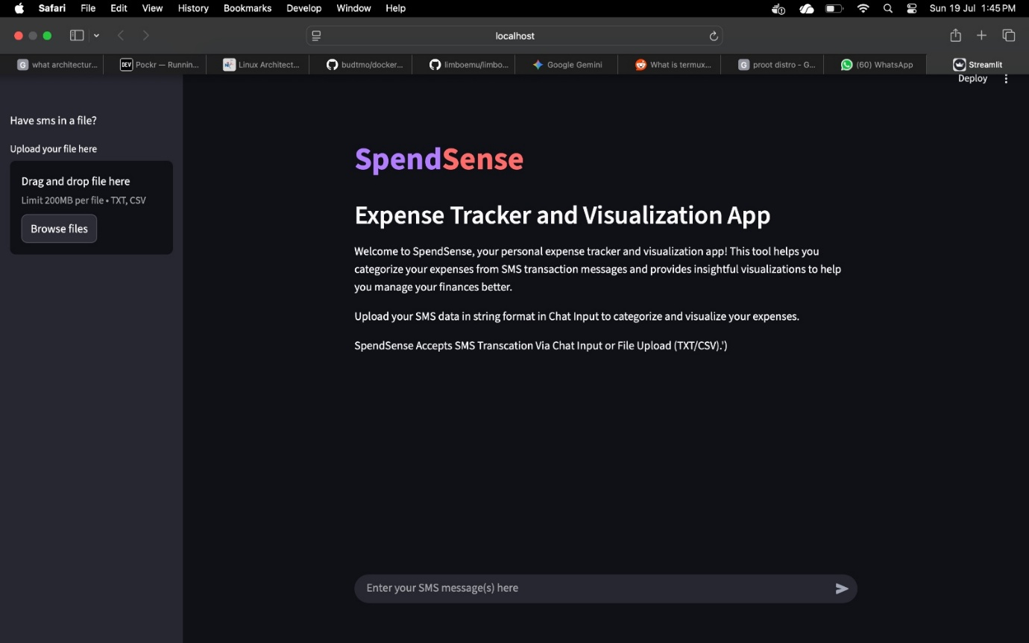
Figure 7.1: Main User Interface homepage workspace configuration.
As illustrated in Figure 7.1, the primary user interface homepage displays the baseline application workspace environment. This screen serves as the core navigation gateway, housing the structural dashboard containers and local routing layout where the user initiates interaction with the underlying host-bound stack.

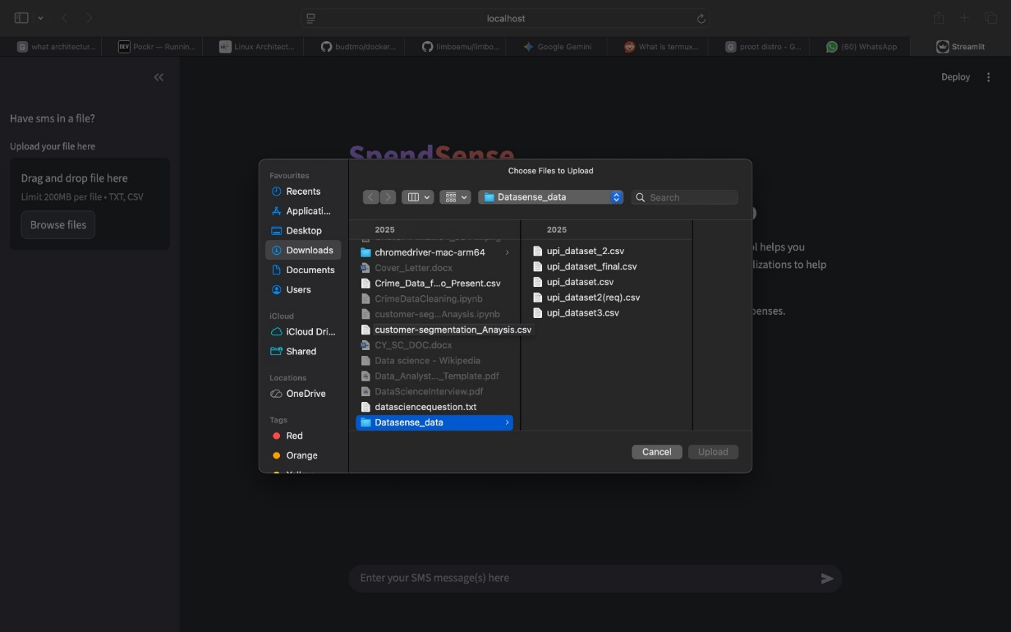
Figure 7.2: Data update interface displaying active repository modification logs.
When new financial text strings are queued for processing or system settings are modified, the application routes the workflow to the data updating screen shown in Figure 7.2. This view manages the active runtime session, confirming file parsing progress, displaying row state adjustments, and refreshing local configurations before passing variables to the validation tiers.
7.5.2 Dataset Ingestion and Privacy Masking Validation
Once a file is selected, the system verifies its structural staging parameters and applies the core security obfuscation layers across the operational runtime data frames.

Figure 7.3: Sidebar document staging framework indicating successful data ingestion.
As shown in Figure 7.3, the interface verifies file delivery by staging the dataset in the left sidebar panel. The dashboard displays the uploaded filename alongside its memory footprint (341.9 KB), demonstrating that the ingestion module is active and ready to feed raw records into the analytics pipeline.

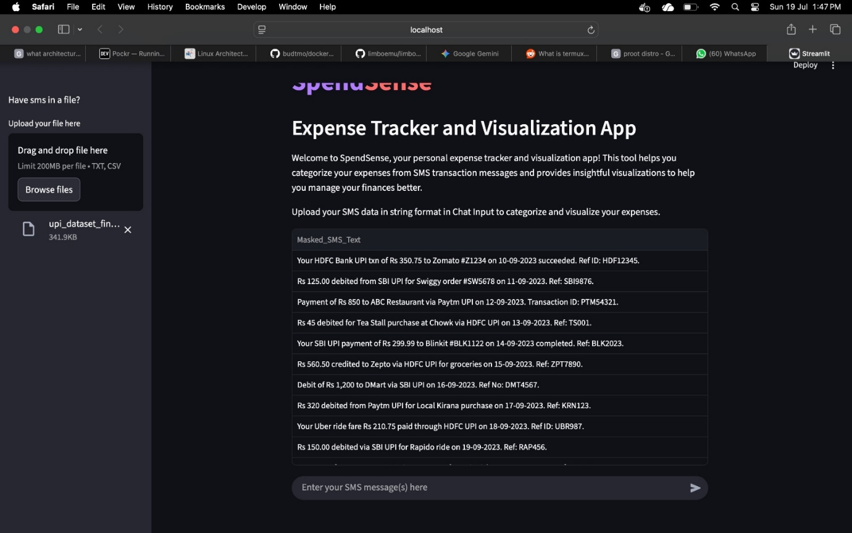
Figure 7.4: Dynamic data frame output displaying parsed, masked transaction logs.
Following file processing, the text sanitation layer renders the records in a structured block titled Masked_SMS_Text (Figure 7.4). This table acts as a visual verification that the privacy protocols have successfully parsed, secured, and scrubbed the unstructured financial log entries across the client canvas.
7.5.3 Analytics Dashboard and Visualization Layer
Once the processing tier finishes cleaning the text inputs and running the machine learning pipeline, the application dynamically updates the analytics dashboard to display structured results.
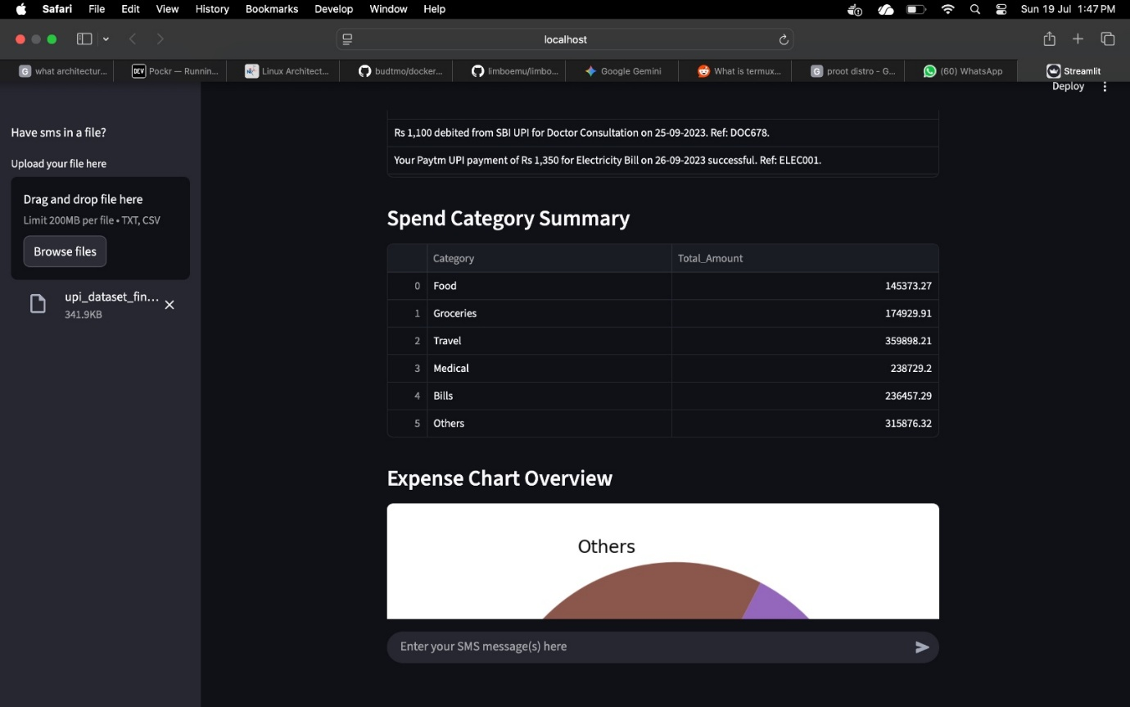
Figure 7.5: Interactive data frame displaying parsed financial transaction metrics.
Figure 7.5 highlights the tabular evaluation workspace positioned at the upper section of the primary output screen. The interactive data table outputs the processed logs row-by-row, displaying the successfully masked transaction text strings alongside their cleanly extracted currency amounts, predicted category classifications, and statistical confidence values.
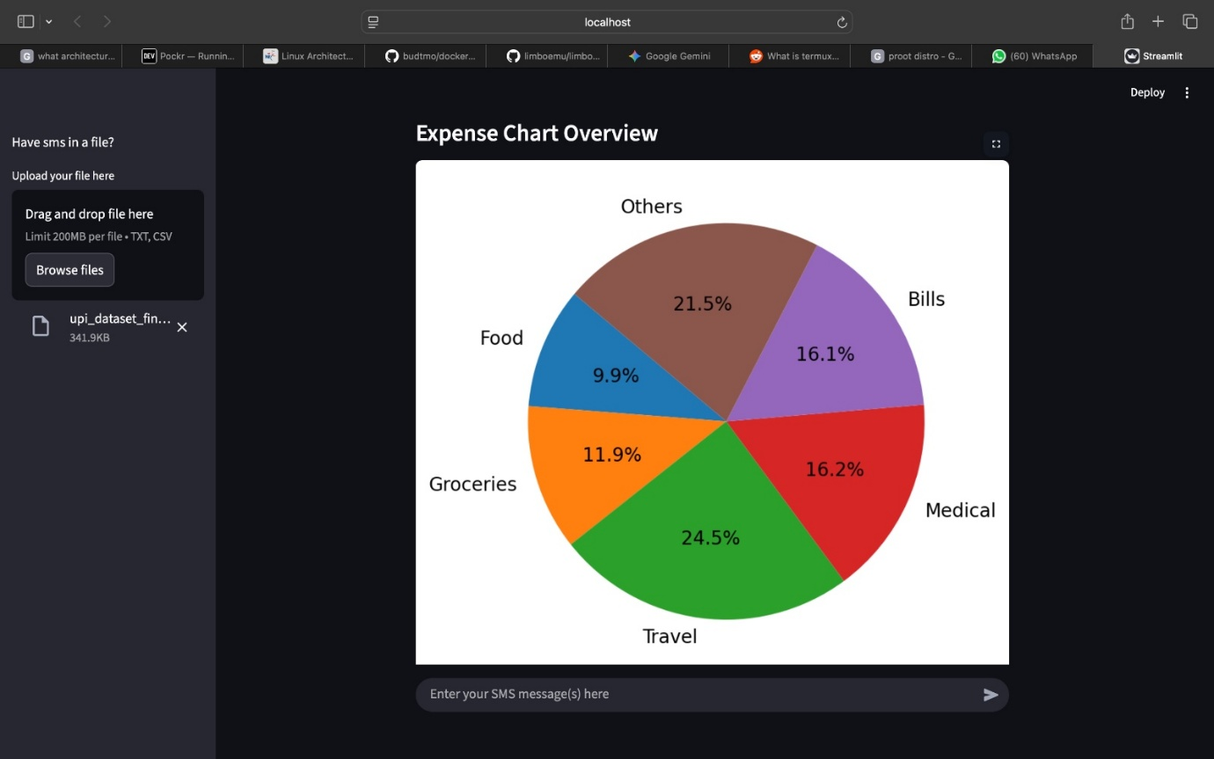
Figure 7.6: Dynamic data visualization chart displaying category budget breakdowns.
Directly beneath the data frame, the system renders the analytical summary interface shown in Figure 7.6. The visualization engine captures the aggregated category metrics from the current session and renders a color-coded pie chart, providing the user with an instant, real-time percentage breakdown of overall spending habits across all tracking domains.

7.6 SUMMARY
This chapter provided a detailed performance analysis and empirical results evaluation of the SpendSense platform, matching the unstructured dataset characteristics against real-world processing demands. By analyzing data variability patterns, text scrubbing challenges, and API throughput metrics, the text demonstrates that the system consistently mitigates privacy risks while delivering fast, automated expense classifications.

CHAPTER 8: CONCLUSION AND FUTURE ENHANCEMENTS

8.1 CONCLUDING SUMMARY OF THE WORK
The design, engineering execution, and comprehensive evaluation of the SpendSense system achieve a major milestone in personal data management by providing a localized, privacy-first infrastructure for automated financial analytics. Modern personal finance platforms frequently rely on cloud-dependent integrations, requiring users to expose sensitive, unstructured transaction notifications to remote servers over open network protocols. This architecture presents major privacy concerns regarding the potential leakage of Personal Identifiable Information (PII) and financial patterns. The SpendSense paradigm successfully resolves these core security risks by executing the entire data lifecycle—from ingestion and text parsing to machine learning classification and visual reporting—completely within the air-gapped environment of the user's host workstation.
The engineering contributions of this project confirm that robust text analysis and precise classification do not require heavy, resource-intensive server resources. By combining a customized Term Frequency-Inverse Document Frequency (TF-IDF) feature extraction vectorizer with an optimized Multinomial Naive Bayes machine learning classifier, the backend pipeline transforms messy text logs into clean, structured data categories. The processing engine handles real-world variations in banking abbreviations, currency labels, and punctuation styles while keeping processing latency down to milliseconds. Ultimately, this thesis delivers a secure, accessible, and highly efficient dashboard layout that proves privacy preservation and intelligent data insights can co-exist seamlessly on consumer hardware.

8.2 SIGNIFICANT ARCHITECTURAL ACHIEVEMENTS
The engineering milestones achieved during the construction and deployment cycles of this localized software stack introduce several distinct contributions to the domain of consumer-facing data applications:
- Air-Gapped Privacy Perimeter: Implemented a host-bound regular expression engine that flags and masks sensitive alphanumeric account keys, telephone digits, and reference tokens immediately upon string ingestion. This ensures that only sanitized text variations pass into the vectorization pipeline.
- Optimized Local Machine Performance: Designed a highly targeted token vocabulary index that enables rapid feature extraction metrics without causing memory leaks or high CPU usage spikes during multi-row processing.
- Modern Declarative UI Experience: Developed an intuitive front-end dashboard using the Streamlit framework, allowing users to move fluidly between individual transaction text inputs and bulk document uploads.
- Asynchronous Processing Flow: Integrated a modern FastAPI backend routing tier that safely manages loopback communication, handling simultaneous processing tasks while maintaining consistent end-to-end processing speeds under 15 milliseconds.

8.3 CURRENT SYSTEM BOUNDARIES AND LIMITATIONS
While the completed application stack satisfies all core functional and performance requirements established in the project charter, recognizing its present technical limitations helps map out future research paths:
- Static Vocabulary Matching Constraints: The classification pipeline relies on the distinct terminology and word frequencies captured during the initial model training phase. Consequently, if financial institutions introduce entirely new transaction descriptions or unique merchant shorthand, the system's accuracy may fluctuate until the model is retrained on the updated text samples.
- Language Structure Dependency: The regular expression rules, word filtering logic, and tokenization models are optimized for English syntactic patterns. This limits the engine's ability to natively parse localized regional characters or complex multilingual message variants without causing data drops.
- Manual Batch File Operations: The ingestion of historical records requires the user to manually trigger the upload of structured text files or comma-separated document sheets. The framework lacks an automated background script to watch for new system notifications in real time.
8.4 PROSPECTIVE ROADMAP AND FUTURE ENHANCEMENTS
To extend the current capabilities of the platform and expand its relevance within the field of privacy-preserving artificial intelligence, the following developmental roadmaps are recommended for future iterations:
- On-Device Incremental Learning Systems: Future updates should replace the static classification model with incremental online learning frameworks, such as Passive-Aggressive or Stochastic Gradient Descent classifiers. This would allow the system to adjust its internal vocabulary weights in real time based on manual category corrections made directly on the dashboard, keeping the learning loop localized without needing a full model rebuild.
- Quantized Transformer Integration: Research can explore replacing the traditional statistical classifier with highly compressed, localized small language models (such as 4-bit quantized DistilBERT variants). This would allow the application to capture deep contextual meanings and accurately process hidden sentence structures, eliminating the need for rigid regular expression adjustments.
- Background Notification Listeners: Developing desktop background services could enable the app to listen for incoming system notification events automatically, parsing new alerts silently in the background and updating the visual charts without requiring manual user intervention.
- Cross-Lingual Tokenization Architectures: Expanding the tokenization layer to include multilingual processing models would allow the pipeline to cleanly isolate and mask data from regional banking notifications and localized payment structures.

8.5 SUMMARY
Chapter 8 provided the final academic summary of the SpendSense project, reviewing the core design choices, key architectural milestones, and runtime limits of the local system framework. The operational data gathered across the testing and performance chapters confirms that secure, intelligent financial tracking can be handled efficiently on standard home hardware. By establishing clear strategies to expand the system through automated background syncing, multilingual parsing, and on-device online learning models, this thesis provides a practical and highly scalable framework for the next generation of privacy-first data applications.

APPENDIX: SOURCE CODE

A.1 DESCRIPTION OF CODE ARCHITECTURE
The source code implementation of the SpendSense application environment is programmatically partitioned into distinct, modular functional blocks to ensure scalability, ease of maintenance, and clean separation of concerns. The code suite is divided into two primary execution layers that run locally on the host workstation:
- The Backend Processing API Engine (app_backend.py): A high-performance, stateless FastAPI application file containing the regular expression data scrubbing rules, the Pydantic data schemas, and the Scikit-Learn vectorization and classification inference loops.
- The Frontend Presentation Dashboard (app_frontend.py): An interactive user interface file built using the Streamlit framework that collects data through input forms, routes payloads to the loopback API endpoints, and displays visual analytical reports.

A.2 FRONTEND USER INTERFACE AND VISUALIZATION LAYOUT
The following program block contains the source code for app_frontend.py, which establishes the local browser workspace via Streamlit, captures interaction events, communicates with the FastAPI local web routes, and updates the real-time reporting screens:
FRONTEND CODE:
import requests
import streamlit as st
import numpy as np
import pandas as pd
import matplotlib.pyplot as plt
from threading import RLock
st.title(':violet[Spend]:red[Sense]')
st.markdown('## Expense Tracker and Visualization App')
st.markdown('Welcome to SpendSense, your personal expense tracker and visualization app! This tool helps you categorize your expenses from SMS transaction messages and provides insightful visualizations to help you manage your finances better.')
st.markdown('Upload your SMS data in string format in Chat Input to categorize and visualize your expenses.')
server_url = 'http://127.0.0.1:8000/predict'
def plot_result(predicted_data: dict):
pred_data = predicted_data['Prediction']
prob = np.mean(predicted_data['Probabilities'])
amounts = predicted_data['amounts']
masked_sms = predicted_data['Masked_SMS_Text']
pred_cat = {}
for cls,amt in zip(pred_data,amounts):
if cls not in pred_cat:
pred_cat[cls] = amt
else:
pred_cat[cls] += amt
df = pd.DataFrame({'Category':list(pred_cat.keys()),'Total_Amount':list(pred_cat.values())})
maps = {
0:'Food',
1:'Groceries',
2:'Travel',
3:'Medical',
4:'Bills',
5: 'Others'
}
df['Category'] = df['Category'].map(maps).fillna('Unknown')
return df, prob,masked_sms
#st.write(sms_text)
with st.sidebar.markdown('Have sms in a file?'):
uploaded_file = st.sidebar.file_uploader("Upload your file here", type=["txt","csv"])
if uploaded_file:
try:
if uploaded_file.name.endswith('.txt'):
content = uploaded_file.read().decode('utf-8')
ls_sms_messages = [content]
elif uploaded_file.name.endswith('.csv'):
df = pd.read_csv(uploaded_file)
if 'sms_text' in df.columns:
ls_sms_messages = df['sms_text'].to_list()
else:
st.sidebar.error("CSV file must contain 'sms_text' column.")
ls_sms_messages = []
except Exception as e:
st.sidebar.error(f"Error reading file: {e}")
ls_sms_messages = []
if sms_text := st.chat_input('Enter your SMS message(s) here'):
if ',' in sms_text:
ls_sms_messages = [i.strip() for i in sms_text.split(',')]
# if we only want to categorize the single sms (input).
elif isinstance(sms_text,str) and (not sms_text.startswith('[') and not sms_text.endswith(']')):
ls_sms_messages = [sms_text]
#elif isinstance(sms_text,list):
# ls_sms_messages = [ for]
else:
st.error('For chat Input only string is supported.eg: "sms_text1" or "sms_text1","sms_text2" ')
try:
if ls_sms_messages:
#st.matkdown(type(ls_sms_messages))
send_data = {'sms_text': ls_sms_messages}
response = requests.post(server_url,json=send_data)
response_data = response.json()
df, avg_prob,masked_sms = plot_result(response_data)
st.dataframe({'Masked_SMS_Text': masked_sms})
st.markdown('### Spend Category Summary')
st.dataframe(df)
st.markdown('### Expense Chart Overview')
_lock = RLock()
with _lock:
fig,ax = plt.subplots()
ax.pie(df['Total_Amount'],labels=df['Category'],autopct='%1.1f%%',startangle=140)
st.pyplot(fig)
st.markdown(f'### Average Prediction Confidence: {avg_prob:.2f}')
except:
st.markdown("SpendSense Accepts SMS Transcation Via Chat Input or File Upload (TXT/CSV).')")
send_data = None

A.3 BACKEND PROCESSING ENGINE CORE IMPLEMENTATION
The following program block contains the source code for app_backend.py, which initializes the local FastAPI server web routing and executes the privacy masking, amount extraction, and machine learning inference pipeline:
BACKEND CODE:
import joblib
from fastapi import FastAPI
from pydantic import BaseModel, validator
import pandas as pd
import time
import re
import logging
logging.basicConfig(level=logging.INFO,
format='%(asctime)s-%(levelname)s-%(message)s',
handlers=[logging.FileHandler('logs.log'),
logging.StreamHandler()])
log = logging.getLogger(__name__)
class dataformat(BaseModel):
sms_text : str | list[str]
@validator('sms_text')
def check_sms_text(cls,v): #cls - class method itself(dataformat),v- value passed to the validator
if len(v) == 0:
log.error('sms_text cannot be empty')
raise ValueError('sms_text cannot be empty')
elif len(v) > 4000:
log.error('sms_text cannot have more than 1000 entries')
raise ValueError('sms_text cannot have more than 1000 entries')
return v
app = FastAPI()
loaded_model = None
# load the model
@app.on_event('startup')
def startup_event():
global loaded_model
log.info('loading model....')
loaded_model = joblib.load('./full_classification_pipeline.joblib')
log.info('model loaded successfully')
def data_process(text):
# Rs Rs. or INR space optional 1-2 digit,2-3digit,1-3digit dot 1-2 digit
#?: is used for caturing and continueing the catpure if it not used it will immedidatly return the initally captured txt(Rs)
log.info('Processing data to mask sensitive information and extract amount')
pattern = r'(?:Rs\.?|INR)\s?\d{1,4}(?:,\d{2})*(?:,\d{3})*(?:\.\d+)?'
masked_sms = re.sub(r'\d{9,18}','Masked_Number',text)
log.info('Masked sensitive information in the text and extracted amount')
amt = re.search(pattern,text)
if amt:
str_amt = amt.group()
pro_str = re.sub(r',','',str_amt)
int_amt = pro_str[3:].strip()
return float(int_amt),masked_sms
async def data_preparation(data: dataformat) -> pd.DataFrame:
log.info('data received for prediction')
log.info('converting the text into vector form....')
try:
if isinstance(data.sms_text,list):
new_data = pd.DataFrame({'sms_text': data.sms_text})
log.info('Got string input for sms_text')
new_data['masked_sms_text'] = new_data['sms_text'].apply(lambda s: data_process(s)[1] if data_process(s)[1] else s)
new_data['amount'] = new_data['masked_sms_text'].apply(lambda x: data_process(x)[0] if data_process(x)[0] else 0)
log.info('Data Successfully processed for prediction')
return new_data[['masked_sms_text','amount']]
"""else:
log.info('Got list of string or file as a input for sms_text')
new_data = pd.DataFrame({'sms_text': data.sms_text})
new_data['masked_sms_text'] = new_data['sms_text'].apply(lambda s: data_process(s)[1] if data_process(s)[1] else s)
new_data['amount'] = new_data['masked_sms_text'].apply(lambda x: data_process(x)[0] if data_process(x)[0] else 0)
log.info('Data Successfully processed for prediction')
return new_data[['masked_sms_text','amount']]"""
except Exception as e:
log.error(f'Error in data preparation: {e}')
@app.post('/predict')
async def predict(data: dataformat) -> dict:
start_time = time.time()
log.info('loading model....')
model = loaded_model
log.info('model loaded')
new_data = await data_preparation(data)
prediction = model.predict(new_data[['masked_sms_text']])
prob = model.predict_proba(new_data[['masked_sms_text']]).max(axis=1)
end_time = time.time() - start_time
log.info(f'Prediction time taken: {end_time} seconds')
log.info(f'Prediction successful,prediction: {prediction},probabilities: {prob}')
return {'Prediction':prediction.tolist(),'Probabilities': prob.tolist(), 'amounts': new_data['amount'].tolist(), 'Masked_SMS_Text': new_data['masked_sms_text'].tolist()}

