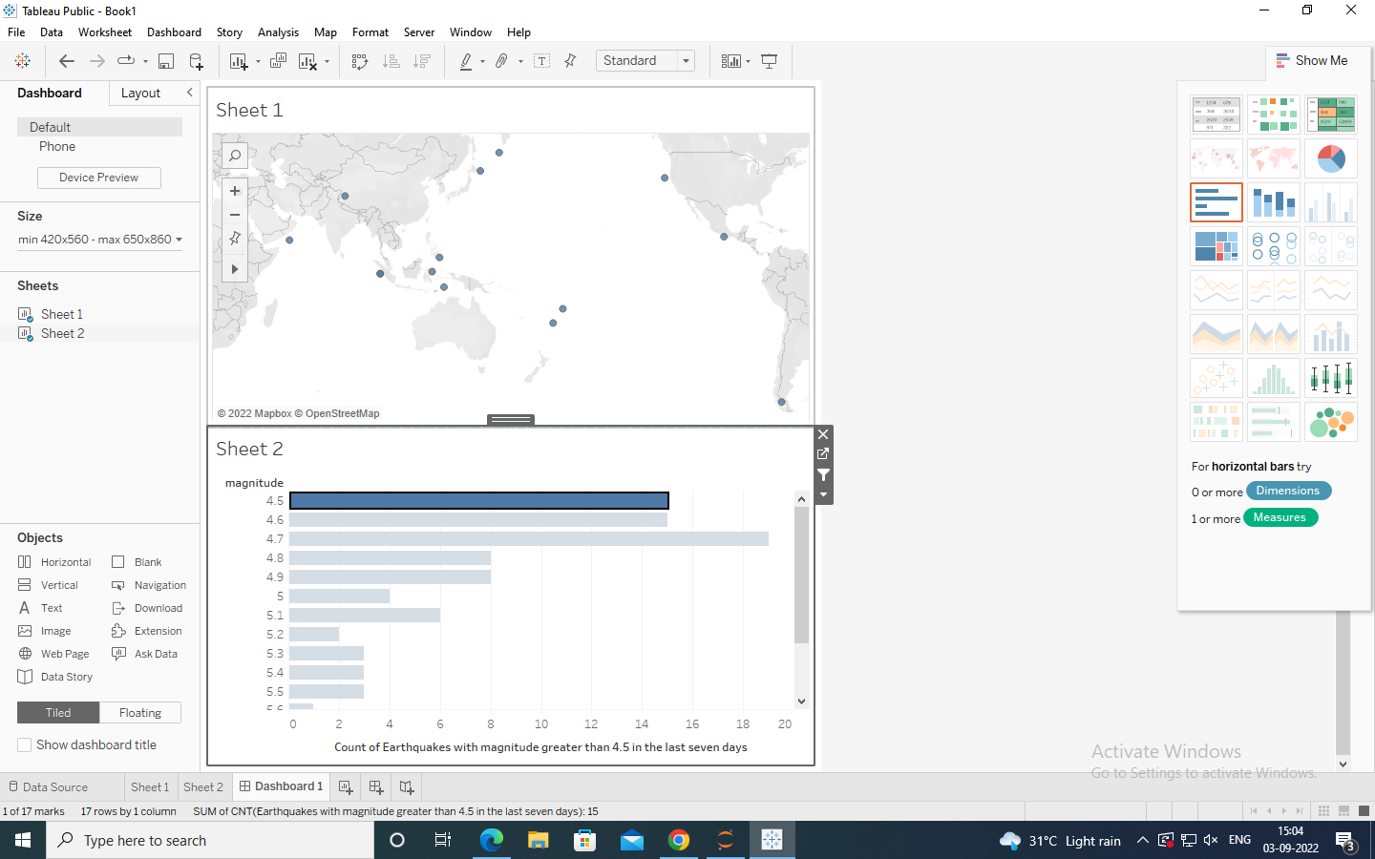

<https://public.tableau.com/app/profile/dinesh.kumar.k8408/viz/dv2_16621977647590/Dashboard1>