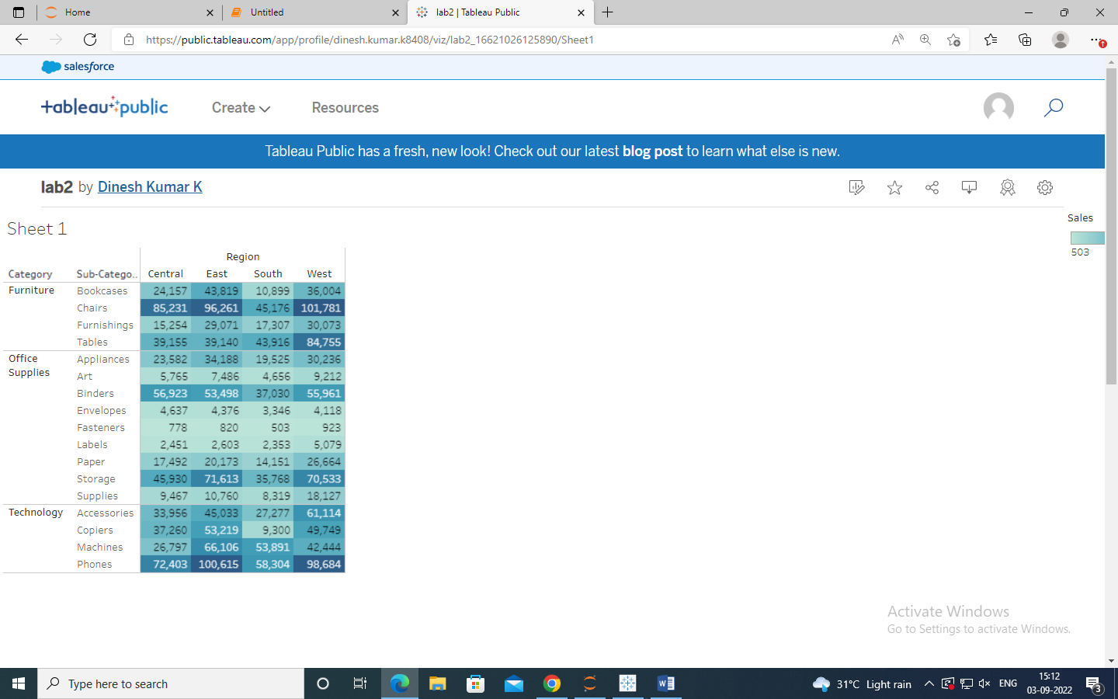

<https://public.tableau.com/app/profile/dinesh.kumar.k8408/viz/lab2_16621026125890/Sheet>