1. Develop a command-line calculator application that can handle arithmetic operations (+, -, *, /) with support for multiple calculations in a single run. Allow the user to input expressions, calculate results, and display them.

import re

def evaluate_expression(expression):

"""Evaluate a simple arithmetic expression."""

try:

# Use eval carefully and ensure it's safe for this use case

result = eval(expression, {}, {})

return result

except (SyntaxError, NameError, ZeroDivisionError) as e:

return f"Error: {e}"

def main():

print("Command-line Calculator")

print("You can perform arithmetic operations (+, -, *, /).")

print("Type 'exit' to quit the application.")

while True:

# Prompt user for input

expression = input("Enter an expression: ").strip()

# Check if the user wants to exit

if expression.lower() == 'exit':

print("Exiting the calculator. Goodbye!")

break

# Validate the expression format

if not re.match(r'^[\d+\-*/().\s]+$', expression):

print("Invalid characters in expression. Please use numbers and operators only.")

continue

# Evaluate and print the result

result = evaluate_expression(expression)

print(f"Result: {result}")

if __name__ == "__main__":

main()

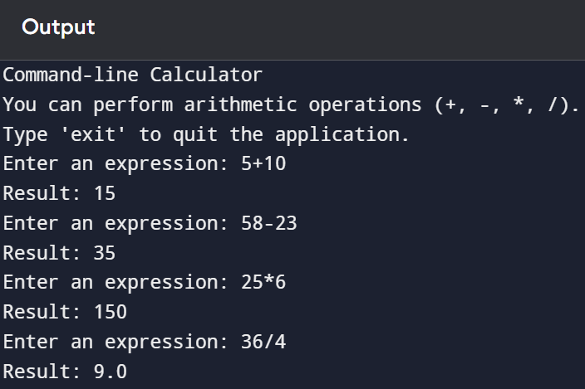

2. Using a dataset, build a predictive model to solve a specific business problem. Responsibilities - Split data into training and testing sets.- Train and evaluate the model's performance using metrics like accuracy, precision, recall, or RMSE.- Fine-tune the model for better results. Apply statistical methods to draw conclusions and make predictions from data Conduct hypothesis testing, analysis of variance (ANOVA), regression analysis, etc- Use tools like Python (with libraries like SciPy , and Stats Models) or R for advanced statistical analysis.

