
Department of Artificial Intelligence & Data Science

PNEUMONIA DETECTION FROM CHEST X-RAY IMAGES USING DEEP LEARNING

Submitted in partial fulfilment of the requirements for the degree of

BACHELOR OF TECHNOLOGY
In
ARTIFICIAL INTELLIGENCE & DATA SCIENCE
Submitted By

Team Members

Dinesh K, Chandru K, Fadil Hameed N

Under the Guidance of

Mrs.R.Kalaiyarasi

SRM TRP ENGINEERING COLLEGE
Academic Year: 2026-27 (ODD)

Department of Artificial Intelligence & Data Science

CERTIFICATE

This is to certify that “Dinesh K, Chandru K and Fadil Hameed N from Third year AI&DS have successfully completed their work titled “Pneumonia Detection from Chest X-Ray Images using Deep Learning” at SRM TRP Engineering, Trichy in the partial fulfillment of the Bachelor’s of Technology in Artificial Intelligence & Data Science.

Mrs.R.Kalaiyarasi |  | Dr. R. Perumal Raja
(Faculty In-charge) |  | (Head of Department)
Artificial Intelligence & Data Science |  | Artificial Intelligence & Data Science |  | Computer Engineering

ACKNOWLEDGEMENT

It is with sincere gratitude and deep appreciation that I take this opportunity to acknowledge the invaluable support and guidance I have received throughout the course of this project. This journey has been both intellectually enriching and personally rewarding, significantly enhancing my understanding of the subject and its practical applications. I would like to express my heartfelt thanks to all those who provided guidance, encouragement, and constructive feedback during the development of this project. Their insights and support were instrumental in shaping the direction and quality of the work. I also extend my appreciation to the department for fostering an environment that promotes learning, innovation, and academic growth. The resources and opportunities provided played a vital role in the successful completion of this project. A special note of thanks goes to the supporting staff for their cooperation and timely assistance, which ensured that the process remained smooth and efficient at every stage. Finally, I would like to express my deepest gratitude to my parents for their constant support, encouragement, and belief in my abilities. Their motivation has been a source of strength throughout this journey. This project has not only strengthened my knowledge but has also emphasized the importance of dedication, perseverance, and continuous learning. I remain sincerely thankful to everyone who contributed, directly or indirectly, to the successful completion of this project.

Academic Year: 2026-2027
Dinesh K
Chandru K
Fadil Hameed N

TABLE OF CONTENTS

Sr. No | Title | Page No.
1 | Acknowledgement…………………………………………… | 3
2 | Abstract ………………………………………………......... | 5
3 | Introduction…...……………………………………………... | 6
4 | System Requirements ………………………………………. | 7
5 | Methodology………………………………………………… | 8
6 | Implementation……………………………………………… | 13
7 | Conclusion…….……………………………………………. | 14
8 | References……………………………………………………. | 14

ABSTRACT

Pneumonia is a serious lung infection that inflames the air sacs (alveoli) and remains one of the leading causes of illness and death worldwide, especially among young children and elderly people. Chest X-ray imaging is the most widely used tool for diagnosing pneumonia, but manual interpretation by radiologists is time-consuming, subjective, and often unavailable in rural and resource-limited regions. This project focuses on designing a deep learning-based system capable of automatically detecting pneumonia from chest X-ray images and classifying each image as Normal or Pneumonia. By leveraging convolutional neural networks (CNNs), the system automatically learns meaningful visual patterns such as lung opacities, consolidation, and infiltrates directly from the images, without any manual feature engineering. The proposed system utilizes the Chest X-Ray Images (Pneumonia) dataset, which contains thousands of labeled pediatric chest radiographs organized into training, validation, and testing sets. These images are preprocessed through steps such as resizing, normalization, and data augmentation to ensure consistency, increase data diversity, and reduce the effect of class imbalance. A CNN model, built from stacked convolutional, pooling, batch normalization, and dropout layers (and optionally enhanced with transfer learning using pretrained networks such as VGG16, ResNet50, or MobileNet), is then trained to learn complex patterns from the X-ray data. The model performs a binary classification task, where a sigmoid output layer produces the probability of pneumonia for each image. During training, the model learns hierarchical features such as edges, textures, and lung region patterns, which are essential for distinguishing infected lungs from healthy ones. The binary cross-entropy loss function is optimized using the Adam optimizer, while techniques such as dropout, early stopping, and class weighting are used to prevent overfitting and handle data imbalance. The performance of the system is evaluated on unseen test images using metrics such as accuracy, precision, recall, F1-score, confusion matrix, and ROC-AUC. Experimental results demonstrate that deep learning models, particularly CNNs, are highly effective in capturing the radiographic features of pneumonia and can serve as a fast, low-cost decision-support tool for doctors. However, factors such as image quality, patient positioning, dataset imbalance, and similarity with other lung diseases can influence model accuracy and must be carefully addressed.

INTRODUCTION

Introduction: Pneumonia Detection using Deep Learning
Pneumonia is an acute respiratory infection that affects the lungs, causing the alveoli to fill with fluid or pus and making breathing painful and difficult. It can be caused by bacteria, viruses, or fungi and remains one of the leading infectious causes of death worldwide, particularly among children below five years of age and elderly patients. Early and accurate diagnosis is essential because timely treatment greatly reduces complications and mortality. Among the available diagnostic methods, chest X-ray imaging is the most common, affordable, and widely accessible technique used by doctors to confirm the presence of pneumonia.
However, interpreting chest X-rays is a challenging task that depends heavily on the experience of the radiologist. Pneumonia appears as subtle, cloudy white regions (opacities) in the lungs that can be confused with other lung conditions, and the diagnosis may differ from one observer to another. In many rural and remote regions, trained radiologists are scarce, which leads to delayed diagnosis and treatment. Traditional computer-aided diagnosis methods relied on handcrafted features such as texture, shape, and intensity descriptors combined with classical machine learning algorithms, but these methods struggled with variations in image quality, patient position, and exposure settings. With the introduction of deep learning, particularly convolutional neural networks (CNNs), feature extraction has become automatic and significantly more effective. CNNs are capable of learning hierarchical representations of data, starting from low-level features such as edges and textures to high-level features such as lung patterns and opacities, making them highly suitable for medical image analysis.
In this project, pneumonia detection is approached as a binary image classification problem, where a deep learning model is trained on chest X-ray images annotated with Normal or Pneumonia labels. The model takes a chest X-ray image as input, extracts discriminative features through convolutional layers, and produces a probability score through a sigmoid output layer. Based on a decision threshold, the image is labeled as Normal or Pneumonia. Such a system can act as a decision-support tool that assists doctors by providing a quick second opinion and helps to prioritize suspicious cases for urgent review.
The effectiveness of such a system depends heavily on the quality and diversity of the dataset used for training. The Chest X-Ray Images (Pneumonia) dataset, which contains pediatric chest radiographs labeled by expert physicians, is used in this project. This dataset provides a large number of images with variations in brightness, contrast, and patient positioning, which helps the model generalize better. Preprocessing steps such as resizing, normalization, and data augmentation (rotation, zooming, and horizontal flipping) are applied to enhance the dataset, handle the class imbalance in which pneumonia images outnumber normal images, and improve model robustness.
One of the major challenges in pneumonia detection is the visual similarity between pneumonia and other lung abnormalities, differences in X-ray machines and exposure settings, and the risk of overfitting due to limited medical data. In medical diagnosis, a missed pneumonia case (false negative) is more harmful than a false alarm; therefore, metrics such as recall and F1-score are given special importance along with accuracy. Designing an effective deep learning model requires careful consideration of architecture, loss function, and training strategy.

SYSTEM REQUIREMENTS

Category | Requirement | Description
Operating System | Windows / Linux / macOS | A compatible OS that supports deep learning frameworks. Linux is preferred for better performance and  GPU support.
Processor (CPU) | Intel i5/i7 or AMD Ryzen 5/7 (or higher) | Multi-core processors help in faster  data preprocessing and model execution.
GPU  (Recommended) | NVIDIA GPU (e.g., GTX 1650 / RTX 2060 / RTX  3060 or higher) | Required for accelerating deep learning training using CUDA. Significantly reduces training time  compared to CPU.
RAM | Minimum 8 GB (Recommended: 16 GB or  more) | Required to handle large image datasets and batch processing during  training.
Storage | Minimum 20–50 GB free  space | Needed for storing datasets (images),  trained models, and project files.
Programming Language | Python | Widely used for deep learning due to  simplicity and extensive library support.
Deep Learning Framework | TensorFlow / Keras | Used to build, train, and evaluate  CNN models for pneumonia detection.
Computer Vision Library | OpenCV | Used for image processing tasks such  as reading X-rays, resizing, and preprocessing.
Data Handling  Libraries | NumPy, Pandas, Scikit-learn | Used for efficient data manipulation,  preprocessing, and metric calculation.
Visualization Tools | Matplotlib, Seaborn | Used for plotting training graphs, accuracy, loss curves, confusion matrix, and ROC curve.
Development Environment | Jupyter Notebook / Google Colab /  Visual Studio Code | Used for writing, testing, and  debugging code.
Dataset | Chest X-Ray Images (Pneumonia) Dataset | Contains labeled chest X-ray images (Normal and Pneumonia)  required for training, validation, and testing.

METHODOLOGY

Methodology: Pneumonia Detection using Deep Learning
The methodology of this project focuses on designing and implementing a deep learning-based system capable of detecting pneumonia from chest X-ray images. The approach follows a structured pipeline that includes data collection, preprocessing, model design, training, evaluation, and deployment. By leveraging convolutional neural networks (CNNs), the system learns to extract meaningful visual features from the lungs and performs binary classification into Normal and Pneumonia classes. The methodology ensures that the model is trained efficiently and produces reliable predictions on unseen chest X-ray images.
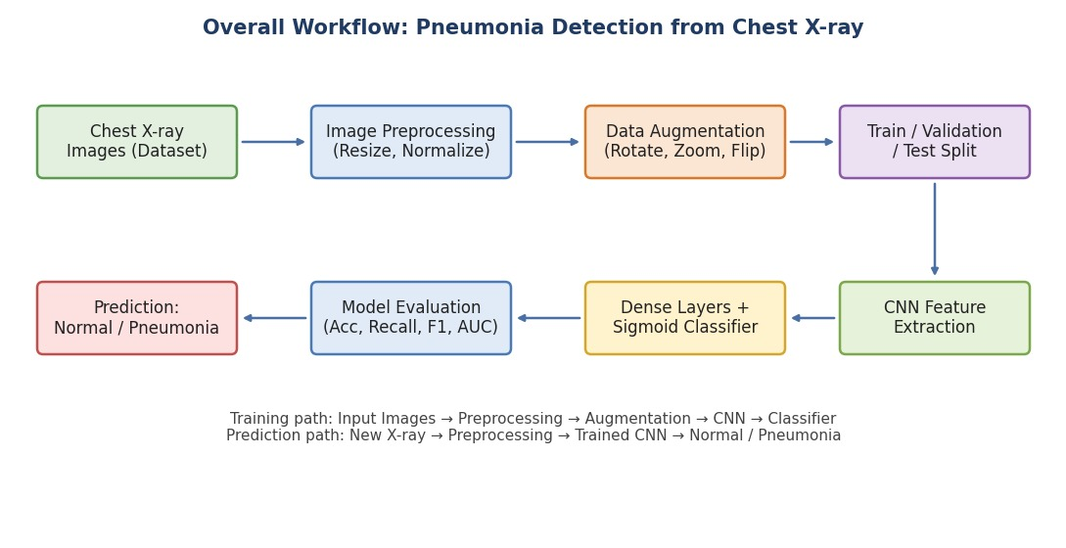

Overall System Workflow
The workflow begins with collecting and preprocessing chest X-ray images, followed by training a CNN model. The trained model is then used to predict whether a new chest X-ray shows a normal lung or pneumonia. Each stage plays a critical role in ensuring the accuracy and robustness of the system.

Data Collection and Dataset Selection
The first step involves selecting a suitable dataset that contains labeled chest X-ray images. The Chest X-Ray Images (Pneumonia) dataset, available on Kaggle and based on the work of Kermany et al., is used in this project. It contains anterior-posterior chest X-ray images of pediatric patients, labeled by expert physicians as Normal or Pneumonia.
Key dataset characteristics:
- Over 5,800 labeled chest X-ray images in JPEG format
- Two classes: Normal and Pneumonia
- Class imbalance, with more pneumonia images than normal images
- Variations in image size, brightness, contrast, and patient positioning
Handling the class imbalance through class weights and augmentation is essential to avoid bias towards the majority class and improve model performance.

Data Preprocessing
Before feeding the data into the model, preprocessing is performed to ensure consistency and improve learning efficiency. Since chest X-rays come in different sizes and intensity ranges, and deep learning models are sensitive to input format, all images must be standardized.
Key preprocessing steps include:
- Resizing: Converting all images to a fixed size (e.g., 150×150 or 224×224 pixels)
- Channel Handling: Converting grayscale X-rays to the number of input channels expected by the model
- Normalization: Scaling pixel values (e.g., between 0 and 1)
- Data Augmentation: Applying transformations such as rotation, zooming, shifting, and horizontal flipping
These steps help improve model robustness, handle class imbalance, and prevent overfitting.

Model Architecture Design

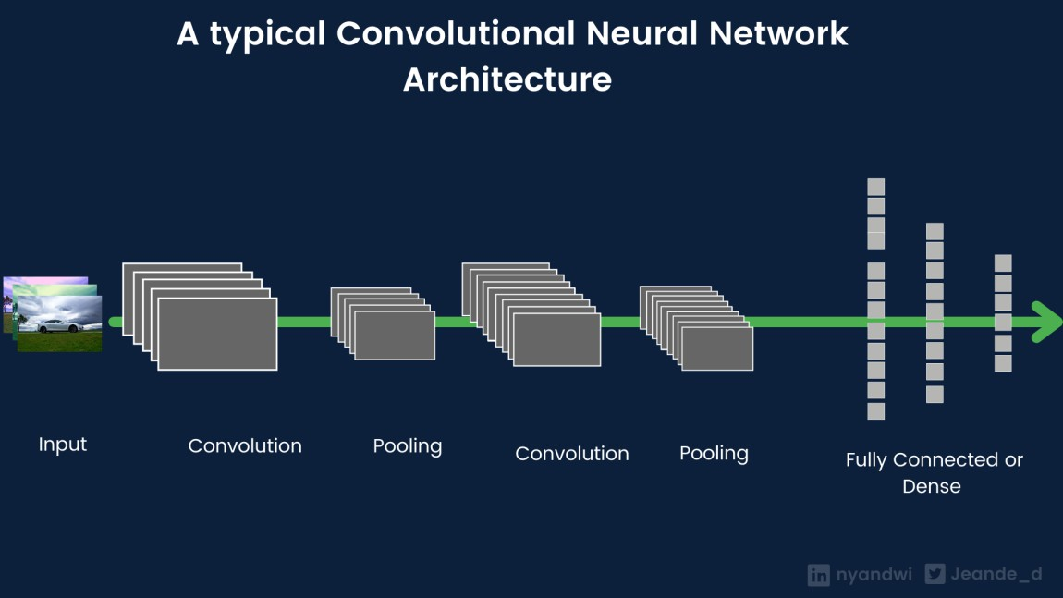

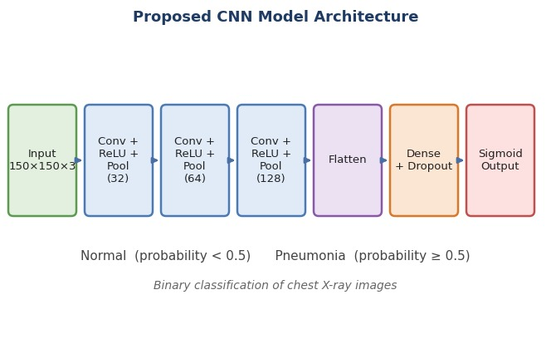

The core of the system is a convolutional neural network (CNN) designed to extract features from chest X-ray images. The architecture consists of multiple convolutional layers followed by pooling layers and fully connected layers, with dropout used to reduce overfitting. The model can be a custom CNN or a pretrained network such as VGG16 or ResNet50 fine-tuned through transfer learning, ending with a sigmoid neuron that predicts the probability of pneumonia.
Model components:
- Convolutional Layers: Extract spatial features (edges, textures, opacities)
- Pooling Layers: Reduce dimensionality and computational cost
- Fully Connected Layers: Learn high-level representations for classification

Output Layers:
  - Pneumonia → Probability above the threshold (e.g., 0.5)
  - Normal → Probability below the threshold (binary classification)
This design allows the model to efficiently learn disease-specific patterns.

Model Training
The model is trained using the preprocessed dataset, where it learns to map input chest X-ray images to the corresponding Normal or Pneumonia labels. The dataset is divided into training, validation, and testing sets to ensure proper evaluation and avoid overfitting.
Key training components:

Loss Functions:
  - Binary Cross-Entropy for Normal vs Pneumonia classification
  - Class weights applied to handle class imbalance
- Optimizer: Adam optimizer for efficient gradient descent

- Batch Size & Epochs: Tuned based on dataset size and validation performance
- Regularization: Dropout layers and early stopping to prevent overfitting
During training, the model updates its weights through backpropagation to minimize prediction error.

Model Evaluation

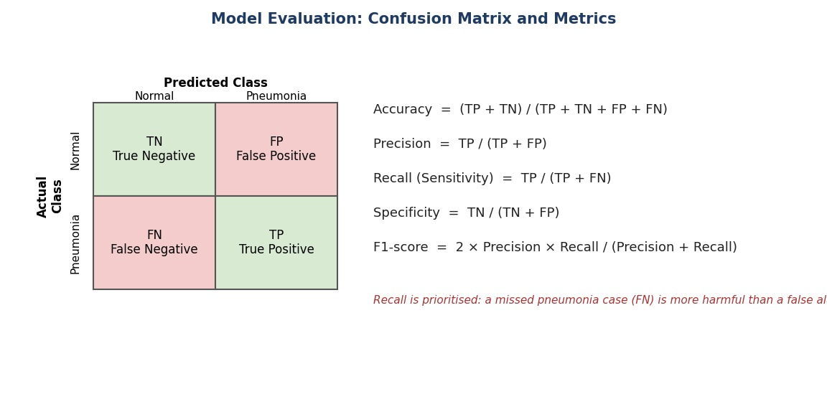
After training, the model is evaluated using the unseen test dataset to measure its performance.
Different metrics are used to evaluate the binary classification performance:
- Classification Metrics: Accuracy, Precision, Recall (Sensitivity), F1-score
- Additional Metrics: Specificity, Confusion Matrix, ROC Curve and AUC score
Visualization tools such as confusion matrices and training curves are used to analyze performance and identify potential improvements.

Prediction and Deployment
Once the model is trained and evaluated, it can be used for real-time predictions. Given a new chest X-ray image, the system performs preprocessing, extracts features using the CNN, and outputs the predicted class (Normal or Pneumonia).
Steps involved:
- Input chest X-ray image
- Image resizing and preprocessing
- Model inference
- Display predicted result (Normal / Pneumonia)

The model can be integrated into applications such as hospital decision-support systems, telemedicine platforms, mobile apps, or web-based interfaces.

Challenges and Optimization
Some challenges encountered in this project include:
- Class imbalance between Normal and Pneumonia images
- Variations in X-ray image quality, contrast, and exposure
- Overfitting due to limited medical image data
- Visual similarity between pneumonia and other lung conditions
To overcome these challenges, techniques such as data augmentation, class weighting, transfer learning, and hyperparameter tuning can be applied.

Summary of Methodology
In summary, the methodology involves a complete pipeline starting from data collection and preprocessing to model training, evaluation, and deployment. By utilizing CNN-based deep learning techniques, the system effectively learns radiographic features from chest X-rays and performs accurate classification of Normal and Pneumonia cases. The structured approach ensures high accuracy, scalability, and real-world applicability, making it a robust decision-support solution for pneumonia screening.

IMPLEMENTATION

Output as expected is as follows
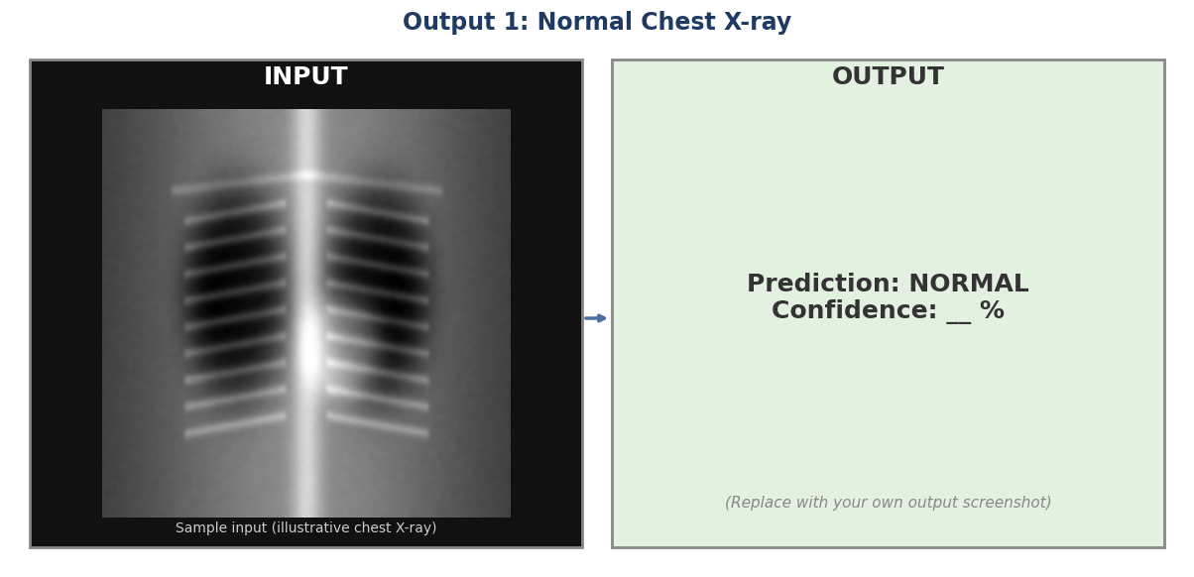

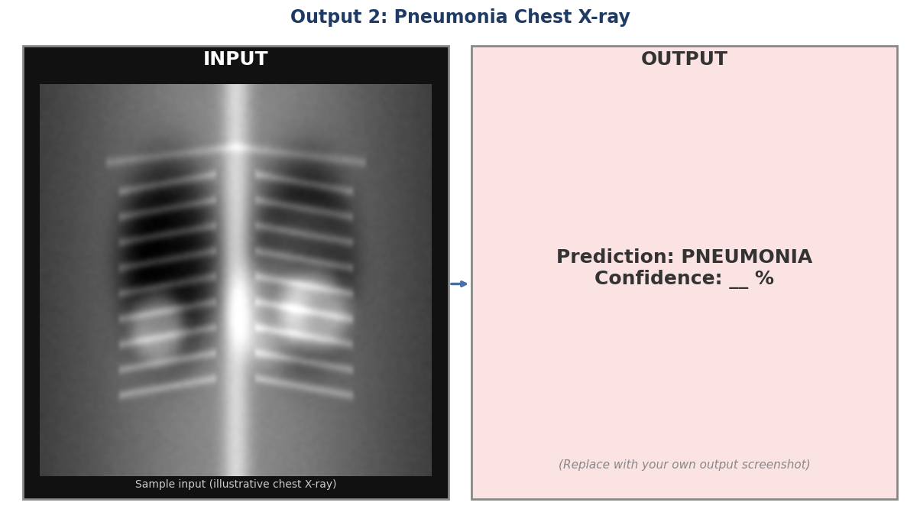

CONCLUSION

The successful implementation of the pneumonia detection system demonstrates the effectiveness of deep learning techniques, particularly convolutional neural networks (CNNs), in analyzing medical images. By leveraging the ability of CNNs to automatically extract hierarchical features from chest X-ray images, the model is able to distinguish between Normal and Pneumonia cases with a high degree of reliability. This project highlights how deep learning eliminates the need for manual feature extraction and significantly improves performance compared to traditional machine learning approaches. Throughout the project, a structured methodology was followed, beginning with dataset selection and preprocessing, followed by model design, training, and evaluation. Data augmentation, class weighting, and dropout regularization helped the model handle class imbalance and generalize well to unseen X-rays. Such a system can serve as a fast and low-cost decision-support tool that assists doctors, especially in regions where trained radiologists are limited, although it is not a replacement for professional clinical judgement. In the future, the work can be extended to classify bacterial and viral pneumonia, include Grad-CAM visual explanations, train on larger multi-hospital datasets, and deploy the model as a web or mobile application.

REFERENCES

- Chest X-Ray Images (Pneumonia) Dataset – Kaggle https://www.kaggle.com/datasets/paultimothymooney/chest-xray-pneumonia
- Kermany et al., Image-Based Deep Learning for Medical Diagnosis, Cell, 2018 https://doi.org/10.1016/j.cell.2018.02.010
- TensorFlow Official Documentation https://www.tensorflow.org
- Keras Official Documentation https://keras.io
- OpenCV Documentation https://docs.opencv.org
- Deep Learning Book – Ian Goodfellow, Yoshua Bengio, Aaron Courville https://www.deeplearningbook.org
- World Health Organization – Pneumonia Fact Sheet https://www.who.int/news-room/fact-sheets/detail/pneumonia
- Rajpurkar et al., CheXNet: Pneumonia Detection on Chest X-Rays https://arxiv.org/abs/1711.05225

