**Topics: Descriptive Statistics and Probability**

1. Look at the data given below. Plot the data, find the outliers and find out $μ, σ, σ^{2}$

|  |  |
| --- | --- |
| **Name of company** | **Measure X** |
| Allied Signal | 24.23% |
| Bankers Trust | 25.53% |
| General Mills | 25.41% |
| ITT Industries | 24.14% |
| J.P.Morgan & Co. | 29.62% |
| Lehman Brothers | 28.25% |
| Marriott | 25.81% |
| MCI | 24.39% |
| Merrill Lynch | 40.26% |
| Microsoft | 32.95% |
| Morgan Stanley | 91.36% |
| Sun Microsystems | 25.99% |
| Travelers | 39.42% |
| US Airways | 26.71% |
| Warner-Lambert | 35.00% |

ANS:

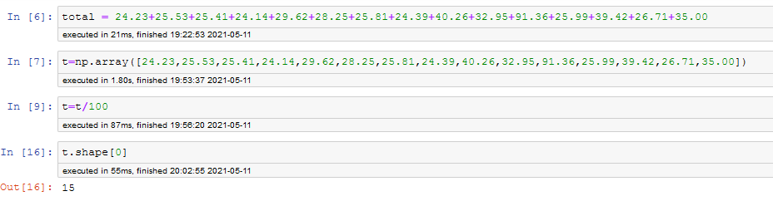

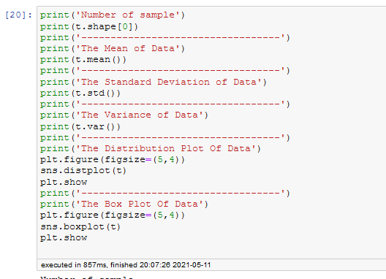

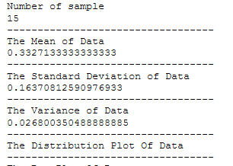

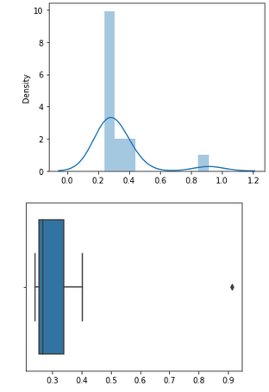

**There is only one outlier that is Morgan Stanley 91.36%.**

2.

Answer the following three questions based on the box-plot above.

1. What is inter-quartile range of this dataset? (please approximate the numbers) In one line, explain what this value implies.

**The inter quartile range of this dataset is 7. This value implies that most of the data lies in the range of 7 only.**

1. What can we say about the skewness of this dataset?

**The skewness of the data is positive skewness.**

1. If it was found that the data point with the value 25 is actually 2.5, how would the new box-plot be affected?

**When the data point value 25 is actually 2.5 means there will be no outlier in our data.**

3.

Answer the following three questions based on the histogram above.

1. Where would the mode of this dataset lie?

**The mode of the data set lies between 4 to 8.**

1. Comment on the skewness of the dataset.

**The skewness of the data is positive skewness.**

1. Suppose that the above histogram and the box-plot in question 2 are plotted for the same dataset. Explain how these graphs complement each other in providing information about any dataset.

**In the boxplot IQR value is 7 and in the histogram plot the mode of the data set is lies between 4 to 8.**

**The boxplot and in histogram plot the outlier is same and it is in Range of 25 in x axis.**

**The boxplot is positive skewness and in histogram plot is positive Skewness.**

**The boxplot 25%** **of the data lies between 5 to 7 and more data lies between 7 to 12.**

**We cannot differentiate mode in box plot but in histogram we can do.**

4. AT&T was running commercials in 1990 aimed at luring back customers who had switched to one of the other long-distance phone service providers. One such commercial shows a businessman trying to reach Phoenix and mistakenly getting Fiji, where a half-naked native on a beach responds incomprehensibly in Polynesian. When asked about this advertisement, AT&T admitted that the portrayed incident did not actually take place but added that this was an enactment of something that “could happen.” Suppose that one in 200 long-distance telephone calls is misdirected. What is the probability that at least one in five attempted telephone calls reaches the wrong number? (Assume independence of attempts.)

**Probability of one misdirected call among 200**

**P (wc) = 1/200 = 0.005**

**Probability of not wrong call: 1-p (wc) = 1-1/200= 0.995**

**Probability of at least one out of five is a wrong number**

**= 1-probability that all five calls are not wrong numbers**

**= 1-(1-p (wc)) ^5**

**=1-(1-0.005) ^5**

**=1-0.975**

**=round (0.02475)**

**=2.5% chance.**

1. Returns on a certain business venture, to the nearest $1,000, are known to follow the following probability distribution

|  |  |
| --- | --- |
| x | P(x) |
| -2,000 | 0.1 |
| -1,000 | 0.1 |
| 0 | 0.2 |
| 1000 | 0.2 |
| 2000 | 0.3 |
| 3000 | 0.1 |

1. What is the most likely monetary outcome of the business venture?

**2000 because of 30% probability distribution**

dd

1. Is the venture likely to be successful? Explain

**The venture may be successful**

**This can be said by plotting histogram plot which is positively skewed.**

1. What is the long-term average earning of business ventures of this kind? Explain

**Average = 60%**

1. What is the good measure of the risk involved in a venture of this kind? Compute this measure

**The venture is risky since the std. dev. is high.**

**std var = 1870.829**

**variance = 3500000.**