Q1 Write a program to calculate the sum of first 10 natural number.

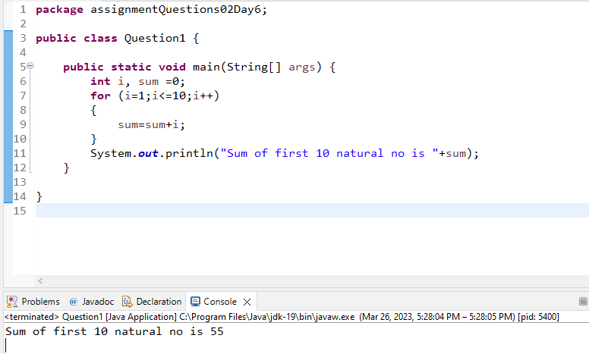

2 Write a program that prompts the user to input a positive integer. It should then print the multiplication table of that number.

**import** java.util.Scanner;

**public** **class** Question2 {

**public** **static** **void** main(String[] args) {

**int** i, table;

Scanner s= **new** Scanner(System.***in***);

System.***out***.println("Enter positive integer ");

**int** inp = s.nextInt();

System.***out***.println("You have Entered integer ="+ inp);

**if**(inp<0)

System.***out***.println("so table cannot be printed ");

**else**

{

**for**( i=1;i<=10;i++)

{

table=inp*i;

System.***out***.println( table);

}

}

s.close();

}

}

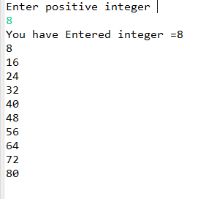

Q 3 Write a program that prompts the user to input an integer and then outputs the number with the digits reversed. For example, if the input is 12345, the output should be 54321.

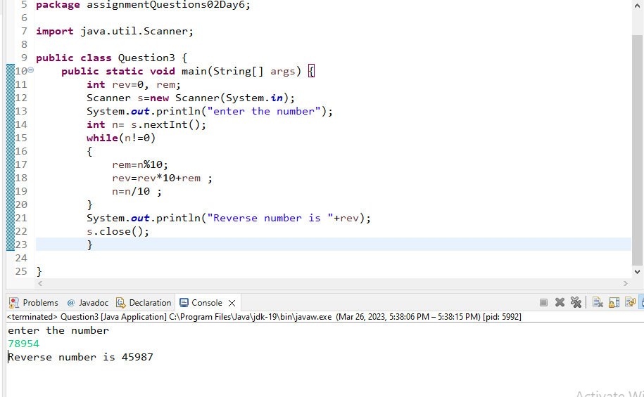

Q 6 Write a program to print Fibonacci series of n terms where n is input by user :  
0 1 1 2 3 5 8 13 24 .....

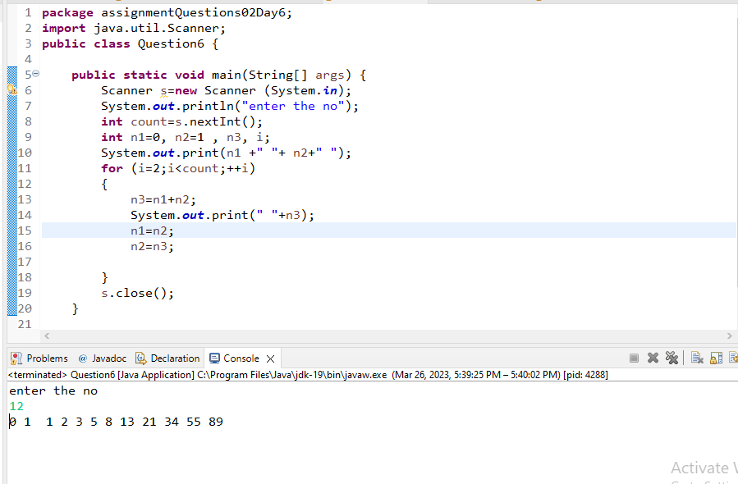

Q 7 Write a program to print following :  
  
  
i)  
  
**********  
**********  
**********  
**********

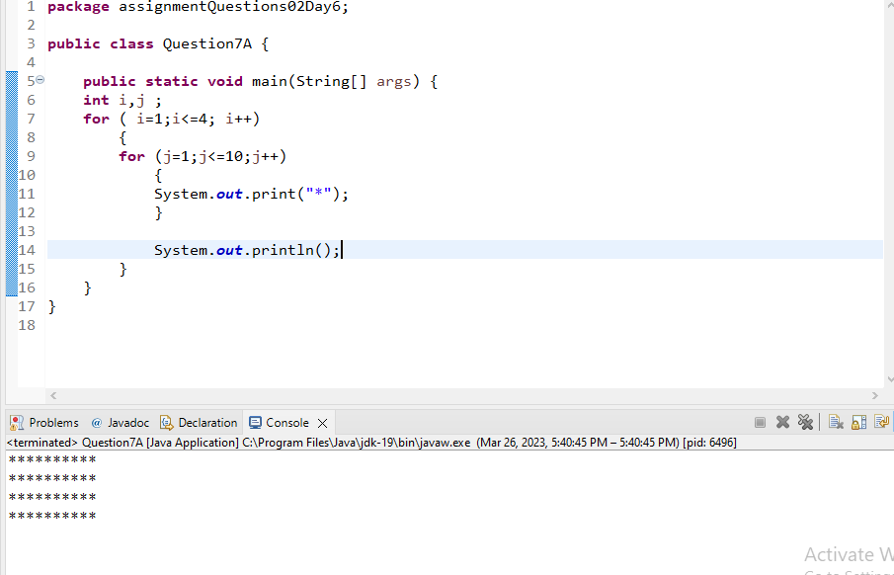

ii)  
  
*  
**  
***  
****  
*****

