Deep Learning based Multi-Modal Algorithms for the Prediction of Diabetic Retinopathy

**Name**Department ,

College Name,  
City,

EmailID

**Name**Department ,

College Name,  
City,

EmailID

**Name**Department ,

College Name,

City,

EmailID

*Abstract*—Diabetic retinopathy (DR) is a prevalent and debilitating condition that affects millions of people worldwide. It is an eye complication that can occur in individuals with diabetes, resulting from the impairment of retinal blood vessels, which is the light-sensitive layer positioned at the back of the eye. Timely detection and management of DR are pivotal to prevent loss of vision and improve patient outcomes. Here, a deep learning-based algorithm for DR detection that uses only fundus photographs is proposed. The proposed algorithm trains and tests five deep learning models - Convolutional Neural Network (CNN), ResNet, GoogleNet, InceptionV3, and VGG16, to classify the severity of DR. To assess the effectiveness of the suggested algorithms, a dataset consisting of 3662 fundus retinal images obtained from patients with and without diabetic retinopathy was utilized. The images were divided into five categories based on DR severity: No DR, mild, moderate, severe, and proliferate. The dataset is analyzed using the stated Deep Learning Algorithms to determine the optimum performance in terms of accuracy, training time, recall, prediction time, test score, precision and the F1 score. The best algorithm is chosen after each one’s overall performance has been assessed. Experimental results show that the best algorithm achieves an accuracy of 96% in DR detection, which is higher than the accuracy achieved by other single-modal algorithms. Furthermore, the algorithm is robust to noise and variability in the images, indicating its potential for clinical use.

*Keywords—CNN, Diabetic Retinopathy (DR), ResNet, VGG16, GoogleNet, InceptionV3, and Fundus Retinal image*

**Introduction**

**1.1 Introduction**The WHO or the World Health Organisation has indicated that DR or Diabetic Retinopathy is a chief factor of ocular disability for people aged 21-65 years who are still working worldwide. In 2017, approximately 4.2 million individuals were blind due to diabetic retinopathy, while another 98 million experienced moderate to severe visual impairment. A study published in the Indian Journal of Endocrinology and Metabolism in 2016 revealed that diabetic retinopathy's occurrence in India is approximately 21.7%. Furthermore, the study also found that the occurrence of DR is directly proportional to the extent of diabetes and that individuals having poor glycemic control are more prone to develop diabetic retinopathy. Among working-age adults, Diabetic retinopathy is a leading contributor to vision loss and impaired eyesight. Detecting and treating diabetic retinopathy at an early stage is crucial to avoid vision loss. Different automated techniques have been suggested for diabetic retinopathy detection using fundus images, but they have some limitations regarding the accuracy and computational efficiency. Lately, there has been an intensified attention on using multi-modal algorithms for detecting diabetic retinopathy, which incorporates data from various imaging modalities such as fundus images and visual field data.

**1.2 Diabetic Retinopathy**

Diabetic retinopathy (DR) is an eye complication that is triggered by diabetes. It results from the damage of retinal vessels, which detects light and transmits signals to the brain. The detriment is caused by high blood sugar levels, which can lead to fluid or blood leakage from the blood vessels or their closure, causing inadequate circulation and retina damage.

The rising prevalence of diabetic retinopathy is becoming a significant public health concern globally. Prompt detection and treatment of diabetic retinopathy are imperative in preventing loss of vision, making it necessary to have reliable and efficient methods for its detection.

**1.3 Detection of Diabetic Retinopathy**

Various techniques have been devised to identify diabetic retinopathy, including manual inspection by eye specialists and computer-based algorithms for image analysis. Nevertheless, these approaches have their limitations, such as being prone to subjectivity and requiring high costs for manual inspection, and lacking accuracy and sensitivity for automated analysis.  
  
Researchers have endeavored to overcome these obstacles by exploring the potential of multi-modal algorithms that amalgamate various imaging modalities and employ machine-learning techniques to enhance the accuracy and sensitivity of diabetic retinopathy detection. These algorithms can scrutinize images from diverse sources, such as fundus photographs and fluorescence angiography, in order to discern and classify different phases of diabetic retinopathy.  
  
The process of manually interpreting images for diabetic retinopathy diagnosis can be time-consuming and the accuracy of the diagnosis may vary between different observers. To overcome this challenge, ML and DL algorithms have been developed for automating the detection of diabetic retinopathy. The integration of multi-modal algorithms has emerged as a promising approach in diabetic retinopathy detection, with several studies reporting high accuracy and sensitivity rates. By leveraging information from diverse imaging techniques, these algorithms can enhance the early identification and management of diabetic retinopathy, potentially reducing risk of sight impairment and blindness among diabetic patients. The motivation behind the research is to address the need for early and accurate detection of diabetic retinopathy, a chief cause of blindness in young and middle-aged adults. Traditional methods of detecting diabetic retinopathy involve manual examination of retinal images by ophthalmologists, which can be time-consuming, expensive, and subjective. Therefore, there is a growing need for automated and reliable methods for prompt diabetic retinopathy detection.

1. **Literature Survey**

**'Treatment of Diabetic Retinopathy: Recent Advances and Future Directions by Nathan G. Congdon et al. (2018) reviews the latest advances in the treatment of diabetic retinopathy, including pharmacotherapy and surgical interventions.** The article discusses the use of UWF fundus images, a retinal imaging technology that catches two hundred degrees of retina in one shot, for the diagnosis and treatment of diabetic retinopathy (DR). UWF retinal pictures, particularly UWF fluorescein angiography, are useful in identifying peripheral neovascularization and ischemia areas. The article also mentions a study. that used UWF fundus images and a DL system to identify proliferative diabetic retinopathy (PDR)'.

**'The Global Prevalence of Diabetic Retinopathy: A Systematic Review and Meta-analysis by Jennifer Y. Y. Koh et al. (2016) reviews the global incidence of diabetic retinopathy and its determinants** The exploitation of AI strategies for diagnosis is one of the strategies that are being utilized in an attempt to remove these obstacles.Throughout the course of the research, their model was subjected to training using 130,000 different photos. As a result, values ranging from 0.97 to 0.99 for the performance metric AUC were obtained from studies using two different data sets in order to identify referable DR'.

**'Artificial Intelligence in Diabetic Retinopathy Screening: A Systematic Review and Meta-analysis by Xiaoxiao Kong et al. (2019) reviews the performance of artificial intelligence-based systems in screening for diabetic retinopathy.** An automated technique for the identification of DR using convolutional neural networks (CNNs) was created and tested on a dataset that was made publically accessible. Since these seminal investigations were conducted, a number of subsequent research projects have given attention on using Deep Learning for diabetic retinopathy detection and grading. In addition, they prospectively evaluated the DR grading system by weighing it against the performance of manual grading spanning 2 regions in India'.

**'Prevalence of Diabetic Retinopathy in the United States, 2005-2008 by Xinzhi Zhang et al. (2012) analyzes the incidences of DR and its determinants in the USA.** Ting et al.16 conducted research on the effects of diabetes on multiethnic populations using a deep learning system (DLS) that took into account AMD which is age-related macular degeneration, glaucoma as well as Diabetic Retinopathy. Conventional fundus photography was used in these representative investigations. This kind of photography catches the optic nerve with an FOV (Field of View) ranging between twenty and fifty degrees'.

**'Nonmydriatic Fundus Photography in Screening for Diabetic Retinopathy: A Systematic Review and Meta-analysis' by Adam R. Glassman et al. (2015) reviews the effectiveness of fundus photography that is nonmydriatic in diabetic retinopathy assessment.** In a previous study conducted, a DL algorithm was used to grade DR based on nonmydriatic forty five degree fundus images of 4 fields. The research findings indicate that 4-field fundus photography is more effective for performance in terms of grading when compared to 1-field fundus photography.'

**'Diabetic Retinopathy: Understanding, Prevention and Treatment 'by Rajiv Raman et al. (2013) provides an overview of the pathophysiology, clinical features, and management of diabetic retinopathy.**. Although diabetic retinopathy has a global prevalence of 27.0% between the years 2015 and 2019, the early stages of the condition, including referable diabetic retinopathy, often have no identifiable symptoms. Unfortunately, DR can progress significantly before affecting vision, and delayed detection and treatment may result in a 57% increased risk of vision loss in some patients. Despite this, several studies have demonstrated that a significant proportion of diabetic patients do not undergo the recommended annual eye checkup.'

**'Prevalence and Causes of Visual Impairment in Diabetic Retinopathy: The Singapore Epidemiology of Eye Diseases Study by Ning Cheung et al. (2012) examines the incidence and origins of visual loss in (DR) diabetic retinopathy.** The study achieved a high level of sensitivity and specificity, as well as an adequate area under the curve. However, as far as we are aware, there has not been a thorough investigation into the automatic detection and grading of DR using deep learning technology. In this research, they present the development and validation of a deep learning system for DR detection based on UWF fundus photography obtained during continual DR assessments in a hospital setting in South Korea.'

**'Risk Factors for Diabetic Retinopathy: A Systematic Review and Meta-analysis by Shuang Wang et al. (2019) reviews the risk factors associated with diabetic retinopathy.** The research is a feasibility study that was conducted using data from a single device, a single facility, and a single ethnicity. The use of ultra-widefield fundus photography in the diagnosis of DR is the subject of the investigation that is the basis of our work. Although UWF fundus photography can capture a wide field of view, it may contain artifacts that are situated outside of the ETDRS 7SF. In order to account for this limitation, the area of interest (ROI) for detecting diabetic retinopathy in UWF fundus images has been restricted to the ETDRS 7SF'

**'Epidemiology of Diabetic Retinopathy, Diabetic Macular Edema, and Related Vision Loss by Emily Y. Chew et al. (2014) examines diabetic retinopathy’s epidemiology related vision loss related to it.** They developed and evaluated a technique for detecting diabetic retinopathy using the ETDRS 7SF. This field is considered the most significant area in Ultra Wide Field fundus photography. For the sake of comparability, the researchers subdivided the Field 1 and 2 areas of ETDRS into F1-F2 regions. They also note that the ETDRS F1-F2 image can serve as a satisfactory substitute for a conventional fundus image.'

**'Diabetic Retinopathy: Pathophysiology and Treatments by Javier Zarranz-Ventura et al. (2020) provides an update on the pathophysiology and various treatments available for diabetic retinopathy**.Timely identification and therapy may lower the chance of visual loss by around 57%5, although DR can be rather advanced before impacting vision2. Thus, it is crucial to test and follow up with patients with diabetes frequently, particularly those in the middle and later stages of life'.

1. **Dataset**

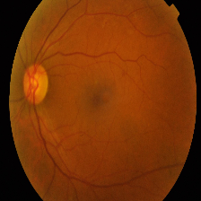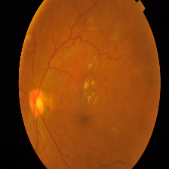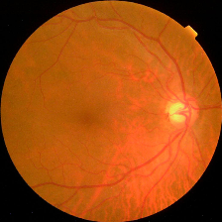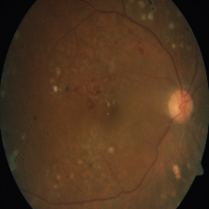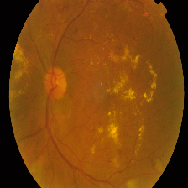

a) Mild b) Moderate c) No DR d) Proliferate e) Severe

Fig__. Dataset Sample

1. **Methodology**

Diabetic retinopathy (DR) is an eye complication that can occur in individuals with diabetes, resulting from the impairment of retinal vessels. Early intervention in DR detection and management is imperative to prevent vision deterioration and improve patient outcomes. However, the traditional method of DR detection using manual inspection of fundus photographs by ophthalmologists is time-consuming and subjective.  
Our system comprises 3 modules:

1. **Data Processing:**
2. **Data collection:** Gathering retinal pictures from a legitimate source is the initial stage in the data collecting module. To ensure reliable analysis and prediction, these photos must be of high quality and resolution
3. **Image pre-processing:** The acquired retinal pictures are then enhanced in order to highlight the pertinent characteristics that are suggestive of diabetic retinopathy. The pre-processing methods could include feature extraction, segmentation, filtering, and image enhancement.
4. **Data Augmentation:** To expand the training dataset and avoid overfitting, the pre-processed images are augmented in the third stage. The pre-processed photos can be subjected to data augmentation methods including flipping, rotating, and cropping to provide extra training examples that are variants of the original images.
5. **Data Labeling:** In accordance with the 'International Clinical Disease Severity Scale' for Diabetic Retinopathy, the fourth stage entails labeling the pre-processed and augmented photos with the severity of diabetic retinopathy for each individual as indicated by their respective levels.
6. **Data Splitting:** The pre-processed, supplemented, and labeled dataset will now be divided into training, validation, and testing datasets depending on a predetermined ratio.In order to adjust hyperparameters, the validation dataset is used, while the training dataset is utilized for training models, and the testing dataset gauges the performance of the trained models.
7. **Implementation of a multi-model Algorithm**

**CNN:** A CNN architecture is designed to simulate the visual processing mechanisms of the human brain, consisting of multiple layers, each performing a different type of computation on the input image. In the proposed system. First, we create an input layer with a shape of (180, 180, 3), which means the input images will have a height and width of 180 pixels and three color channels (RGB). We are going to have 3 layers excluding the input and output layers. Each layer has sixteen, thirty-two and sixty four filters respectively with a kernel of (3, 3) size. The padding is given as 'same', which indicates that the output size is identical to the input size, and activation function for the hidden layers is ReLU. Following each convolutional layer, a max pooling layer is appended with a pool of (2, 2) size, which downsamples the feature maps by taking the maximum value in each (2, 2) block of the feature maps. The padding is set to 'valid', which means only full blocks are used. Batch normalization is also applied after each convolutional layer to enhance resilience and fine-tuning of the model during training. The last layer is a dense layer with 256 neurons and a dropout rate of 0.5, followed by a softmax activation function, which creates a distribution of probabilities among the 5 potential categories.

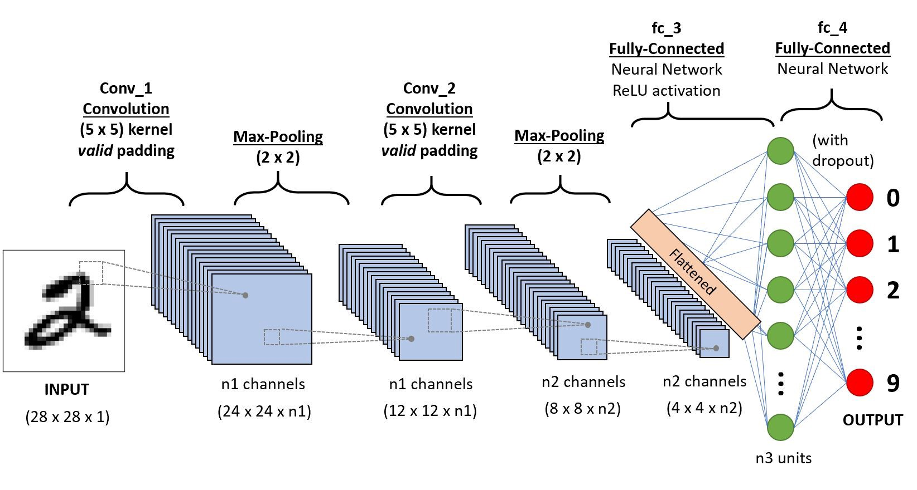

Fig__ CNN architecture

**GoogleNet:** Google Net is a CNN architecture that enables the network to simultaneously learn 1x1 and 3x3 convolutions, capturing both local and global information in the image. In the proposed system. We create a new sequential model in TensorFlow using the InceptionV3 architecture as a model trained earlier on the ImageNet dataset. Then we load this model. The 'input shape' parameter is set to (180, 180, 3), which specifies the input image size. In the next step, we add layers to the 'googlenet_model' sequential model. First, a flatten layer is incorporated into the pre-existing InceptionV3 model to condense its output..Then, two dense layers with 512 and 256 neurons, respectively, are added. Both use ReLU activation functions.The last layer is another fully connected (Dense) layer with 5 units (one for each image category) with a softmax activation function employed to create a distribution of probabilities among the 5 potential categories.

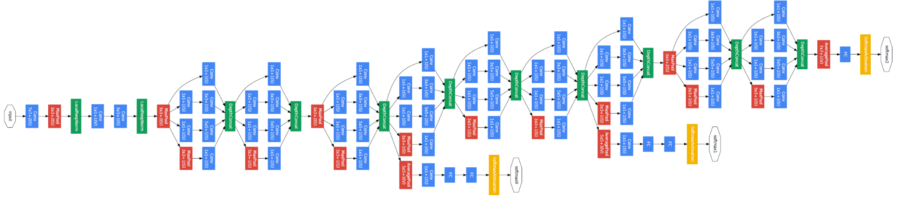

Fig__. GoogleNet Architecture

**VGG16:** VGG16 is another CNN architecture that has been widely used in the classification of diabetic retinopathy. Its design comprises thirteen convolutional layers succeeded by three fully connected layers, capturing features in the image in a hierarchical fashion. A sequential model in TensorFlow is created using VGG16 as a pre-trained model. The VGG16 is loaded with weights that are trained earlier from the ImageNet database with its input shape set to (180, 180, 3). The sequential model then adds a flattened layer to convert the output to a 1D tensor. Two dense layers with ReLU activation functions are then added, with 512 and 256 units respectively. The final dense layer has a softmax activation function with 5 units, which is suitable for multi-class classification tasks where the model needs to predict one of five classes.

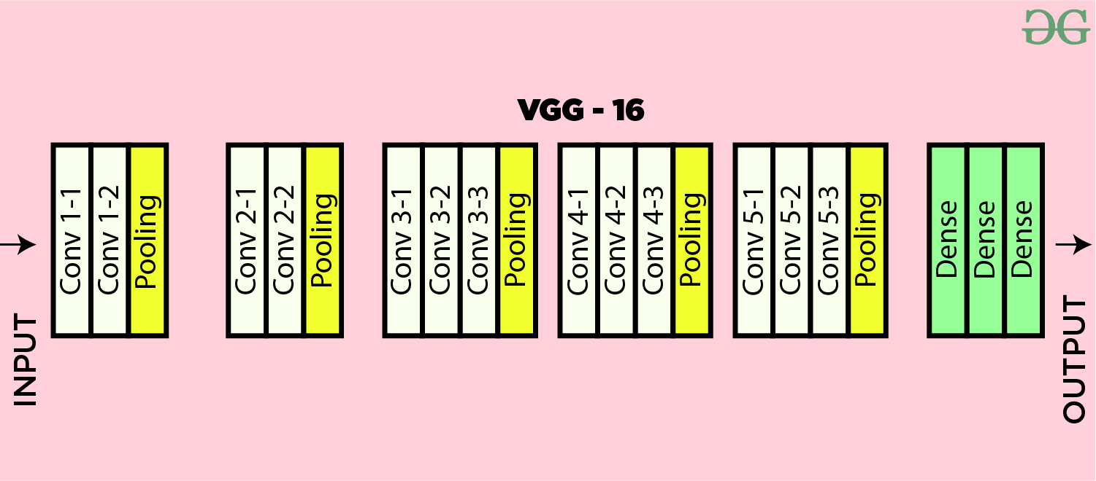

Fig__. VGG16 Architecture

**ResNet:** ResNet is a CNN architecture that has been highly effective in the classification of diabetic retinopathy, addressing the problem of vanishing gradients that can occur in deep neural networks. A sequential model TensorFlow is created using ResNet50 as a pre-trained model. The ResNet50 is loaded with weights that are trained earlier from the ImageNet database with its input shape set to (180, 180, 3). The sequential model then adds the pre-trained ResNet50 model, followed by a flattened layer to convert the output to a 1D tensor. Two dense layers with ReLU activation functions are then added, with 512 and 256 units respectively. The final dense layer has a softmax activation function with 5 units, which is suitable for multi-class classification tasks where the model needs to predict one of five classes.

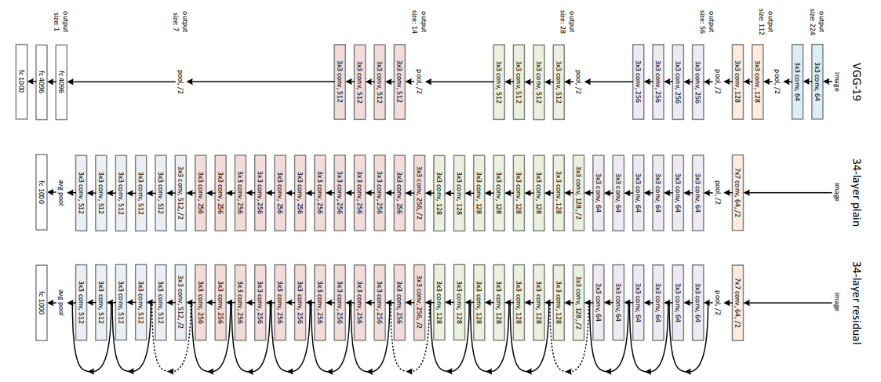

Fig__. ResNet Architecture

**Inception:**The Inception Module is utilized in CNNs to enhance streamlined computation through reducing dimensionality by stacking convolutions that are 1x1. Instead of stacking various kernel filter sizes sequentially, they are arranged to function at the same level. The first layer in the model is the pretrained InceptionResNetV2 model. After loading the pre-trained model, the next layer is a Flatten() layer, After, two fully connected (Dense) layers are introduced with 512 and 256 units respectively, with ReLU activation functions. The last layer is another fully connected (Dense) layer with 5 units (one for each image category) with a softmax activation function employed to create a distribution of probabilities among the 5 potential categories. During training, the model minimizes the cross-entropy loss between predicted probabilities and true labels of the train data to classify the images accurately.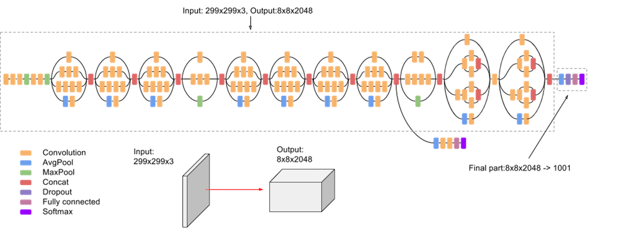

Fig__. Inception Architecture

1. **Severity Classification**

The Severity Classification task is a critical component of the proposed system for diabetic retinopathy prediction. The predicted severity levels are classified into one of the five categories in accordance with the ‘International Clinical Disease Severity Scale’ for Diabetic Retinopathy. The severity categories are defined based on the severity and extent of the retinal abnormalities, and are used to determine the appropriate treatment plan for patients.

The first category is **No Diabetic Retinopathy**, which indicates that there are no signs of diabetic retinopathy in the patient's retina.  
The second category of diabetic retinopathy is **Mild Diabetic Retinopathy**, characterized by microaneurysms, blots, dots, and small hard excrescences.  
The third category is **Moderate Diabetic Retinopathy**, which indicates that there are moderate abnormalities in the patient's retina, such as more numerous or larger areas of cotton wool spots and venule dilation along with microvascular intraretinal anomalies  
The fourth category is **Severe Diabetic Retinopathy,** which indicates that there are severe abnormalities in the patient's retina, such as multiple areas of intraretinal hemorrhages, apparent abnormalities in the microvascular level and neovascularization in a single quadrant leastwise  
Finally, **Proliferative Diabetic Retinopathy** is the most severe category, indicating that there is an extensive proliferation of abnormal blood vessels in the optic disc or retina which will possibly result in neovascular glaucoma or vitreous hemorrhage

Once the severity category has been determined, it can be used to give healthcare professionals a standardized severity level. This can help them make accurate diagnoses and choose the best course of treatment for their patients. For example, patients with mild diabetic retinopathy may not require immediate treatment but will need to be closely monitored, while patients with severe or proliferative diabetic retinopathy will require urgent treatment to prevent vision loss.

1. **System Architecture**

This graphic provides a concise and understandable description of all the entities currently integrated into the system. This is the graphical representation of the whole process and how it was carried out as a picture. Firstly the dataset is acquired and is subjected to analysis. Meaning, how many images are in five classes of severity namely: No DR, Mild, Moderate, Severe and Proliferate. After that, the data is split into a train set and a test set. The data is input into the selected model built. This data is then processed within the CNNs. Data is processed in order to make it consistent and prepare it for use. It is cleaned, formatted, or normalized. Many techniques take place in terms of data processing. The Edge Zero Padding is a method that is done to make sure the image’s aspect ratio is not changed. Adaptive Histogram Equalization is done by redistributing light and dark pixels in images to represent the original image contrast better. Morphological Dilation increases the accuracy of object detection by smoothing edges and filling gaps or holes within the object Apart from stated, median filtering, image blurring, masking, and erosion are performed on the data. The image segmentation followed by feature extraction takes place to train the model. Each model is evaluated based on accuracy, recall, precision, true positive, false negative, true negative, and false positive predicted instances. The model is then compared to another based on their training score, test score, percentage of misclassification, training time, and prediction time. Upon observation of these metrics, the best algorithm for the prediction of DR is deemed.

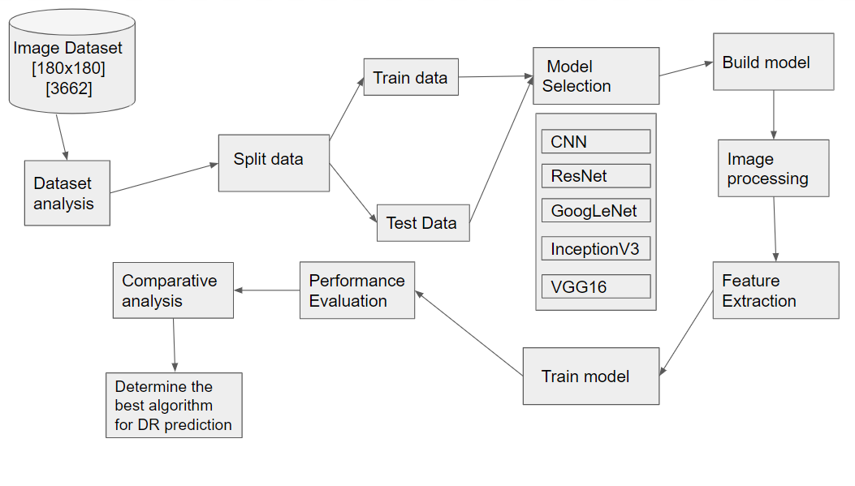

Fig__ System Architecture

**Sequence Diagram:** This is another type of interaction-based diagram used to display the workings of the system. They record the conditions under which objects and processes cooperate.

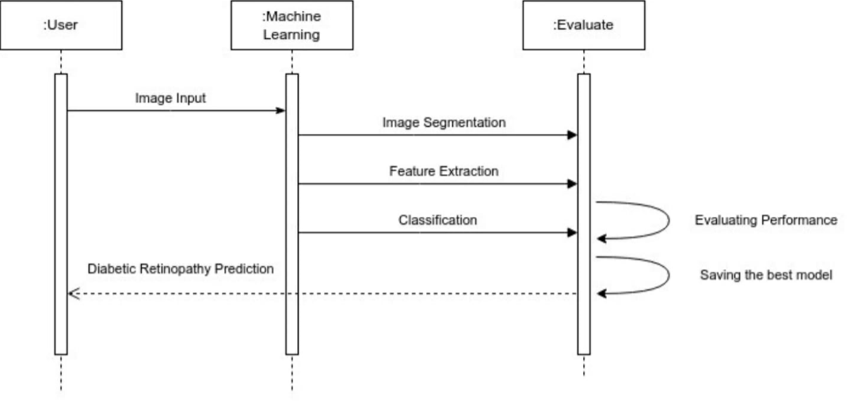

Fig__. Sequence Diagram

**Use Case Diagram:** The possible interactions between the user, the dataset, and the algorithm are often depicted in a use case diagram. It's created at the start of the procedure.

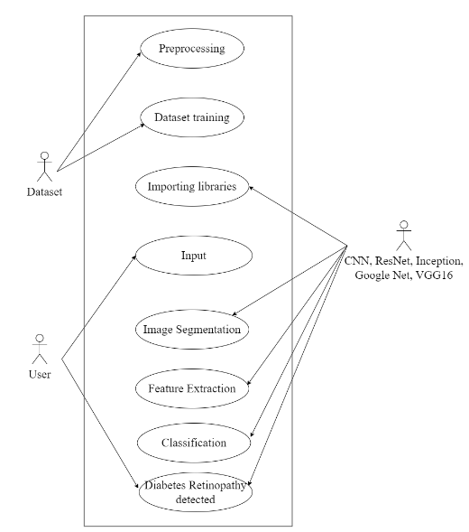

Fig__ Use Case Diagram

1. **Testing**
2. **Architectures’ performance**
3. **CNN**

Training Score: 0.952

Testing Score: 0.95

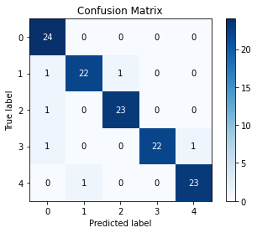

**Classification Report:**

|  |  |  |  |  |
| --- | --- | --- | --- | --- |
|  | precision | recall | f1-score | support |
| 0 | 0.89 | 1.00 | 0.94 | 24 |
| 1 | 0.96 | 0.92 | 0.94 | 24 |
| 2 | 0.96 | 0.96 | 0.96 | 24 |
| 3 | 1.00 | 0.92 | 0.96 | 24 |
| 4 | 0.96 | 0.96 | 0.96 | 24 |
| accuracy |  |  | 0.95 | 120 |
| macro  avg | 0.95 | 0.95 | 0.95 | 120 |
| weighted avg | 0.95 | 0.95 | 0.95 | 120 |

1. **ResNet**

Training score = 0.95

Testing score = 0.958

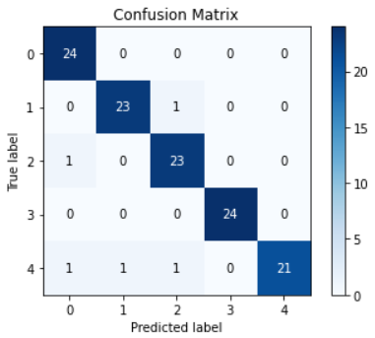

**Classification report:-**

|  |  |  |  |  |
| --- | --- | --- | --- | --- |
|  | precision | recall | f1-score | support |
| 0 | 0.92 | 1.00 | 0.96 | 24 |
| 1 | 0.96 | 0.96 | 0.96 | 24 |
| 2 | 0.92 | 0.96 | 0.94 | 24 |
| 3 | 1.00 | 1.00 | 1.00 | 24 |
| 4 | 1.00 | 0.88 | 0.93 | 24 |
| accuracy |  |  | 0.96 | 120 |
| macro  avg | 0.96 | 0.96 | 0.96 | 120 |
| weighted avg | 0.96 | 0.96 | 0.96 | 120 |

1. **GoogleNet**

Training score = 0.9526

Testing score = 0.95

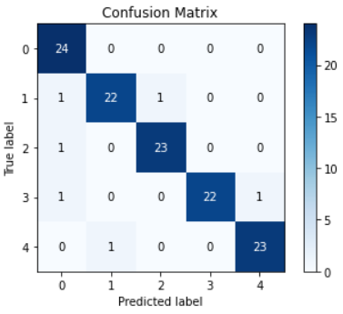

**Classification report:-**

|  |  |  |  |  |
| --- | --- | --- | --- | --- |
|  | precision | recall | f1-score | support |
| 0 | 0.89 | 1.00 | 0.94 | 24 |
| 1 | 0.96 | 0.92 | 0.94 | 24 |
| 2 | 0.96 | 0.96 | 0.96 | 24 |
| 3 | 1.00 | 0.92 | 0.96 | 24 |
| 4 | 0.96 | 0.96 | 0.96 | 24 |
| accuracy |  |  | 0.95 | 120 |
| macro  avg | 0.95 | 0.95 | 0.95 | 120 |
| weighted avg | 0.95 | 0.95 | 0.95 | 120 |

1. **Inception**

Training score = 0.93

Testing score = 0.941

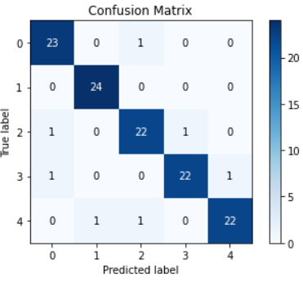

**Classification report:-**

|  |  |  |  |  |
| --- | --- | --- | --- | --- |
|  | precision | recall | f1-score | support |
| 0 | 0.92 | 0.96 | 0.94 | 24 |
| 1 | 0.96 | 1.00 | 0.98 | 24 |
| 2 | 0.92 | 0.92 | 0.92 | 24 |
| 3 | 0.96 | 0.92 | 0.94 | 24 |
| 4 | 0.96 | 0.92 | 0.94 | 24 |
| accuracy |  |  | 0.94 | 120 |
| macro  avg | 0.94 | 0.94 | 0.94 | 120 |
| weighted avg | 0.94 | 0.94 | 0.94 | 120 |

1. **VGG16**

Training Score: 0.915

Testing Score: 0.933

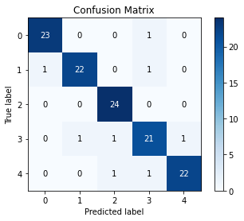

**Classification report:-**

|  |  |  |  |  |
| --- | --- | --- | --- | --- |
|  | precision | recall | f1-score | support |
| 0 | 0.96 | 0.96 | 0.96 | 24 |
| 1 | 0.96 | 0.92 | 0.94 | 24 |
| 2 | 0.92 | 1.00 | 0.96 | 24 |
| 3 | 0.88 | 0.88 | 0.88 | 24 |
| 4 | 0.96 | 0.92 | 0.94 | 24 |
| accuracy |  |  | 0.93 | 120 |
| macro  avg | 0.93 | 0.93 | 0.93 | 120 |
| weighted avg | 0.93 | 0.93 | 0.93 | 120 |

1. **ArchitecturesComparison Analysis**
2. **CNN Vs ResNet**

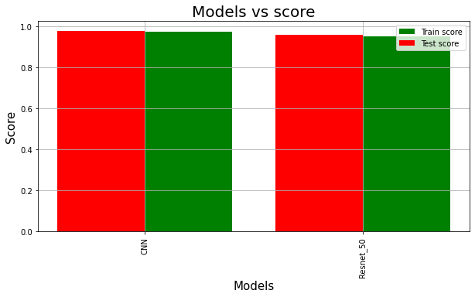

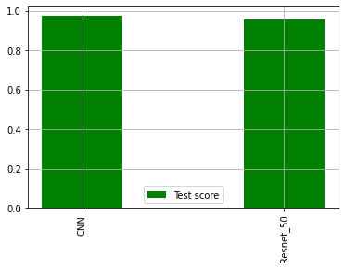

From the above comparison charts it is interpreted that CNN is faster and more efficient compared to ResNet

1. **CNN Vs GoogleNet**

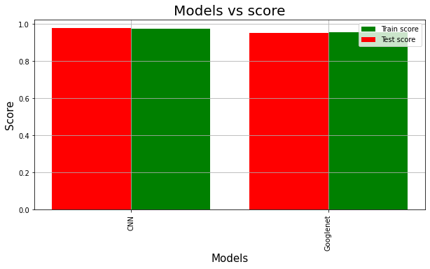

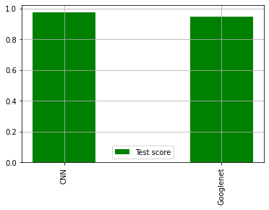

From the above comparison charts it is interpreted that CNN is faster and more efficient compared to GoogleNet

1. **CNN Vs Inception**

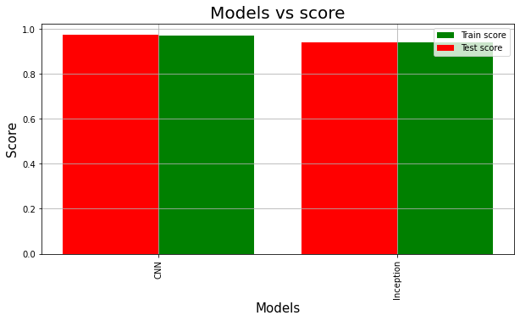

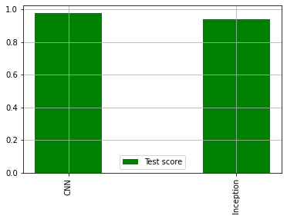

From the above comparison charts it is interpreted that CNN is faster and more efficient compared to Inception

1. **CNN Vs VGG**

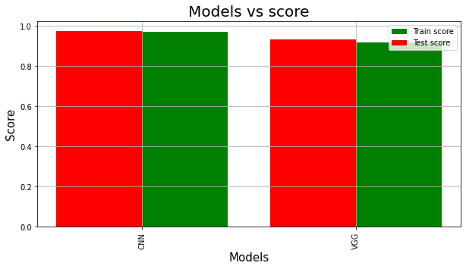

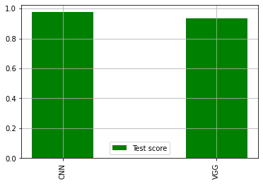

From the above comparison charts it is interpreted that CNN is faster and more efficient compared to VGG

1. **Overall Comparison**

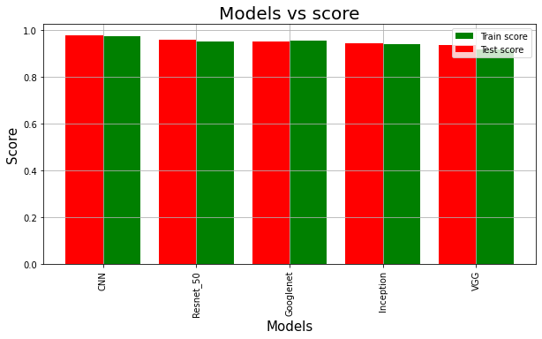

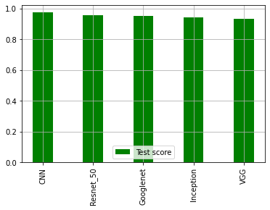

In summary, the conventional CNN when compared to the other algorithms good for image classification surpasses them all in terms of training and test scores along with superior performance

1. **Result**

Through rigorous testing of the proposed models, we come to a result, that in general CNN performs better in comparison with its counterparts when it comes to Image classification for Data retinoscopy, achieving 95% accuracy, which will help us to detect the symptoms in the early stages, which can further help in the prevention of loss of eyesight.

1. **Conclusion and Future Work**

In conclusion, our proposed multi-modal algorithm for the detection of diabetic retinopathy uses fundus photographs and has shown promising results. The convolutional neural network has been deemed the best algorithm for the prediction of Diabetic Retinopathy. The algorithm achieves an accuracy of 95% in the detection of diabetic retinopathy, which is higher than the accuracy achieved by other algorithms. The algorithm's robustness to noise and variability in the images indicates its potential for clinical use, and it can be integrated into telemedicine systems or used in primary care settings to improve the efficiency and accuracy of diabetic retinopathy screening. The proposed algorithm uses fundus photographs which allow for a more comprehensive assessment of diabetic retinopathy severity, which can inform treatment decisions and improve patient outcomes. Future research can focus on expanding the algorithm to include other imaging modalities and integrating it into clinical decision support systems. Overall, the advancement of automated detection of diabetic retinopathy using computer-based algorithms has taken a positive step with the introduction of the multi-modal algorithm which has potential to improve patient outcomes and lower healthcare costs.

**References**

1. Early Treatment Diabetic Retinopathy Study Research Group. (1991). Grading diabetic retinopathy from stereoscopic color fundus photographs—an extension of the modified Airlie House classification: ETDRS report number 10. Ophthalmology, 98(5 Suppl), 786-806.
2. American Diabetes Association. (2017). Standards of medical care in diabetes—2017. Diabetes Care, 40(Supplement 1), S4-S5.
3. Fong, D. S., Aiello, L. P., Ferris, F. L., & Klein, R. (2004). Diabetic retinopathy. Diabetes Care, 27(10), 2540-2553.
4. Wilkinson CP, Ferris FL, Klein RE, et al. Proposed international clinical diabetic retinopathy and diabetic macular edema disease severity scales. Ophthalmology 2003; 110: 1677-1682.
5. Writing Committee for the Diabetic Retinopathy Clinical Research Network. (2015). Panretinal photocoagulation vs intravitreous ranibizumab for proliferative diabetic retinopathy: A randomized clinical trial. JAMA, 314(20), 2137-2146.
6. Simó, R., & Hernández, C. (2015). Intravitreal anti-VEGF for diabetic retinopathy: Hopes and fears for a new therapeutic strategy. Diabetologia, 58(8), 1626-1631.
7. Stitt, A. W., & Curtis, T. M. (2010). Advanced glycation and retinal pathology during diabetes. Pharmacological Reports, 62(1), 155-163.
8. Chew, E. Y., Ferris, F. L., & Csaky, K. G. (2014). Diabetic retinopathy. In Ryan's retina (pp. 1243-1299). Elsevier.
9. Schmidt-Erfurth, U., Garcia-Arumi, J., Bandello, F., Berg, K., Chakravarthy, U., Gerendas, B. S., ... & Loewenstein, A. (2018). Guidelines for the management of diabetic macular edema by the European Society of Retina Specialists (EURETINA). Ophthalmologica, 239(4), 185-222.
10. Yau, J. W., Rogers, S. L., Kawasaki, R., Lamoureux, E. L., Kowalski, J. W., Bek, T., ... & Wong, T. Y. (2012). Global prevalence and major risk factors of diabetic retinopathy. Diabetes Care, 35(3), 556-564.