**MACHINE LEARNING ASSIGNMENT -1** DINESHS(018)

**Dataset Name** : Diabetes

**Dataset link** : <https://drive.google.com/file/d/1I3vLLCYnnBOfksEA-7iewkEDCMYLY37l/view?usp=sharing>

**Feature Selection algorithm :**

**1 .PCA (Principal component analysis) :**

**Code:**

import pandas as pd

from sklearn.decomposition import PCA

from sklearn.preprocessing import StandardScaler

from sklearn.model_selection import train_test_split

from sklearn.linear_model import LogisticRegression

from sklearn.metrics import accuracy_score, classification_report

from sklearn.tree import DecisionTreeClassifier

# Step 1: Load the dataset

data = pd.read_csv('./diabetes1.csv')  # Update this with the correct path

# Step 2: Preprocess the data

# Separate features and target

X = data.drop('Outcome', axis=1)

y = data['Outcome']

# Step 3: Standardize the features

scaler = StandardScaler()

X_scaled = scaler.fit_transform(X)

# Step 4: Apply PCA

pca = PCA(n_components=2)  # Reduce to 2 principal components

X_pca = pca.fit_transform(X_scaled)

# Step 5: Show the explained variance ratio

print("Explained variance ratio:", pca.explained_variance_ratio_)

# Display the first few rows of the PCA-transformed dataset

print("PCA-transformed data (first 5 rows):\n", X_pca[:20])

# # Step 6: Split the PCA data into train and test sets

X_train, X_test, y_train, y_test = train_test_split(X_pca, y, test_size=0.2, random_state=42)

clf = DecisionTreeClassifier(random_state=42)

clf.fit(X_train, y_train)

# Step 5: Make Predictions

y_pred = clf.predict(X_test)

# Step 6: Evaluate the Model

accuracy = accuracy_score(y_test, y_pred)

print("Accuracy:", accuracy)

print("\nClassification Report:\n", classification_report(y_test, y_pred))

**Output:**

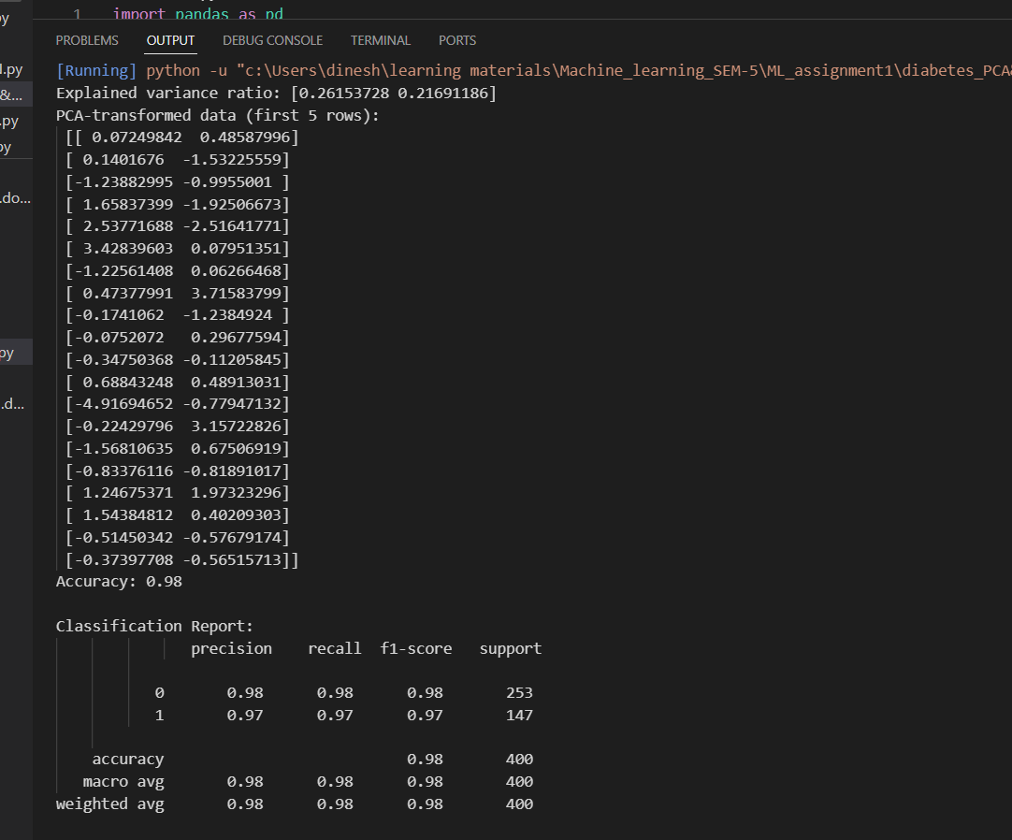

**2 . LDA (Linear discriminant analysis) :**

**Code:**

import pandas as pd

from sklearn.discriminant_analysis import LinearDiscriminantAnalysis as LDA

from sklearn.preprocessing import StandardScaler

from sklearn.model_selection import train_test_split

from sklearn.linear_model import LogisticRegression

from sklearn.metrics import accuracy_score, classification_report

data = pd.read_csv('./diabetes1.csv')  # Update this with the correct path

X = data.drop('Outcome', axis=1)

y = data['Outcome']

scaler = StandardScaler()

X_scaled = scaler.fit_transform(X)

lda = LDA(n_components=1)  # Reduce to 1 linear discriminant component

X_lda = lda.fit_transform(X_scaled, y)

print("Explained variance ratio (Not applicable for LDA): N/A")  # LDA does not provide variance ratio like PCA

print("LDA-transformed data (first 5 rows):\n", X_lda[:40])

X_train, X_test, y_train, y_test = train_test_split(X_lda, y, test_size=0.2, random_state=42)

model = LogisticRegression()

model.fit(X_train, y_train)

y_pred = model.predict(X_test)

accuracy = accuracy_score(y_test, y_pred)

print("Accuracy after LDA:", accuracy)

print("\nClassification Report:\n", classification_report(y_test, y_pred))

**output:**

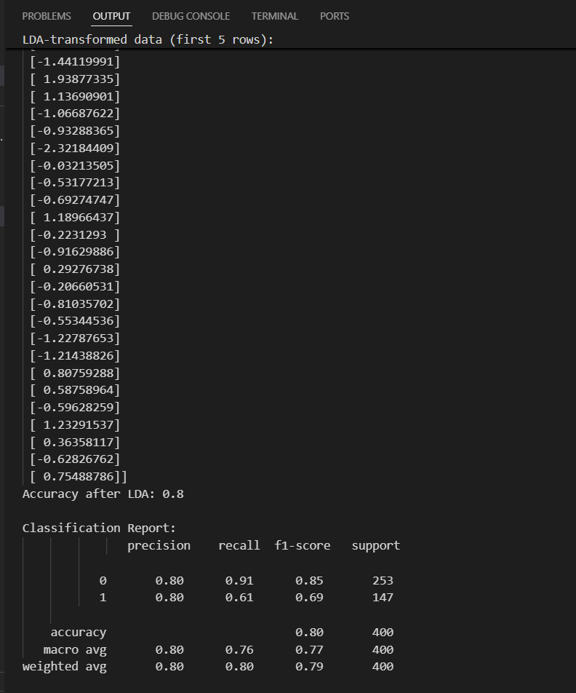

**Classification algorithm :**

1. **Decision Tree :**

**Code :**

import pandas as pd

from sklearn.model_selection import train_test_split

from sklearn.tree import DecisionTreeClassifier

from sklearn.metrics import accuracy_score, classification_report

data = pd.read_csv("C:/Users/dinesh/learning materials/Machine_learning_SEM-5/ML_assignment1/diabetes1.csv")  # Replace with your actual CSV file path

data[['Glucose', 'BloodPressure', 'SkinThickness', 'Insulin', 'BMI']] = data[['Glucose', 'BloodPressure', 'SkinThickness', 'Insulin', 'BMI']].replace(0, pd.NA)

data.fillna(data.mean(), inplace=True)

X = data.drop('Outcome', axis=1)  # Features (all columns except Outcome)

y = data['Outcome']  # Labels (Outcome column)

X_train, X_test, y_train, y_test = train_test_split(X, y, test_size=0.2, random_state=42)

clf = DecisionTreeClassifier(random_state=42)

clf.fit(X_train, y_train)

y_pred = clf.predict(X_test)

accuracy = accuracy_score(y_test, y_pred)

print("Accuracy:", accuracy)

print("\nClassification Report:\n", classification_report(y_test, y_pred))

**output :**

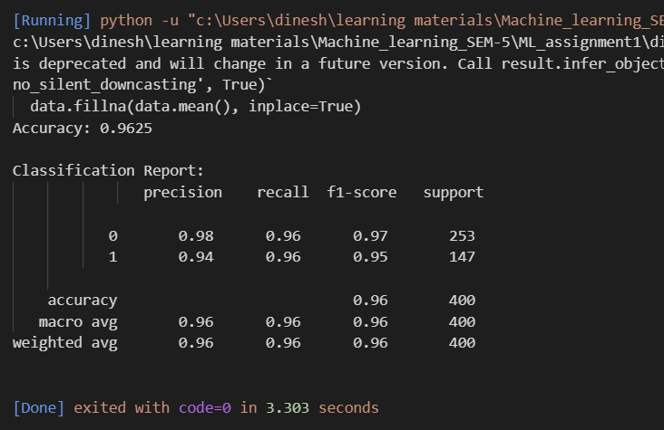

**2 . KNN (K-Nearest neighbour) algorithm :**

**Code :**

import pandas as pd

from sklearn.model_selection import train_test_split

from sklearn.preprocessing import StandardScaler

from sklearn.neighbors import KNeighborsClassifier

from sklearn.metrics import accuracy_score, classification_report

data = pd.read_csv('./diabetes1.csv')  # Update file path if needed

columns_to_replace = ['Glucose', 'BloodPressure', 'SkinThickness', 'Insulin', 'BMI']

data[columns_to_replace] = data[columns_to_replace].replace(0, pd.NA)

data.fillna(data.mean(), inplace=True)

X = data.drop('Outcome', axis=1)  # Features (all columns except Outcome)

y = data['Outcome']  # Target label (Outcome column)

scaler = StandardScaler()

X_scaled = scaler.fit_transform(X)

X_train, X_test, y_train, y_test = train_test_split(X_scaled, y, test_size=0.2, random_state=42)

knn_clf = KNeighborsClassifier(n_neighbors=20)  # You can change the value of k (number of neighbors)

knn_clf.fit(X_train, y_train)

y_pred = knn_clf.predict(X_test)

accuracy = accuracy_score(y_test, y_pred)

print("Accuracy:", accuracy)

print("\nClassification Report:\n", classification_report(y_test, y_pred))

**output :**

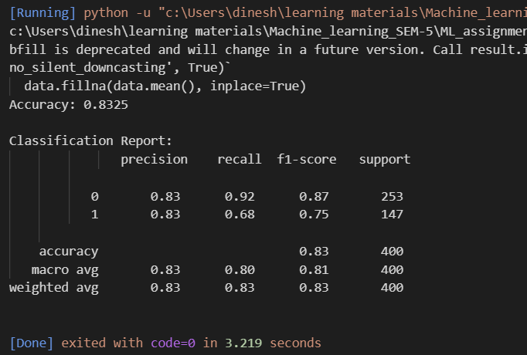

**DATA VISUALIZATION:**

**In Decision Tree :**

