MACHINE LEARNING ASSIGNMENT -2 DINESHS(018)

Dataset Name : Diabetes (for clustering algorithms only)
Dataset link : https://drive.google.com/file/d/1I3vLLCYnnBOfksEA-7iewkEDCMYLY37l/view?usp=sharing

Github link : https://github.com/Dinesh8110/ML-models/tree/master

Clustering algorithm :
1 . K-means clustering:

Code:
import pandas as pd
import matplotlib.pyplot as plt
from sklearn.cluster import KMeans
from sklearn.preprocessing import StandardScaler
from sklearn.decomposition import PCA
data = pd.read_csv("diabetes1.csv")
df = pd.DataFrame(data)
scaler = StandardScaler()
X_scaled = scaler.fit_transform(df)
kmeans = KMeans(n_clusters=3, init='k-means++', random_state=42)
print("\nInitial cluster centers:")
initial_centroids = [[0] * X_scaled.shape[1]] * 3 # Adjust for 3 clusters and number of features
print(initial_centroids)
clusters = kmeans.fit_predict(X_scaled)
print("\nFinal cluster centers:")
print(kmeans.cluster_centers_)
print("\nNumber of iterations until convergence (Epoch size):", kmeans.n_iter_)
print("\nFinal error rate (Inertia):", kmeans.inertia_)
df['Cluster'] = clusters
pca = PCA(n_components=2)
X_pca = pca.fit_transform(X_scaled)
plt.figure(figsize=(8, 6))
plt.scatter(X_pca[:, 0], X_pca[:, 1], c=clusters, cmap='viridis', s=100)
plt.title('K-Means Clustering Visualization')
plt.xlabel('Principal Component 1')
plt.ylabel('Principal Component 2')
plt.colorbar(label='Cluster')
plt.show()

Output:
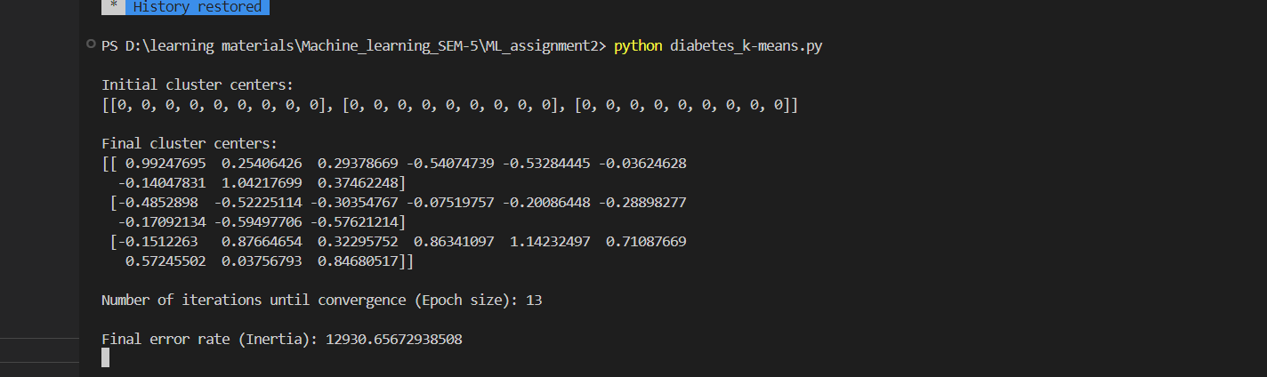

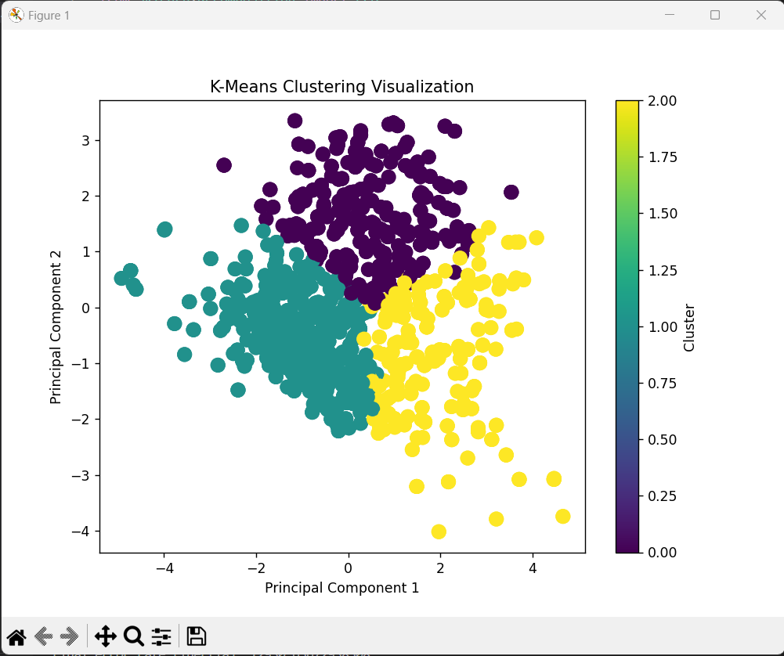

2 .AGNES(Agglomerative Nesting):
Code:
import pandas as pd
import matplotlib.pyplot as plt
from sklearn.preprocessing import StandardScaler
from sklearn.decomposition import PCA
from sklearn.cluster import AgglomerativeClustering
from scipy.cluster.hierarchy import dendrogram, linkage
data = pd.read_csv("diabetes1.csv")
df = pd.DataFrame(data)
scaler = StandardScaler()
X_scaled = scaler.fit_transform(df)
agg_cluster = AgglomerativeClustering(n_clusters=3, linkage='ward')
clusters = agg_cluster.fit_predict(X_scaled)
df['Cluster'] = clusters
Z = linkage(X_scaled, method='ward')
plt.figure(figsize=(10, 7))
plt.title("Dendrogram for Agglomerative Clustering")
dendrogram(Z)
plt.show()
pca = PCA(n_components=2)
X_pca = pca.fit_transform(X_scaled)
plt.figure(figsize=(8, 6))
plt.scatter(X_pca[:, 0], X_pca[:, 1], c=clusters, cmap='viridis', s=100)
plt.title('Agglomerative Clustering Visualization')
plt.xlabel('Principal Component 1')
plt.ylabel('Principal Component 2')
plt.colorbar(label='Cluster')
plt.show()

output:
Dendrogram:
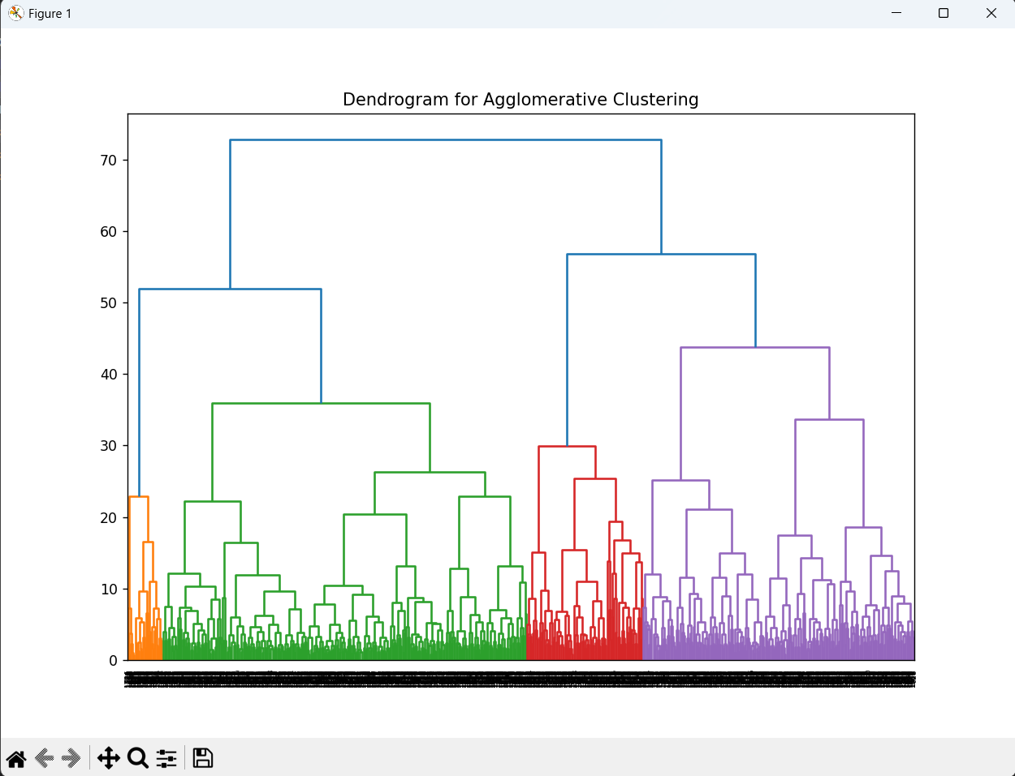

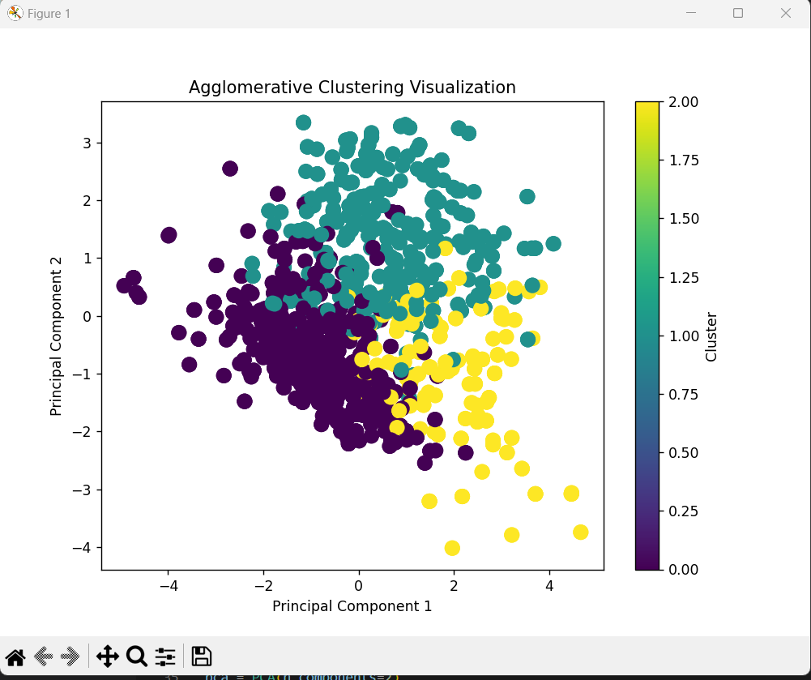

Applications of Reinforcement Algorithm:
- Autonomous Taxi:

Code :
import numpy as np
import gym
import random
from IPython.display import clear_output
import time
env = gym.make("Taxi-v3", render_mode="human")
q_table = np.zeros([env.observation_space.n, env.action_space.n])
alpha = 0.1 # Learning rate
gamma = 0.6 # Discount factor
epsilon = 0.1 # Exploration rate
num_episodes = 250
for episode in range(num_episodes):
# Use only the state ID if reset returns a tuple
state = env.reset() if isinstance(env.reset(), int) else env.reset()[0]
done = False
while not done:
# Exploration-exploitation tradeoff
if random.uniform(0, 1) < epsilon:
action = env.action_space.sample() # Explore action space
else:
action = np.argmax(q_table[state]) # Exploit learned values
result = env.step(action)
next_state = result[0] if isinstance(result, tuple) else result # Next state ID
reward = result[1]
done = result[2]
old_value = q_table[state, action]
next_max = np.max(q_table[next_state])
new_value = (1 - alpha) * old_value + alpha * (reward + gamma * next_max)
q_table[state, action] = new_value
state = next_state
print("Training completed!")
state = env.reset() if isinstance(env.reset(), int) else env.reset()[0]
env.render()
done = False
for step in range(20):
clear_output(wait=True)
print("Step:", step + 1)
action = np.argmax(q_table[state])
result = env.step(action)
state = result[0] if isinstance(result, tuple) else result
reward = result[1]
done = result[2]
env.render()
time.sleep(1)
if done:
break
env.close()

output :
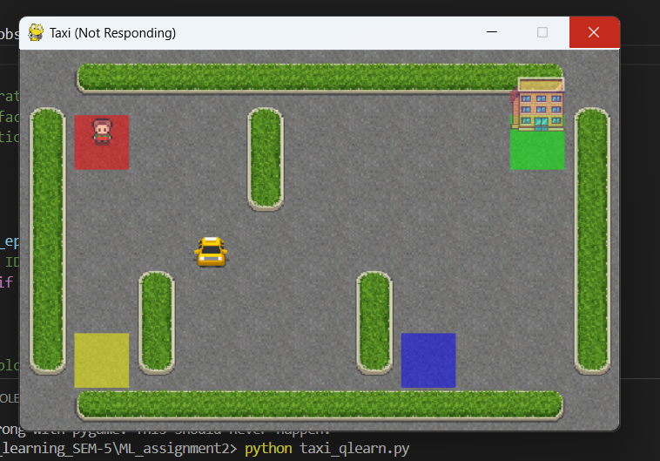
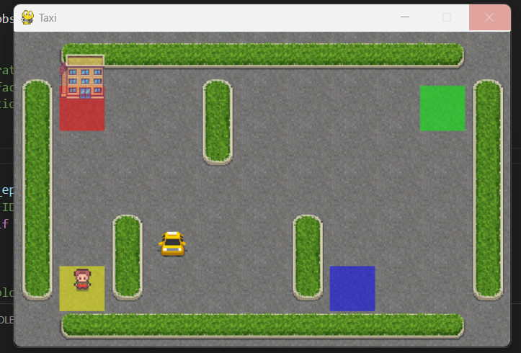

2 . KNN (K-Nearest neighbour) algorithm :
Code :
import pandas as pd
from sklearn.model_selection import train_test_split
from sklearn.preprocessing import StandardScaler
from sklearn.neighbors import KNeighborsClassifier
from sklearn.metrics import accuracy_score, classification_report
data = pd.read_csv('./diabetes1.csv') # Update file path if needed
columns_to_replace = ['Glucose', 'BloodPressure', 'SkinThickness', 'Insulin', 'BMI']
data[columns_to_replace] = data[columns_to_replace].replace(0, pd.NA)
data.fillna(data.mean(), inplace=True)
X = data.drop('Outcome', axis=1) # Features (all columns except Outcome)
y = data['Outcome'] # Target label (Outcome column)
scaler = StandardScaler()
X_scaled = scaler.fit_transform(X)
X_train, X_test, y_train, y_test = train_test_split(X_scaled, y, test_size=0.2, random_state=42)
knn_clf = KNeighborsClassifier(n_neighbors=20) # You can change the value of k (number of neighbors)
knn_clf.fit(X_train, y_train)
y_pred = knn_clf.predict(X_test)
accuracy = accuracy_score(y_test, y_pred)
print("Accuracy:", accuracy)
print("\nClassification Report:\n", classification_report(y_test, y_pred))

output :

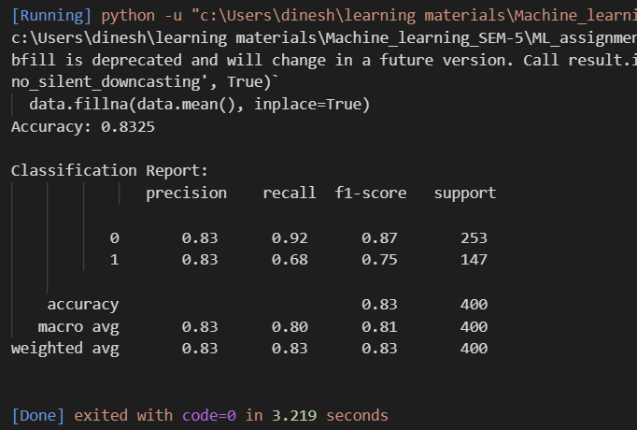

DATA VISUALIZATION:

In Decision Tree :

