- Click on Setup File.
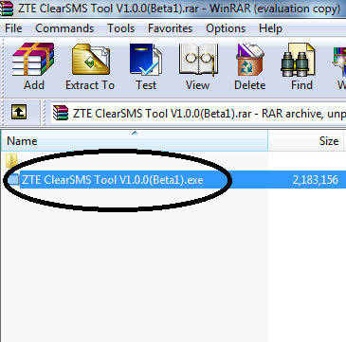
- New Window will pop up and click on “NEXT
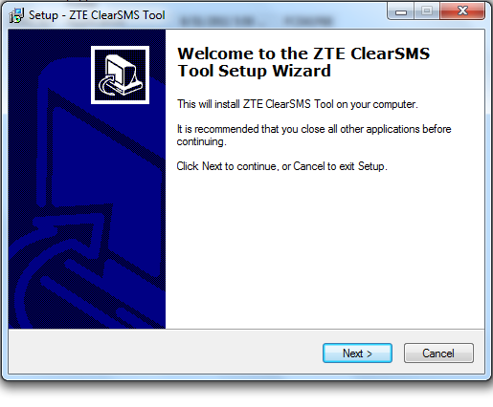
- Press Next
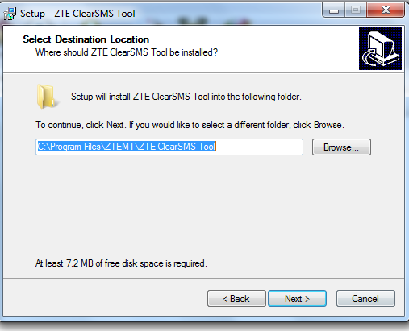

- Press Next
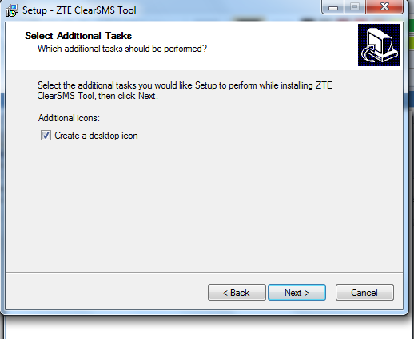
- Press Install
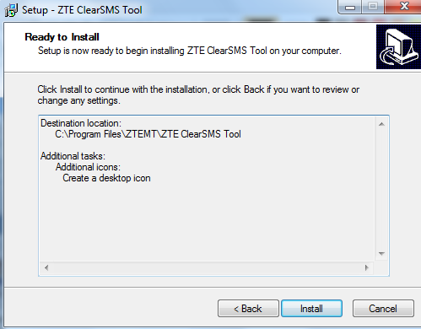

- Installation will progress
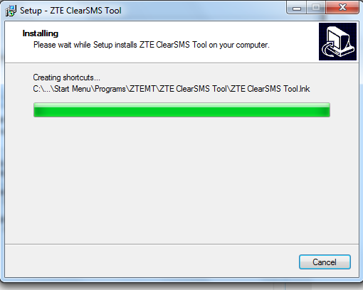
- Press Finish
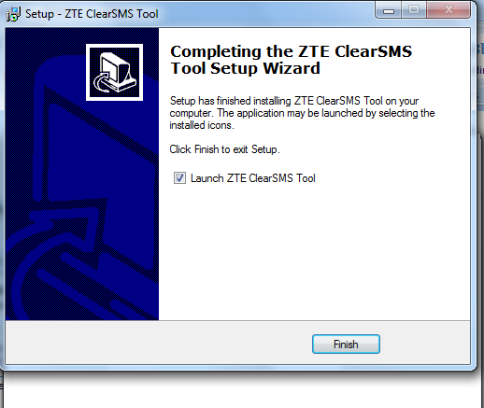
- PLUG THE DEVICE NOW AND CLICK ON BELOW ICON.
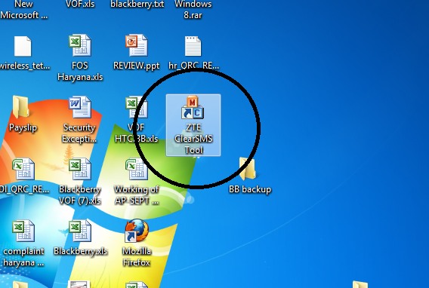
- CLICK ON CLEAR SMS AND IT WILL REMOVE ALL MESSAGE FROM INBOX
