Activity

Configuring the manifest :-

Declare Activities - Every activity is declared to manifest file.
<manifest ... >
<application ... >
<activity android:name=".ExampleActivity" />
...
</application ... >
...
</manifest >

Declare intent filter - It provide the ability to lunch an another activity.
// Create the text message with a string
Intent sendIntent = new Intent();
sendIntent.setAction(Intent.ACTION_SEND);
sendIntent.setType("text/plain");
sendIntent.putExtra(Intent.EXTRA_TEXT, textMessage);

// Start the activity
startActivity(sendIntent);

Declare Permissions
<manifest>
<activity android:name="...."
android:permission=”com.google.socialapp.permission.SHARE_POST”
/>

Managing the activity lifecycle :-

OnCreate() - Your implementation should initialize the essential components of your activity
OnStart() - the activity enters the Started state, and the activity becomes visible to the user
OnResume() - The system invokes this callback just before the activity starts interacting with the user
The onPause() callback always follows onResume().
OnPause() - The paused activity does not receive user input and cannot execute any code and called when the current activity is being paused
Once onPause() finishes executing, the next callback is either onStop() or onResume()
OnStop() - This callback is called when the activity is no longer visible
OnRestart() - This callback is called when the activity restarts after stopping it.
This callback is always followed by onStart()
OnDestroy() - This callback is called before the activity is destroyed by the system.

Application Lifecycle

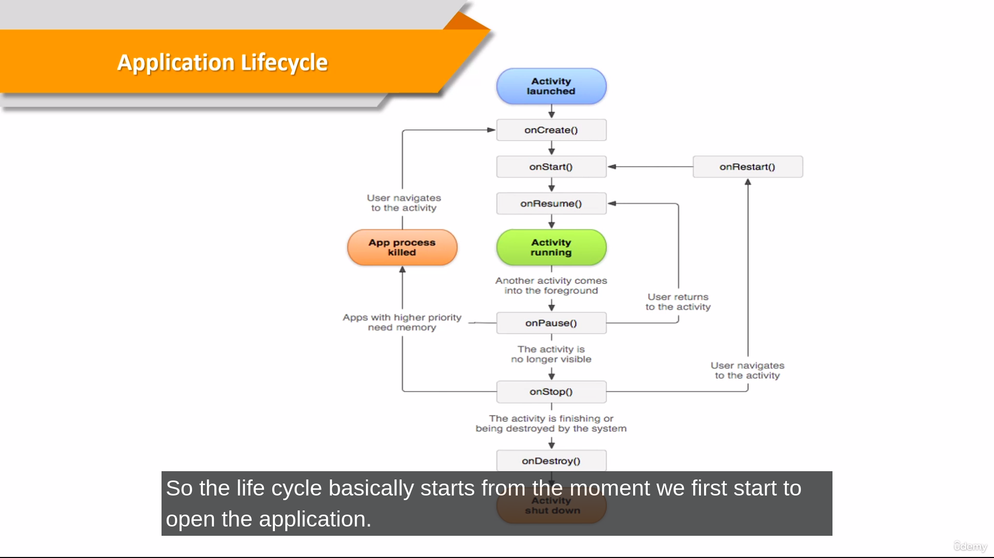

Different Stages of Lifecycles :-

Application Lifecycles
Activity Lifecycles
Fragment Lifecycles

Program :-

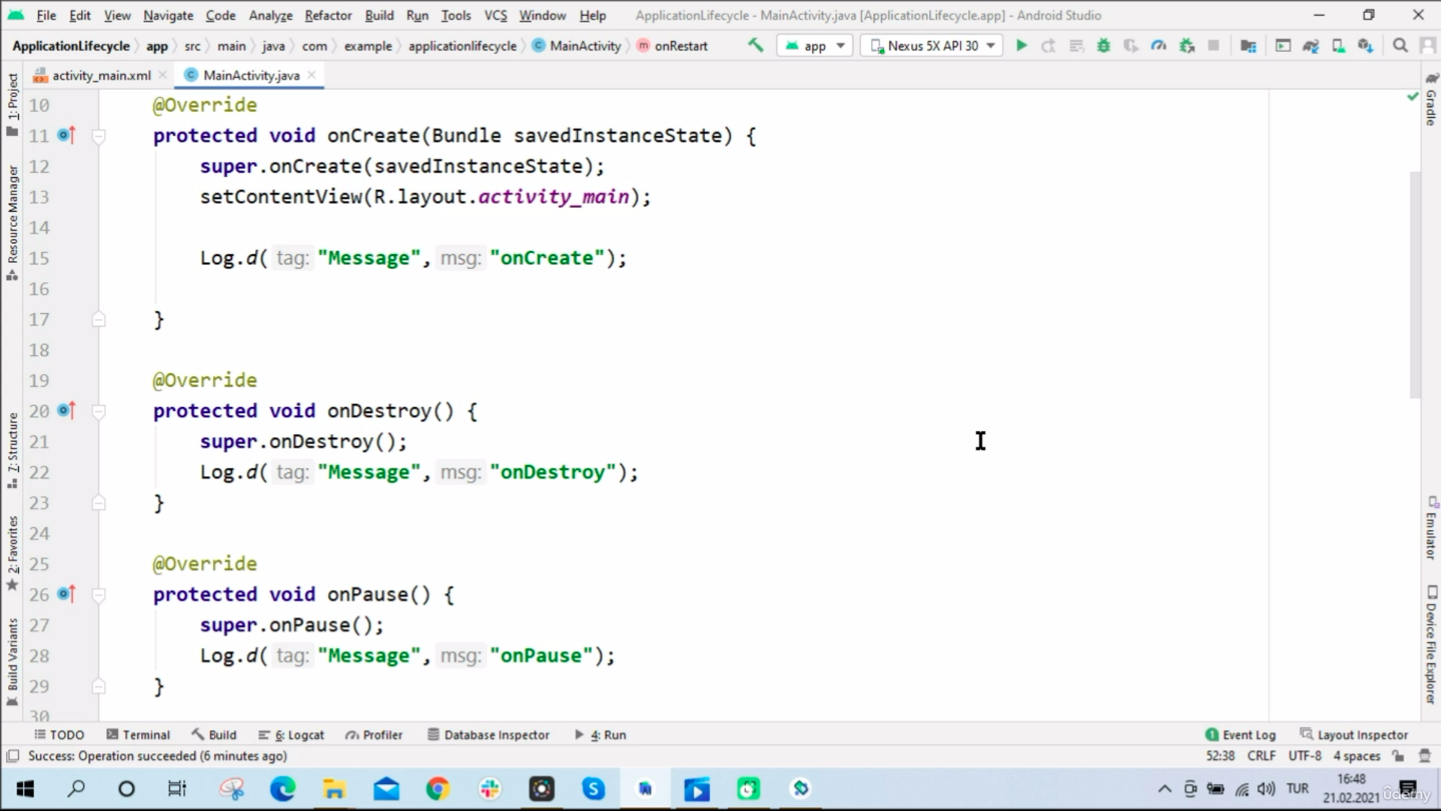
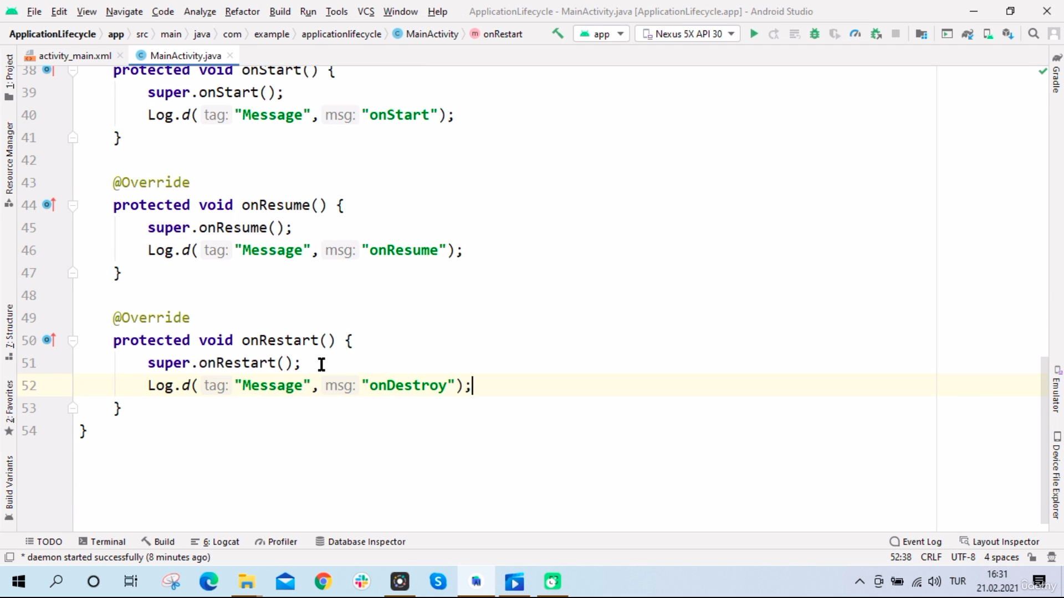
Fragment Lifecycle :-

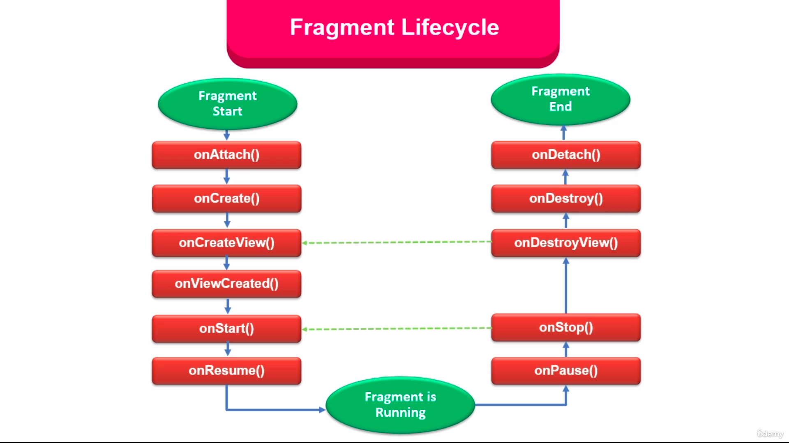

Changing One activity to another activity :-
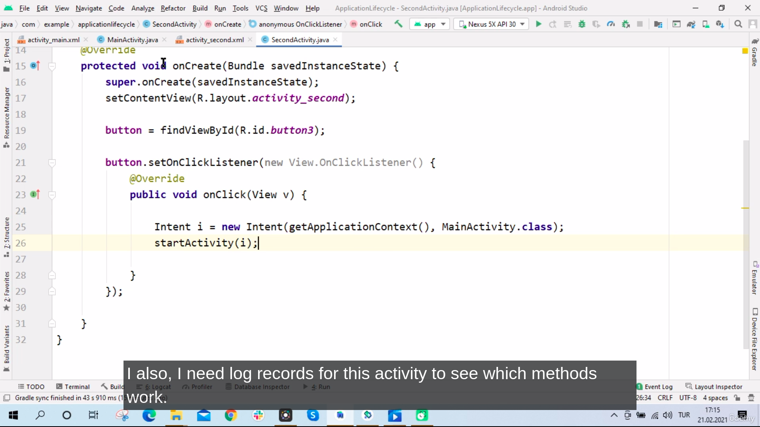

Service :-

A service is an application component that can perform long running operation in the background.
Services do not provide a user interface.
Another application compount can start a service.

There are three different types of services
Foreground service.
Background service.
Bound service.

There are two service class
Standard service class
Intent service class

Standard service class:-
Use mainthread.

Intent service class:-
it is a subclass of the service class
do not use the application main thread.
It used in long term background processes

Intents:-
An Intent is an object that provides runtime binding between separate components,such as two different activity.
Data transfer one activity to another activity.

