**JMeter**

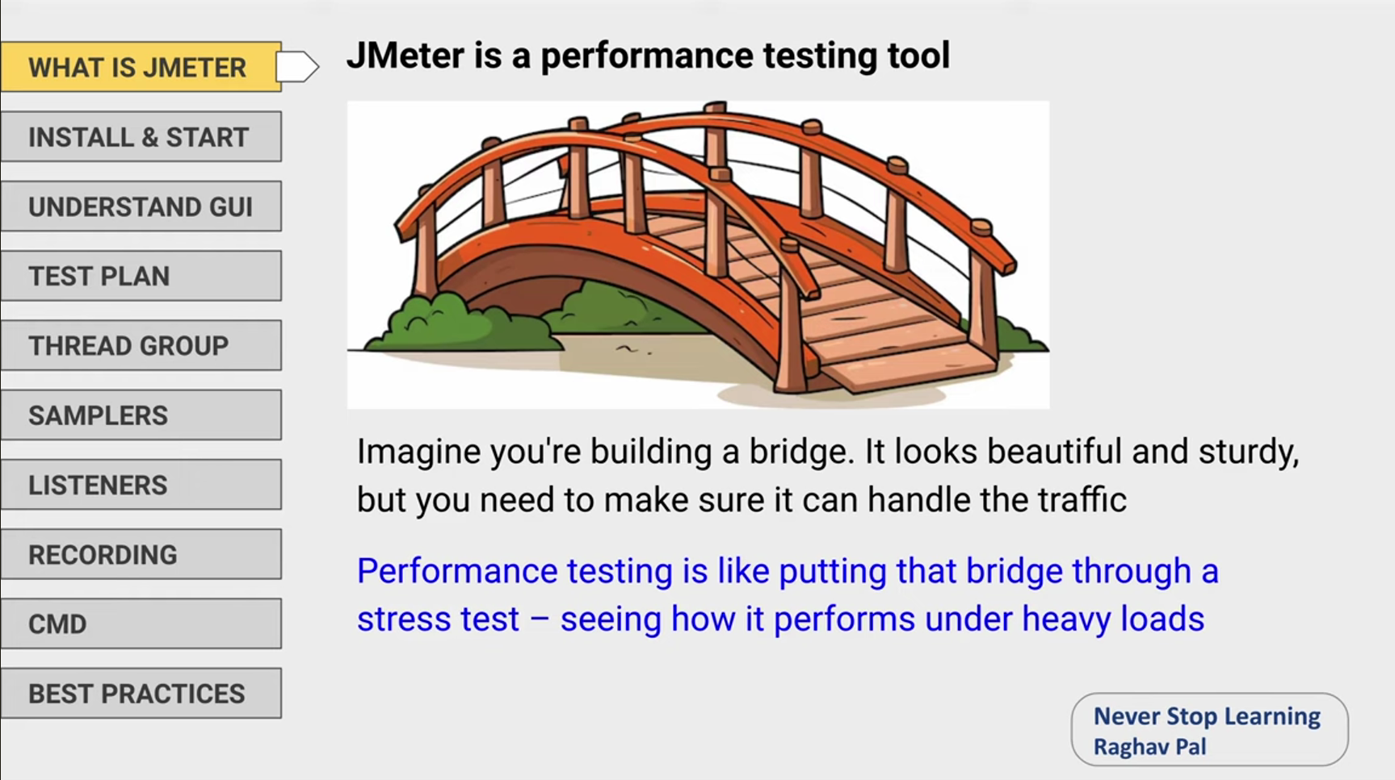

**View results tree**

When we needed to do real performance test it is advised to disable view result tree. It may consume lot of resources because it has showing lot of details and getting so many data.

**Connect time, Latency, Response time**

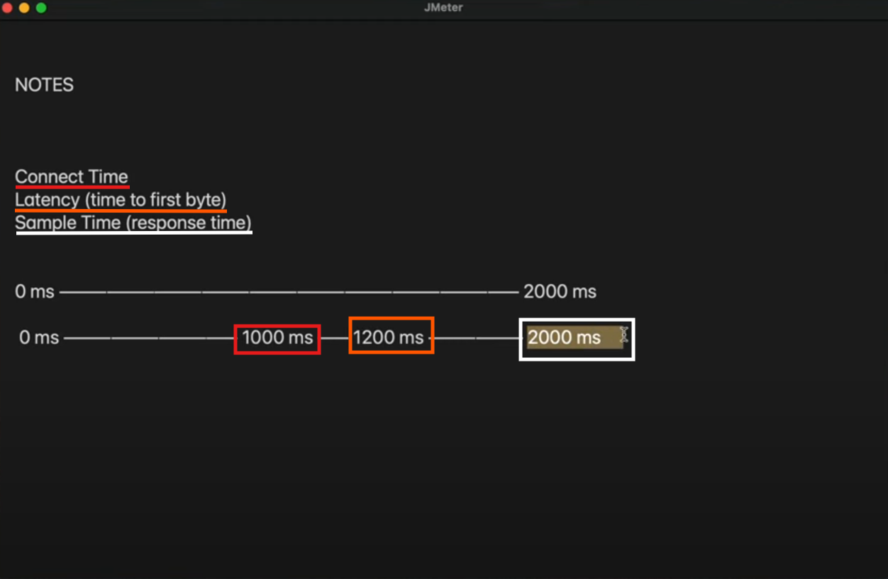

**Connect time**- The amount of time spent by a computer user in being connected to a network, **note:** that connect time is not automatically subtracted from latency.

**Latency**- (time to first byte)the number of milliseconds between the time JMeter sent the request and when an initial response was received. The time from just before sending the request to just after receiving the first part of the response

Time that we started getting the response- **Latency**

**Latency is the time until we receive the first byte and connect time is how long it took to initiate the HTTP connection**

1. **Format to Initiate the test in Command Prompt along with csv/jtl report:**

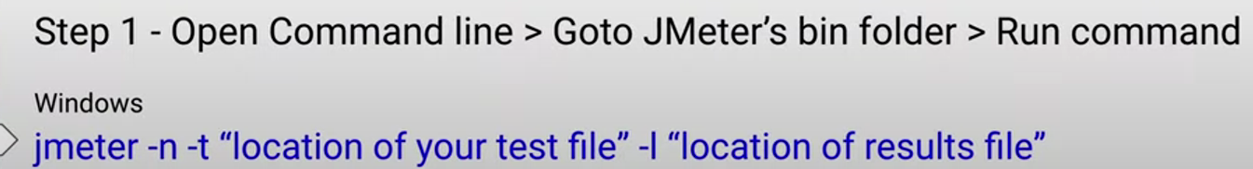

**jmeter -n -t "location of your test file" -I "location of results file"**

**Explanation:**

* -n → Non-GUI mode
* -t → Path to your .jmx file
* -J → Set JMeter properties (used as variables)
* -l → Path to save the results .jtl

**Example:**

jmeter -n -t "D:\Performance Test\Web_Scripts\OHRM\ORANGEHRM_WEB_APP_09102023_scripted.jmx" -l "D:\Performance Test\Web_Scripts\OHRM\Reports\jun25_01.csv"

**Execution in CMD:**

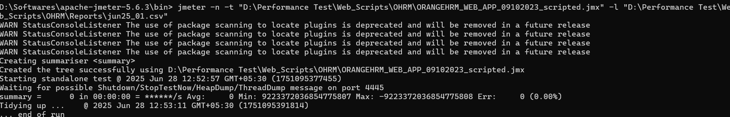

1. **Format to Initiate the test with csv/jtl report and HTML report:**

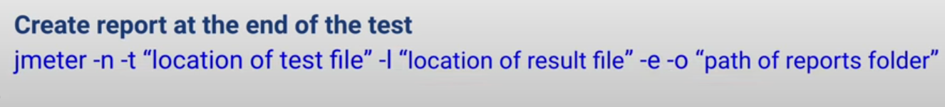

**jmeter -n -t "location of test file" -I "location of result file" -e -o "path of reports folder"**

**Example:**

jmeter -n -t "D:\Performance Test\Web_Scripts\OHRM\ORANGEHRM_WEB_APP_09102023_scripted.jmx" -l "D:\Performance Test\Web_Scripts\OHRM\Reports\jun25_02.csv" -e -o "D:\Performance Test\Web_Scripts\OHRM\Reports\sample2"

**Execution in CMD:**

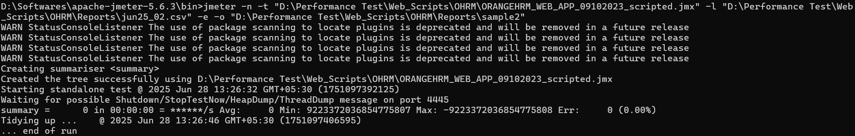

1. **Create HTML report from existing standalone csv file,**

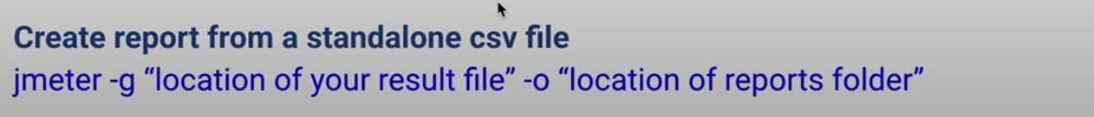

**jmeter -g "location of your result file" -o "location of reports folder"**

**Example:**

jmeter -g "D:\Performance Test\Web_Scripts\OHRM\Reports\jun25_02.csv" -o "D:\Performance Test\Web_Scripts\OHRM\Reports\sample3"

**Execution in CMD:**

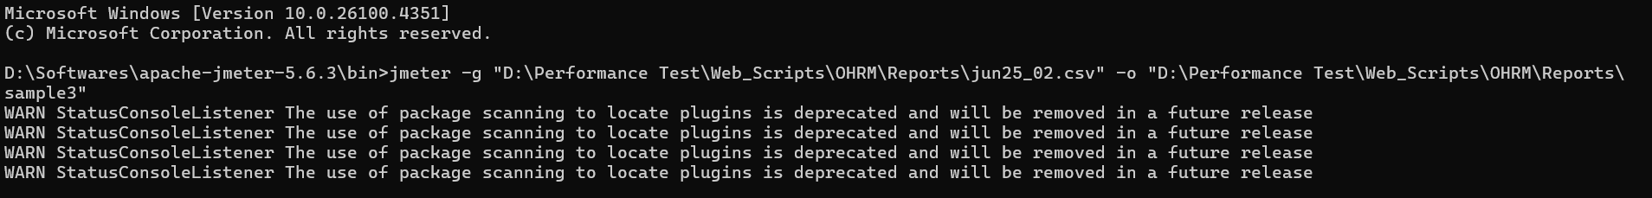

1. **Execute test by providing thread,rampup & duration from CMD**

**jmeter -n -t "location of test file" -Jthreads=20 -JrampUpTime=60 -Jduration=60 -JloopCount=1 -Jdelay=1 -l "location of result file" -e -o "path of HTML reports folder"**

**Update the parameters in JMeter JMX file:**

|  |  |
| --- | --- |
| Thread Count | ${__P(threads,1)} |
| Ramp-up time | ${__P(rampUpTime,1)} |
| Loop Count | ${__P(loopCount,1)} |
| Duration | ${__P(duration,60)} |
| Start-up Delay | ${__P(delay,1)} |
| Access Token | ${__P(AccessToken,1)} |

Instead of **${__P(threads,1)}** this format you can use this **${threads}** as well.

**Example:**

jmeter -n -t "D:\Performance Test\Web_Scripts\OHRM\ORANGEHRM_WEB_APP_09102023_scripted.jmx" -Jthreads=20 -JrampUpTime=60 -Jduration=60 -JloopCount=1 -Jdelay=1 -l "D:\Performance Test\Web_Scripts\OHRM\Reports\jun25_03.csv" -e -o "D:\Performance Test\Web_Scripts\OHRM\Reports\sample2"

**Execution in CMD:**

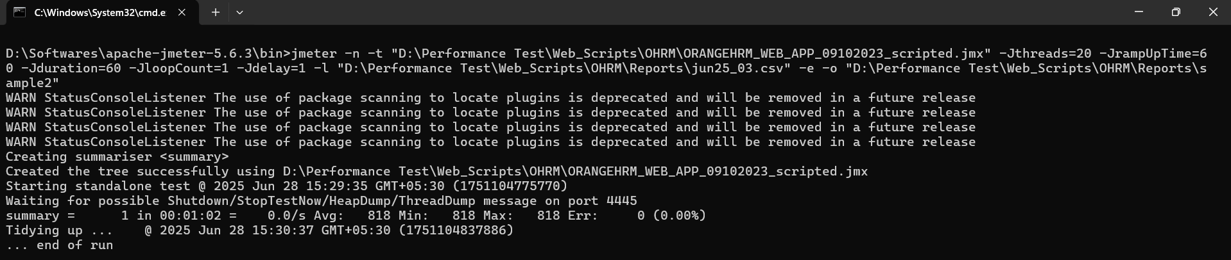

**Remote test or Distributed test**

**Step 1 :** SetUp Master added remote system’s ip in jmeter.properties

**Step 2 :** Create keystore file run create-rmi-keystore.bat / create-rmi-keystore.sh name : rmi password : changeit

**Step 3 :** run jmeter-server file on slave (remote) system

**Illustration:**

Step1: Add the remote machine ip address

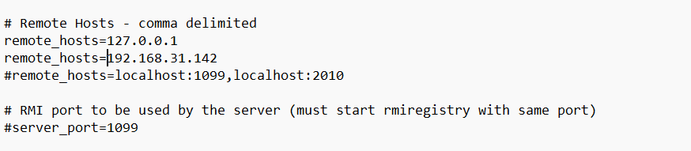

Step 2: Open **Create keystore file** in bin folder and provide the answers

**Illustration**

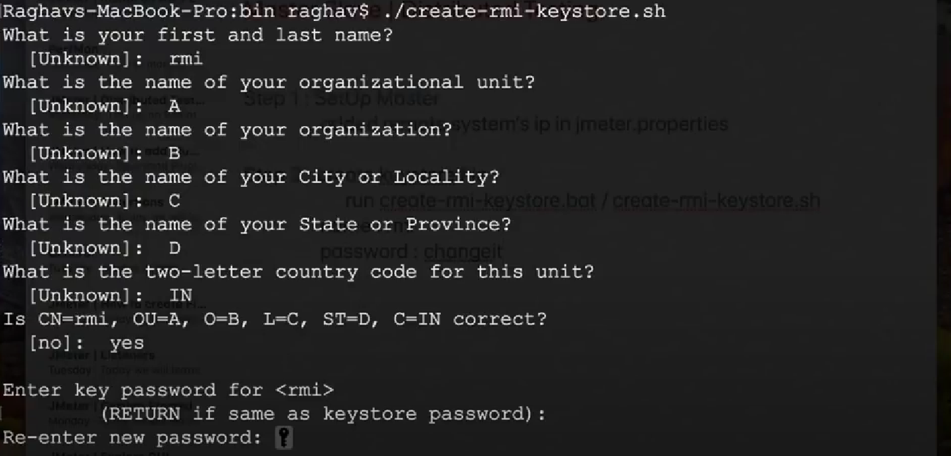

Keep password as: **changeit** (if its asked)

Once its id done we can able to find: **rmi_keystore.jks**

**Step 3:** Now you need to start **run jmeter-server file on slave (remote) system** in bin folder

Step 4: Remote test will work fine

**To run the distributed test in CMD and saving the results**

Open the jmeter server batch file as well while running

**Command:** Syntax

**jmeter -n -t "location of test file" -I "location of result file" -R 192.168.31.142**

**Example:**

**jmeter -n -t "D:\Performance Test\Web_Scripts\OHRM\ORANGEHRM_WEB_APP_09102023_scripted.jmx" -l "D:\Performance Test\Web_Scripts\OHRM\Reports\july25_01.csv" -R 192.168.31.142**

**Example in CMD:**

