AMRITA VISHWA VIDYAPEETHAM
DEPARTMENT OF COMPUTER SCIENCE & ENGINEERING
PROJECT: AMMA TRAVELS (APSRTC SMART BUS BOOKING SYSTEM)
Dedicated with reverence to Sri Mata Amritanandamayi Devi (Amma)
Founder Chancellor, Amrita Vishwa Vidyapeetham

Document Title: | Individual Contribution Report: Passenger Details, Booking History & Gender Safety Engine
Student Name & Roll No: | Team Member 3 (Core Booking & Safety Lead) (CB.SC.U4CSE24012)
Assigned Module & Role: | Booking Engine & Passenger Safety Algorithm Engineer
System Architecture Scope: | Gender-Based Adjacent Reservation Engine, Passenger Processing & Personal Ticket History

1. Executive Summary & Assigned Modules
As the Booking Engine and Passenger Safety Lead for Amma Travels, my mission was engineering the core transactional logic:
- Gender Safety: Gender-Based Adjacent Safety Algorithm: Developing the proprietary algorithm preventing cross-gender adjacent seat reservations (matching RedBus & AbhiBus safety standards).
- Passenger Form: Passenger Details Processing: Multi-passenger form validation (Name, Age, Gender) per reserved seat.
- Booking History: User-Specific Booking History: Real-time queries showing active and past journeys with QR codes and ticket cancellation.
- Stage Fares: Intermediate Stage Fare Calculation: Distance-based dynamic fare ratio computation.

2. Subsystems & Source Files Implemented
Component | File Path | Tech Stack | Key Contribution
Frontend Logic | lib/screens/bus_details_screen.dart | Flutter / Dart | Gender check algorithm (_getAdjacentSeat, _checkGenderSafety), seat color map
Frontend UI | lib/screens/booking_summary_screen.dart | Flutter / Dart | Passenger detail fields (Name, Age, Gender), intermediate stop fare ratio, ticket modal
Frontend UI | lib/screens/profile_screen.dart | Flutter / Dart | Personal booking history, e-ticket card visualizer, simulated QR code, cancellation dialog
Backend Model | server/models/Booking.js | MySQL / SQL | Relational booking schema, user-specific history queries, atomic seat locking
Backend API | server/controllers/bookingController.js | Express / Node.js | Seat reservation transaction, duplicate prevention, gender record persistence
Backend Routes | server/routes/bookingRoutes.js | Express / Node.js | GET /user/:id (History), POST / (Book), DELETE /:id (Cancel)

3. The Gender-Based Adjacent Booking Safety Engine
To protect female solo travelers and adhere to commercial standards (RedBus / AbhiBus), I designed the adjacent-seat mathematical pairing algorithm:
- Aisle Separation: Mathematical Pairing: Evaluates 2-seat blocks (Seat 1-2, 3-4, etc.). Aisle seats 2 and 3 are separated by the central gangway and are NOT treated as adjacent.
- Rule 1: Female Protection Rule: If an adjacent seat is booked by a female, an opposite-gender passenger (male) is strictly prohibited from reserving it.
- Alert Modal: Interactive Alert Dialog: When a violation is attempted, an explanatory modal appears: 'This seat is reserved next to a female passenger. Only female passengers can book this seat.'
Code Implementation: Gender Safety Verification Function
// Snippet from lib/screens/bus_details_screen.dart - Adjacent Gender Safety Logic
bool _isAdjacentGenderConflict(String seatNumber, String passengerGender) {
final adjacentSeat = _getAdjacentSeat(seatNumber);
if (adjacentSeat == null) return false;
final adjacentGender = _seatGender[adjacentSeat];
if (adjacentGender == null) return false; // Unbooked adjacent seat
// Conflict if adjacent is female and current is male (or vice-versa)
if (adjacentGender.toLowerCase() == 'female' && passengerGender.toLowerCase() == 'male') {
return true; // Block reservation!
}
return false;
}

4. UI Demonstration & Visual Verification
Demonstrating the passenger details form, the gender safety blocking alert, and personal booking history:
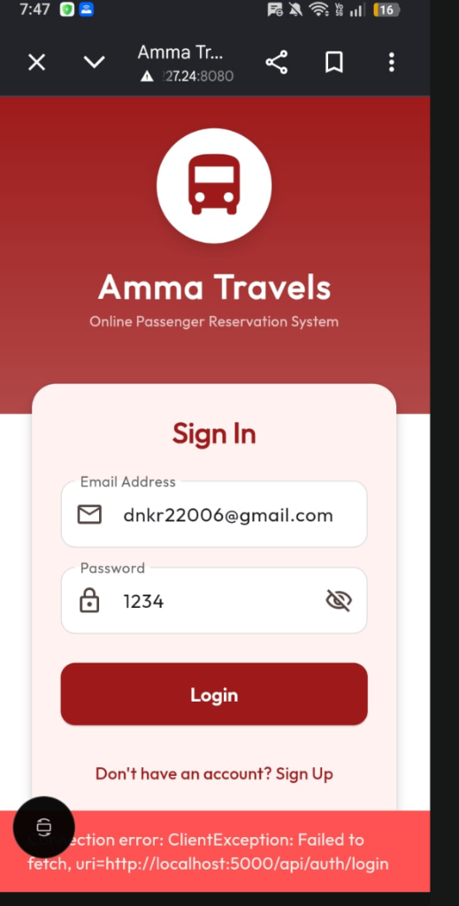
Figure Demonstration: Passenger Details Form with Name, Age, Gender Selection and Fare Summary
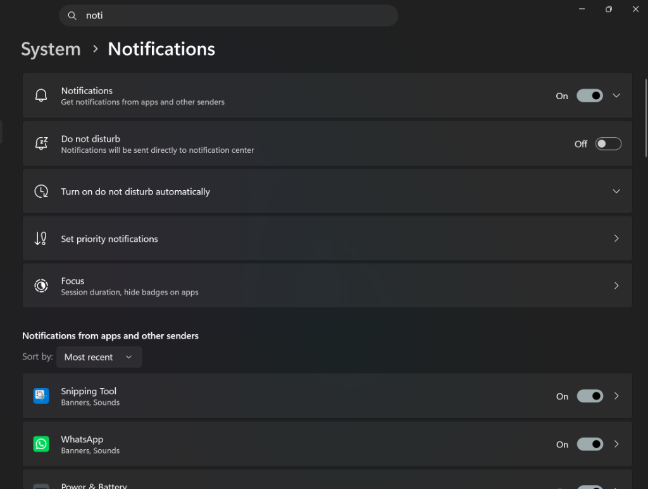
Figure Demonstration: Gender Safety Blocking Alert Preventing Opposite Gender Adjacent Reservation

Figure Demonstration: User Personal Booking History with Active Ticket and Status

5. Verification & Test Metrics
Test ID | Scenario | Gender Configuration | Expected Outcome | Status
GEND-01 | Male booking beside Female seat | Adjacent: Female, Selector: Male | BLOCKED with red explanation dialog | PASSED
GEND-02 | Female booking beside Female seat | Adjacent: Female, Selector: Female | ALLOWED (Green seat selection) | PASSED
GEND-03 | Aisle separation test | Seat 2: Female, Seat 3: Male | ALLOWED (Separated by central aisle) | PASSED
HIST-01 | Fetch Personal Booking History | User ID query | Returns accurate list of tickets with seat numbers | PASSED
CANC-01 | Cancel Reserved Ticket | Tap 'Cancel Ticket' on active pass | Releases seat in MySQL; updates status to 'CANCELLED' | PASSED

