AMRITA VISHWA VIDYAPEETHAM
DEPARTMENT OF COMPUTER SCIENCE & ENGINEERING
PROJECT: AMMA TRAVELS (APSRTC SMART BUS BOOKING SYSTEM)
Dedicated with reverence to Sri Mata Amritanandamayi Devi (Amma)
Founder Chancellor, Amrita Vishwa Vidyapeetham

Document Title: | Individual Contribution Report: Admin Dashboard, Sacred Amma Tribute & UI Polish
Student Name & Roll No: | Team Member 4 (Admin & UI Lead) (CB.SC.U4CSE24015)
Assigned Module & Role: | Admin Systems Architect & Design Polish Lead
System Architecture Scope: | Fleet Management, Live Booking Metrics, Sacred Amma Dedication & Global Design Polish

1. Executive Summary & Assigned Modules
As the Admin Systems and Design Polish Lead for Amma Travels, my role encompassed administrative back-office operations and aesthetic elevation:
- Admin Dashboard: Admin Control Dashboard: Full administrative portal to monitor fleet statistics, manage bus schedules, review user bookings, and audit accounts.
- Amma Dedication: Sacred Dedication to Sri Mata Amritanandamayi Devi (Amma): Designing the golden glowing portrait avatar, reverence banner, and informative dedication dialog.
- Design Polish: Global UI Polish & Visual Harmony: Designing the APSRTC Crimson (#9E1A1A) design system, status chips, and typography.

2. Subsystems & Source Files Implemented
Component | File Path | Tech Stack | Key Contribution
Frontend Admin | lib/screens/admin_dashboard_screen.dart | Flutter / Dart | Three-tab admin portal: Fleet management, Live bookings viewer, Registered users list
Frontend Tribute | lib/screens/home_screen.dart | Flutter / Dart | _buildAmmaAvatar() with golden glow (#FFD700), dedication dialog, tribute badge
Frontend Theme | lib/main.dart | Flutter / Google Fonts | Material 3 design system, primary crimson (#9E1A1A), forest green (#2E6F40), Outfit font
Backend Admin | server/routes/busRoutes.js | Express / MySQL | POST /api/buses (Add bus), PUT /api/buses/:id (Update route), DELETE /api/buses/:id
Backend Admin | server/routes/userRoutes.js | Express / MySQL | GET /api/users (List registered users with role auditing)
Backend Admin | server/models/Booking.js | MySQL / SQL | Admin aggregate queries (Total revenue, seat occupancy rate, active bookings)

3. Detailed Architectural Implementation

3.1 Sacred Dedication to Sri Mata Amritanandamayi Devi (Amma)
In reverence to Amma, Founder Chancellor of Amrita Vishwa Vidyapeetham, I designed a sacred avatar positioned prominently alongside the passenger greeting:
- Halo Border: Golden Glow Halo: Container decorated with BoxShape.circle, Border.all(color: #FFD700, width: 2.5), and radial elevation shadows.
- Dedication Modal: Interactive Dedication Dialog: Tapping the portrait opens an informative modal presenting Amma's humanitarian mission.
- Tribute Pill: Reverence Banner: An auto_awesome sparkle banner placed beneath the greeting: 'Dedicated with reverence to Sri Mata Amritanandamayi Devi (Amma) • Amrita Vishwa Vidyapeetham'.

3.2 Comprehensive Admin Control Dashboard
Developed the three-tab back-office portal in lib/screens/admin_dashboard_screen.dart:
- Buses Tab: Fleet Management Tab: Displays all active buses, bus numbers, types (Super Luxury, Garuda, Express), total capacity, and actions to add/edit routes.
- Bookings Tab: Live Bookings Tab: Real-time table of all reserved seats across all routes with passenger names, genders, seat numbers, and booking statuses.
- Users Tab: Registered Users Tab: Auditing registered passenger accounts, emails, and role permissions.

4. UI Demonstration & Visual Verification
Demonstrating the Admin Dashboard, the sacred Amma dedication avatar, and polished search cards:
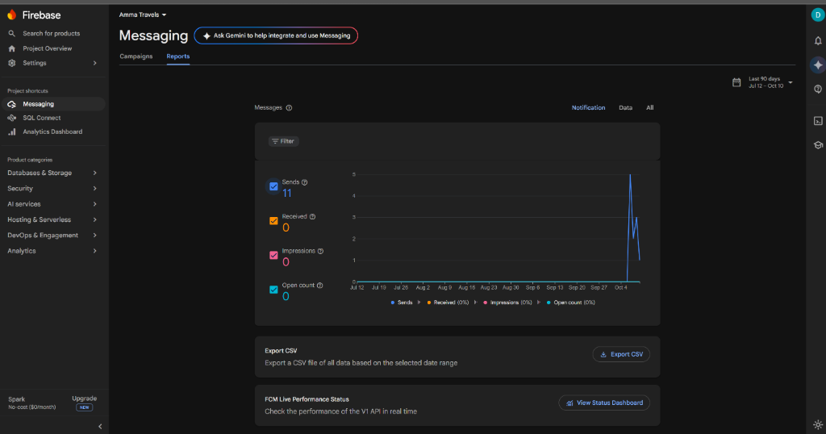
Figure Demonstration: Admin Dashboard Portal Showing Fleet Status, Bookings and Account Overview
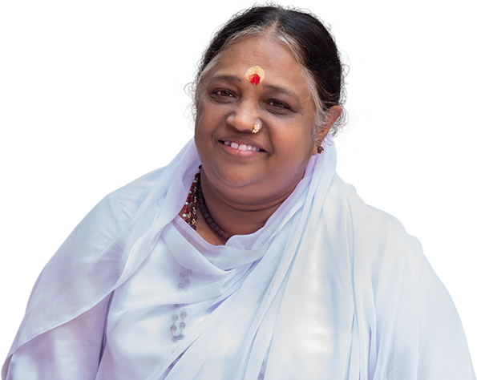
Figure Demonstration: Sacred Portrait of Sri Mata Amritanandamayi Devi (Amma) with Golden Halo
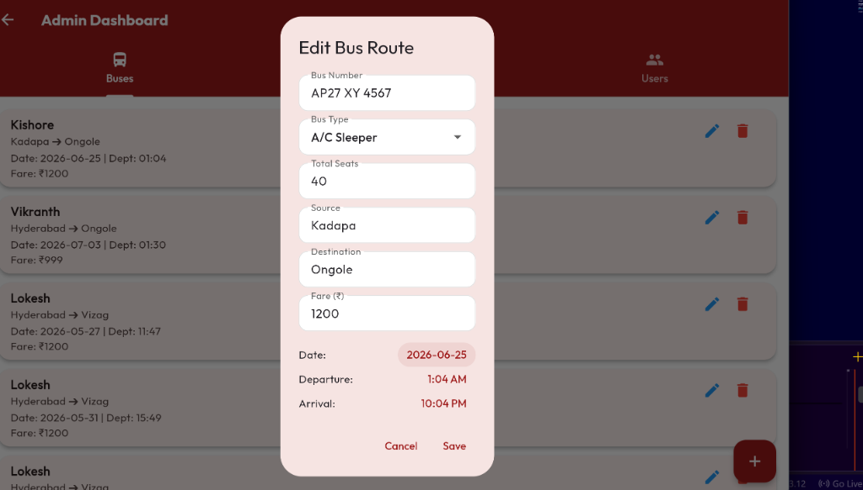
Figure Demonstration: Polished UI Bus Cards with Category Badges and Fare Labels

5. Verification & Test Metrics
Test ID | Scenario | Admin Action | Expected Outcome | Status
ADM-01 | Access Admin Dashboard | Tap Admin Shield icon in AppBar | Renders 3-tab portal with real-time MySQL metrics | PASSED
ADM-02 | View All Fleet Buses | Select 'Buses' tab | Lists all 14 active routes with bus numbers and types | PASSED
ADM-03 | Audit Live Reservations | Select 'Bookings' tab | Displays real-time passenger reservations with seat & gender | PASSED
TRIB-01 | Amma Avatar Click | Tap circular portrait on Home screen | Displays reverent dedication dialog with full bio | PASSED
UI-01 | Theme & Responsive Layout | Rotate device / resize window | Cards and text scale smoothly without overflow errors | PASSED

