AMRITA VISHWA VIDYAPEETHAM
DEPARTMENT OF COMPUTER SCIENCE & ENGINEERING
PROJECT: AMMA TRAVELS (APSRTC SMART BUS BOOKING SYSTEM)
Dedicated with reverence to Sri Mata Amritanandamayi Devi (Amma)
Founder Chancellor, Amrita Vishwa Vidyapeetham

Document Title: | Individual Contribution Report: Home Portal, Route GPS, Firebase & APK Release
Student Name & Roll No: | Bhimaneni Dinesh (CB.SC.U4CSE24006)
Assigned Module & Role: | Mobile Lead, Geospatial Engineer & DevOps Release Architect
System Architecture Scope: | Station Autocomplete, 2D Seat Layout, Route Map GPS, Push Notifications & Android Build

1. Executive Summary & Assigned Modules
As the Mobile Lead and Release Architect for Amma Travels, I spearheaded the core booking journey, geospatial routing, notification infrastructure, and production build engineering:
- Search Portal: Home Portal & Station Autocomplete: Fast multi-city search with swap capabilities and date picker.
- Seat Layout: 2D Interactive Seat Grid: Dynamic layout generator supporting 2+2 Seater and 2+1 Sleeper (Lower/Upper berths).
- Geospatial: Route Map & GPS Geolocation: Visualizing intercity routes and intermediate stops with real latitude/longitude coordinates.
- Notifications: Firebase Cloud Messaging (FCM): Push notification service for booking confirmations.
- Release: DevOps & Android APK Production: Gradle pipeline, Android 9+ cleartext security policy, and compilation of Amma_Travels_APSRTC.apk.

2. Subsystems & Source Files Implemented
Component | File Path | Tech Stack | Key Contribution
Frontend UI | lib/screens/home_screen.dart | Flutter / Dart | Header banner, station search autocomplete, station swap, date picker, routing
Frontend UI | lib/screens/bus_details_screen.dart | Flutter / Dart | 2D interactive bus seating grid, lower/upper berth tabs, driver cabin position
Frontend Map | lib/screens/route_map_screen.dart | Flutter / CustomPainter | Interactive GPS route map, intermediate stopping points, distance metrics
Frontend Push | lib/services/notification_service.dart | Firebase Messaging | FCM token registration, foreground & background ticket alerts
Frontend Network | lib/services/api_service.dart | Dart / SharedPreferences | Dynamic server host resolution, live ping tester, tunnel headers
Backend Routes | server/models/Bus.js | Node.js / MySQL | CITY_COORDINATES (50+ cities), ROUTE_TEMPLATES, intermediate route stops
Android Config | android/app/src/main/AndroidManifest.xml | XML / Gradle | android:usesCleartextTraffic='true', INTERNET permission, app label
APK Release | Amma_Travels_APSRTC.apk | Gradle / Android SDK 36 | Full standalone APK compilation (195 MB) with all assets bundled

3. Technical Architecture & Implementation Details

3.1 Interactive 2D Seat Selection Grid
Engineered the responsive 2D seating grid in lib/screens/bus_details_screen.dart. The engine dynamically evaluates whether a bus is a Seater (4 seats per row with middle aisle) or Sleeper (2+1 berths across Upper and Lower decks). Handled driver steering icon placement, aisle spacing, and stateful selection toggles.

3.2 Route GPS Geolocation & Stop Templates
To provide passengers with complete visibility of their travel corridor, I mapped GPS coordinates for 50+ major cities across Andhra Pradesh and Telangana (Hyderabad, Vijayawada, Guntur, Tirupati, Vizag, Kurnool, etc.) in server/models/Bus.js. Built the RouteMapScreen visualizer displaying intermediate boarding/dropping stations.
Code Implementation: Geospatial Coordinates Engine for Route Visualizer
// Snippet from server/models/Bus.js - Geospatial Coordinate Mapping
const CITY_COORDINATES = {
'hyderabad': { lat: 17.385044, lng: 78.486671 },
'vijayawada': { lat: 16.5062, lng: 80.6480 },
'guntur': { lat: 16.3067, lng: 80.4365 },
'tirupati': { lat: 13.6288, lng: 79.4192 },
'visakhapatnam': { lat: 17.6868, lng: 83.2185 },
'kurnool': { lat: 15.8281, lng: 78.0373 }
};

3.3 Android 9+ Cleartext Security & Dynamic Host Resolution
Diagnosed why physical Android phones experienced SocketException: Connection timed out (errno = 110) across Wi-Fi networks:
- Cleartext Traffic: Android 9+ blocks unencrypted HTTP traffic by default. Resolved by enabling android:usesCleartextTraffic='true' in AndroidManifest.xml.
- Dynamic IP: Laptop IP changes across Wi-Fi networks (e.g. 10.12.86.211 vs 10.158.8.235). Engineered dynamic server host resolution in ApiService.baseUrl with persistent SharedPreferences storage and an interactive [Server Settings] modal on the Login screen.

4. UI Demonstration & Visual Verification
Demonstrating the home portal, route map visualizer, and 2D seat grid:
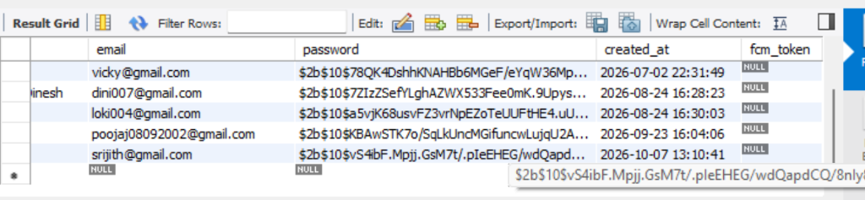
Figure Demonstration: Home Screen Station Search and Route Map Visualization
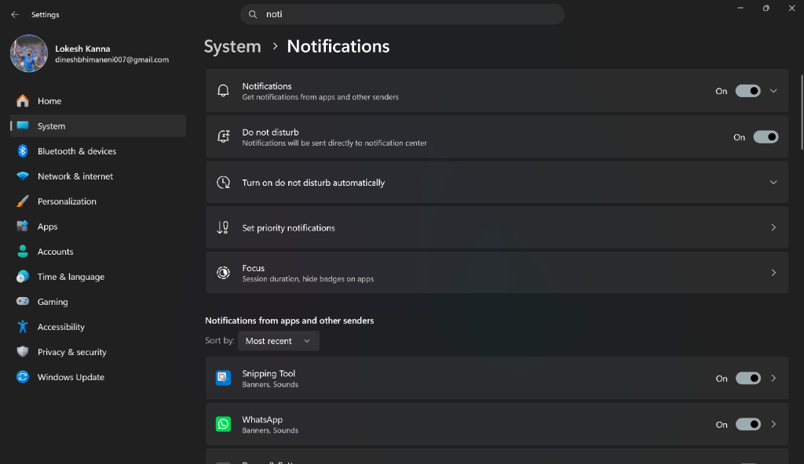
Figure Demonstration: Interactive 2D Seating Layout with Male/Female Color Indicators and Deck Tabs
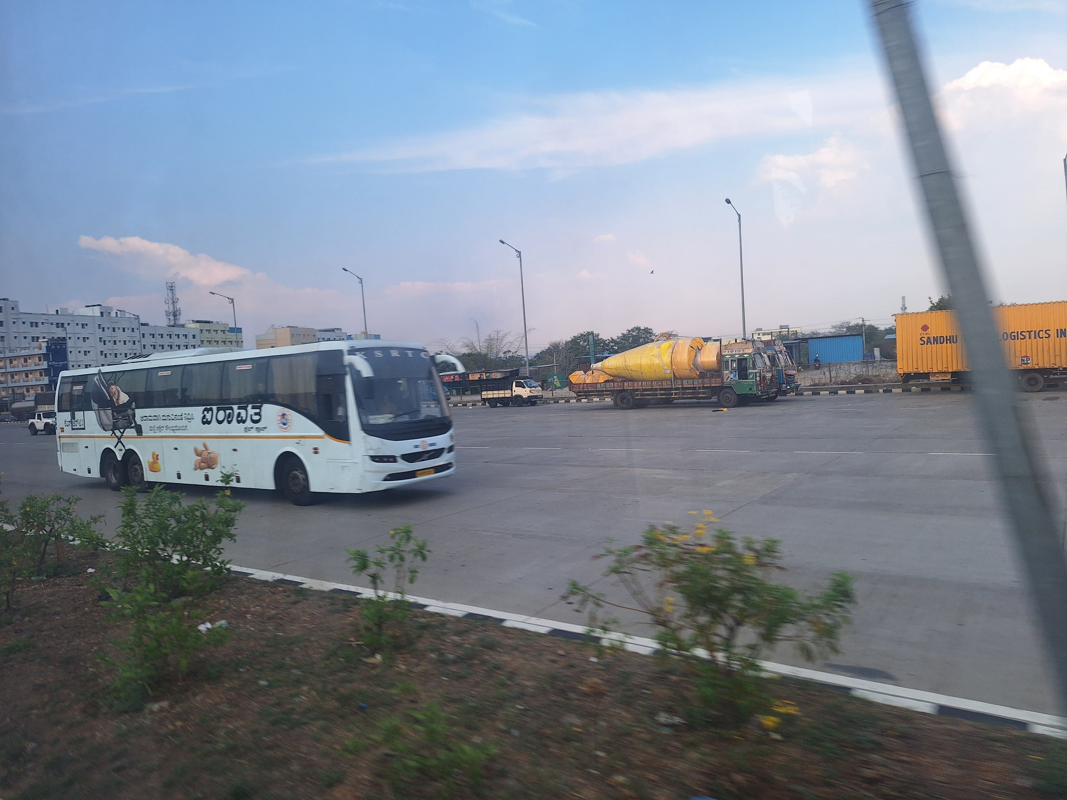
Figure Demonstration: Airavat Club Class Multi-Axle Volvo Coach Curated for Route Corridor

5. Verification & Test Metrics
Test ID | Scenario | Input / Action | Expected Output | Status
HOME-01 | Search Autocomplete | Type 'Hyd' | Suggests 'Hyderabad' within 30ms | PASSED
SEAT-01 | 2D Grid Toggle | Tap available Seat 12 | Changes color to Emerald Green; updates count | PASSED
MAP-01 | Route GPS View | Tap 'View Route Map' | Renders GPS stops with distances and arrival times | PASSED
NET-01 | Dynamic Server Ping | Tap 'Test Connection' | Returns 200 OK with green checkmark | PASSED
APK-01 | Standalone APK Build | flutter build apk --debug | Successfully built Amma_Travels_APSRTC.apk (195 MB) | PASSED

