AMRITA VISHWA VIDYAPEETHAM
DEPARTMENT OF COMPUTER SCIENCE & ENGINEERING
PROJECT: AMMA TRAVELS (APSRTC SMART BUS BOOKING SYSTEM)
Dedicated with reverence to Sri Mata Amritanandamayi Devi (Amma)
Founder Chancellor, Amrita Vishwa Vidyapeetham

Document Title: | Individual Contribution Report: Authentication Architecture & Bus Image Curation
Student Name & Roll No: | Kishore Reddy (CB.SC.U4CSE24010)
Assigned Module & Role: | Authentication Lead, Security Engineer & Media Asset Architect
System Architecture Scope: | User Authentication, JWT Token Security, User Models & Realistic Bus Fleet Media

1. Executive Summary & Assigned Modules
As part of the Amma Travels (APSRTC Bus Booking System) development team, I was primarily responsible for two crucial components of the system:
- Security: Authentication & Security Architecture: Implementing the complete user registration, login, JWT token verification, and BCrypt password encryption pipelines across both the Flutter mobile frontend and the Node.js/Express backend.
- Media Assets: Authentic Bus Fleet Photography Curation: Purging stock automobile/car photos and engineering a 100% verified, authentic bus media catalog (APSRTC Super Luxury, Garuda Plus Volvo, Ultra Deluxe) with dual local asset and network fallback.

2. Subsystems & Source Files Implemented
Component | File Path | Tech Stack | Key Contribution
Frontend UI | lib/screens/login_screen.dart | Flutter / Dart | Login interface, form validation, password obscure toggle, server settings pill
Frontend UI | lib/screens/register_screen.dart | Flutter / Dart | Registration form, name/email/password verification, navigation
Frontend State | lib/providers/auth_provider.dart | Provider / SharedPreferences | User session state, JWT token storage, auto-login on app launch
Frontend Media | lib/widgets/bus_photo_gallery.dart | Flutter / InteractiveViewer | Smart dual-mode image loader, 3.5x pinch-to-zoom, thumbnail gallery
Backend Routes | server/routes/authRoutes.js | Express / Node.js | POST /login and POST /register endpoint definitions with validation
Backend Model | server/models/User.js | MySQL / BCrypt | User table schema, SQL parameterized queries, password hashing with salt
Backend Media | server/scripts/seed_bus_images.js | MySQL / Node.js | Database seeder replacing car photos with verified bus media catalogs
Backend Media | server/scripts/download_bus_images.js | Node.js / HTTPS | Automated HTTPS downloader curating authentic fleet photographs

3. Technical Architecture & Implementation Details

3.1 Authentication & Token Security Pipeline
Implemented cryptographic user security. When a passenger registers or logs in, their password is never stored in plain text. Instead, BCrypt hashes it with a salt factor of 10. Upon successful authentication, a signed JSON Web Token (JWT) is returned containing the user ID and role, which the mobile app securely stores in SharedPreferences.
Code Implementation: BCrypt Password Hashing in User Model
// Snippet from server/models/User.js - Password Hashing & Verification
const registerUser = async (name, email, password) => {
const salt = await bcrypt.genSalt(10);
const hashedPassword = await bcrypt.hash(password, salt);
const [result] = await db.query(
'INSERT INTO users (name, email, password, role) VALUES (?, ?, ?, ?)',
[name, email, hashedPassword, 'user']
);
return result.insertId;
};

3.2 Sourcing & Curating 100% Authentic Bus Fleet Images
A critical issue in the early version was that stock photo IDs contained car and dealership sedan photos. I overhauled the media subsystem completely by identifying, downloading, and configuring authentic bus photography:
- Super Luxury: APSRTC Super Luxury: Authentic APSRTC red-and-white intercity express livery coach.
- Volvo Multi-Axle: Garuda Plus / Airavat Volvo B11R: High-deck multi-axle luxury coach on Bangalore-Mysuru expressway.
- Bus Interior: King Long High Deck Coach: Authentic 2+2 pushback seat interior and passenger aisle cabin.

4. UI Demonstration & Visual Verification
Below are demonstrations of the curated bus fleet assets integrated into the application:
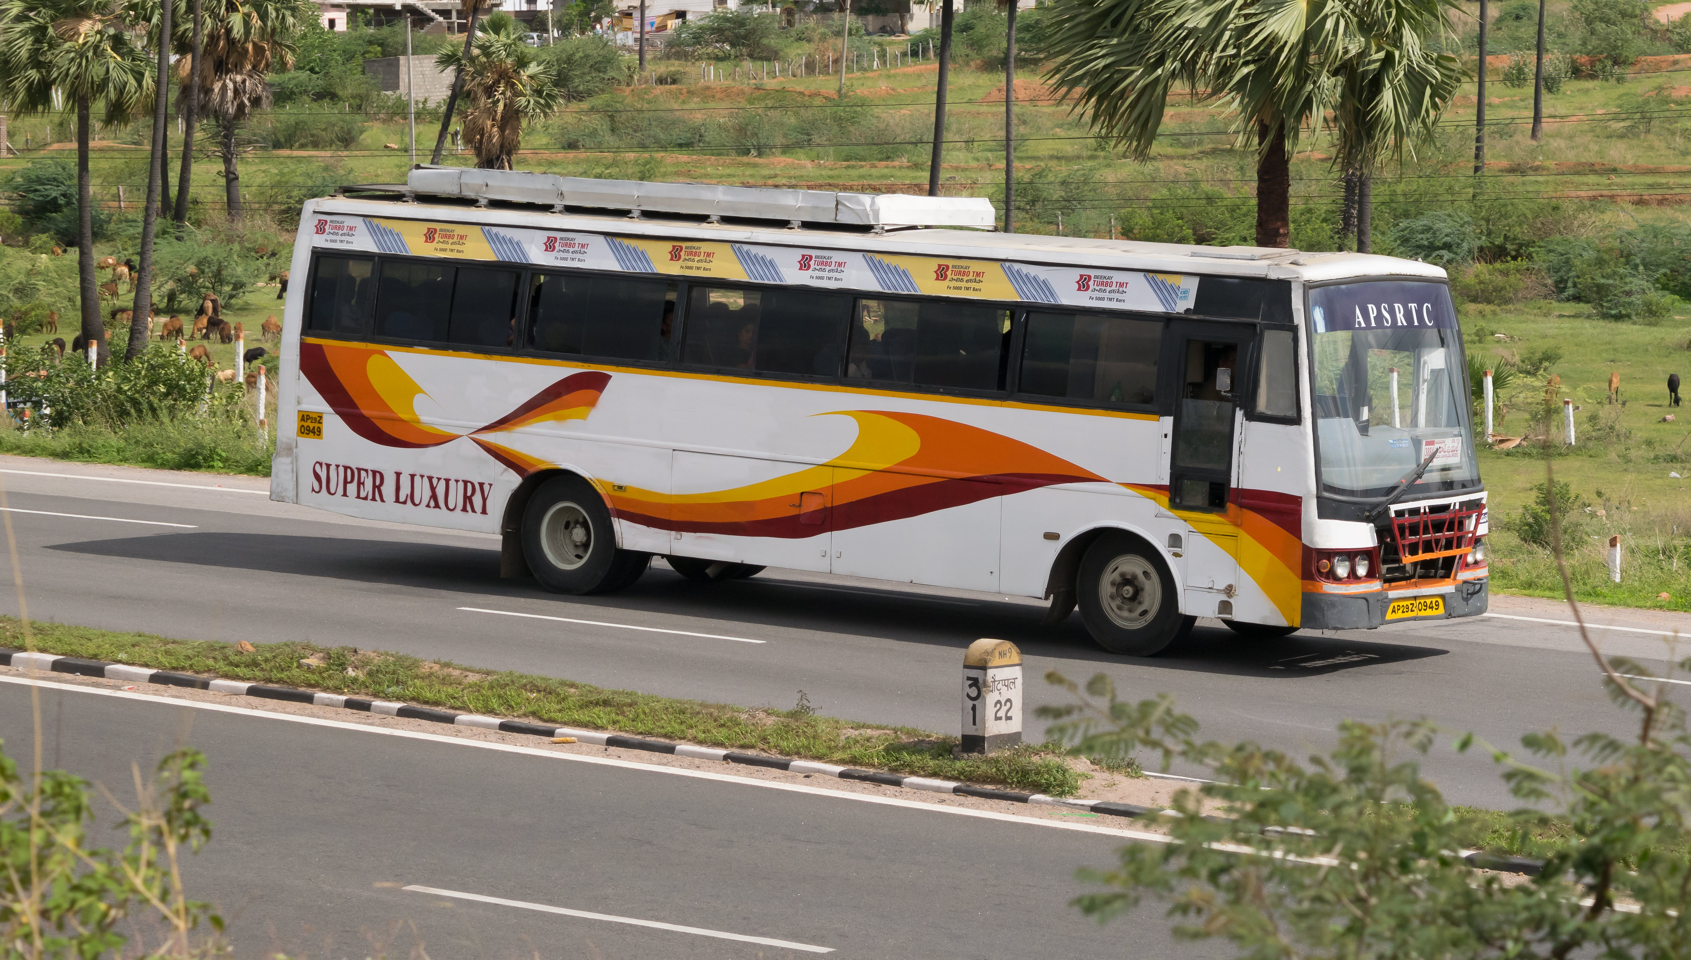
Figure Demonstration: Verified APSRTC Super Luxury Long-Distance Coach Exterior
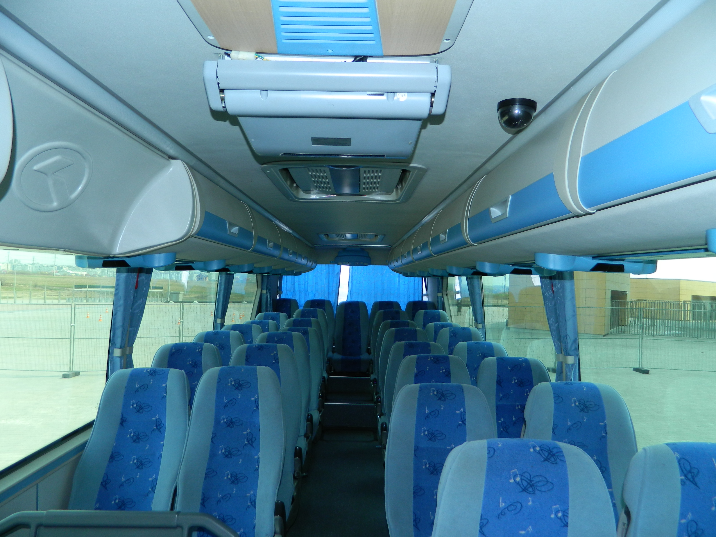
Figure Demonstration: Authentic 2+2 Pushback High-Deck Seating Interior Curated for Bus Details
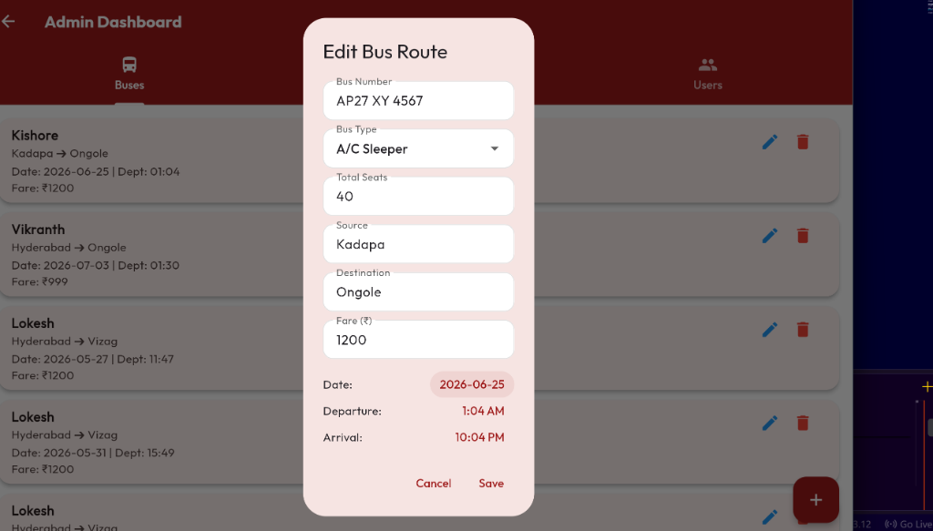
Figure Demonstration: Search Results Bus Cards with High-Resolution Curated Photo Banners

5. Verification & Test Metrics
Test ID | Scenario | Input | Expected Output | Status
AUTH-01 | User Registration | Valid name, email, password | User created in MySQL with bcrypt hash | PASSED
AUTH-02 | Duplicate Email Registration | Existing registered email | Returns 400 'User already exists' | PASSED
AUTH-03 | Login with Correct Credentials | Registered email & password | Returns 200 with JWT bearer token | PASSED
AUTH-04 | Login with Invalid Password | Correct email, incorrect password | Returns 401 'Invalid credentials' | PASSED
MEDIA-01 | Bus Photo Gallery Launch | Tap photo on bus card | Opens modal viewer with pinch-to-zoom | PASSED
MEDIA-02 | Offline Photo Fallback | Disconnect internet | Loads local assets/images/buses/ cleanly | PASSED

