# Machine Learning Zoomcamp

# Week_5: Machine Learning Model Deployment

From Data to Deployment: A Comprehensive Guide to Deploying Machine Learning Models

1. Save Machine Learning Model
2. Serve model via Web Service (Flask, Fast API, Django)
3. Setup environment python dependency
4. Setup System Dependency via Docker
5. Deploy docker image on Cloud (AWS / GCP/ AZURE)

Thanks @[Alexey Grigorev](https://www.linkedin.com/in/ACoAAAW0LKEBXPrPQ9kGjzloHkzNwHOFxLiHcBU)

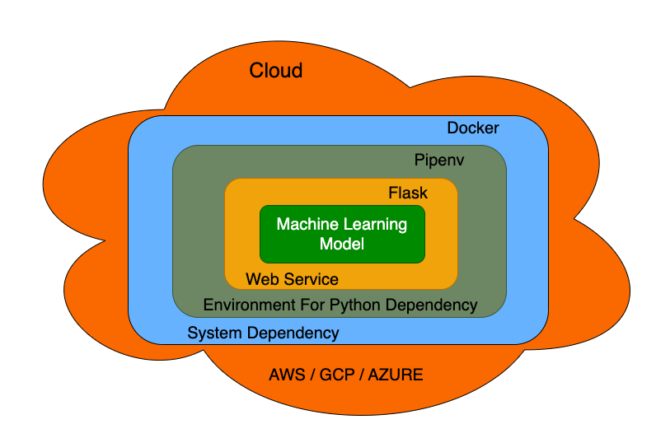

<https://www.linkedin.com/feed/update/urn:li:activity:7117861771196952577/>