House Prices Prediction Using Regression Models

Problem Description:
The data set for this project has been taken from Kaggle's Housing Data Set Knowledge Competition.This project aims at predicting house prices (residential) in Ames, Iowa, USA. The problem statement is quite self-explanatory and doesn't need more explanation. Hence, we move to the next step.

Hypothesis Generation:
Defining a hypothesis has two parts: Null Hypothesis (Ho) and Alternate Hypothesis(Ha). They can be understood as:
Ho - There exists no impact of a particular feature on the dependent variable.
Ha - There exists a direct impact of a particular feature on the dependent variable.
Some factors which can directly influence house prices are the following:
- Area of House
- How old is the house
- Location of the house
- How close/far is the market, school,and hospital.
- Connectivity of house location with transport
- How many floors does the house have
- What material is used in the construction
- Water /Electricity availability
- Play area / parks for kids (if any)
- If terrace is available
- If car parking is available
- If security is available
- History of accidents in the house
- If backyard is available
- If basement available

Dataset Description:
Here's a brief version of what you'll find in the dataset:
SalePrice - the property's sale price in dollars. This is the target variable that you're trying to predict.

MSSubClass: The building class
MSZoning: The general zoning classification
LotFrontage: Linear feet of street connected to property
LotArea: Lot size in square feet
Street: Type of road access
Alley: Type of alley access
LotShape: General shape of property
LandContour: Flatness of the property
Utilities: Type of utilities available
LotConfig: Lot configuration
LandSlope: Slope of property
Neighborhood: Physical locations within Ames city limits
Condition1: Proximity to main road or railroad
Condition2: Proximity to main road or railroad (if a second is present)
BldgType: Type of dwelling
HouseStyle: Style of dwelling
OverallQual: Overall material and finish quality
OverallCond: Overall condition rating
YearBuilt: Original construction date
YearRemodAdd: Remodel date
RoofStyle: Type of roof
RoofMatl: Roof material
Exterior1st: Exterior covering on house
Exterior2nd: Exterior covering on house (if more than one material)
MasVnrType: Masonry veneer type
MasVnrArea: Masonry veneer area in square feet
ExterQual: Exterior material quality
ExterCond: Present condition of the material on the exterior
Foundation: Type of foundation
BsmtQual: Height of the basement
BsmtCond: General condition of the basement
BsmtExposure: Walkout or garden level basement walls
BsmtFinType1: Quality of basement finished area
BsmtFinSF1: Type 1 finished square feet
BsmtFinType2: Quality of second finished area (if present)
BsmtFinSF2: Type 2 finished square feet
BsmtUnfSF: Unfinished square feet of basement area
TotalBsmtSF: Total square feet of basement area
Heating: Type of heating
HeatingQC: Heating quality and condition
CentralAir: Central air conditioning
Electrical: Electrical system
1stFlrSF: First Floor square feet
2ndFlrSF: Second floor square feet
LowQualFinSF: Low quality finished square feet (all floors)
GrLivArea: Above grade (ground) living area square feet
BsmtFullBath: Basement full bathrooms
BsmtHalfBath: Basement half bathrooms
FullBath: Full bathrooms above grade
HalfBath: Half baths above grade
Bedroom: Number of bedrooms above basement level
Kitchen: Number of kitchens
KitchenQual: Kitchen quality
TotRmsAbvGrd: Total rooms above grade (does not include bathrooms)
Functional: Home functionality rating
Fireplaces: Number of fireplaces
FireplaceQu: Fireplace quality
GarageType: Garage location
GarageYrBlt: Year garage was built
GarageFinish: Interior finish of the garage
GarageCars: Size of garage in car capacity
GarageArea: Size of garage in square feet
GarageQual: Garage quality
GarageCond: Garage condition
PavedDrive: Paved driveway
WoodDeckSF: Wood deck area in square feet
OpenPorchSF: Open porch area in square feet
EnclosedPorch: Enclosed porch area in square feet
3SsnPorch: Three season porch area in square feet
ScreenPorch: Screen porch area in square feet
PoolArea: Pool area in square feet
PoolQC: Pool quality
Fence: Fence quality
MiscFeature: Miscellaneous feature not covered in other categories
MiscVal: $Value of miscellaneous feature
MoSold: Month Sold
YrSold: Year Sold
SaleType: Type of sale
SaleCondition: Condition of sale

Data Exploration:

- The train data has 1460 rows and 81 columns and the test data has 1459 rows and 80 columns.
- It is found out that out of 81 features, 19 features have missing values.
- The percentage of the missing values is as presented in the bar chart below
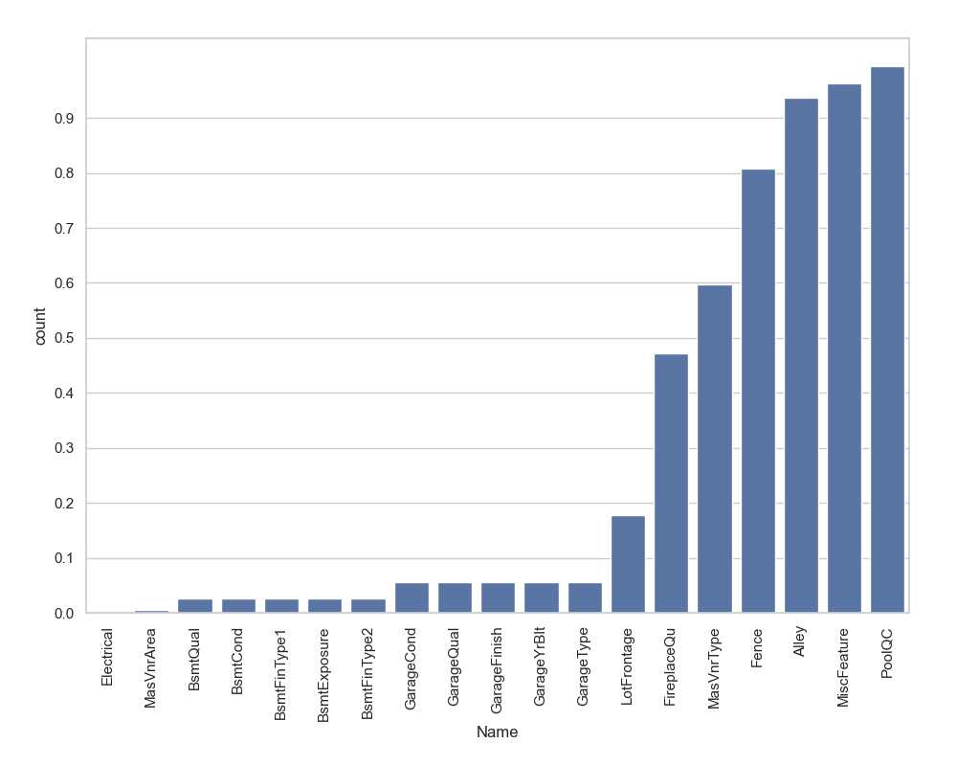
- ‘PoolQC’, ‘MiscFeature’ and ‘Alley’ are the top columns with over 90% null values.
- The distribution of the target ‘SalePrice’ is shown below
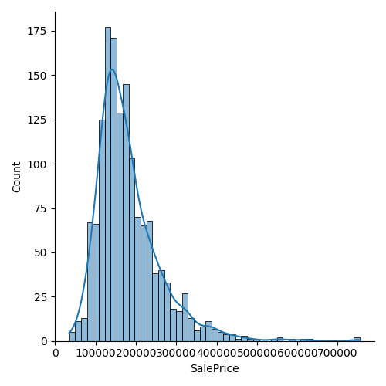
- It is clear that the distribution is right skewed. The skewness of ‘SalePrice’ is found out to be 1.8828757597682129
- A log transformation is performed on the target to adjust the distribution. The skewness of the target after the log transformation is: 0.12133506220520406 and the plot is shown below.
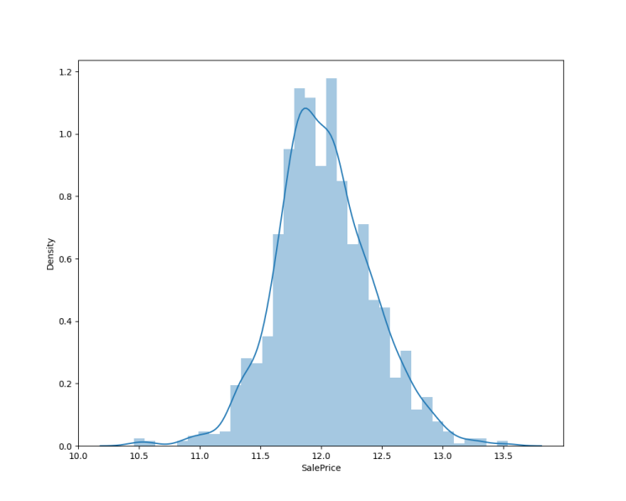
- The correlation of numeric variables need to be found as highly correlated variables contribute less information to the model.
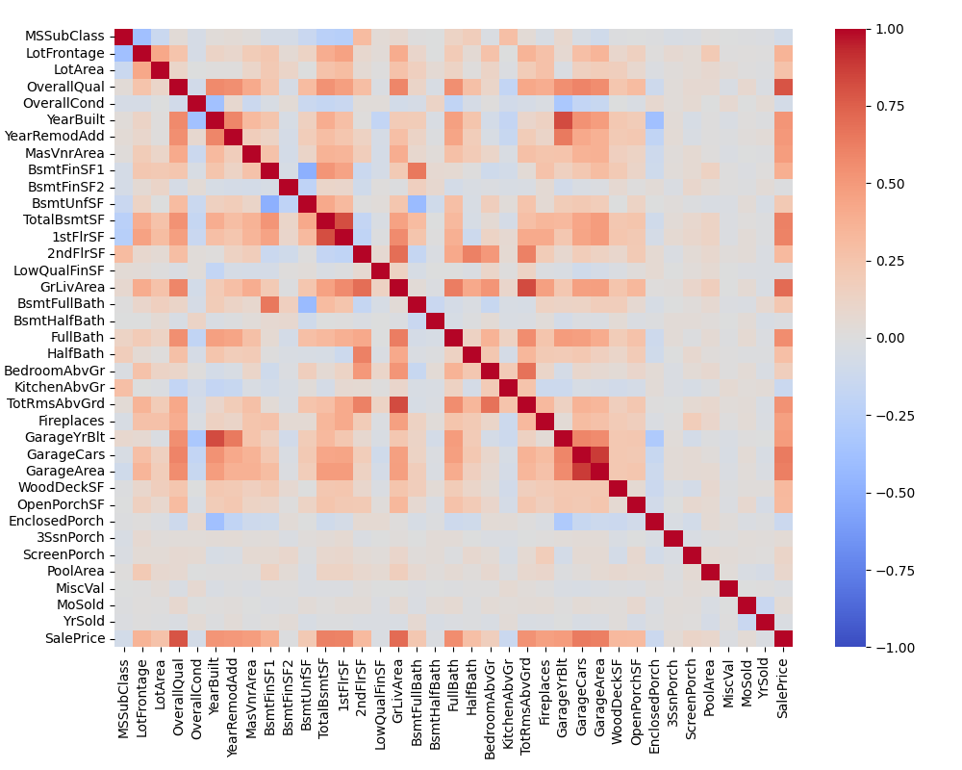
- The heatmap shows the correlation between the 38 numeric variables.
- From the analysis it is observed that ‘OverallQual’ and ‘GrLivArea’ has the highest correlation over 70% with the target ‘SalePrice’.
- The variable ‘OverallQual’ is measured in a scale of 1 to 10. It is safe to consider it as an ordinal variable. The median of sale price of houses with respect to Overall quality is shown below.
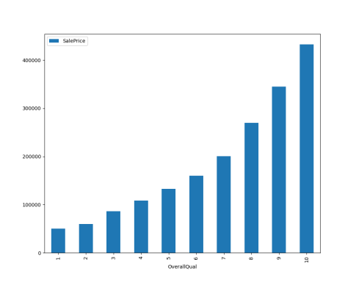
- We can see a direct correlation between ‘OverallQual’ and ‘SalePrice’ which is normal as the quality of the house increases the price will be high.
- The correlation between the next variable ‘GrLivArea’ and ‘SalePrice’ is given below
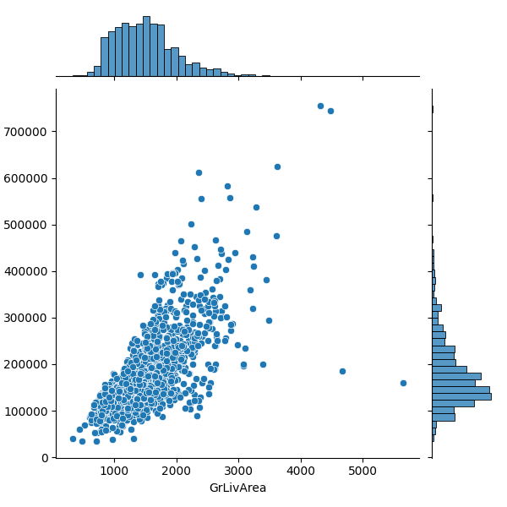
- As we can see there is a direct correlation in this case too. However, there are some outliers where ‘GrLivArea’ > 4000 which we have to remove.
- To understand the correlation between the categorical variables and ‘SalePrice’ we will perform ANOVA test. The plot of the results of the ANOVA test is given below.
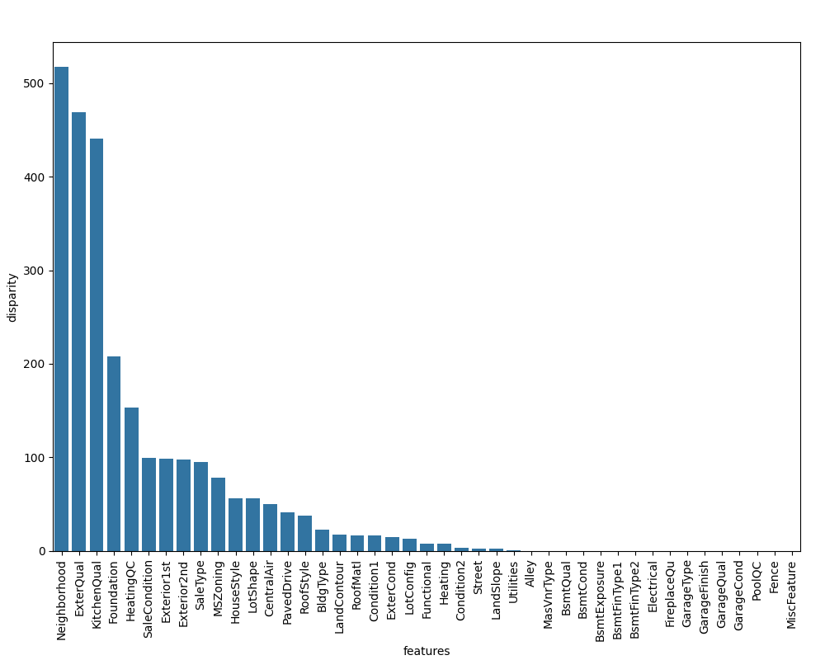
- Here we see that among all categorical variables ‘Neighborhood’ turned out to be the most important feature followed by ‘ExterQual’, ‘KitchenQual’, etc. It means that people also consider the goodness of the neighborhood, the quality of the kitchen, the quality of the material used on the exterior walls, etc.

Data Preprocessing:
- We discovered that the variable ‘GrLivArea’ has outlier values which exceed 4000. those values are removed.
- In row 666, in the test data, it was found that information in variables related to 'Garage' (GarageQual, GarageCond, GarageFinish, GarageYrBlt) is missing. The variables are imputed using the mode of these respective variables.
- In row 1116, in test data, all garage variables are NA except ‘GarageType’. That is marked as NA as well.
- Label encoder from ‘sklearn’ is used to encode categorical variables for model development.
- ‘LotFrontage’ variable using the median value of ‘LotFrontage’ by ‘Neighborhood’.
- In other numeric variables the missing values are imputed with 0.
- Variable names which have 'quality' or 'qual' in their names can be treated as ordinal variables, as mentioned above. The categorical variables are also converted into ordinal variables

Feature Engineering:
- Most categorical variables have near-zero variance distribution. We'll create some binary variables depicting the presence or absence of a category. The new features will contain 0 or 1 values.
- Just like Garage, we have several columns associated with the area of the property. An interesting variable could be the sum of all areas for a particular house. In addition, we can also create new features based on the year the house built like how many years has it been since re-modelling of the house.
- We will also create bins for ‘Neighbourhood’ based on the median sale price for the ‘Neighbourhood’
- Including the new features, we’ll transform all the numeric features to remove their skewness.

