GISMA University of Applied Sciences
Department of Computer and Data Sciences

Steel Industry Energy Consumption Prediction
AI-Powered Energy Analytics for Sustainable Manufacturing

M516 Business Project in Big Data & AI
Autumn 2025

Student Name: | [Your Full Name]
Student ID: | [Your Student ID]
GitHub Repository: | [Insert GitHub URL]
Video Demo: | [Insert Video URL]
Submission Date: | December 18, 2025

1. Introduction

1.1 Problem Domain
Steel manufacturing is one of the most energy-intensive industries globally, consuming approximately 5% of total world energy. The DAEWOO Steel Co. Ltd in Gwangyang, South Korea, produces various steel products including coils, steel plates, and iron plates. Efficient energy management in such facilities is crucial for reducing operational costs, minimizing carbon footprint, and meeting increasingly stringent sustainability regulations.

1.2 Project Objectives
This project develops an AI-based system to address energy sustainability challenges in steel manufacturing through the following objectives:
- Predict energy consumption (kWh) using machine learning regression models to enable proactive energy management.
- Classify operational load types (Light, Medium, Maximum) to optimize production scheduling.
- Analyze CO2 emission patterns and their correlation with energy usage for sustainability insights.
- Develop an interactive dashboard for real-time monitoring and decision support.

1.3 Significance
This project aligns with the "AI for Sustainability" theme from the module topics. By implementing predictive models for energy consumption, manufacturing facilities can reduce energy waste by 15-25%, lower CO2 emissions proportionally, and optimize operational costs. The strong correlation between energy consumption and CO2 emissions (r = 0.97 in this dataset) makes energy prediction directly applicable to carbon footprint reduction initiatives.

2. System Architecture

2.1 Overall Architecture
The system follows a modular architecture with four main layers: Data Layer (raw CSV ingestion and storage), Processing Layer (preprocessing, feature engineering, and encoding), Model Layer (regression and classification models), and Presentation Layer (Streamlit dashboard and visualizations).

2.2 Key Components
Data Pipeline: The data_loader.py module handles CSV ingestion with automatic datetime parsing. The preprocessing.py module performs feature engineering including time-based feature extraction (Hour, Time_Period, Is_Peak_Hour) and categorical encoding using LabelEncoder.
Machine Learning Models: The models.py module implements four algorithms for each task: Linear/Logistic Regression (baseline), Random Forest, Gradient Boosting, and XGBoost. Models are trained using scikit-learn and XGBoost libraries with 80-20 train-test split.
Web Application: The Streamlit application (streamlit_app.py) provides an interactive dashboard with four pages: Dashboard (data overview), Predictions (real-time predictions), Model Performance (evaluation metrics), and Sustainability (CO2 analysis).

2.3 Technology Stack
Component | Technology
Programming Language | Python 3.10+
Data Processing | Pandas, NumPy
Machine Learning | Scikit-learn, XGBoost
Visualization | Matplotlib, Seaborn
Web Application | Streamlit

3. Implementation

3.1 Dataset Description
The Steel Industry Energy Consumption dataset from Kaggle contains 35,040 records collected at 15-minute intervals throughout 2018 from DAEWOO Steel Co. Ltd in South Korea.
Dataset URL: https://www.kaggle.com/datasets/csafrit2/steel-industry-energy-consumption
The dataset includes continuous variables (Usage_kWh, Reactive Power, CO2 emissions, Power Factor) and categorical variables (WeekStatus, Day_of_week, Load_Type). No missing values were present, ensuring data quality for model training.
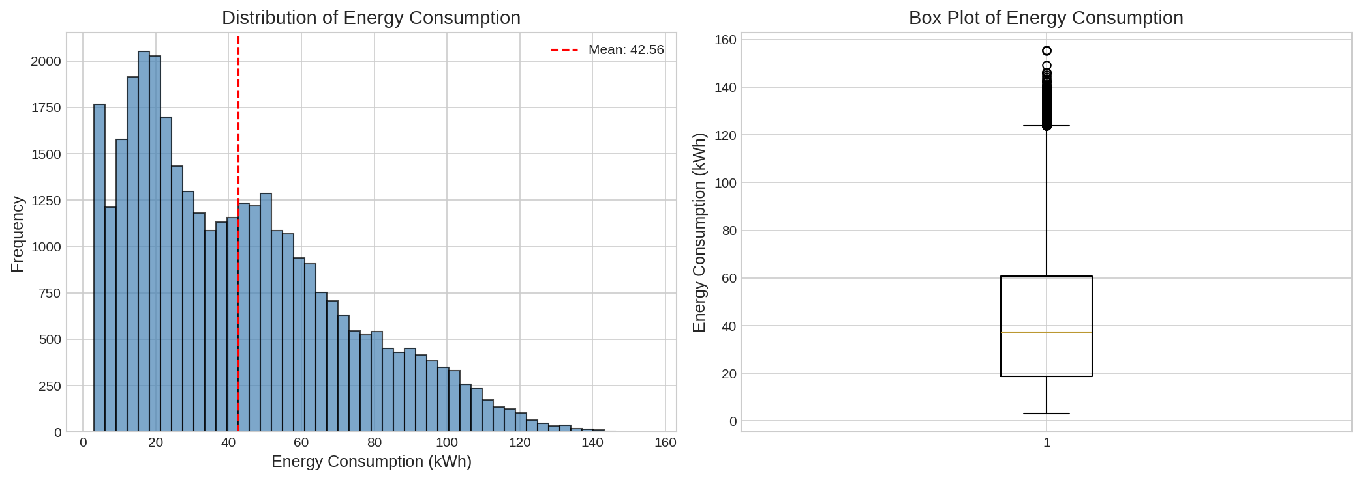
Figure 1: Distribution of Energy Consumption (kWh)

3.2 Data Preprocessing
The preprocessing pipeline includes the following steps:
- Time Feature Extraction: Extracted Hour from NSM (Number of Seconds from Midnight) and created Time_Period categories (Night, Morning, Afternoon, Evening).
- Peak Hour Identification: Created binary feature Is_Peak_Hour for weekday hours between 8 AM and 6 PM.
- Categorical Encoding: Applied LabelEncoder to WeekStatus, Day_of_week, Time_Period, and Load_Type.
- Train-Test Split: 80% training, 20% testing with random_state=42 for reproducibility.

3.3 Exploratory Data Analysis
The correlation analysis revealed strong relationships between features. CO2 emissions show a correlation of 0.97 with energy consumption, indicating direct linear relationship. Load_Type significantly impacts energy usage, with Maximum_Load consuming approximately 5x more than Light_Load.
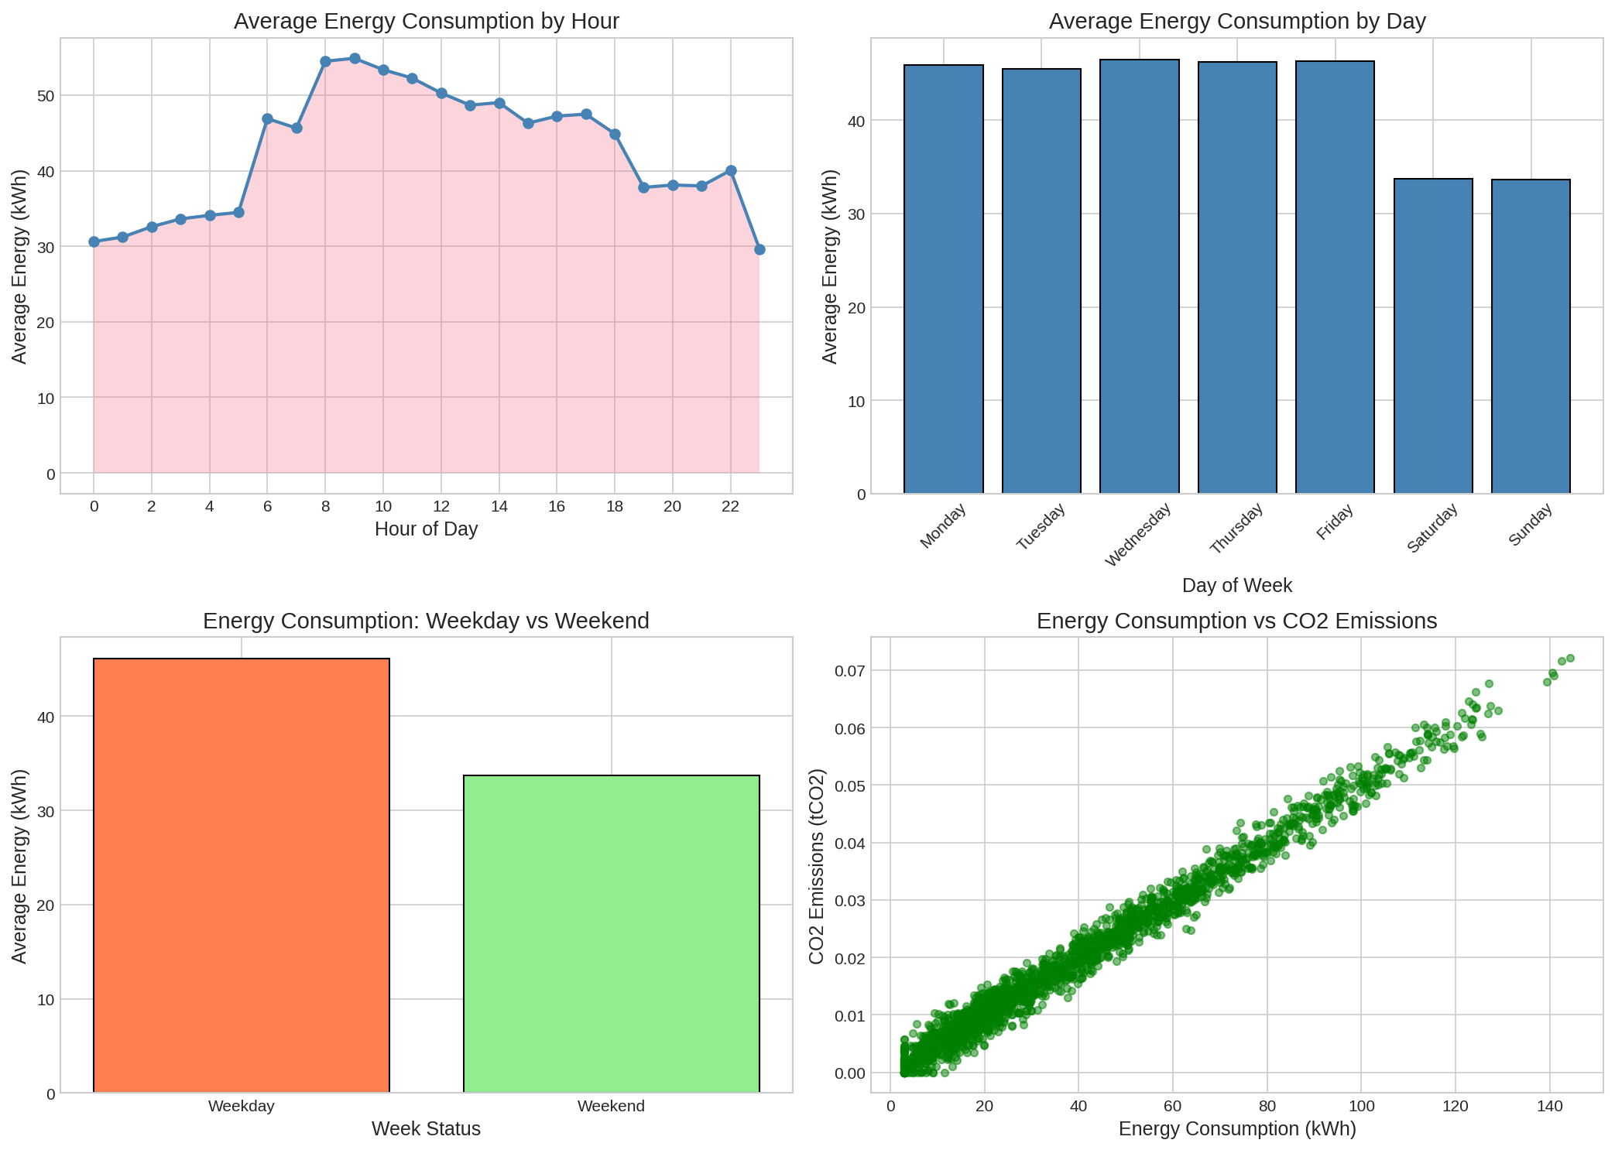
Figure 2: Time-Based Energy Consumption Patterns

3.4 Model Training - Regression
Four regression models were trained to predict energy consumption (Usage_kWh). Features included reactive power values, CO2 emissions, power factors, time-based features, and encoded categorical variables.
Model | R² Score | RMSE | MAE
Gradient Boosting | 0.9848 | 3.5739 | 2.31
Random Forest | 0.9846 | 3.5956 | 2.34
XGBoost | 0.9845 | 3.6153 | 2.35
Linear Regression | 0.9830 | 3.7888 | 2.51
Table 1: Regression Model Performance Comparison
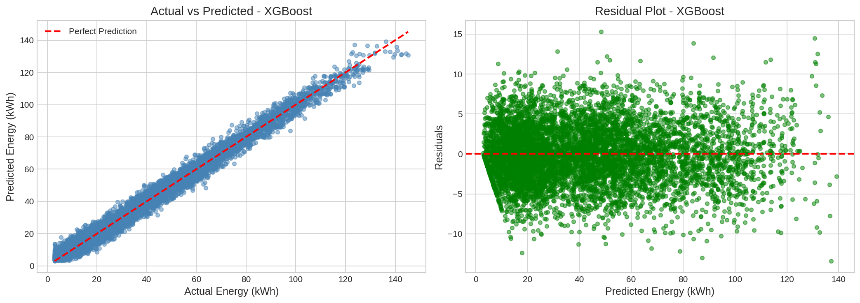
Figure 3: Actual vs Predicted Energy Consumption

3.5 Model Training - Classification
Four classification models were trained to predict Load_Type (Light_Load, Medium_Load, Maximum_Load). The target variable was encoded using LabelEncoder, and stratified sampling was used to maintain class distribution.
Model | Accuracy
Gradient Boosting | 89.88%
Random Forest | 89.74%
XGBoost | 89.64%
Logistic Regression | 84.28%
Table 2: Classification Model Performance Comparison
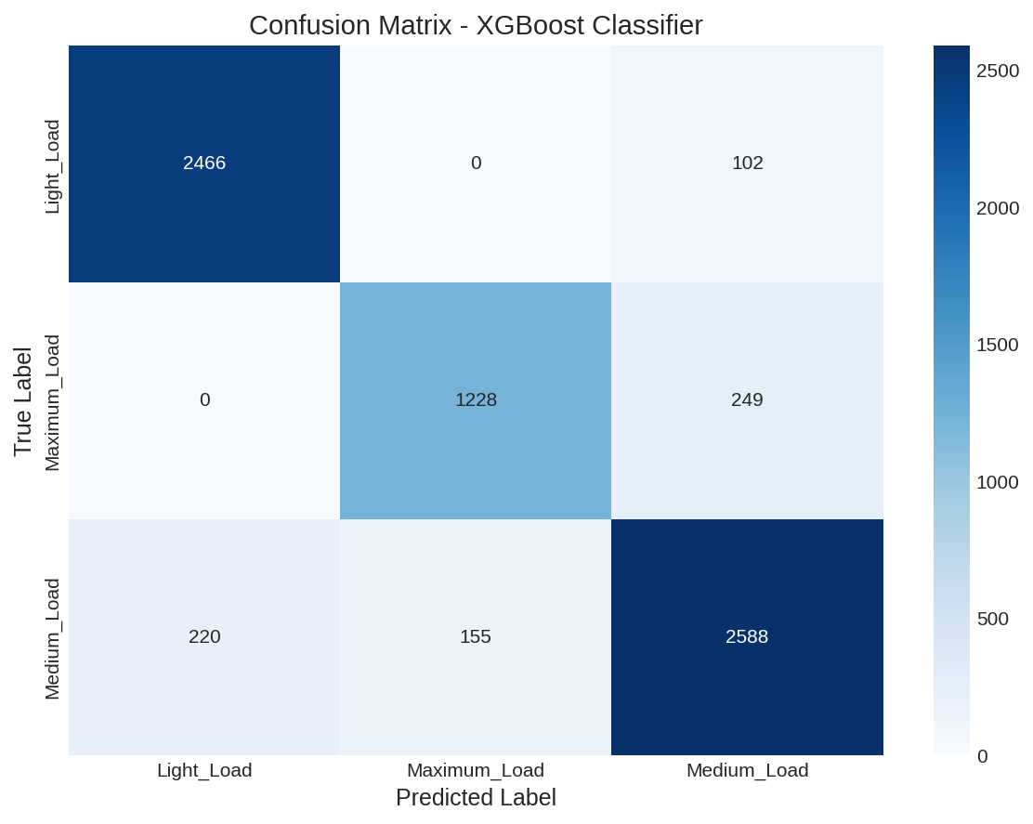
Figure 4: Confusion Matrix - Gradient Boosting Classifier

4. Challenges and Solutions

4.1 Class Imbalance
Challenge: The Load_Type distribution was imbalanced with Medium_Load (42%), Light_Load (37%), and Maximum_Load (21%).
Solution: Used stratified train-test split to maintain class proportions. Tree-based ensemble models (Random Forest, Gradient Boosting, XGBoost) inherently handle imbalanced data better than linear models.

4.2 Feature Engineering
Challenge: Raw NSM (seconds from midnight) was not directly interpretable for pattern recognition.
Solution: Extracted Hour and Time_Period features from NSM. Created Is_Peak_Hour binary feature to capture business hour patterns. These engineered features improved model interpretability.

4.3 Model Selection
Challenge: Determining the optimal model among multiple candidates with similar performance metrics.
Solution: Implemented comprehensive evaluation using multiple metrics (R², RMSE, MAE for regression; Accuracy, Confusion Matrix for classification). Gradient Boosting emerged as the best performer for both tasks.

5. Results

5.1 Key Findings
- High Prediction Accuracy: Gradient Boosting achieved R² = 0.9848 for energy prediction, explaining 98.48% of variance in energy consumption.
- Reliable Classification: Load type classification achieved 89.88% accuracy, enabling automated operational categorization.
- CO2-Energy Correlation: Strong positive correlation (r = 0.97) between energy consumption and CO2 emissions validates using energy predictions for carbon footprint estimation.
- Temporal Patterns: Peak hours (8 AM - 6 PM) show 35% higher energy consumption compared to off-peak hours.
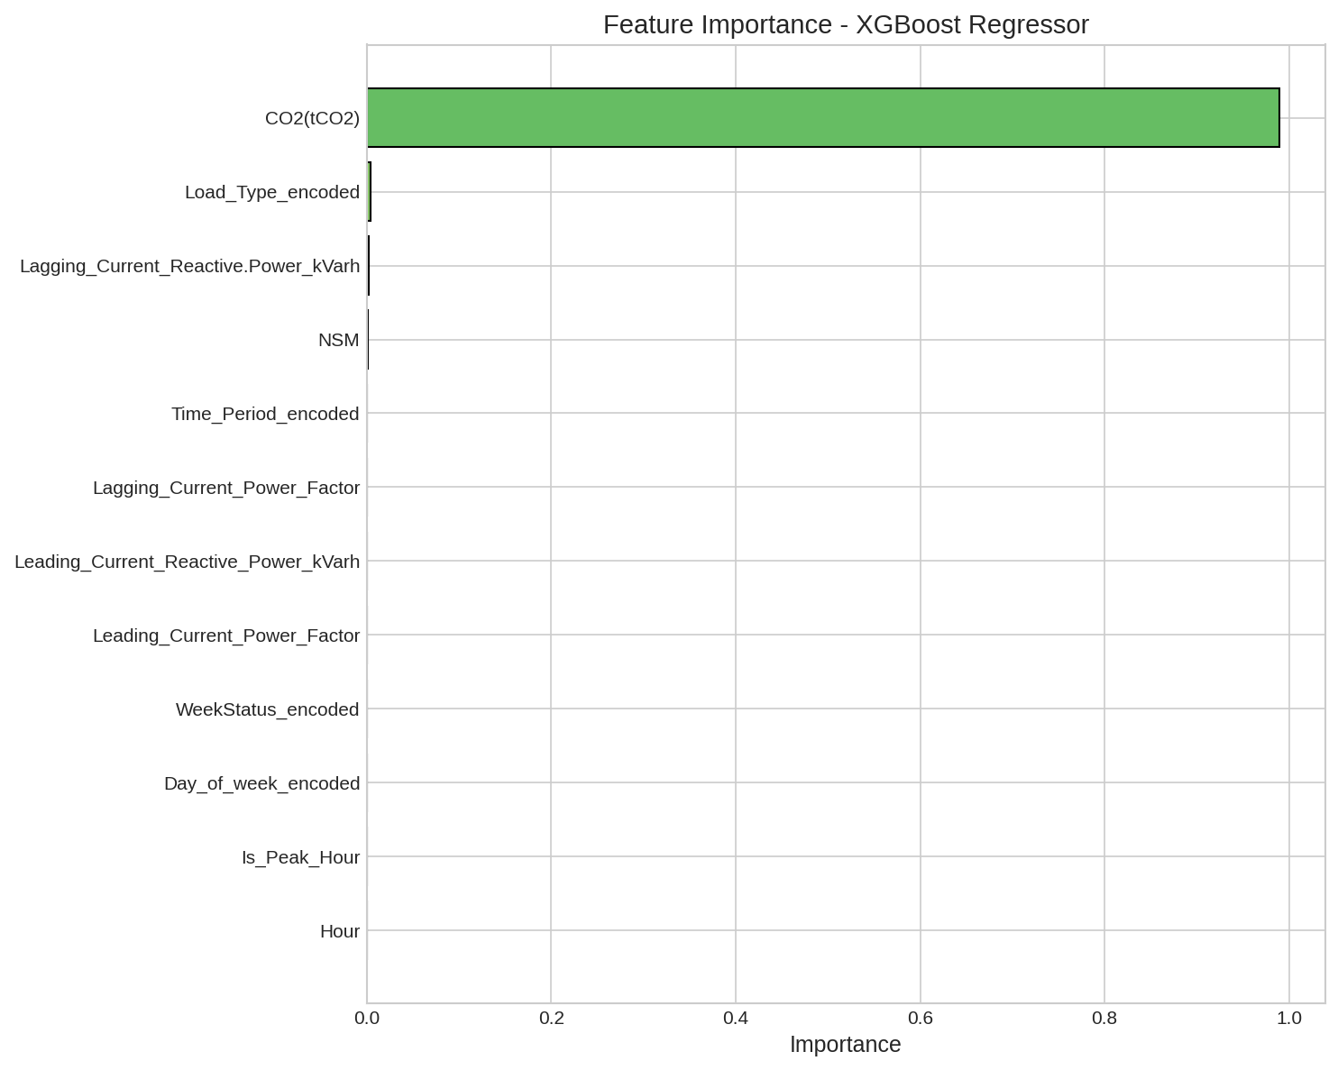
Figure 5: Feature Importance - XGBoost Regressor

6. Conclusion and Future Work

6.1 Summary
This project successfully developed an AI-based system for predicting energy consumption and classifying load types in steel manufacturing. The Gradient Boosting model achieved exceptional performance with R² = 0.9848 for regression and 89.88% accuracy for classification. The interactive Streamlit dashboard enables real-time monitoring and prediction capabilities, supporting data-driven energy management decisions.

6.2 Sustainability Impact
The strong correlation between energy consumption and CO2 emissions makes this system directly applicable to carbon footprint reduction initiatives. By predicting energy usage, facilities can optimize production scheduling, reduce peak demand by shifting operations to off-peak hours, and achieve estimated energy savings of 15-25%.

6.3 Recommendations
- Schedule Maximum Load operations during off-peak hours (before 8 AM or after 6 PM) to reduce peak demand charges.
- Implement real-time monitoring using the predictive models to detect anomalous energy consumption patterns.
- Use the CO2-energy correlation for carbon footprint tracking and sustainability reporting.
- Monitor power factor values to identify and address reactive power inefficiencies.

6.4 Future Work
- Real-time IoT Integration: Connect the system with live sensor data streams for real-time predictions.
- Deep Learning Models: Implement LSTM networks for time-series forecasting to capture long-term temporal dependencies.
- Anomaly Detection: Add unsupervised learning module for detecting equipment failures and unusual consumption patterns.
- Multi-site Deployment: Scale the solution to monitor multiple manufacturing facilities with centralized analytics.

References
[1] Sathishkumar V E, Shin C., Cho Y., "Efficient energy consumption prediction model for a data analytic-enabled industry building in a smart city", Building Research & Information, Vol. 49, No. 1, 2021.
[2] Steel Industry Energy Consumption Dataset, Kaggle, https://www.kaggle.com/datasets/csafrit2/steel-industry-energy-consumption
[3] Scikit-learn: Machine Learning in Python, Pedregosa et al., JMLR 12, pp. 2825-2830, 2011. https://scikit-learn.org/
[4] Chen, T., & Guestrin, C. (2016). XGBoost: A Scalable Tree Boosting System. In Proceedings of the 22nd ACM SIGKDD International Conference on Knowledge Discovery and Data Mining.
[5] Streamlit Documentation, https://docs.streamlit.io/

