Project Design Phase-II
Technology Stack (Architecture & Stack)
Date | 23 June 2026
Name | Dinesh S
Project Name | CampusMind AI – Smart Campus Incident Management System
Maximum Marks | 4 Marks

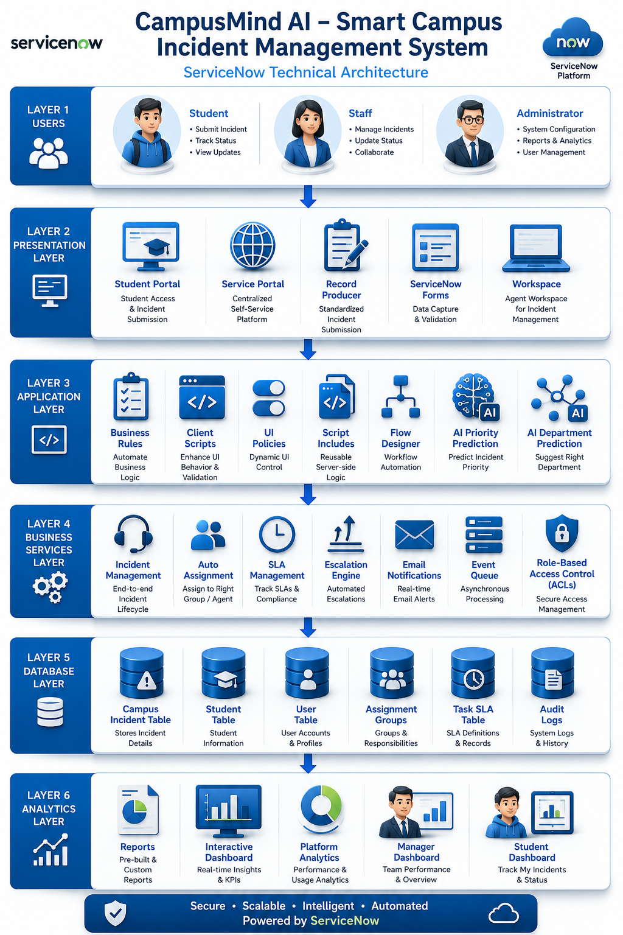
Technical Architecture:
Reference: https://learn.microsoft.com/en-us/azure/architecture/

Table-1 : Components & Technologies
S.No | Component | Description | Technology
1 | User Interface | Provides an interactive Student Portal and administrator interface for reporting, tracking, and managing campus incidents through easy-to-use forms. | ServiceNow Forms, Service Portal & Workspace
2 | Incident Submission Module | Captures campus incident details such as category, building, room number, description, student information, and attachments securely. | ServiceNow Record Producer, Custom Tables & Form Layouts
3 | Business Logic | Validates user inputs, automatically fills student information, assigns departments, predicts priority, and manages application rules. | Business Rules, Client Scripts, UI Policies & Script Includes
4 | Workflow Automation | Automates incident assignment, SLA initiation, escalation, notifications, and incident lifecycle management. | ServiceNow Flow Designer
5 | Security & Access Control | Restricts access to incidents, dashboards, and portal pages based on Admin, Student, and Staff roles. | ACLs (Access Control Lists), User Roles & Role-Based Security
6 | Database | Stores campus incidents, student details, assignment groups, SLA records, escalation information, and audit history. | ServiceNow Custom Tables
7 | Notification Service | Sends automatic email notifications when incidents are created, assigned, escalated, resolved, or closed. | ServiceNow Notifications, Events & Email Engine
8 | Reports & Dashboard | Displays incident statistics, category analysis, priority distribution, SLA performance, escalation reports, and assignment analytics. | ServiceNow Reports, Dashboards & Platform Analytics
Table-2 : Application Characteristics
S.No | Characteristics | Description | Technology
1 | User-Friendly Interface | The application provides an intuitive Student Portal for reporting issues and an administrator interface for managing incidents efficiently. | Service Portal, ServiceNow Forms & Workspace
2 | Role-Based Security | Students, Staff, and Administrators can access only the modules, records, and actions permitted by their assigned roles. | ACLs, User Roles, Client Scripts & UI Policies
3 | Workflow Automation | Automatically assigns incidents, initiates SLA tracking, performs escalations, and sends notifications without manual intervention. | Flow Designer, Business Rules & Events
4 | Availability | The application is available through the ServiceNow cloud platform, allowing authorized users to access the system anytime from campus or remote locations. | ServiceNow Cloud Platform
5 | Performance | The system processes incident submissions, assignments, SLA calculations, escalations, and dashboard updates with minimal delay. | ServiceNow Platform Engine, Business Rules & Custom Tables
6 | Scalability | The solution can support a large number of students, staff members, incidents, and departments without affecting system performance. | ServiceNow Multi-Tenant Cloud Architecture
7 | Maintainability | The application can be enhanced easily using configurable ServiceNow components such as Business Rules, Flows, Client Scripts, and Update Sets without significant code modifications. | ServiceNow Studio, Update Sets & Scoped Application
8 | Reporting & Analytics | Interactive dashboards and reports provide insights into incidents by category, priority, SLA status, assignment groups, escalations, and overall campus service performance. | ServiceNow Reports, Dashboards & Platform Analytics

